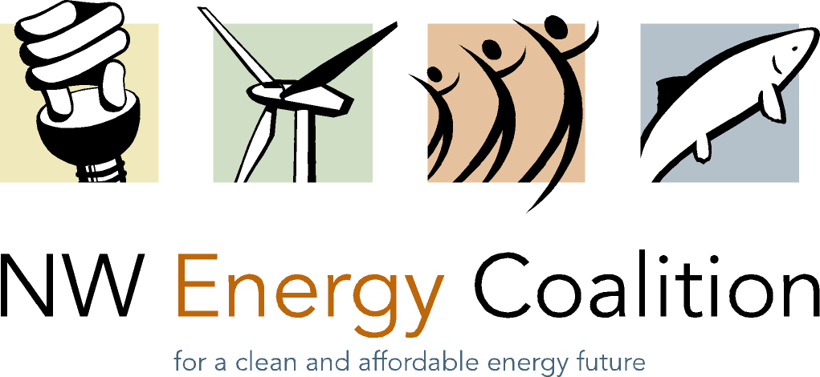
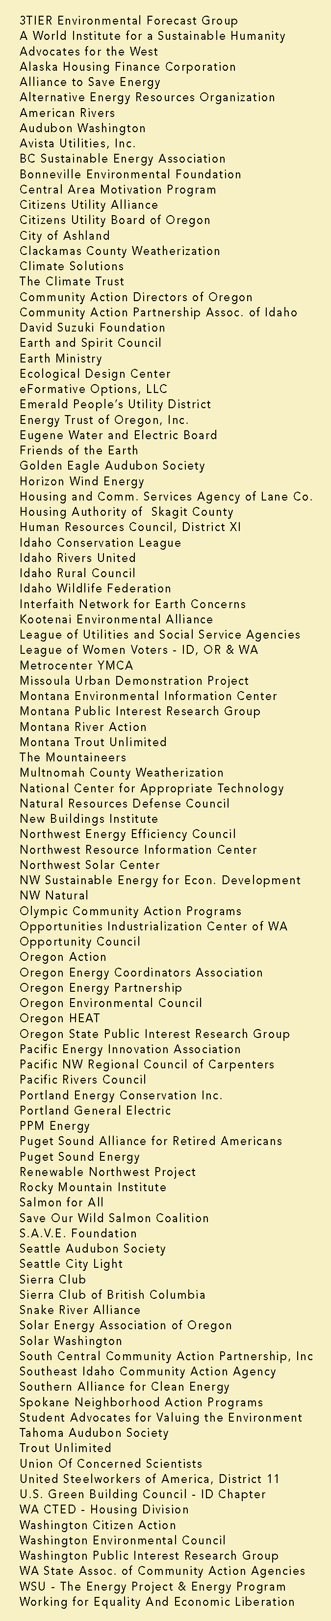

April 24, 2008

BY ELECTRONIC FILING AND FIRST CLASS MAIL

Ms. Carole Washburn, Executive Secretary
Washington Utilities and Transportation Commission
1300 S. Evergreen Park Drive SW
Olympia, WA 98504-7250

RE: WUTC vs. Northwest Natural Gas Company, Docket No. UG-080546

Dear Ms. Washburn:

Attached please find the NW Energy Coalition's Petition to Intervene and Notice of Appearance for Northwest Natural Gas Company’s general rate case, Docket No. UG-080546. The originals and 12 copies are being sent to the Records Department via Federal Express. They have also been sent via electronic mail and first class mail to the service list.

Sincerely,
Danielle Dixon
Senior Policy Associate

