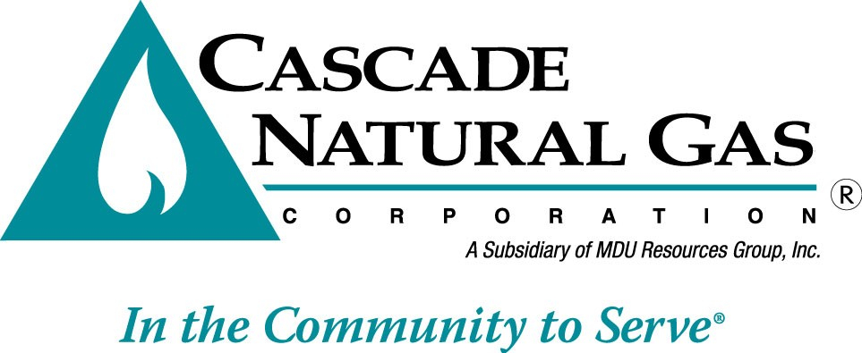

2012
Integrated Resource Plan
(DRAFT)

November 11, 2012

TABLE OF CONTENTS

Pages

Section 1 –Executive Summary............................................................... 4

Section 2 – Introduction & Planning Overview
- Company Overview................................................................... 10
- Bundled vs. Unbundled ............................................................. 11
- IRP Guidelines & Policies ......................................................... 12
- Resource Decision Making Overview....................................... 14
- Disclaimer.................................................................................. 15

Section 3 - Demand Forecast
- Forecast Methodology………………………….. ....................... 17
- Peak Day Forecasting............................................................... 18
- Forecast Results ....................................................................... 18
- Demand Forecast Uncertainties ............................................... 22

Section 4 - Distribution System Enhancements
- Distribution System Modeling ................................................... 24
- Engineering Modeling by Town ................................................ 24
- Key Findings.............................................................................. 25

Section 5 - Supply Side Resources
- Gas Supply Resource Options ................................................. 28
- Capacity and Alternative Resources.......................................... 33
- Natural Gas Price Forecast....................................................... 59
- Supply Side Uncertainties ......................................................... 62
- Financial Derivatives ................................................................. 63
- Portfolio Purchasing Strategy ................................................... 64

Section 6 - Demand Side Resources
- Demand Side Management Overview...................................... 67
- Two-Year Action Plan Update ................................................. 68
- Potential DSM Measures and Their Costs ............................... 79
- Oregon Conservation Potential Study Results ................... ….. 82
- Washington Conservation Potential Study Results ............ ….. 88
- Conservation Summary …………………………………………. 94
- DSM Implementation Issues and Uncertainty .......................... 94
- Environmental Externalities .......................................................99
- Other Demand Side Management............................................ 100

Section 7 - Resource Integration
- Resource Optimization Analysis Tools ..................................... 103
- Scenarios versus Simulations................................................... 104
- Decision Making Tool................................................................ 105
- Key Inputs.................................................................................. 109
- Integration Results & Findings .................................................. 111

Section 8 - Two Year Action Plan .......................................................... 134

Glossary…………………………………………………………………..... 138

Citygate/Zone Cross reference……………………………………….....148

LIST OF APPENDICES

Appendix A - IRP Process
Appendix A-1 IRP Workplan
Appendix A-2 TAG Meeting Participants, Agendas and Materials
Appendix A-3 IRP Guidelines & Rules

Appendix B - Demand Forecast Appendices
Appendix B-1 Demand Forecast Model Escalation Rates
Appendix B-2 Demand Forecast Model Results & Summary Tables

Appendix C – Distribution System Analysis

Appendix D - Conservation Measures – Technical Potential
Appendix D-1 Oregon Residential Measures
Appendix D-2 Oregon Commercial & Industrial Measures
Appendix D-3 Washington Residential Measures
Appendix D-4 Washington Commercial & Industrial Measures

Appendix E – Supply Resource Alternatives

Appendix F - Capacity Requirements & Peak Day Planning Appendix G –Weather & Price Uncertainty Analyses Appendix H - Avoided Cost Calculations
Appendix I – Prior 2-Year Action Plan Update

Section 1

Executive Summary

Cascade’s resource planning continues to focus on ensuring that the Company can meet the needs of our firm gas sales customers in a way that minimizes costs over the long term. Although some pipeline area zones indicate potential shortfalls, in aggregate, through 2012, Cascade has sufficient upstream pipeline capacity. However, as we move past the 2012-2013 winter heating season, primarily as a result of Cascade’s growth in its residential and commercial customer base, Cascade’s capacity will fall short of its design peak day demand forecast. As a result Cascade is entering a period where it will need to acquire additional resources to meet the growing needs of these core customers. The following summarizes key findings from this plan.

Adequacy of Gas Supply
Physical gas supply is expected to be adequate to meet growing demand in the Pacific Northwest and North America. New supply development technologies continue to provide additional resources in British Columbia and the Rocky Mountain regions. Shale gas from the Horn River Basin, Montney and Marcellus are likely to keep sufficient supplies available in North America. Several sources believe that shale is set to comprise more than a third of the US production by the mid 2020s. Well performance in the Horn River play has improved over the past few years. Although players must overcome a multitude of challenges, including a remote operating environment, water availability and disposal issues, infrastructure constraints, and high upfront capital costs, Canadian production and exports are anticipated to decline.

Still, due to on-going financial and regulatory issues, there is still some question as to whether or not a new pipeline will transport Alaskan gas into the North American market, or if it will be completed within the Company’s planning period. The Mackenzie Gas Project, which would bring gas from the Canadian Arctic to Alberta, has pushed out their start date to 2018 (from 2014) due to regulatory issues, incomplete financial arrangements and staffing shortages. The Alaska pipeline project, designed to deliver
4.5 (up to 5.9 Bcf/d under maximum compression) Bcf/d from Alaska’s North Slope into Alberta and/or the US Lower-48, is not dead, with two competing projects still officially in the works. The TransCanada-ExxonMobil Alaska Pipeline Project is expected to file their draft Resource Reports to FERC in the coming months, although, like many projects—it may expand to include an LNG option. Still, Lower-48 shale development has called into question the ultimate need for this project but indicators are that eventually it will get done around 2023.

Load Resource Balance
During this planning cycle, Cascade continued to evaluate the impacts on both its load and resources and portfolio costs associated with its peak day planning criteria. Until the 2008
IRP, Cascade had historically utilized a system average of 65 heating degree days (dd) for its peak demand forecast as it represented the coldest day recorded in Cascade’s 60 plus years of weather history. However, the Company had only experienced a 65dd once in its history (which occurred in 1968), and therefore commencing with the 2008 Plan, the Company modified its design day criteria to utilize the coldest day during the past 30

years. This modification reduced the peak day to 61dd which occurred as recently as
1990.

The following graph shows the peak day requirements compared to the Company’s existing pipeline capacity resources under the various load growth forecasts. It is important to note that while it appears on a system wide basis Cascade appears to have sufficient capacity to meet load through approximately 2029, this is in fact misleading. Certain zones on the system have significant excess capacity due to low load growth and the shape of the capacity at the time the space was acquired. See Appendix C for specific zone to capacity comparison charts.

Figure 1-A
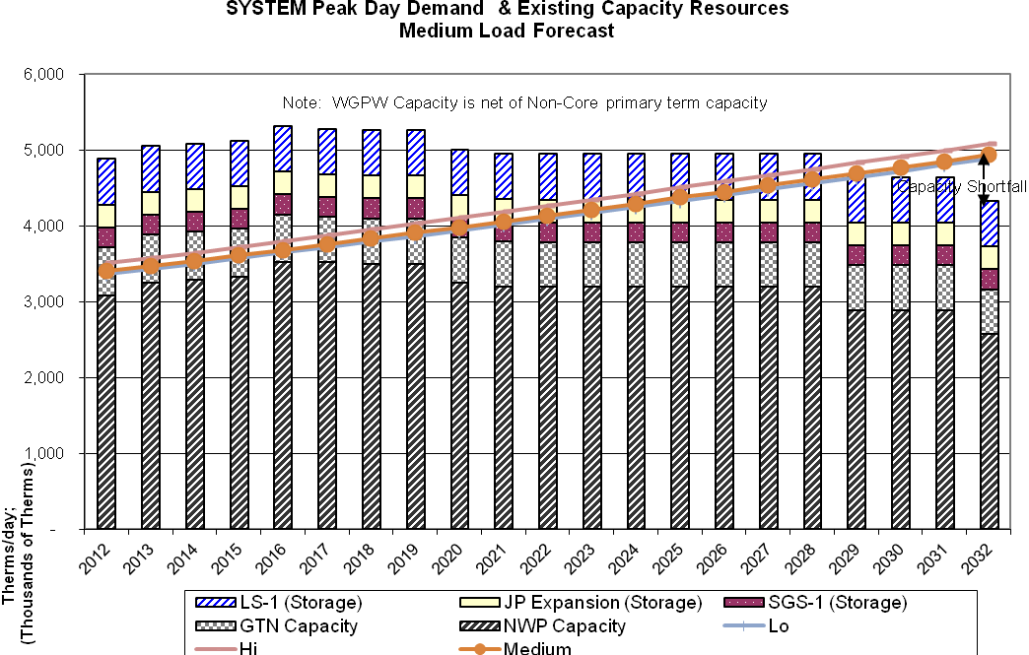

Analytical Methods
Cascade continues to utilize the SENDOUT model to assist with the analysis of resource alternatives. SENDOUT is a linear optimization model that helps identify the long-term least cost combination of resources to meet stated loads. The model determines the optimal portfolio of resources that will minimize costs over the planning horizon based on
a set of assumptions regarding resource alternatives, resource costs, demand growth and gas prices. Linear optimization models, such as SENDOUT, are basically deterministic. In other words, they solve the “least cost problem” based upon the assumptions provided to the model. As a result, the Company, beginning with its 2007 IRP, expanded its uncertainty analysis through the purchase of VectorGasTM (an add-on product) that
facilitated the ability to model gas price and load (driven by weather) uncertainty. The Monte-Carlo functionality was integrated in SENDOUT Version 12.5, which is the platform that Cascade used to prepare its integration analysis. The Monte-Carlo modeling capability provides additional information to decision-makers under conditions of uncertainty. The Monte-Carlo analysis was used in this plan to test the physical and financial risks associated with the optimal portfolio from the basecase planning scenario. This tool provides a valuable enhancement to the robustness of the Company’s resource planning.

Generic Resources
One of the purposes of Integrated Resource Planning is to identify an illustrative resource portfolio to help guide specific resource acquisitions. In this planning cycle, the Company considered a host of resource alternatives that can be added to its resource portfolio, including additional conservation programs, incremental off-system storage alternatives at MIST and Ryckman Creek, additional transportation capacity on NWP, Ruby and GTN pipeline systems, several of the proposed pipelines to move Rockies gas to the northwest, along with on-system satellite LNG facilities, biogas, and imported LNG. Typically, utility infrastructure projects are “lumpy”, since demand grows annually at a small percentage rate, while capacity is typically added on a project-by-project basis. Utilities often have surplus capacity and must “grow into” their new pipeline capacity, because it is more cost effective for pipelines to build for several years’ worth of load growth at one time than to make small additions each year. However, the Company can minimize the impacts through the acquisition of citygate peaking resources which include both the supplies and the associated pipeline delivery for a certain number of days or through the purchase of other’s excess capacity through short or medium term capacity releases.

Analytical Framework
Traditional integrated resource planning would include analyses targeted at identifying the optimal long-term resource portfolio to meet the demand of the gas utility’s customers
across a few customer growth and gas price scenarios. In this plan, Cascade’s resource analysis includes 8 different scenarios that focus solely on gas utility operations. In addition to scenario analysis, Cascade performed two different kinds of Monte-Carlo analyses to examine a variety of risks as noted above.

Summary of Key Findings
Cascade anticipates its core customer base will continue to grow over the planning horizon and annual throughput is anticipated to increase between 1.1% and
1.4% per year.

The projected costs for natural gas have declined significantly and long-term prices are estimated to range between $3 to $6 over the planning horizon compared to the $8 to $13 forecasted in the 2008 IRP. This improvement to the long-term gas supply outlook is a stark contrast to the diminishing supply outlook that was prevalent during the development of the Company’s 2008 IRP.

The Company has chosen to utilize the $.65 levelized cost screen in order to factor for increases in avoided costs over the 30-year planning horizon. However, it is likely in the short term, the actual conservation portfolio implemented by the Company will need to adhere to a more stringent cost effectiveness limit in the $.40 - $.50 range. For the purposes of pure DSM planning, Cascade has chosen to include a broader range of potential, recognizing that further refinement to the Company’s DSM potential assessment will be critical for the 2014 IRP planning period.

Even with energy efficiency programs, Cascade will need to acquire additional capacity resources or enter into other supply arrangements to meet anticipated peak day requirements, primarily due to continued growth in the company’s residential and commercial customer base. Ruby went on line in 2011 and has been running at near capacity since it’s in-service date. Utilizing the SENDOUT resource optimization model, several scenarios were run to test the viability of acquiring Ruby capacity either based on existing recourse rates, discounted rates and via capacity release through a third party. Incremental and corresponding GTN Malin north capacity was also modeled at recourse (secondary firm) and higher pricing levels. Basin prices in the model over the 20 year planning horizon have Rockies trading at a slight
discount to AECO, Malin and Sumas ($0.06 - $0.15). Regardless of the scenarios modeled, SENDOUT consistently selected Ruby capacity in a range of 17,000 to approximately 19,000 dths/day.

Many of the proposed pipeline projects will not be viable resources for some time. In the interim, capacity shortfalls will be met through the use of peaking and citygate
gas supply deliveries which will utilize third-party (non-Cascade) upstream pipeline transportation.

Satellite LNG facilities that are located within Cascade’s distribution system are also attractive alternatives. Satellite LNG may alleviate the need for incremental pipeline capacity and to the extent the facility could be strategically located on a portion of the distribution system, it could provide the further benefit of eliminating or reducing distribution system constraints. Cascade has considered bio natural gas (BNG) as an alternative, but at the time of this writing, there are no viable projects available to our distribution territory. Regardless, prior to any BNG supplies being added to the portfolio, gas quality issues will need to be satisfactorily addressed. In addition to

Cascade, upstream pipelines, such as Northwest Pipeline are beginning to address gas quality issues regarding BNG. We will continue to monitor our market intelligence sources to see if viable BNG opportunities develop.

None of the proposed LNG projects are within Cascade’s distribution system. Many of the proposed LNG import facilities located in the Pacific Northwest (Bradwood Landing, Jordan Cove) would require backhaul capability or additional infrastructure on upstream pipelines in order to reach Cascade’s distribution system. Prior to September 19, 2008, LNG supplies sourced at Kitimat were selected as part of the least cost-portfolio mix, however, on September 19, 2008, Kitimat LNG announced that the development focus of the facility would switch from a regasification to a liquefaction facility, making Kitimat an exporter, rather than an importer of natural gas. Kitimat did leave open the possibility of providing regasification in addition to liquefaction. As of this writing, it appears that Kitimat will focus on exporting natural gas, particularly given the huge supply of shale gas from northeastern British Columbia. The company did analyze the other two LNG options in the Northwest
(Bradwood and Jordan Cove) along with the incremental pipeline capacity that would be necessary to reach Cascade’s service territory and found that based on preliminary cost estimates that model preferred the Ruby and Malin transportation resources over the import LNG options. The company will continue to monitor the impact of various imported LNG options and update its modeling assumptions as more information becomes available.

20 year portfolio costs, on a Net Present Value (NPV) basis, are expected to range between $2,276,000,000 to $2,881,000,000 for the planning period, with an average cost per therm ranging between $.3223 and $.41115.

Use and Relevance of the Integrated Resource Plan
Cascade’s Integrated Resource Plan provides the strategic direction guiding the Company’s long-term resource acquisition process. The plan does not commit Cascade to the acquisition of a specific resource type or facility, nor does it preclude the Company from pursuing a particular resource or technology. Rather, the plan identifies key factors related to resource decisions and provides a method for evaluating resources in terms of their cost and risk. Cascade recognizes that integrated resource planning is a dynamic process reflecting changing market forces and a changing regulatory environment.

Section 2

Introduction and Planning Overview

Company/Service Area Profile - Customers, Resource Maps
Beginning in 1953, Cascade Natural Gas Corporation began acquiring small local gas distribution companies in anticipation of the construction of an interstate pipeline to bring natural gas into the Pacific Northwest in 1956. The pipeline began in New Mexico and moved northwesterly into the northeast corner of Oregon and on into Washington, to the Canadian border near Sumas, Washington. Cascade's distribution system tapped into the pipeline at many places in Oregon and Washington. Usually, an industrial operation located in the area made it economically feasible for Cascade to construct its initial distribution system to serve the industrial customer and then branch out from there to serve the residential and commercial communities in the nearby area.

Today, Cascade's service territory covers about 32,000 square miles and extends over
700 highway miles from end to end, encompassing a richly diverse economic base as well as varying climatological areas (see service area map, Figure 2-A). Cascade serves 96 communities throughout Washington and Oregon consisting of about 260,000 customers. All of the communities Cascade serves are small cities and towns. This makes Cascade unique in the gas distribution business in the Pacific Northwest. Cascade's customer base currently includes approximately 226,000 residential customers, 33,000 commercial customers, and 700 industrial customers. Cascade's sales volumes reflect the ratio of approximately 75% in Washington and 25% in Oregon.

For modeling purposes, Cascade’s distribution system is divided into several zones. These zones are generally based on where the upstream pipelines have major compressor stations, have been historical upstream pipeline constraint or in specific weather areas. Where appropriate the Zone-IRP is separated by state. Please see the charts starting on page149 that references the citygate/location to the appropriate IRP zone.

Bundled vs. Unbundled Service
Since Cascade began distributing natural gas in the Pacific Northwest, the Company has offered its customers a “bundled” natural gas distribution service. This bundled service included purchasing the gas supply, transporting that supply to Cascade's city gate, and
distributing that transported supply to each Cascade customer through the Company’s
local distribution system. Customers receiving traditional bundled services are referred to as core customers. In 1989, Cascade “unbundled” its rates and as a result approximately
200 of the 700 industrial customers have elected to become "non-core" customers. These customers have made the choice to rely on alternative methods of service rather than the traditional bundled gas supply and pipeline transportation services available to core customers for their gas requirements. Therefore, providing gas supply and transportation capacity resources to non-core customers is not considered part of this Integrated Resource Plan as such resources are separate from the supply and capacity contracts for the core customers who continue to utilize Cascade’s bundled system gas supplies and capacity. Although the resource needs for non-core customers are not included in either the conservation or supply side resource analysis, their contracted peak day delivery is considered in the distribution system planning analysis discussed in Section 4.

For the Calendar year ended December 2011, Cascade's 260,000 residential customers represented approximately 13% of the total natural gas delivered on Cascade's system, while the 33,000 commercial customers represented approximately 10% and the 500 core market industrial customers consumed approximately 2% of total gas throughput.

FIGURE 2-A
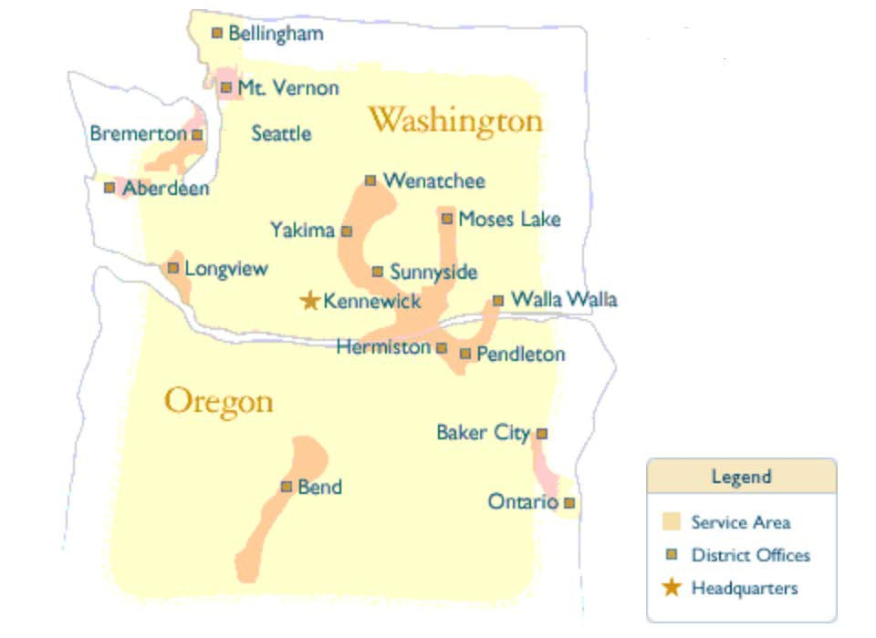

The remaining 200 non-core industrial customers represented about 75% of total throughput.

Cascade purchases natural gas from a variety of suppliers and transports gas supplies to its distribution system via two natural gas pipeline companies. Williams’ Northwest Pipeline GP (NWP) provides access to British Columbia and domestic Rocky Mountain gas while the Gas Transmission Northwest (GTN) provides access to Alberta gas. Cascade also holds transportation contracts upstream of these systems on TransCanada Pipeline’s Foothills Pipeline (formerly ANG) and Alberta System (also known as NOVA), as well as on Ruby Pipeline and Westcoast Energy, Inc. (Spectra Energy).

IRP Guidelines and Policies
Cascade utilizes integrated resource planning to maximize the efficiencies of the Company’s utility operations. The planning process includes an assessment of current and future gas load requirements, the possible resource options for serving the projected load requirements, and a selection of the set of least cost resource alternatives with acceptable level of reliability through the use of an optimization model. Monte-Carlo simulation tools

are utilized to further analyze the results of the optimization model to quantify the range of uncertainty in market price and demand due to changes in weather.

Cascade is subject to regulatory oversight by the Washington Utilities and Transportation Commission (WUTC) and the Oregon Public Utility Commission (OPUC). Each commission has established a set of guidelines or rules, which the company’s plan must meet. In Washington those guidelines are contained in WAC 480-90-238 and in Oregon the guidelines are found in the Commission Order No. 07-002 in docket UM 1056. In general, both Commissions’ guidelines require that the utility develop a range of demand forecasts, examine all feasible resources for meeting that demand whether they are supply-side or demand side and compare them on an equal basis, considering the uncertainty over the planning horizon, develop a 2 year action plan and involve the public and the various stakeholders in the planning process.

Cascade believes that its IRP meets the substantive requirements of both the Washington and Oregon Commissions. This IRP includes a range of demand forecasts that encompass the anticipated forces, both economic and weather-driven, that will impact the load forecasts over the planning horizon. The demand side resource section includes an assessment of technically feasible improvements in the efficient use of natural gas. The supply resource section includes a discussion of the supply side resource options available including an assessment of conventional and commercially available non- conventional gas supplies, an assessment of opportunities for additional company-owned and contracted storage, and an assessment of the Company’s existing pipeline transportation capability and reliability along with the opportunity for incremental pipeline transportation resources. The integration section provides a comparative evaluation of the cost of the various resource options on a consistent and comparable method. The resource integration section also describes the integration of the demand forecast and resource evaluations into a long range resource plan describing the strategies designed to reliably meet current and future needs at the lowest reasonable cost to Cascade's ratepayers. The short-term action plan describes the specific actions the utility will take to implement the long-range integrated resource plan during the next two years and reports on the Company’s progress in meeting its prior 2-year action plan goals.

Cascade believes all resources described in this IRP have been evaluated on a consistent and comparable basis through the use of its optimization model. Uncertainty has been considered in each component of this plan. The demand forecast includes a reasonable range of uncertainty as quantified in the low, medium and high load growth scenarios along with the additional simulation analysis calculated through Sendout’s Monte-Carlo functionality that assesses the impacts of weather on the load forecasts. The demand side and supply side resource sections describe relative uncertainties regarding reliability, cost and operating constraints and external costs. Uncertainties associated with the environmental effects of carbon emissions have also been included through an analysis of the impact of carbon legislation on the portfolio. Price volatility and market risks and their impacts on the Company’s long-term resource portfolio have been assessed through the use of the Sendout model.

To involve public interests in the development stages of this IRP, Cascade has a Technical Advisory Group (TAG). Five meetings were held to discuss the major IRP topics including the demand forecast, distribution system planning, demand side resources, supply side resources, and resource integration and uncertainty analysis. The TAG meetings were helpful to Cascade as questions were answered and varying points of view were explored. Appendix A-2 contains an outline of the meeting content, a list of participants and the presentation materials.

Appendix A-3 provides additional information regarding the specific requirements or guidelines for each commission and how the company has met those requirements.

Resource Decision Making Process Overview
Cascade makes resource decisions based on the best quantitative and qualitative information available. The IRP tools that are continually evolving assist Cascade in formulating energy resource decisions in a logical, consistent and comparable manner. The steps outlined below are those utilized by Cascade for both its short-term and long- term resource decisions:

1. Construct a range of possible demand forecasts for the core market.

2. Calculate avoidable distribution system enhancement costs.

3. Provide the optimization model the existing supply side and demand side resource options to meet demand.

4. Run the optimization model to identify resource needs including the types of resources and their timing requirements. The existing portfolio is modeled under a range of demand forecast conditions.

5. Identify incremental supply and demand side resources to satisfy a range of incremental growth scenarios.

6. Run the optimization and Monte-Carlo simulation models to identify the best- fit portfolio given an expected range of forecasted core loads and operating conditions.

The resource decision-making process is dynamic and ongoing and the Company’s resource strategy must constantly evolve to reflect dynamic market forces and a continually changing regulatory environment. This IRP document represents a snapshot in time similar to a balance sheet. It is not meant to be a prescription for all future energy resource decisions as conditions will change over the planning horizon and will impact areas covered by this IRP. Rather, this document is meant to describe the currently anticipated conditions over the long-term planning horizon, the anticipated resource selections and most importantly the process for making resource decisions.

Disclaimer –Important notice
Cascade makes the following cautionary statements in its Integrated Resource Plan and appendices to make applicable and to take advantage of the safe harbor provisions of the Private Securities Litigation Reform Act of 1995 for any forward-looking statements made by or on behalf of Cascade. This Plan, its appendices, and any amendments or supplements to it, include forward-looking statements, which are statements of expectations, beliefs, plans, objectives, and assumptions of future events or performance. Words or phrases such as “anticipates”, “believes”, “estimates”, “expects”, “intends”, “plans”, “predicts”, “projects”, “will likely result”, “will continue” or similar expressions identify forward-looking statements.

Forward-looking statements involve risks and uncertainties which could cause actual results or outcomes to differ materially from those expressed. Cascade’s expectations, beliefs and projections are expressed in good faith and are believed by the Company to have a reasonable basis; however, there can be no assurance that Cascade’s expectations, beliefs or projections will be achieved or accomplished.

Any forward-looking statement speaks only as of the date on which such statement is made and except as required by law, Cascade undertakes no obligation to update any forward-looking statement to reflect events or circumstances after the date on which such statement is made or to reflect the occurrence of unanticipated events. New factors emerge from time to time and it is not possible for management to predict all such factors, nor can it assess the impact of any such factor on the business or the extent to which any factor, or combination of factors, may cause results to differ materially from those contained in any forward-looking statement. These materials and any forward-looking statements within them should not be construed as either projections or predictions or as business, legal, tax, financial, or accounting advice and should not be relied upon for any such purpose.

Section 3

Demand Forecast

Each year Cascade develops a 20-year forecast of customers, therm sales and peak requirements for use in short (annual budgeting) and long-term (distribution and integrated resource planning) planning processes. This forecast is a robust portfolio of estimates created by enhancing a single best-estimate forecast with various potential economic, demographic and marketplace eventualities into low, medium and high growth forecast scenarios. The scenarios are used for distribution system enhancement planning and as inputs in optimization models to determine the least cost portfolio of supply and DSM resources.

Forecast Methodology
Cascade begins the forecast process by developing three separate econometric models for each of the Company’s 15 districts. Three models for each district, for a total of 45 models, predict customer counts in the three main core customer classes – residential, commercial and industrial. Models are built from the district level up as it is the smallest level at which there is a high degree of consistency and availability of raw data. This is a change of methodology from previous years where certain models were built from the town level and others from the district. The unification of methodologies is expected to increase reliability of the forecast. The district models are rolled up into zones which segregate Cascade’s system based on pipelines and weather (see Appendix C).

In addition to these 45 customer count forecasting models, a separate and parallel set of 45 models is developed to estimate per-customer therm usage for each customer class in each district. A multiplicative combination of the customer count and therm usage models is Cascade’s annual load projection.

Customer count forecasts are designed to reflect both demographic trends and economic conditions both in the short and long term. Indicators included in the model include: employment and household count forecasts, mortgage rates (for residential customer counts) and the prime rate (for commercial and industrial customer counts). Therm forecasts are constructed from median household income forecast, weather and natural gas prices. Economic indicator forecasts are supplied by Woods & Poole. Mortgage and prime rates are forecast by Cascade using base data provided by Freddie Mac and the Federal Reserve, respectively. Past weather is sourced from NOAA and future weather is Cascade’s 20-year normal developed for the Company’s last rate case. Natural gas prices are provided by Wood Mackenzie and equal weights are assigned to the AECO, NYMEX and SUMAS indexes based on Cascade’s general portfolio mix (Appendix E). These indicators and the functional forms illustrated on the following page were chosen over others as they were the most consistent in returning statistically valid results. Historical data used in the regression extends back up to 1980 for customer counts and 1994 for therms.

Customer count and therm forecasts are augmented by revisions to the base data and output to create a portfolio of potential scenarios. Low and high growth scenarios are created by altering Woods & Poole’s forecasts to reflect Cascade’s service territory’s strongest and weakest performing decades over the last 30 years (Appendix B). These scenarios, along with the original best-estimate mid case scenario, encapsulate a range of most-likely possibilities given known data. Based on historical experience, Cascade expects system load will likely remain within a range bounded by the low and high growth scenarios.

Peak Day Forecast
In order to ensure satisfaction of core customer demand on the coldest days, Cascade develops peak day usage forecasts in conjunction with annual basis load forecasts. Peak day forecasts enable Cascade to make prudent distribution system and peak capacity planning decisions to fulfill its responsibility to provide heating under all but force majeure conditions, particularly as most space-heating customers will have no alternative heating source during the coldest of days in the event gas does not flow.

Historically Cascade has developed peak day forecasts based on a 65 HDD day (0°F) to reflect the coldest day in Cascade’s 60-year weather history. Cascade’s 2008 IRP changed this practice to reflect the coldest day during the past 30 years. This record is held by December 21, 1990 at 61 HDDs. The peak day forecast is developed by adjusting the therm usage on coldest day in recent history (January 5, 2004 at 56 HDD) upwards to an estimate of therm usage would have been had that day been 61 HDD. The therm usage is then applied to each district and escalated into the future at the forecast therm usage annual growth rate.

This method rests on the assumption that core market load shape does not significantly change throughout the forecast horizon. Cascade believes that the peak day forecast conservatively overestimates peak day usage as the base forecast does not explicitly include future conservation measures implemented by customers that would act to increase energy efficiency and reduce therm day usage.

Forecast Results
Load growth across Cascade’s system through 2032is expected to fluctuate between
1.4 and 1.7% annually, with lower, recessionary growth in the short term. Load growth consists of a split between residential and commercial demand, with a slow decline in industrial demand.

 | Residential | Commercial | Industrial | System
2012 – 2016 | 1.71% | 1.68% | -3.22% | 1.48%
2016 – 2021 | 1.78% | 1.81% | -1.85% | 1.66%
2021 – 2026 | 1.74% | 1.83% | -1.06% | 1.68%
2026 – 2031 | 1.50% | 1.59% | -1.24% | 1.46%
2011 – 2032 | 1.68% | 1.73% | -1.84% | 1.57%
Table 3-1: Expected Load Growth by Class

In absolute numbers, system load under normal weather conditions is expected to reach over 400 million therms in 2030. A majority of core load today is residential. Not only will this continue into the future, but since residential load growth is expected to be higher than commercial and industrial, residential customers will experience a slightly increased profile on Cascade’s system.
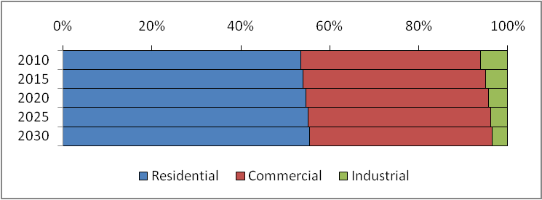

Figure 3-1: Relative Expected Load by Class

 | Residential | Commercial | Industrial
2012 | 163,007,592 | 122,912,569 | 13,931,851
2016 | 177,442,906 | 133,565,259 | 11,822,190
2021 | 193,769,389 | 146,098,658 | 10,767,863
2026 | 211,207,260 | 159,939,319 | 10,202,021
2032 | 227,541,615 | 173,091,273 | 9,586,154
2012 - 2032 | 39.6% | 40.8% | -31.2%
Table 3-2: Expected Load by Class

Residential and commercial load growth is primarily a result of increased customer counts. The number of residential and commercial customers is expected to increase faster than therm usage. Several factors are believed to be the cause of this phenomenon; among them are soft conservation, building codes and heat pump penetration. This reduction is more prevalent among residential customers than commercial.

 | Residential | Commercial | Industrial
2012 | 230,831 | 34,611 | 440
2016 | 255,767 | 38,204 | 400
2021 | 282,006 | 41,954 | 377
2026 | 309,492 | 45,861 | 365
2032 | 338,158 | 49,908 | 361
2012 - 2032 | 46.5% | 44.2% | -18.2%
Table 3-3: Expected Customer Counts by Class

Core industrial load and customer counts are a more complex and difficult to distill story. First, industrial users in Cascade’s service territory are subject to the same overarching economic conditions that industry elsewhere in the United States has been experiencing. A slow but steady economic shift away from manufacturing towards the service industry is reflected in lower industrial load and less industrial customers. Second, industrial customers may be faced with consolidation and mergers, which would reduce customer counts faster than per customer therm usage. Third, within the historical data period used to develop the industrial customer econometric models was the introduction of unbundled service. With unbundling, many industrial customers have switched to non-core, a trend that will continue into the future. For this reason, the 18% reduction in core industrial demand does not necessarily indicate that industry in Cascade’s service territory is in a state of distress.

Year | Residential | Commercial | Industrial
2012 | 704 | 3550 | 31588
2016 | 694 | 3496 | 29553
2021 | 687 | 3482 | 28565
2026 | 682 | 3487 | 27959
2032 | 673 | 3468 | 26581
2012 - 2032 | -4.7% | -2.3% | -15.9%
Table 3-4: Expected Reduction in Therm Usage per Customer

Geography
Load across Cascade’s two-state service territory is expected to increase 37%, with the
Oregon portion outpacing Washington at 41% versus 35%.

 | Washington | Oregon | System
2013 | 220,618,667 | 75,559,872 | 296,178,539
2016 | 246,062,671 | 78,801,495 | 324,864,165
2021 | 266,601,645 | 86,068,075 | 352,669,721
2026 | 288,322,552 | 95,059,860 | 383,382,411
2031 | 308,136,988 | 104,108,821 | 412,244,144
Table 3-5: Expected Load by State

Within Oregon, the Bend area is expected to grow significantly faster than the rest of Eastern Oregon. Pendleton is expected to grow faster than Cascade’s Baker/Ontario region, which is expected to experience minimal growth.

20-Year Load Growth

Baker | 0.5%
Bend | 54.5%
Ontario | -4.0%
Pendleton | 22.1%
Oregon | 41.0%
Table 3-6: Oregon 20-Year Load Growth by District

Peak Day
Residential customers have higher temperature sensitivity than commercial or industrial. Because of their increasing profile on Cascade’s system over the coming 20 years, weather-sensitive peak demand will increase faster than annual load. 2012 load on 61
HDDs is expected to be 3.5 million therms, rising to 5 million by 2032. Peak day load will increase at 2.0% annually while annual load will increase by 1.6%.

 | Peak Growth | Annual Load |  |  | Peak Day Therms
2012 - 2015 | 2.08% | 1.48% |  | 2012 | 3,468,074
2015 - 2020 | 1.98% | 1.66% |  | 2016 | 3,682,762
2020 - 2025 | 1.88% | 1.68% |  | 2021 | 4,132,422
2025 - 2032 | 1.78% | 1.46% |  | 2026 | 4,530,867

2012 - 2032 1.93% 1.57%
2032 4,979,511

Table 3-7: Expected Peak Day Growth and Therms

High and Low Scenarios
High and low scenarios were created by examining the best and poorest performing years from the historical data period, 1980 to 2009. These scenarios bookend the range within which annual load and peak day usage will reside should underlying indicators vary from Woods & Poole’s long range estimates.

 | Low | Mid | High
2011 - 2015 | 1.30% | 1.48% | 1.71%
2015 - 2020 | 1.47% | 1.66% | 1.82%
2020 - 2025 | 1.49% | 1.68% | 1.85%
2025 - 2031 | 1.28% | 1.46% | 1.67%
2011 - 2031 | 1.39% | 1.57% | 1.76%
Table 3-8: Expected Total System Load Growth Across Scenarios

Load growth under poor economic conditions is expected to be around 1.4% annually over the forecast period while load growth under good economic conditions is expected to be around 1.8% annually. The cumulative effect of high growth over 20 years could result in additional load of 20 million therms while low growth will result in load 17 million therms less than predicted in the medium growth scenario.

 | Low | Mid | High
2011 | 299,438,282 | 301,885,823 | 304,992,382
2015 | 319,401,636 | 324,864,165 | 331,972,707
2020 | 343,577,530 | 352,669,721 | 363,230,566
2025 | 369,975,542 | 383,382,411 | 398,054,290
2031 | 394,334,672 | 412,244,157 | 432,407,449
Deviation | (17,909,485) |  | 20,163,292
Table 3-9: Expected Total System Load Across Scenarios

Uncertainties
This forecast represents Cascade’s best guess about future events. There are several important factors that make prediction future load at this time particularly difficult – economic recovery, carbon legislation, building code changes, carbon legislation, direct use campaigns, soft conservation, and long term weather patterns. The range of scenarios presented here encompasses the full range of possibilities through econometric analysis. These forecasts were created after running through a matrix of different functional forms and economic indicators. The chosen indicators, unchanged from Cascade’s 2008 IRP, where chosen because of their consistency in returning statistically valid results. While they maybe the best mathematically, they are not the sole and only determinants of load. As a result, while Cascade believes that the numbers presented here are accurate, and that the scenarios presented represent the full range of possibility, there is and always will be uncertainties in predicting the future.

Section 4

Distribution System Enhancements

Forecasting by town allows Cascade to estimate the need for distribution system enhancements with a reasonable level of accuracy in the near term of the planning horizon. A localized forecast approach also allows a non-coincidental peak forecast to be developed which is necessary when estimating distribution system enhancement needs. Gas supply and pipeline transportation become secondary issues if the distribution system is constrained. An important part of the planning process is to determine potential areas of distribution system constraints, analyze possible solutions, and estimate costs for eliminating constraints.

Distribution System Modeling
Gas distribution networks rely on pressure differentials to move gas from one place to another. If the pressure is exactly the same on both ends of a pipe, the gas will not flow. Therefore, it is important that gas engineers design the distribution network such that the pressure in the pipe will always be high enough that a differential can be created when gas leaves the system. As gas flow increases, pressure is lost due to friction. Using the laws of fluid mechanics, engineers determine the maximum flow of gas through a pipe of a certain diameter and length that will not cause pressure drops that are too great. This process is known as "gas distribution system modeling".

The modeling process is important because it lets the engineer determine how much flow can be delivered at various places on the distribution system. For instance, when large customers are added to a distribution network, the engineer must determine if the network capacity is large enough to provide the additional flow needed to fulfill customer requirements. Modeling is also important when planning new distribution systems. The correct size main distribution pipes must be installed to allow for the flow needed to meet the requirements of current customers, and reasonably anticipated future customers at reasonable costs.

It is desirable to know if an existing distribution system has enough capacity to satisfy new loads due to increasing numbers of customers in the future. The model can also be used to simulate increasing the gas flows through the existing pipes until the pressure loss in the pipes becomes unacceptable.

Engineering Modeling by Town
Utilizing computer software, individual models were created for each of Cascade's different systems. These models include both high-pressure lines and distribution system networks. As gas loads are simulated to increase according to the load forecasts, the pressures within each system are checked. When the simulation shows
the pressure dropping to an unacceptable level, that system and the surrounding area is determined to be a constraint area. When constraint areas are found, the analyst determines the most effective way of solving the problem. The solutions sometimes entail increasing the pressure in the system. However, in most situations where future constraint areas are identified, some amount of looping is also needed. The costs for
the loops are determined based on system wide averages of past system reinforcements and extensions projects. The average cost per foot is established for

each area, and then the most cost-effective alternative to solving the pressure problem is found. After these costs are tabulated, potential reductions of demand within constraint areas due to conservation will be included in the analysis to determine whether any of the costs can be avoided or delayed.

The modeling output is compared to and, where appropriate, supplemented with data from local field personnel to provide forecasts by town. This allows the analyst to specifically determine, town by town, what reinforcement would be necessary to each system for each year. These town by town costs are then grouped together by gate station.

Key Findings
The results of the distribution system analysis are shown in Table 4-1. The table shows the estimated costs of distribution system enhancements necessary to eliminate constraint areas over the 20 year planning horizon. Appendix C contains further information regarding the possible solutions to alleviate the distribution system constraints. It should be noted that the proposed solutions are preliminary estimates of reinforcement solutions and actual solutions may be different due to differences in actual growth patterns and/ or construction conditions from those assumed in the initial modeling.

These results were based on the best information available and included both the anticipated load growth for the core market from the medium demand forecast along with the contracted peak delivery for each of the non-core customers.

Equally important is to review the impacts of proposed conservation resources on anticipated distribution constraints. Although the Company historically provides utility sponsored conservation programs throughout a particular jurisdiction (i.e. all of Washington or all of Oregon), there may be instances where a more targeted approach could reduce or delay the estimated reinforcement for a specific area. However, as will be discussed in Section 5, the acquisition of conservation resources is entirely dependent upon the individual consumers’ day-to-day purchasing and behavior decisions. Although the utility attempts to influence these decisions through its conservation programs, the consumer is still the ultimate decision maker regarding the purchase of a conservation measure. Therefore, the Company does not anticipate that the peak day load reductions resulting from incremental conservation will be adequate enough to eliminate distribution system constraint areas at this time. However, over the longer term, (the 2015 through
2025 timeframe) the opportunity for targeted conservation programs to provide a cumulative benefit that offsets potential constraint areas may be an effective strategy.

Table 4-1
Yearly Reinforcement Costs by Gate

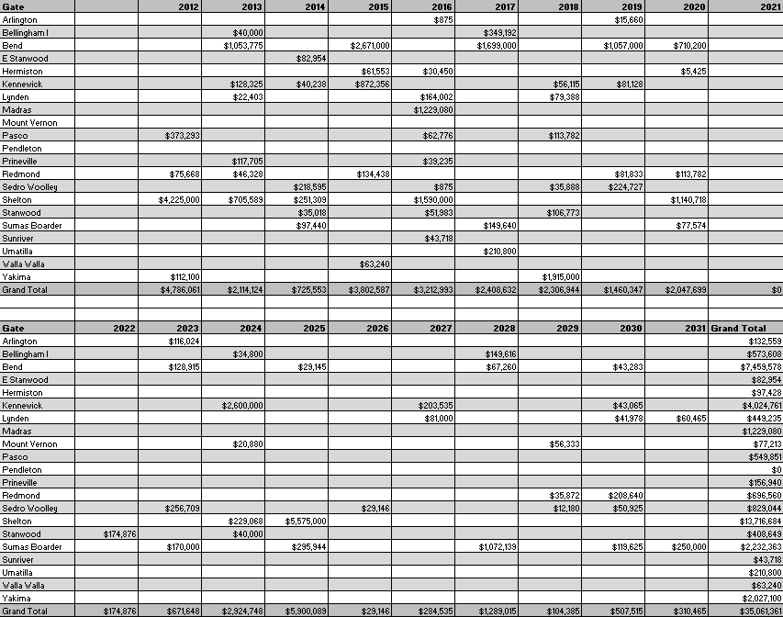

Section 5

Supply Side Resources

Cascade's core market residential and small volume commercial and industrial customers expect and require the highest reliability of energy service. Because of the Company's obligation to provide gas service to these customers, the Company must determine and achieve the needed degrees of service reliability and attain the lowest costs possible while providing an infrastructure that responds to the customers' concerns in meeting customer growth and provides all necessary administrative services to provide the stated services. Assuming such an infrastructure is in place and operating effectively, the most important functions necessary for reliable natural gas service are planning for, providing and administering the gas supply, interstate pipeline transportation capacity, and distribution service components that constitute the "bundled services" required by core market customers.

Cascade's 20-year supply side resource goal is to continue to meet the energy needs of its core market customers with a package of services that combines adequate gas supplies and cost-effective winter peaking services with long-term pipeline transportation contracts and sufficient distribution system capacity at the lowest possible cost.

This section describes the various gas supply resource and transportation resource options that are available to the Company as supply side resources.

Gas Supply Resource Options
Gas supply options available to Cascade to meet the core market demand requirements generally fall into two groups: 1) Firm gas supplies on a short or long-term basis, and 2) Short term gas supplies purchased on the open market as needed for a particular
month for one or more days. A separate and important source of gas supply is natural
gas storage service, which is required to meet the needs of the broad seasonal peak and the needle peaks of the heating season in order to provide economical service to low load factor customers.

Firm Supply Contracts
Firm supply contracts commit both the seller and the buyer to deliver and take gas on a firm basis, except for force majeure conditions. From Cascade's perspective, the most important consideration is the seller's contractual commitment to make gas available day in and day out, regardless of market conditions. Firm supplies are a necessary component of Cascade's core market portfolio given the obligation to serve and the lack of easily obtainable alternatives for consumers during periods of peak demand. Firm contracts can provide baseload services, provide seasonal peaking services during the winter months, or can be used to meet daily needle peaking requirements. Each of
these services is discussed briefly below.

Baseload resources are those that are taken day in and day out, 365 days a year. As a result, baseload gas tends to be the least expensive of the firm supply contracts
because it matches the production of gas and guarantees the producer that the volumes will be taken. Cascade’s ability to contract for baseload supplies is limited because of

the relatively low summer demand on the system. Baseload resources are used to meet the non-weather sensitive portion of the core market requirements, or may be used to refill storage reservoirs during periods of lower demand.

Winter gas supplies are firm gas supplies that are purchased for a short period during the winter months to cover increased loads, primarily for space heating. The contracts are typically 3 to 5 month durations (primarily November through March). This enables the Company to ensure firm winter supplies without incurring obligations for high levels of take during periods of low demand in the summer months. Winter supplies combined with baseload supplies will be adequate to cover the moderately cold days in winter.

Peaking gas supplies, similar to storage, are firm contracts purchased only as load actually materializes due to high winter demand. That is, the producer must deliver the gas when the Company requires it, but the Company is not required to take gas unless needed to meet customer load requirements. Peaking resources typically allow the Company to take between 15 and 20 days of service during the winter period. These resources are more expensive than baseload or winter supplies and typically include fixed charges to cover the costs for the producers to stand by to deliver the supplies.

Needle peaking resources are utilized during severe or “arctic” cold experiences when demand can increase sharply. These resources are very expensive and are available
for a very short period of time. One source of needle peaking gas supply that is actually a form of demand side management may be obtained from Cascade's industrial customer base. These customers would be required to maintain standby or alternate fuel capability that Cascade would contract the right to request the customer switch to so Cascade could utilize (divert) their gas supply and transportation capacity to meet the Company’s core market requirements. The benefits associated with this type of resource would include lowering the demand of the industrial facility, and providing a like amount of additional gas supply with pipeline capacity to meet core demand. Needle peaking requirements can also be met through the use of propane air plants, or on-site liquefied natural gas (LNG) facilities.

Contract terms for firm commodity supplies vary greatly. Some contracts specify fixed prices, while others are based on indices that float from month to month. Some contracts have fixed reservation charges assessed each month, while others may have minimum daily or monthly take requirements. Most contain penalty provisions for failure to take the minimum supply according to the contract terms. Contract details will also vary from year to year, depending on company and supplier needs and the general trends in the market.

More specific descriptions of the alternatives appear later in this section. Appendix E summarizes the gas supply alternatives evaluated during this planning cycle.

Spot Market Supplies (also “just in time” or “day gas”)
Gas that is purchased for a short period of time (1 to 30 days) when neither the seller nor the buyer has a longer-term firm commitment to deliver or take the gas is referred to as a spot market purchase. Spot market supplies differ from firm resources in that they are more volatile, both in terms of availability and price, and are largely influenced by the laws of supply and demand.

In general, spot market supplies are provided from gas supplies not under any long- term firm contract, as mentioned earlier. Therefore, as firm market demand decreases, more gas becomes available for the spot market. Prices for spot market supplies are market driven and may be either lower or higher than prices under firm supply contracts. In warmer weather, as firm market demand requirements decrease, usually more gas becomes available for the spot market, resulting in lower prices. In colder weather, as firm markets demand their gas supplies, the remaining spot market supplies can carry higher prices until the price equates or exceeds that of alternate energy supplies (such as oil or electricity). Spot supplies can be expected to move to the markets that offer the highest price, which in turn can affect delivery reliability.

Due to the potential for interruption of the spot market, these supplies are not considered as reliable a source of gas supply for the winter peaking requirements of Cascade’s core market. As identified earlier, part of the reason these supplies are considered less reliable is that these volumes are made available after longer-term firm commitments have been contracted for delivery by upstream suppliers. These available volumes are likely to vary daily, depending on production or the suppliers’ ability to store un-marketed supply. Under a NAESB (North American Energy Standards Board) contract, which is the standard contract used by buyers and sellers when entering into short term supply transactions, parties have the ability to identify firm variable or interruptible quantities for these supplies. Therefore, these spot volumes are more susceptible to daily operational constraints on the upstream pipelines. This is particularly true in the case of Northwest Pipeline, which is a displacement pipeline with bi-directional flow. Depending on how gas is scheduled versus actually flowing between compressor stations, constraints can possibly occur. Complicating matters is that each of the pipelines has multiple supply scheduling deadlines, allowing scheduled volumes to be adjusted. As a result, at any given point in the process, constraints can occur, leading to the potential of the scheduled spot supply volumes being reduced or not delivered to the citygate at all.

The role for spot market gas supply in the core market portfolio is based upon economics. Spot market supplies may be used to supplement firm contracts during periods of high demand or to displace other volumes when it is cost-effective to do so. For example, should prices in one basin drop radically compared to another basin, a contract may allow the flexibility to reduce takes in order to take advantage of supply from a lower priced basin. Depending upon availability and price, spot market volumes may be used in place of storage withdrawal volumes to meet firm requirements on a given day or for mid-heating season refills of storage inventory during periods of weather moderation.

Other Unconventional Gas Supply Resources
Cascade considers Unconventional Gas Supply Resources such as supplies from an LNG Import Terminal, BNG or other manufactured gas supply opportunities as speculative supply side resources at this point in time. In most cases unconventional gas supply resources would become an alternative to traditional gas supplies from the conventional gas fields in Canada or the Rockies and would have to compete for inclusion in the Company’s portfolio planning. The two remaining LNG Import Terminal projects since the publishing of the last IRP, Jordan Cove and Oregon LNG, have shifted to export facilities. In early 2012, both facilities filed with FERC to withdraw their plans to import LNG. Jordan Cove re-filed with FERC to become an exporter; industry experts expect Oregon LNG to follow suit. Recently, a natural gas power plant is being planned to be built in the Jordan Cover region to power the LNG exportation.

One of the potential impacts of having export facilities in the Pacific Northwest (including the Kitimat) is what affect the flow of natural gas to export facilities will have on competition and pricing of natural gas supplies. Demand for natural gas in Asia, coupled with relatively inexpensive and plentiful shale gas may create a favorable long-term market opportunity for North American producers. For example, Japan has been hesitant to restart their nuclear plants in the aftermath of the devastating earthquake and tsunami of 2011. However, demand for energy will continue there as well as in China, as that country increasingly flexes its growing economic muscle and need for energy to drive its manufacturing base.

Infrastructure such as the Williams’ Companies’ Pacific Connector Pipeline to move natural gas to these facilities also means the opportunity to divert some of these supplies to markets such as LDCs that are located near the routes to the exportation facilities. In periods of great demand in Asia one would expect upward pressure on natural gas prices; correspondingly during periods of lower demand, prices would likely drop. Of course, if it is economical to do so, producers will increase the volumes of natural gas to this area, which will provide another supply resource alternative for Cascade. While it is much too early to tell (since exportations have yet to begin at any of these facilities), exportation facilities in the Pacific Northwest could potentially create a new pricing dynamic for the region; a dynamic which Cascade will be monitoring carefully as both public (EIA) and private (Wood MacKenzie, Bentek) intelligence becomes available.

Palomar Gas Transmission has withdrawn its application for a certificate to build a natural gas pipeline in Oregon, and it has told the Federal Energy Regulatory Commission that it continues to work with potential customers and a potential additional partner to provide a regional solution to the need for access to this important form of energy. Palomar said that while they will no longer seek to permit a pipeline to serve the previously proposed liquefied natural gas terminal on the Columbia River, it will continue its effort to find commercial support for a new pipeline in Oregon to meet the needs of the Pacific Northwest.

Another alternative is BNG. Bio natural gas continues to receive increased attention as a possible resource. BNG typically refers to a gas produced by the biological breakdown of organic matter in the absence of oxygen. BNG originates from biogenic material and is a type of biofuel. One type of BNG is produced by anaerobic digestion or fermentation of biodegradable materials such as biomass, manure or sewage, municipal waste, green waste and energy crops. This type of BNG is comprised primarily of methane and carbon dioxide. The principal type of BNG is wood gas which is created by gasification of wood or other biomass. This type of BNG is comprised primarily of nitrogen, hydrogen, and carbon monoxide, with trace amounts of methane.

The gases methane, hydrogen and carbon monoxide can be combusted or oxidized with oxygen. Air contains 21% oxygen. This energy release allows BNG to be used as a fuel. BNG can be used as a low-cost fuel in any country for any heating purpose, such as cooking. It can also be utilized in modern waste management facilities where it can be used to run any type of heat engine, to generate either mechanical or electrical power. BNG is a renewable fuel, which can be used for transport, and electricity production, so it attracts renewable energy subsidies in some parts of the world.

In many cases, there is currently not enough pricing and information available to be considered in this planning cycle; however, where possible, we have endeavored to analyze those situations where we feel sufficient data is available. Cascade continues to monitor the BNG activities of companies such as Pacific Gas & Electric, Intermountain Gas, Sempra Utilities and Puget Sound Energy.

Storage Resources
Cascade also utilizes natural gas storage to meet a portion of the requirements of its core market. Storing gas supplies, purchased and injected during periods of low demand, is a cost-effective way of meeting some of the peak requirements of Cascade’s firm market. Natural gas can be stored in naturally occurring reservoirs, such as depleted oil or gas fields, salt caverns or other geological formations with an impermeable cap over a porous reservoir. Gas can also be stored in vessels or tanks under pressure as compressed natural gas, or cooled to a liquid state, which is liquefied natural gas (LNG).

Natural gas storage service is not only an excellent supply source for meeting peak winter demand, but it can also be an important gas supply management tool. Storing excess or unused supply during periods of low demand increases the annual utilization rate of a supply contract, therefore improving the annual load factor for the Company’s gas supplies. Improving the annual load factor of a supply contract improves the Company's ability to purchase gas supplies on a more economical basis. Purchasing natural gas for storage during periods of low demand generally yields prices at the low point on the seasonal price curve.

Depending upon the location of the storage facility, pipeline transportation may also be required. Storage facilities located within the Company’s distribution system or on the interstate pipeline are preferable to those located “off-system”. Off-system storage requires additional pipeline transportation and may limit the flexibility of the resource. Cascade does not own its own storage facility and therefore must contract with storage owners to access a portion of their storage capacity. In 1994, Cascade had two contracts for utilization of underground storage located at Jackson Prairie (SGS-1). SGS-1 service is contracted directly from NWP and additional SGS-1 service was assigned from Avista Corporation for Cascade's use. Both of these contracts provided daily deliverability and seasonal inventory capacity. However, Avista declined to extend its agreement with Cascade and the Avista storage service was no longer available following the 2006/07 heating season.

Consequently, Cascade entered into an Agreement with Northwest Pipeline for additional Jackson Prairie storage service that will replace the access to storage that was available through the Avista storage contract. The new Agreement will provide Cascade with twice the amount of daily deliverability of the Avista agreement (30,000 Dth/d vs. 15,000 Dth/d) with approximately the same annual storage quantity. The Jackson Prairie expansion will be fully operational by late Fall 2012. Cascade has also entered into a companion transportation Agreement with Northwest Pipeline for the transportation of gas supplies stored under this Agreement to Cascade’s service area. The Company also has contracted for service (LS-1) from NWP's Plymouth, Washington LNG facility. Both Jackson Prairie facilities and the Plymouth facility are located directly on NWP's transmission system. Therefore, storage withdrawal rates can be changed several times during an individual gas day to accommodate weather driven changes in core customer requirements. This type of operating flexibility would not necessarily be available with off-system storage. The Company’s contracted storage services as of the last IRP (2010) are summarized below. Cascade has recently acquired two additional storage accounts at Jackson Prairie. Those will be discussed in more detail later in this section.

TABLE 5-1
Cascade’s contracted storage services

Volumes in Therms
 | Storage Capacity | Withdrawl
Total | (therms) | (thms/day)
Jackson Prairie (Principle) | 6,043,510 | 167,890
Jackson Prairie (Expansion) | 3,500,000 | 300,000
Plymouth LNG | 5,622,000 | 600,000
Jackson Prairie (new - 2012) | 2,812,420 | 95,770

Withdrawal capabilities must also be accompanied by firm capacity on the transporting pipeline(s) to be of any value as a reliable source of gas supply. Cascade's SGS-1 and LS-1 service requires TF-2 firm transportation service for storage withdrawals; Cascade has sufficient firm TF-2 service to meet its storage daily deliverability levels.

Capacity Resource Options
Capacity options are either interstate pipeline transportation resources or capacity on Cascade's local distribution system. Cascade's local distribution system was built to serve the entire connected load in its various distribution service areas, on a coincidental demand basis, regardless of the type of service the customer may have been receiving. Cascade generally has the distribution capacity available to deliver the gas to customers if the pipeline delivers the gas to the Company's citygate stations. Core interruptible service relates to the spot market supplies and interruptible interstate pipeline transportation contracted to serve these markets. Cascade does not contract for firm supply or interstate transportation for these interruptible customers. Cascade's interruptible rates also reflect the fact that no firm supply or transportation services are purchased on behalf of interruptible customers.

Interstate Pipeline Transportation Services
Pipeline transportation resources are utilized to transport the gas supplies from the producer/supply sources to Cascade's system. Cascade currently purchases supplies from three different regions or basins: U.S. Rockies, British Columbia, and Alberta, Canada. Unless the gas supplies have been "bundled" by the supplier, these resources require pipeline transportation to deliver them to Cascade's local distribution system.

Cascade has several long-term annual contracts with NWP, two long-term annual contracts and three long-term winter-only contracts with GTN (including the upstream capacity on Trans Canada Pipeline’s Foothills and Alberta systems), a long-term winter-only contract with Ruby Pipeline and one long-term annual contract with Spectra in British Columbia, Canada. These contracts do not include storage or other peaking services that provide additional delivery capability rights ranging from 9 to 120 days.

As noted earlier, available capacity exists on two of the three upstream pipelines serving the region: Spectra Energy’s T-South Mainline from Northeast BC to the BC-Washington Border at Sumas, and TransCanada’s GTN System that takes natural gas from Alberta at Kingsgate, Idaho and ships it to and through the region. The Company constantly reviews existing capacity options and works to negotiate contract terms that make sense for both parties, whenever we determine a project is viable.

Section 5-A

Supply Side Resources Acquired Since 2010 IRP

Transportation resources historically have been purchased from the pipeline at the time of an expansion under long-term (twenty to thirty year) contracts. As a result, the Company may find that it has capacity excess to its core market needs, especially in the early years following an expansion. Since late 1989, Cascade has, through its Optional Firm Pipeline Capacity tariffs, allowed its non-core customers to utilize Cascade’s firm pipeline capacity that is excess to current core customer requirements. By accepting all of the obligations associated with the underutilized pipeline capacity, the non-core customers have relieved Cascade’s core customers of the costs associated with holding the pipeline capacity for future growth.

Additionally, pipeline capacity is a tradable commodity through each pipeline’s Electronic Bulletin Board (EBB). Should a utility have temporarily underutilized transportation capacity it can release that capacity to third parties. Such activities allow holders of pipeline capacity contracts to recoup a portion of the fixed costs incurred. The value of the capacity will fluctuate depending upon market conditions. Any pipeline capacity in excess of core requirements can be offered to qualified buyers. The capacity is offered to any credit-worthy market through the respective pipeline's EBB.

Cascade’s utilization of pipeline transportation and peak day capacity for core and contracted for non-core firm transportation gradually changes over the planning horizon. Current company-acquired firm supplies utilize existing core firm transportation capacity. A portion of future core market growth utilizes non-core firm transportation capacity that will be converted to core market firm transportation capacity as core market growth occurs.

Package 1: Vintage NWP capacity throughout the region

As Cascade’s customer count and loads continue to grow, the Company will need to acquire additional capacity resources. In May 2011, Cascade was able to obtain vintage NWP capacity through a pre-arranged agreement with NWP that provided additional MDDOs (maximum daily delivery obligations) to several gates, including Yakima/Union Gap on the Wenatchee lateral and Bellingham/ (Ferndale) gates. This capacity (27,063 dths) became available to Cascade in April 2012. The current vintage transportation rates on NWP compared favorably to any of the other proposed pipeline projects at the time, such as the Blue Bridge/Palomar integrated project. For the past several Integrated Resource Plans, Cascade has identified the need for incremental pipeline capacity in order to meet anticipated peak day requirements for its core market as early as the 2012/2013 timeframe. Additionally, there are several locations where Cascade’s design day requirements are greater than existing contracted delivery, including the Bellingham area. With the incremental capacity Cascade will have enough receipt contract rights to meet core requirements until 2023 and will provide adequate delivery MDDOs until the 2022 timeframe. This capacity is priced at current tariff rates and is less expensive than adding pipeline infrastructure.

The table below describes the capacity associated with Package 1:

TABLE 5-2: Package 1
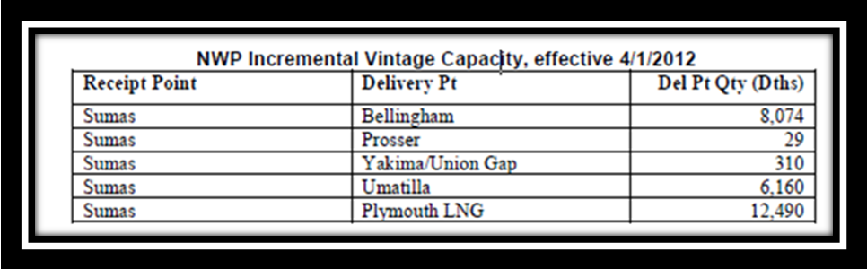

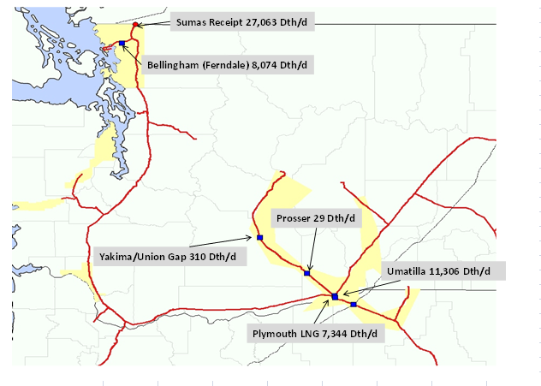

Package 2: Vintage NWP Capacity in the Sedro-Woolley area
In December 2011, the Company was presented with an opportunity to obtain vintage NWP capacity through a pre-arranged agreement with Northwest Pipeline that provided additional MDDOs to Sedro-Woolley, and by extension increase our firm rights in NWP Zone 30 (Cascade Zone 30-S and 30-W).
TABLE 5-3

NWP Incremental Vintage Capacity, Sedro-Woolley block

REC PT | DEL PT | Dths/DAY | DTHS/D AND TERM
SUMAS | SEDRO | 6191 | 03/2012 – 10/2050
SUMAS | SEDRO | 1050 | 04/2013 – 10/2050
SUMAS | SEDRO | 3259 | 01/2014 – 10/2050

The pre-arranged agreement was subject to competitive bid and it was ultimately awarded based on the offer which represented the highest net present value (NPV). We believed that based on our modeling, economic feasibility of vintage vs. incremental capacity costs, proximity to our distribution system and our ongoing obligation to serve, that proposing a long-term contract through October 2050 would ensure that the agreement would be awarded to Cascade.
SUPPLMENTAL BACKGROUND AND ANALYSIS
- For the past several Integrated Resource Plans requirements are greater than existing contracted delivery in CNG Zone 30-W, particularly the Bellingham area. Cascade has identified the need for incremental pipeline capacity in order to meet anticipated peak day requirements for its core market in Whatcom County (CNG Zone 30-W) as early as the 2018 timeframe. Figure 5-C-1 provides a clear picture of the impending peak day shortfall.

- Even at maximum rate, vintage capacity is considerably less expensive than proposed pipeline expansion projects including a Palomar/Blue Bridge type of scenario, which is anticipated to be upward of $.82/dkth and is not guaranteed to be built.

- Both TransAlta and Boardman coal-fired generation plants have committed to reduce and eventually cease operation and will likely be replaced with gas fired generation, providing greater interest in the pipeline capacity, particularly if Puget determines to add to their gas fired generation in the areas to meet power shortfalls identified in their integrated resource plan.

- The proposed capacity package provides delivery to Sedro-Woolley, a point on CNG’s system.

- Although this capacity will become effective prior to the actual need, NWP has not identified any plans for a future system expansion in the area; however, having this capacity would lessen the amount of incremental capacity (and associated costs) Cascade would need to pay for to participate in a future system expansion.

- Acquiring the proposed capacity from NWP will extend our ability to meet peak day in CNG Zone 30-W to around the 2022 time frame. The combined Zone 30-S and Zone 30-W (the actual nominated zone) would have sufficient capacity to meet peak day through 2026.

- These measures are part of a larger strategy to secure NWP turned back vintage capacity acquisitions to mitigate shortfalls . Work will continue to work with NWP to re-align our contractual delivery rights (where operationally feasible) from citygates with projected excess capacity to citygates where we forecast shortfalls exist.

FIGURE 5-C-1
Before Acquiring Packages 1 and 2
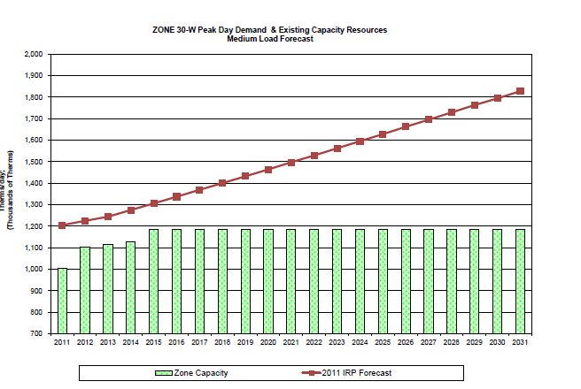

After acquiring Package 1 and 2
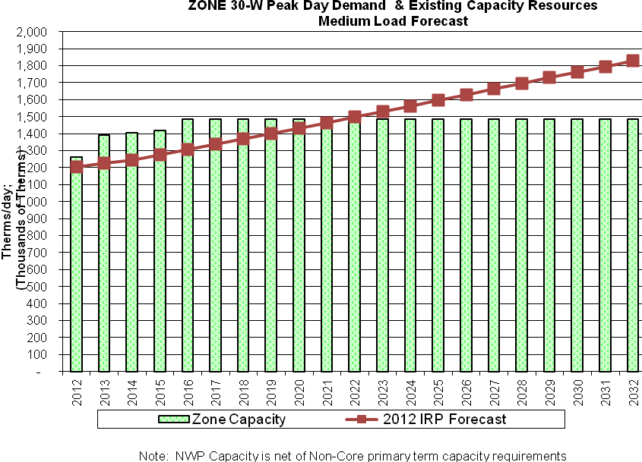
FIGURE 5-C-2

Package 3: Ruby Pipeline and Incremental GTN northbound firm service
On July 28, 2011, El Paso Corporation placed the Ruby Pipeline in service. Ruby is a 680-mile, 42-inch interstate natural gas pipeline, providing transportation service from Opal, Wyoming, to interconnections near Malin, Oregon. Ruby has an initial design capacity of up to 1.5 billion cubic feet per day (Bcf/d) and traverses portions of four states: Wyoming, Utah, Nevada, and Oregon. The project utilizes four compressor stations: one near the Opal Hub in southwestern Wyoming; one south of Curlew Junction, Utah; one at the mid-point of the project, north of Elko, Nevada; and one in northwestern Nevada.

Throughout 2011, Cascade worked with both existing Ruby shippers and with Ruby Pipeline to obtain discounted, long-term firm capacity on Ruby Pipeline along with the chance to acquire firm Malin north capacity on GTN through a pre-arranged agreement via Ruby that would provide the means to deliver Rockies supplies to Central Oregon, thereby increasing supply diversity and mitigating some of the negative impacts of constraints on Northwest Pipeline. Currently, gas supplies for Central Oregon are almost exclusively sourced from Alberta. While this has been a price advantage we feel it is important to have flexibility of supply options, particularly since we may find ourselves competing for Canadian supplies that will be pulled to the exportt facility in Kitimat to serve increasing Asian demand.
Ultimately, as will be explained further, Cascade worked with Ruby to finalize a long term transportation agreement based on the following original proposal which went through several revisions due to federal regulatory concerns:

- Term: The term of the proposed Ruby Pipeline capacity is for 25 years, beginning as early as April 1, 2012 but no later than November 1, 2012.
- Maximum Daily Quantity (MDQ): November 1st - April 30th of each year: 10,000 dths/day. Ruby would also provide Cascade with an option for 20,000 Dth per day (in addition to the 10,000 Dth described above) pursuant to the same terms and conditions. The option would expire on October 31, 2014. If at any time during the option period, Ruby receives a bona fide offer from a third party to contract for the optioned capacity, Ruby would provide notice to Cascade with sixty days to exercise the option. This will be contractually structured consistent with FERC allowances.

- Receipt Point(s): Any Ruby interconnect at the Opal Hub, including (CIG, Overthrust, Pioneer)

- Delivery Point: Ruby – GTN interconnect at Malin, Oregon (Turquoise Flats)

- Rate: Fixed reservation rate of $ 0.75 per dth/d for the twenty-five year term, plus Ruby commodity and FERC fuel and variable charges as authorized (estimated at $0.01 and 1.5% respectively). The current recourse rate is $0.95 per dth/d. This proposal represents a 21% discount.

- GTN Capacity: Separate from the Cascade/Ruby capacity, Ruby has been working with GTN to contract for maximum rate firm transportation rate on GTN and compensating GTN for its capital expenditures in providing firm, northbound service. Ruby would, in turn, post on GTN’s EBB a pre-arranged capacity release to Cascade with Malin northbound firm transportation capacity, subject to bid, consistent with FERC rules.

SUPPLEMENTAL BACKGROUND AND ANALYSIS for RUBY ACQUISITION
As the chart below indicates, the annual cost per unit for the Nov-Mar Ruby capacity is less than vintage year round capacity on Northwest Pipeline. Granted, Northwest Pipeline does have some capacity release value but there is intrinsic value with Ruby capacity associated with providing supply diversity for Central Oregon, plus the Ruby/GTN path will give us an alternative path for re-directing NWP Rockies gas around a Kemmerer constraint. Rockies gas originally destined for NWP could be shipped via Ruby-GTN to Stanfield where it can then flow back on NWP if needed, potentially avoiding having to sell otherwise constrained supplies at less than purchase contract terms or incur banking or penalty charges.

TABLE 5-4
Ruby vs Vintage NWP annualized capacity costs
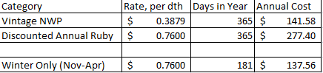

At the time the Company began to seriously consider Ruby, the proposed Blue Bridge and Palomar pipelines which would also bring Rockies gas to the Pacific Northwest were put on hold by their respective owners and as of this writing it is questionable as to whether they will be built. In addition, these options have projected rates that exceed $0.80/dth.

As indicated earlier during this time the Company was also in discussions to acquire multi-year (up to ten) capacity releases from existing Ruby shippers; however, none of the parties we worked with were able to match the discount being proposed by Ruby. In fact, most of the parties we spoke with initially did not offer a discount; and when they did the discounts were typically less 10% versus the recourse rate ($0.95). Additionally, none of these parties had or were seeking to obtain firm primary northbound service on GTN. From the Company’s perspective under current resource planning guidelines we could only use the current GTN backhaul as a secondary service; it couldn’t be used for peak day planning in the IRP. However, if Ruby was successful in acquiring the GTN northbound capacity and we acquired it via GTN’s EBB, then the Ruby/GTN capacity would form a needed primary firm resource for regular use as well as for peak day.

As the following chart shows, Oregon faces sizeable capacity shortfalls on peak day in the long-term. Short-term, we have been and plan on continuing to meet these needs via citygate supplies, which do not require Cascade to pick up additional capacity. Additionally, since GTN is still experiencing continued de-contracting, it is likely that there will be available capacity available on GTN for short term capacity releases. While this is fine for the short-term, we will need to consider acquiring additional resources to meet peak day. The portions of Oregon served by NWP (Zone 24 and Zone ME-OR) have sufficient long-term capacity through 2026.

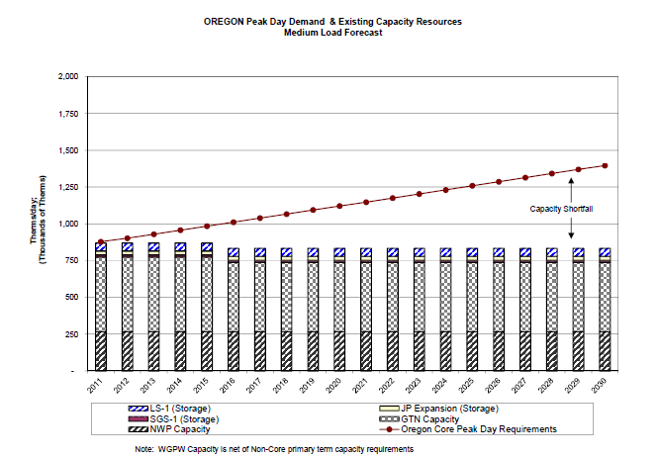

However, as can be seen on the following chart, the GTN zone, which is primarily supported by Alberta sourced supplies, is significantly short. Therefore, not only will acquiring Ruby bring supply diversity to supplement what is purchased from Alberta, having Ruby acquire firm northbound GTN capacity and releasing it to Cascade will help us meet our long-term incremental need for capacity. It should also be noted that our modeling and discussions with stakeholders have recognized that Cascade needs more storage to serve Oregon. One possible source of storage Cascade will consider as a result of having Ruby capacity is Ryckman Creek storage at the Opal Hub, which will connect to Ruby and other Rocky Mountain area pipelines, thereby giving Cascade a possible storage source to meet Oregon load, as well as price arbitrage to the benefit of all ratepayers.

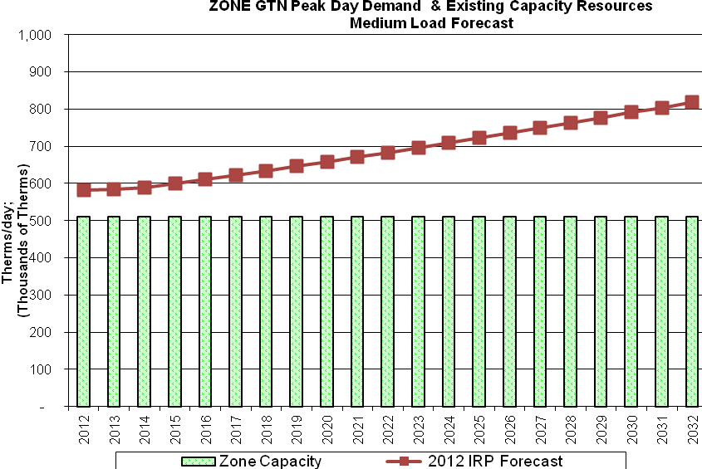
Modeling for Ruby Pipeline and Incremental GTN northbound firm service
Described below is additional information regarding these two alternative resources. Utilizing the SENDOUT™ resource optimization model, several scenarios were run to test the viability of acquiring Ruby capacity either based on their proposal, or through a third party. Incremental and corresponding GTN Malin north capacity was also modeled. At the time of the modeling last year basin prices in the model over the 20 year planning horizon had Rockies trading at a slight discount to AECO, Malin and Sumas ($0.06 - $0.15). This relatively inexpensive Rockies supply coupled with discounted Ruby capacity utilizing existing secondary GTN backhaul capability proved to be attractive to SENDOUT.

Regardless of the scenarios modeled, SENDOUT™ consistently selected Ruby capacity in a range of 10,000 to approximately 19,000 dths/day. A recap of some of the scenarios run and the results follows:

Summary of SENDOUT™ results for Ruby and Incremental GTN northbound firm service

SCENARIO (Description of the terms, conditions, pricing, etc) | RESULTS | ADDITIONAL COMMENTS
RUBY DISCOUNTED PROPOSAL WITHOUT DISCOUNTED GTN BACKHAUL  Ruby Transport: 25 years, Seasonal (Nov-Mar),$0.75 reservation, $0.01 commodity, 1.5% Fuel, no limit MDQ, allow resizing every year after Oct13:  GTN backhaul at current recourse rate (approx $0.26) | SENDOUT™ selected 17.26 MDth/day Nov12-Oct13 and 17 MDth of GTN backhaul | This is the ORINGAL Ruby deal without taking into account discounted GTN backhaul, or comparisons to a shorter term Ruby capacity release.
RUBY PROPOSAL AT RECOURSE VS RUBY DISCOUNTED CAP REL  Ruby Transport: 25 years, Seasonal (Nov-Mar),$0.95 reservation (recourse rate), $0.01 commodity, 1.5% Fuel, no limit on MDQ, allow resizing every year after Oct13  Vs  Ruby Cap Release: 10 years, Annual release from 3rd party,$0.69(discounted) reservation, $0.01 commodity, 1.5% Fuel, 10,000 dth MDQ | SENDOUT™ selected 10 MDth of 3rd party capacity release and 7.45MDth/d of the Ruby proposal and 17.19 MDth of GTN backhaul | Even at the recourse rate, SENDOUT™ selects a substantial portion of Ruby on a seasonal basis
Ruby Transport: 25 years, Seasonal (Nov-Mar),$0.75 reservation, $0.01 commodity, 1.5% Fuel, no limit on MDQ, allow resizing every year after Oct13  Vs:  Ruby Cap Release: 10 years, Annual release from 3rd party,$0.75 reservation, $0.01 commodity, 1.5% Fuel, 10,000 dth MDQ | SENDOUT™ selected 10 MDth of 3rd party capacity release and 7.26 MDth/d of the Ruby proposal and 17 MDth of GTN backhaul
25 YR RUBY DISCOUNTED PROPOSAL VS 25 YR ANNUAL CAP REL VS 10 YR CAP REL  Ruby Transport: 25 years, Seasonal (Nov-Mar),$0.75 reservation, $0.01 commodity, 1.5% Fuel, no limit on MDQ, allow resizing every year after Oct13  vs.  Ruby Cap Release Annual: 25 years, Annual release from 3rd party,$0.75 reservation, $0.01 commodity, 1.5% Fuel, 10,000 dth MDQ  vs.  Ruby Cap Release: 10 years, Annual release from 3rd party,$0.75 reservation, $0.01 commodity, 1.5% Fuel, 10,000 dth MDQ | SENDOUT™ selected 10 MDth of 3rd party capacity release and 7.45MDth/d of the Ruby proposal and 17.19 MDth of GTN backhaul
RUBY DISOUNTED PROPOSAL VS STEEP DISCOUNT RUBY CAP REL  Ruby Transport: 25 years, Seasonal (Nov-Mar),$0.75 reservation, $0.01 commodity, 1.5% Fuel, no limit on MDQ, allow resizing every year after Oct13  Vs.  Ruby Cap Release: 10 years, Annual release from 3rd party,$0.57(40% discount of recourse rate of $0.95) reservation, $0.01 commodity, 1.5% Fuel, 10,000 dth MDQ | SENDOUT™ selected 10 MDth of 3rd party capacity release and 7.26MDth/d of the Ruby proposal and 17 MDth of GTN backhaul
RUBY DISCOUNTED PROPSAL WITH DISCOUNTED GTN VS STEEP DISCOUNT RUBY CAP RELEASE  Ruby Transport: 25 years, Seasonal (Nov-Mar), $0.75 reservation, less $0.06 through March 2017 to represent the 80% discounted GTN northbound capacity that Ruby has offered to acquire and then re-release to Cascade for approximately 4 years. Per Ruby email 11/15/2011: If the delivery point is Stanfield, assume a ~ $0.20 rate (depends on points selected), with a 10,000 Dthd MDQ. Therefore $ 3,200,000 / $0.20 /10,000 = 1,600 days of FTSA. 1,600 / 365= 4.38 years of discounted GTN capacity, model assumes GTN northbound returns to recourse levels after 2017, $0.01 commodity, 1.5% Fuel, MDQ limited to 10 MDTh/day  vs.  Ruby Cap Release: 10 years, Annual release from 3rd party,$0.57(40% discount of recourse rate of $0.95) reservation, $0.01 commodity, 1.5% Fuel, 10,000 dth MDQ | SENDOUT™ selected 8.84 MDth of 3rd party capacity release and 10MDth/d of the Ruby proposal and 18.56 MDth of GTN backhaul | This scenario mimics the current Ruby proposal against a steeply discounted yearly capacity release from a 3rd party.

Ultimately, FERC Commission issued an order accepting (subject to conditions) Ruby’s Non-Conforming Transportation Service Agreement with Cascade. In its order, the Commission noted three areas of concern in the Cascade TSA that would require compliance by Ruby within 30 days.

Seasonal Service – Commission stated that Ruby’s Rate Schedule FT and pro forma agreement do not expressly provide shippers with the option to have contracts with seasonal contract demands. To give Cascade alone this option “constitutes a substantial risk of undue discrimination.”

“[t]he Commission will accept the agreement subject to the condition that Ruby, within 30 days of this letter order, either eliminate the provision granting seasonal service, or revise its Rate Schedule FT and pro forma service agreement to clarify that this seasonal variation in maximum daily quantity is part of the recourse service available to all shippers taking service under the rate schedule.”

Varying MDQ – The Commission stated that the option to vary the MDQ of an agreement (outside the stated tariff procedures) is a right that is not currently provided by Ruby’s Tariff to all customers. This constitutes a “substantial risk of undue discrimination.”

“[t]he Commission will accept the agreement subject to the condition that Ruby eliminate the provision providing Cascade the option to increase its MDQ from the agreement, within 30 days of this letter order.”

Third-Party Capacity/Capacity Release – Commission noted that Ruby would release the acquired capacity to Cascade pursuant to the provisions of GTN’s Tariff…“This appears to contravene both Commission policy as well as Ruby’s tariff. If Ruby intends to acquire downstream capacity for Cascade on GTN that capacity must be made available to Cascade through Ruby’s existing tariff mechanism.”

“Ruby is directed to revise section 17 of the service agreement such that any capacity purchased on GTN may be made available to Cascade”
All the parties worked collectively to determine the best way forward. In the end, Ruby filed a winter service tariff, the option to increase the MDQ was removed, and a non-regulated entity of Ruby acquired the GTN capacity which was ultimately awarded to Cascade. The terms of the GTN backhaul are described in Package 5 below. Please note this discounted capacity was subject to bid, but no party opted to “bid up” the offer.

Package 4: GTN backhaul capacity release

ITEM | RESPONSE
Releasing Shipper | El Paso Ruby Holding Company, LLC
Replacement Shipper | Cascade Natural Gas
Type | Biddable
GTN Receipt Point | Turquoise Flats (near Malin)
GTN Delivery Point | Stanfield Interconnect
Quantity | 10,000 dths/day
Contract Type | Annual
Maximum Tariff Rate | $0.204766 (reservation components only)
Minimum Bid Rate | 80% of maximum tariff rate
Effective Date | November 1, 2012
Termination Date | March 31, 2018

Package 5: PSE and CNGC deal for Jackson Prairie/Wenatchee

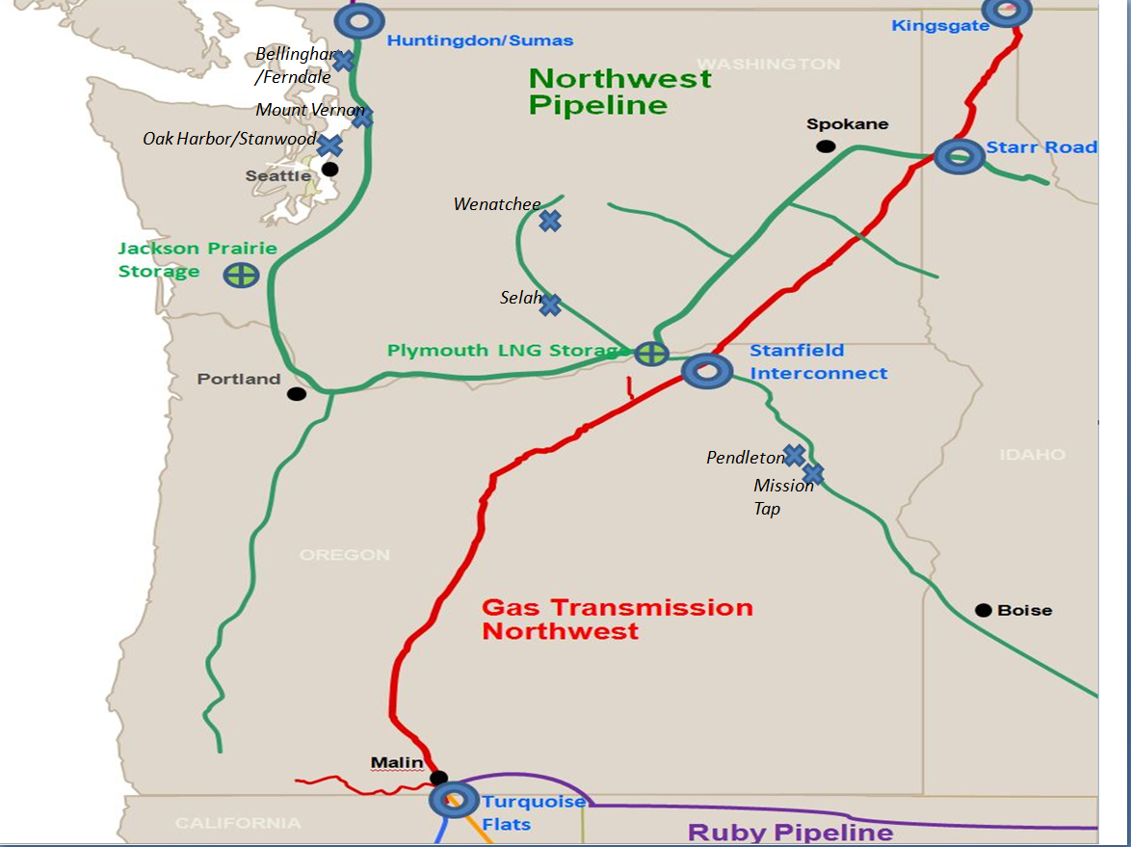
The development of this package goes back several years.
The Wenatchee Lateral is a NWP lateral pipeline connected to their mainline at the south-central Washington Plymouth LNG facility near the Washington Oregon border and running approximately 120 miles up the Yakima Valley to the city of Wenatchee. The lateral is divided into two nomination zones; zone 10 and zone 11. Cascade serves Prosser, Grandview, Sunnyside, Zillah and Toppenish in Zone 10. In Zone 11, Cascade serves Moxee City, Yakima, Selah, Quincy, Wenatchee and East Wenatchee. The City of Ellensburg is also a firm shipper on Northwest located and is in Zone 11. PSE’s service to Cle Elum and the Suncadia resort is also transported on the Wenatchee Lateral Zone 11 but PSE does not have any firm capacity rights on the lateral.
The peak day capacity of the Wenatchee Lateral is insufficient to provide firm service to all of Cascade’s core and noncore customers. The majority of the non-core customers located along the lateral relies upon pipeline capacity that is flexed to the city gate serving their plant location. For example, NWP will accept a flexed nomination only if the primary firm capacity held by Cascade and the City of Ellensburg is not being fully utilized. Tree Top, Alcoa and a few other non-core customers have or had access to firm pipeline capacity on the lateral through Cascade’s Optional Firm Pipeline Capacity Service Schedule 685. Cascade has the right to pull back the capacity upon the expiration of the primary term and has either pulled back the capacity or has provided notice to the customer that Cascade will pull back the capacity at the end of the contract.
Upon the total recall of the capacity, Cascade will have sufficient capacity to serve all firm core customer growth on the Wenatchee Lateral for several more years, likely through 2023. However, a few non-core customers had hoped to secure firm capacity beyond the expiration of their contract with Cascade and asked Cascade to explore with them the various options to expand peak day capacity on the lateral. The City of Ellensburg also projected the need for additional capacity in the future as growth occurred. PSE also was interested in obtaining firm capacity for the current and future needs of the Cle Elum/Suncadia service area. As a group, we explored various scenarios of pipeline looping and added compression to increase Northwest’s available Wenatchee Lateral capacity. Northwest’s estimated costs and rates for these scenarios all were too expensive for the group to want to pursue.
After exhausting pipeline looping and compression alternatives, the group explored various scenarios of LNG peak shaving. We examined the possibility of a single LNG facility located a various different points along the Wenatchee Lateral. We examined two smaller LNG satellites located at Yakima and Ellensburg. We examined three smaller satellites located at Wenatchee, Yakima and Ellensburg. The estimated costs and rates for these LNG scenarios all were also too expensive for the group to want to pursue.
Lastly, the group examined propane-air peaking facilities as a solution for the capacity constraint. We examined the possibility of a single propane-air peaking facility located at various different points along the Wenatchee Lateral. We examined two smaller propane-air facilities located at Yakima and Ellensburg. We examined three smaller propane-air facilities located at Wenatchee, Yakima and Ellensburg. We also examined locating five propane-air facilities located at various sites along the lateral. Although the cost of 5 propane-air facilities was clearly the lowest cost option, a few non-core customers decided that they would rather become an interruptible customer instead. The City of Ellensburg decided that they did not need any incremental capacity.
With the expiration of two non-core customer capacity agreements, Cascade would not need any incremental capacity for ten to fifteen years, depending upon actual growth in core demand. Only PSE, who has zero firm capacity on the lateral currently, is still interested in somehow obtaining firm capacity. Without any natural gas to mix with the propane on a peak day, a propane-air facility solution would not be particle.

Additional background and analysis

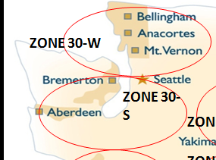
- Estimated 2011 Core Peak requirements were estimated at 36,700 dkth on a 67DD, with core growth on the lateral estimated at approximately 1%/year.
- Based on 2010 IRP load forecast, Cascade has adequate capacity on Wenatchee lateral through 2015.
- Each drop in HDD, reduces the estimated core requirements by 510 dth. Even with release to PSE through 2019 we would be able to meet core load requirements without peak shaving, providing it is warmer than 60DDs (97%)
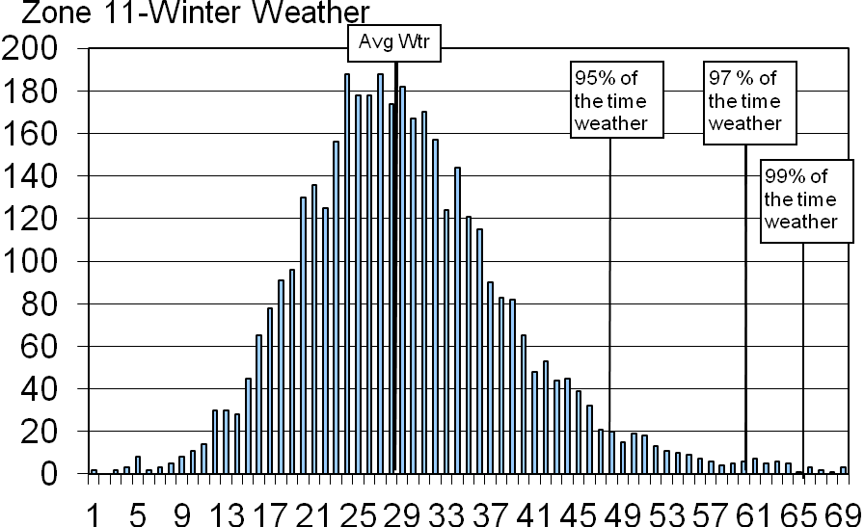

- The arrangement with PSE would provide incremental delivery MDDOs to Bellingham, an area where we currently are forecasted to be short (contractually) by approximately 20,000 dths on peak delivery.

- The arrangement provides for additional storage—at the time this transaction was being considered Cascade had 904,000 dths annual inventory and roughly 47,000 dths withdrawal capability (excluding Plymouth LS service). This represents approximately 3% of annual core load and about 13% of peak day requirements.

  - Jackson Prairie is one of the more flexible storage facilities which allows for frequent injections/withdrawals.
  - The arrangement involves obtaining vintage Jackson Prairie, which is less expensive than recent Jackson Prairie expansion capacity
  - The proposed arrangement would increase the annual inventory to approximately 17% of peak requirements and 4% of annual throughput
The Proposed Solution
PSE offered to release some of their excess Jackson Prairie underground storage capacity if Cascade would agree to release to PSE a portion of Wenatchee Lateral capacity. It is the perspective of both companies that any contract was freely negotiated between two LDC market participants seeking to reliably serve their respective retail customers

Therefore PSE and Cascade agreed that:
Cascade needs additional peak-season storage and firm capacity to serve its growing market in the Bellingham, WA area
- Cascade holds firm year-round pipeline capacity to and on NWP's constrained Wenatchee Lateral
  - Due to permanent loss of certain industrial loads Cascade has determined that some of this capacity is surplus to its long-term needs
  - Due to slower than expected load growth Cascade has determined some of the capacity is surplus to our short-term needs
PSE needs year-round firm pipeline capacity on NWP’s constrained Wenatchee Lateral to reliably serve Kittitas portion of its distribution system
- PSE holds (under separate contracts) firm storage service and seasonal firm transportation service to Bellingham area and has determined that portions of these contracts are surplus either on a short-term or long-term basis
  - Due to slower than expected load-growth PSE has determined some firm storage service is surplus to its needs
  - The seasonal firm transportation service from Jackson Prairie to Bellingham was originally acquired to deliver storage gas to PSE’s combined cycle combustion turbine connected to the Cascade’s system, but can be served with other capacity held be PSE
Cascade and PSE were prepared to make both permanent and temporary, pre-arranged capacity releases to the other at the maximum rate; the non-biddable releases would be posted on NWP’s EBB with no other conditions
PSE would permanently release at maximum rate: 102,782 Dth of storage capacity and the associated 3,500 Dth/day deliverability of NWP SGS-2 storage service at Jackson Prairie and 3,500 Dth/day of NWP TF-2 transportation service from Jackson Prairie to Bellingham to Cascade, as a pre-arranged shipper (2012)
And temporarily release, with recall provisions, at maximum rate: 178,460 Dth of storage capacity and the associated 6,077 Dth/day deliverability of NWP SGS-2 storage service at Jackson Prairie and 6,077 Dth/day of NWP TF-2 transportation service from Jackson Prairie to Bellingham to CNGC, as pre-arranged shipper (2012 to 2020, with recall rights commencing in 2015)
Cascade would permanently release at maximum rate: 1,000 Dth/day of NWP TF-1 transportation service from Sumas and Opal to Wenatchee to PSE, as pre-arranged shipper (2012)

And temporarily release, with recall provisions, at maximum rate: 2,000 Dth/day of NWP TF-1 transportation service from Sumas and Opal to Wenatchee to PSE, as pre-arranged shipper (2012 to 2020, recall rights commence in 2015)

Cascade and PSE executed a contract which:
  - required each party to release specified amount of capacity on a prescribed date
  - required capacity to be released through NWP’s EBB
  - required permanent and temporary, recallable releases to pre-arranged shipper at maximum rate
  - specified a “then current” market price for purchase of any remaining storage inventory at time of release and recall
  - defined damages to each party for breach of agreement
  - all subject to receipt of an acceptable response from FERC Staff to the No Action Letter request
As stated above, each capacity release in this arrangement would be executed through the NWP’s EBB as a prearranged release with no other conditions. The idea is that capacity will then be held by the party that values it most and will be at the maximum recourse rate. Neither party would pay more than the maximum rate for the capacity it obtains for the other party. Additionally, neither Cascade nor PSE exchanged cash or any other consideration to consummate the capacity releases (except for any storage inventory at “then current” market price, if applicable. Finally, NWP wouldl continue to receive maximum recourse rate, so they are not harmed.
Although Order No. 636-A includes a broad prohibition on tying a capacity release to other extraneous conditions, we felt the transactions described did not violate the prohibition.
  - Goal to protect gas purchasers who sought a competitive gas market by preventing shippers from obtaining market advantages by tying capacity release to the purchase or sale of gas or other services
  - Proposed transactions do not implicate circumstances the prohibition on tying is intended to prevent
The only potential extraneous condition is the mutuality of the desired releases between PSE and Cascade. Consequently, we decided to seek confirmation from FERC Staff that the transactions would not result in recommendation of enforcement action. PSE and Cascade personnel met with FERC staff who issued a No Action Letter, clearing the way for Cascade and PSE to complete the arrangement.

Package 6: Increased Wenatchee capacity and extension of 100002

In August Cascade had an opportunity to obtain vintage long-term firm capacity on Northwest Pipeline along with the ability to extend the term of our principle NWP transport agreement through 2032. The extension of our principle agreement, which is set to expire in 2021, will ensure that our core customers will continue to have their major upstream delivery resource for an additional twelve years without incurring the costs associated with a significant pipeline expansion. This transaction also represented an opportunity to address shortfalls in Zones 11 (Wenatchee) and 30 (Bellingham) , plus acquire capacity that could be segmented and re-aligned to other points along our distribution system. Total Gas Costs of the incremental capacity, based on current estimates (excluding amortization and without revenue sensitive costs), would increase approximately $0.00619 per therm in Oregon and $0.0007 per therm in Washington per year. NWP has no plans to offer a pipeline guaranteed expansion in our critical need areas in the foreseeable future, but even if they did the costs associated with such a project would likely be close to triple the current tariff rate.
Extension of the Base 100002 contract
Cascade’s primary NWP transport contract, 100002 has a primary end date of April 30th, 2020. By negotiating a contract extension through October 31, 2032, we will be able to realign our Maximum Daily Delivery Obligations (MDDO’s) to delivery points that better meet our customer’s projected needs provided the MDDOs are: (1) to delivery points with posted available capacity within the same zone and to a point already existing on this Agreement; and (2) not in violation with NWP’s New Contract Prohibition as contained in the Settlement Agreement for Reduction in Displacement Reliance, dated May 1, 2001, and the Settlement Agreement for Reduction in Displacement Reliance Through the Columbia River Gorge Corridor, dated July 27, 2001.
Additional Zone 30 & 11 Capacity:
As part of this negotiation we acquired an additional 7,241 Dth/day of Sumas receipt with deliveries of 2,500 Dth/day to Zone 30 and 4,741 Dth/day to Zone 11. Cascade has until the term start date of January 1, 2013 to determine the specific delivery points on this additional capacity. Most importantly, we have negotiated the flexibility of moving 3,320 Dth/day in MDDO’s from Wenatchee to the Selah delivery point. In doing so, NWP will allow us a gain in operational efficiency of an additional 1,421 Dth/day in MDDO’s at Selah to more effectively cover projected shortfalls at the Yakima/Selah gates along the Wenatchee lateral.

 |  |  | 2011 IRP Over / (Under) Subscribed |  | 2021 IRP Over / (Under) Subscribed |  | 2032 IRP Over / (Under) Subscribed
Total Zone 30 |  |  | (7,125) |  | (39,711) |  | (65,353)
Total Zone 26 |  |  | 9,770 |  | 8,523 |  | 8,034
Total Zone 10 |  |  | 2,399 |  | 2,154 |  | 2,060
Total Zone 11 |  |  | (8,612) |  | (10,594) |  | (8,987)
Total Zone 20 |  |  | 11,884 |  | (6,229) |  | (15,963)
Total Zone ME |  |  | 32,648 |  | 27,952 |  | 28,083
Total Zone 24 |  |  | 3,628 |  | 3,919 |  | 3,804
Total MDDOs |  |  | 48,445 |  | (10,131) |  | (44,467)

Additional Stanfield Capacity:
As part of this negotiation we acquired 7,450 Dth/day of Stanfield South capacity beginning September 1st, 2012 with deliveries to Zone 24. We will also retain some additional flexibility to further realign MDDO’s prior to April 30, 2020. As part of this arrangement, NWP will also provide segmentation rights totaling 15,697 Dth/day of Stanfield receipt and 12,970 Dth/day of Stanfield delivery point capacity which will add further value to the overall package.
As part of NWP’s contract extension tariff, the additional capacity above will be under the 100002 contract (TF-1) without contract specific OFO requirements or NWP having to place it out for competitive bid.

Other Resource Options

Some of the growth will require Cascade to look at alternatives to pipeline mainline capacity such as LNG satellite facilities located near or within the Company’s distribution system. The Company is continuing to study the viability of LNG satellite facilities to meet these needs.

The Wenatchee lateral is an example where an LNG satellite facility may be more cost effective than the traditional solution of pipeline expansion for solving the upcoming capacity constraints on the lateral. Preliminary cost studies indicate that an LNG satellite facility solution may be 1/3 to 1/2 the cost of a pipeline expansion project that would provide the same peak day incremental capacity.

Additionally, the historic load growth the Company enjoyed throughout much of its service areas has begun to create the need to increase the physical capabilities of some of the pipeline’s citygates. Even though Cascade may have an adequate amount of transportation capacity available on the pipeline, we may not have the contractual or physical capabilities at the citygate to meet the incremental load requirements. LNG satellite facilities or trucked in LNG re-gasification facilities or other similar type solutions may provide lower cost alternatives to the cost of city gate rebuilding projects. The Company will continue to study the viability of these alternatives.

Appendix E provides a summary of current and potential capacity resources evaluated during this planning cycle.

Proposed and New Pipelines
Additionally, several pipeline projects have been proposed by a variety of developers to serve the region.

Northwest Market Area Expansion (N-MAX) and Washington Expansion
NWP has been working with the partners of Palomar Pipeline (NW Natural and TransCanada) to provide an expansion option from Stanfield, Oregon to markets along the I-5 corridor. Essentially would create an “Oregon Hub” via a Transportation by Other (TBO) process using vintage NWP capacity across the Columbia Gorge combined with vintage GTN capacity from Stanfield to Madras, then using Palomar capacity from Madras to Molalla tied to NWP expansion capacity up the I-5 Corridor in Washington.
Similar to another regional solution proposed a few years ago, NWP is looking to combine available GTN capacity with Palomar (from Madras, west) along with an I-5 Expansion to near Mount Vernon. NWP is still in the development stages and has not finalized the expansion scenarios or developed the rates. NWP anticipates holding an Open Season in early 2013, with service expected in 2018. We anticipate that along the proposed path there may be an opportunity for Cascade to pick up additional capacity to address our projected shortfalls in the in the Bend, Oregon and Bellingham, Washington areas.

Washington Expansion
NWP is working with Oregon LNG to develop incremental capacity to serve the LNG terminal in Warrenton, Oregon. The LNG facility is proposed to be a 1.25 Bcf/d export facility. Currently, NWP looking at a 750,000 dths/day expansion that would require installation of 138 miles of 36-inch loop and compression at existing compressor stations. Similar to the N-MAX described above, NWP is still in the development stages and has not finalized the expansion scenarios or developed the rates. NWP anticipates holding an Open Season in early 2013, with service expected in 2016. We anticipate that along the proposed path there may be an opportunity for Cascade to pick up additional capacity to address our projected shortfalls in the Bellingham area.
- Palomar Pipeline – Palomar Gas Transmission is a partnership between NW Natural and TransCanada. The proposed 212 mile, 36-inch-diameter underground pipeline will extend from TransCanada’s GTN system near Madras, Oregon to NW Natural’s system near Molalla, Oregon. It will be a bi- directional pipeline with an initial capacity of 1,200 MMcf/d. As noted earlier, Palomar Gas Transmission has withdrawn its application for a certificate to build a natural gas pipeline in Oregon.

- Pacific Connector Gas Pipeline Project – as identified earlier, is a proposed234-mile, 36-inch diameter pipeline designed to transport up to 1 billion cubic feet of natural gas per day from the Jordan Cove LNG terminal to markets in the region. The Pacific Connector project includes interconnects to Williams´ Northwest Pipeline near Myrtle Creek, Oregon; Avista Corporation´s distribution system near Shady Cove, Oregon; Pacific Gas and Electric Company´s gas transmission system; Tuscarora Gas Transmission´s system; and Gas Transmission Northwest´s system, all located near Malin, Oregon. As noted earlier, this project is now viewed as an export facility; but it also has the possibility of bringing additional supply to the area to make part of our resource portfolio.

- T-South Enhancement/Southern Crossing Pipeline Extension – this is a project development that is being developed by FortisBC and Spectra Energy. A T-South pilot project has been in place since 2010, providing additional flexibility and optionality with bi-directional transport between Kingsgate and Huntingdon/Sumas. The proposed project would bill 160 km of 24 inch pipeline looping and add three new compressors. This will increase capacity to 284 MMcfd to Kingsgate and up to 140 MMcfd to Huntingdon/Sumas. This $440 million dollar project has an expected 2016 in-service date.
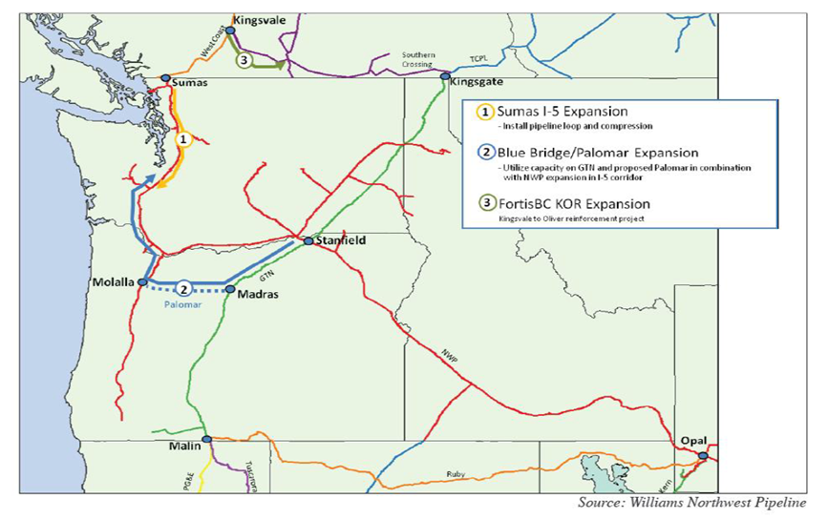
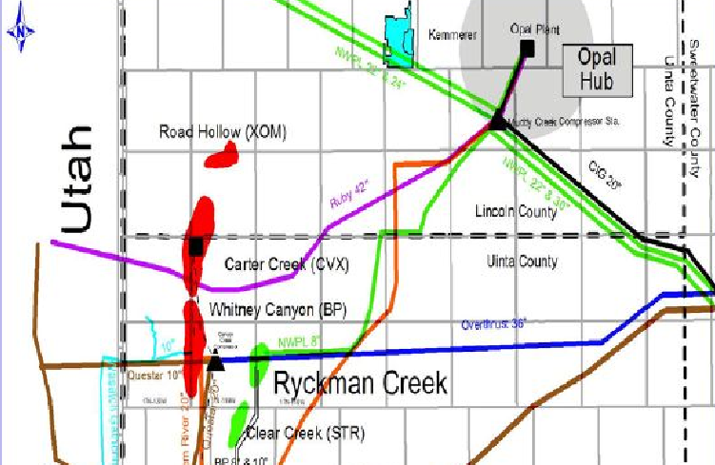
- Ryckman Creek Resources, LLC, a wholly-owned subsidiary of Peregrine Midstream Partners, LLC, recently announced they are conducting a non- binding Open Season to determine the interest of prospective customers in contracting for up to 8 BCF of firm, high- deliverability, multi-cycle (HDMC) working gas storage capacity beginning April 1, 2013. Ryckman Creek is located in Uinta County, Wyoming, near the Opal Hub. Ryckman Creek has converted a partially depleted oil and gas reservoir into a gas storage facility with 35 BCF of working gas and a maximum daily withdrawal rate of 480,000 Dth/d. The initial in-service date was August 20th, 2012. Ryckman Creek Gas Storage Facility is located near the town of Evanston, Wyoming and approximately twenty-five miles southwest of the Opal Hub. Ryckman Creek currently has interconnects with Questar Gas Pipeline, Kern River Transmission, Questar Overthrust Pipeline, Ruby Pipeline and Northwest Pipeline.

Natural Gas Price Forecast
For IRP planning purposes the company develops a baseline, high and low natural gas price forecast. Demand, oil price volatility, the global economy, electric generation, opportunities to take advantage of new extraction technologies, hurricanes and other weather activity will continue to impact natural gas prices for the foreseeable future. Cascade has considered price forecasts from several sources, such as Wood Mackenzie, Energy Information Administration, the Financial Forecast Center’s forecast, as well as our observations of the market to develop the low, base and high price forecast. The following discussion provides an overview of the development of the baseline forecasts.

Development of Baseline Henry Hub price forecast
Cascade’s long term planning price forecast is based on a blend of current market pricing along with long term fundamental price forecasts. Since pricing on the market is heavily influenced by Henry Hub prices, the Company closely monitors this market trend. While not a guarantee of where the market will ultimately finish, the current market (NYMEX) is the most current information available that provides some direction as to future market prices. On a daily basis, we can see where Henry Hub is trading and how the future basis differential in our physical supply receiving areas (Sumas, AECO, Rockies) is trading.

The fundamental forecasts include Wood Mackenzie, Energy Information Administration (EIA), Northwest Power Planning Council, the Texas Comptroller and the Financial Forecast Center’s long term price forecasts. Wood MacKenzie publishes a long-term price forecast each quarter to subscribing customers. While Cascade did not renew this service for the 2012 IRP we have used Wood MacKenzie help establish the basin pricing. This forecast is broken down by month through the planning horizon and includes Henry Hub as well as basis differentials for our receiving areas. The company also considers the EIA forecast; however, it has its limitations since it is not always as current as the most recent market activity. Further, the EIA forecast provides monthly breakdowns in the short term, but longer term forecasts are only by year. Many of the other sources mentioned only provide price forecasts by year. Given Cascade’s load profile and the need for more winter gas than summer, the company develops a pattern based on the market monthly forward prices to create a long-term, monthly Henry Hub price.

With a monthly Henry Hub price determined for the above sources, the company assigns a weight to each source to develop the monthly Henry Hub price forecast for the 20 year planning horizon. The forecast weighting factors are shown in Table 5-2. At the time the price forecast was developed, the Financial Forecast Center forecast was significantly lower than the EIA forecast and the forward market. Given the significantly higher future prices at the time versus the Comptroller forecast in addition to the fact that it only gives a three year forecast (2012-2014), the Company decided to severely limit the Financial Forecast Center from the weighted average. The Financial Forecast Center is unlikely to be a price source for Cascade in future plans. In recent years the EIA forecast has often been lower than the actual monthly price; however it is still a respected industry barometer of prices. Therefore, the EIA forecast was given a higher weight. As discussed earlier, while current market pricing may not accurately estimate the final market price, it often is a reliable indicator. Therefore, the company gave the current market pricing (NYMEX HH) some weight based on nearness to term. It should be noted that most of the forecast providers did not provide price forecasts for 2031. We chose to blend the Texas Comptroller and the EIA. While this represented a significant increase in weight for the Comptroller (moving from 1.5% to 45% weight) we decided to use the Comptroller given that 2031 is farthest year for the price forecast and desire to use more than one source for price forecasting. We had the option of also extending the trend-line of the NYMEX HH beyond year 2022, but felt it important to recognize that NYMEX HH is more a factor in short rather than long-term price. In future plans will not use the NYMEX HH trend-line for years beyond NYMEX trading period, consistent with how all other tools are used to develop the 20 year price forecast.

Development of the Basis Differential for Sumas, AECO and Rockies
Since the company’s physical supply receiving areas (Sumas, AECO, and Rockies) are at a discount to Henry Hub, we utilize the basis differential from Wood Mackenzie’s most recently available update and compare that to the future markets basis trading as reported in public market. Although it is impossible to accurately estimate the future, for trading purposes the most recent period has been the best indicator of the direction of the market. Correspondingly, we applied a weighted average to determine the individual basis differential in the price forecast. Typically, we give the most weight to the current NYMEX Henry Hub price in the early years. As our forecast moves ahead we start to reduce the impact of the NYMEX (and the impact of speculation and other market
uncertainties) and give greater weight to NWPPC, Wood Mackenzie and EIA.

In order to determine the low case and high case, the Company utilized the EIA economic growth factors (EIA Annual Energy Outlook 2011, Table E-1). This resulted in using 2.1 for the Low Case, 2.7 for the Reference Case and 3.2 for the High Case.

TABLE 5-3
HENRY HUB FORECAST WEIGHTING FACTORS

Year | Financial Forecast Center | NWPPC | TEXAS Comptroller | BenTek | EIA | NYMEX
2012 | 0.50% | 15.00% | 0.50% | 5.00% | 35.00% | 44.00%
2013 | 0.50% | 15.00% | 0.50% | 5.00% | 40.00% | 39.00%
2014 | 0.50% | 15.00% | 0.50% | 5.00% | 45.00% | 34.00%
2015 | 0.00% | 15.00% | 0.00% | 5.00% | 50.00% | 30.00%
2016 | 0.00% | 15.00% | 0.00% | 0.00% | 55.00% | 30.00%
2017 | 0.00% | 15.00% | 0.00% | 0.00% | 60.00% | 25.00%
2018 | 0.00% | 15.00% | 0.00% | 0.00% | 65.00% | 20.00%
2019 | 0.00% | 15.00% | 0.00% | 0.00% | 70.00% | 15.00%
2020 | 0.00% | 15.00% | 0.00% | 0.00% | 75.00% | 10.00%
2021 | 0.00% | 15.00% | 0.00% | 0.00% | 80.00% | 5.00%
2022 | 0.00% | 15.00% | 0.00% | 0.00% | 85.00% | 0.00%
2023 | 0.00% | 15.00% | 0.00% | 0.00% | 85.00% | 0.00%
2024 | 0.00% | 15.00% | 0.00% | 0.00% | 85.00% | 0.00%
2025 | 0.00% | 50.00% | 0.00% | 0.00% | 50.00% | 0.00%
2026 | 0.00% | 50.00% | 0.00% | 0.00% | 50.00% | 0.00%
2027 | 0.00% | 50.00% | 0.00% | 0.00% | 50.00% | 0.00%
2028 | 0.00% | 50.00% | 0.00% | 0.00% | 50.00% | 0.00%
2029 | 0.00% | 50.00% | 0.00% | 0.00% | 50.00% | 0.00%
2030 | 0.00% | 50.00% | 0.00% | 0.00% | 50.00% | 0.00%
2031 | 0.00% | 0.00% | 0.00% | 0.00% | 100.00% | 0.00%
2032 | 0.00% | 0.00% | 0.00% | 0.00% | 100.00% | 0.00%

Figure 5-D on the following page provides a summary of the medium price forecast (in real dollars) over the near term. Appendix E provides the detailed 20 year price forecasts.

FIGURE 5-D

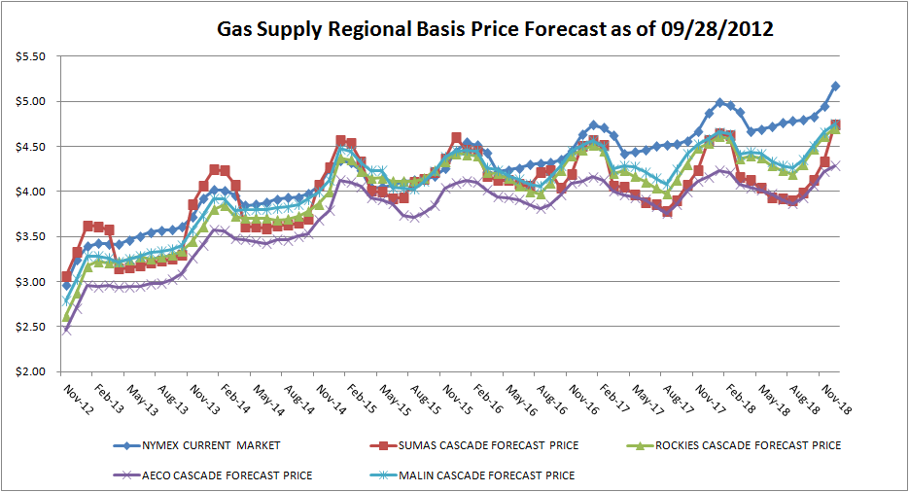

Supply Side Resource Uncertainties
Several uncertainties exist in evaluating supply-side resources. They include regulatory risks, deliverability risks, and price risks. Regulatory risks include the unknown impacts of future Federal Energy Regulatory Commission or Canada’s National Energy Board rulings that may impact the availability and cost of interstate pipeline transportation.

Deliverability risk is the risk that the firm supply will not be available for delivery to the Company’s distribution system. Purchasing resources from larger producers or marketers who typically have gas reserves in multiple locations may minimize this risk. The risks associated with prices rising or falling during any winter period represent another supply-side uncertainty. To the extent the company purchases firm contracts that are tied to an index price, it may be at risk for paying more than was initially anticipated for the resource when the decision was made. Price risks associated with climbing prices can be minimized through the use of fixed price contracts or through the use of financial derivatives.

It should be noted that several proposals being discussed or that are in process involve a number of Canadian upstream pipelines which could have a direct impact on the availability of supply or at least may pose potential risks to increases in the price of supplies sourced from British Columbia and Alberta. For example, in response to competitive pressure on their mainline tolls, TransCanada Pipeline filed with the NEB to extend NOVA service east to Steelman and west to Kingsgate. This includes the roll-in of Foothills Pipeline. Under the plan, TCPL estimates western shippers (i.e. Cascade) will save between 5-7 cents including fuel. Eastern shippers will also see reduced rates while receipt shipper rates will increase 3-5 cents. Increases in costs for receipt shippers led to concerns that commodity prices for future gas supplies on the Alberta system may raise substantially. The Company will continue to monitor and be actively involved in the various pipeline forums as these initiatives develop.

As noted earlier, demand in Asia will likely make LNG exports from the Pacific Northwest a competitor for natural gas. It is also important to note an increasing trend in the use of natural gas vehicles (NGV) which utilize natural gas that has been compressed into a transportation fuel, also known simply as compressed natural gas. Taxis, transit and school buses, as well as heady- duty trucks are among the users of natural gas powered vehicles. The Natural Gas Vehicle Institute estimates there are more than 112,000 NGVs in the United States. Plentiful reserves of natural gas exist as a domestic fuel, typically at substantial discounts compared to gasoline. From an environmental impact, exhaust emissions are generally much lower than gasoline powered vehicles. As the United States continues to search for environmentally friendly, economically viable options to displace gasoline, natural gas is seen as a fuel that could significantly contribute to lessening American dependency on foreign oil.

According to the January 2012 Alternative Fuel Price Report from the Department of Energy, compressed natural gas had a price differential of between $1.50 and $2.25 compared to gasoline prices in Washington and Oregon. Several compressed natural gas fueling stations exist in the Seattle Metropolitan area; additionally, Avista has an active NGV fleet program in the works. While we have yet to see the demand for NGVs create notable competition for natural gas in the Pacific Northwest (although there are estimates that over 12 million NGVs exist world-wide), as technology improves and costs of fueling stations become more economical there exists the probability that NGV use will put pressure on future gas prices and availability. Cascade will continue to monitor activities in the NGV sector for possible impacts to our resource planning.

Financial Derivatives
Cascade constantly seeks methods to ensure ratepayers of price stability. In addition to methods such as long-term physical fixed price gas supply contracts and storage, another means for creating stability is through the use of financial derivatives. The general concept behind a derivative is to lock-in a forward natural gas price with a hedge, consequently eliminating exposure to significant swings in rising and falling prices. Financial derivatives include futures, swaps, and options on futures or some combination of these.

Natural gas futures contracts are actively traded on the New York Mercantile Exchange (NYMEX). The use of futures allows parties to lock-in a known price for extended periods of time (up to 6 years) in the future. Contracts are typically made in quantities of 10,000 dekatherms to be delivered to agreed-upon points (e.g., Sumas, Station 2, AECO, Northwest Pipeline Rockies, etc.) In a “swap”, parties agree to exchange an index price for a fixed price over a defined period. In this scenario, Cascade would be able to provide its customers with a fixed price over the duration of the swap period. In theory the idea is to level the price over the long term. Futures and swaps are typically called “costless” because they have no up-front cost. Unlike futures and swaps, an option on futures only provides protection in one direction—either against rising or falling prices. For example, if Cascade wanted to protect itself against rising gas prices but keep the ability to take advantage of falling prices, Cascade can purchase a “call” option on a natural gas future contract. This arrangement would give the Company the right (but not the obligation) to buy the futures contract at a previously determined price (“strike price”). Similar to insurance, this transaction only protects the company from volatile price spikes, via a premium. The premium is typically a function of the variance between the strike price compared to the underlying futures price, the period of time before the option expires, and the volatility of the futures contract.

Portfolio Purchasing Strategy
Cascade’s Gas Supply Oversight Committee (GSOC) oversees the Company’s gas supply purchasing strategy. Beginning with the 2004/05 gas supply portfolio, Cascade has employed a more rigorous gas procurement strategy for both physical gas supplies and for hedging the price of the core portfolio. Cascade has contracted for physical supplies for up to three years (based on a warmer-than-normal weather pattern). The Company’s current gas procurement strategy is to have physical gas supplies under contract for 100% of year one’s warmer than normal core needs, 66% of year two, and 33% of year three. This strategy results in the need to contract annually for approximately one-third of the core portfolio supply needs for the upcoming three-year period. Under this procurement strategy, this leaves roughly 10 to 20% of the annual portfolio to be met with spot purchases. Spot purchases consist of either “First of the Month” deals executed during bid week for the upcoming month, or day purchases which are utilized to meet incremental daily needs.

Once the portfolio procurement strategy and design has been approved by GSOC, the Company employs a variety of methods for securing the best possible deal under existing market conditions. Cascade employs a bidding process when procuring Fixed physical, Indexed Spot physical, as well as financial swaps used to hedge the price of index based physical supplies. In the bidding process we alert a minimum of three suppliers and/or financial counterparties of the specific gas supply transactions Cascade plans to fill. We then collect bids from these parties over a period of days or weeks depending on the number or time requirements of the packages sought, comparing the indicative pricing to each party as well as comparing the information to market intelligence available at the time. Ideally, after monitoring these indicatives and the market, Cascade will award the specific packages to individual parties. Naturally, price is the principle factor; however, Cascade also considers reliability, financial health, past performance, and the party’s share of the overall portfolio so that we ensure party diversity. It should be noted that there is always the possibility the lowest market price may be during a period when we are initially gathering the price indicatives; in that situation there is a risk that a sudden price run-up may lead to filling the transaction at the higher end of the bids over time, or delay the acquisition to another time. However, the reverse is also true—the initial price indicatives may start high and drop over time allowing us to capture the transaction on the downward swing. In the end, timing is always a factor as the market cannot be predicted with any certainty.
GSOC also oversees the Company’s gas supply hedging strategy. The Company’s current gas hedging strategy is to hedge 45% of the contracted physical supplies of Year One, 30% of Year Two and 15% of Year Three. Depending on market conditions, the strategy allows for the ratchets to increase to 75%, 50% and 30%, respectively, provided current market information supports moving to a higher level. Currently, depressed market prices as well as concerns regarding new laws as a result of Dodd-Frank, have significantly reduced the need for financial swaps; the Company’s current strategy is to rely primarily on fixed-priced physical supplies for hedging purposes.
Cascade’s programmed buying approach has Cascade negotiating with suppliers and/or financial institutions throughout the year, loosely grouped during three specific time periods (Spring, Summer, and Fall). Ideally, the periods are designed so that each pricing basin (Sumas, Rockies, AECO) has financial swaps or fixed-priced physical supplies in each of the three buy periods. Typically, financial swaps are contracted in amounts in standard blocks of 10,000 dths. While it is possible to contract for other amounts, deviating from the standard blocks could potentially result in having to pay a premium as it is harder for the financial institution to hedge that odd amount with one of their counterparties. As a relatively small LDC, Cascade’s ability to hedge in standard blocks is severely limited. Dividing the blocks into numerous smaller or odd sizes would incur increased transactional costs. In fact, some trading partners will not even consider executing a transaction that has varying volumes or are of a non-standard size. Consequently, Cascade’s procurement and hedging periods are designed with these concerns in mind while trying to ensure that the total notional volume to be contracted is spread as equally as possible across the buy periods.

Utilizing the consistency of a programmed buying method as described above should help ensure that any locked-in prices provide stability over time, in addition to preventing Cascade from being over or under hedged. In the current contract year and beyond, Cascade plans to annually review our gas procurement physical and hedging strategy and, if unchanged, the company would continue its physical and hedging strategies as outlined above.

Cascade believes its gas procurement strategy is achieving diversity and flexibility in its gas supply portfolio through a combination of physical and financial structures. This goal encompasses not only supply basin origination and capacity limitations, but also includes a combination of pricing options that will assist Cascade in minimizing exposure to price volatility. The programmed buying approach to locking in a significant portion of gas prices maintains a market sensitive and balanced supply portfolio that continues to represent stable pricing as well as secure physical supplies for the Company’s core customers.

Section 6

Demand Side Resources

Introduction and Overview
Demand Side Management (DSM) resources are generally thought of as conservation measures or actions that result in the reduction of natural gas consumption due to increases in efficiency of energy use or load management. Oregon and Washington Utility Commissions require gas utilities to consider cost-effective DSM resources in their energy portfolio on an equal and comparable basis with supply side resources. In the gas industry, DSM resources are conservation measures that include but are not limited to ceiling, wall and floor insulation, higher efficiency gas appliances, insulated windows and doors, ventilation heat recovery systems and weather stripping to name a few. By prompting customers to change their demand for gas, Cascade can displace the need to purchase additional gas supplies, displace or delay contracting for incremental pipeline capacity and possibly displace or delay the need for reinforcements on the Company’s distribution system.
There are two basic types of demand side resources. These are baseload resources and heat sensitive resources. Baseload options are those that displace the need for baseload supply-side resources. They will offset gas supply requirements day in and day out regardless of the weather. Baseload DSM resources include high efficiency water heaters, higher efficiency cooking equipment and horizontal axis washers. Heat sensitive DSM resources are measures whose therm savings increase during cold weather. For example, a high efficiency furnace will lower therm usage in the winter months when the furnace is utilized the most and will provide little if any savings in the summer months when the furnace is rarely used or is turned off. Examples of heat sensitive DSM measures are ceiling/floor/wall insulation measures, high efficiency gas furnaces, and improvements to duct work. These types of measures will offset more of the peaking or seasonal gas supply resources, which are typically more expensive than baseload supplies.
Note on Technical Potential in Oregon:
Technical potential for heat sensitive measures remains viable into the 2012 IRP planning period with the levelized cost for insulation, hearths, furnaces, and weatherization measures below the ETO avoided cost limit. More details regarding the cost-effectiveness of these measures in the State of Oregon can be found in Tables 6-2 and 6-3.
It should be noted that the ETO has reported blended cost-effectiveness achievements for the two gas utilities they serve at levels more conservative than those listed above, with an ETO Conservative Goal of $.47 levelized cost for 2012. In turn, the OPUC, via Docket UM 1158, has enacted an ETO Performance Measure of $.52 levelized costs or lower. While this is not an unreasonable guideline for assessing the combined levelized cost threshold for conservation efforts on behalf of Cascade Natural Gas and Northwest Natural, the benchmark would be less realistic if treated as an individual, utility-specific goal for conservation achievements exclusive to CNGC’s service territory.
Energy Trust is forecasting to meet 2012 goals for Cascade’s Oregon territory and stay below the key performance measure for levelized cost of $0.52/therm as measured across Energy Trust’s full natural gas efficiency delivery portfolio which includes NW Natural savings. The KPM metric is inclusive of program management, program incentives, program payroll and related expenses and is set at $0.52/th levelized for 2012. The value of this metric will be adjusted for 2013 based upon Energy Trust and utility (CNGC and NW Natural) budgeting for next year’s planned goals. The 2012 levelized cost metric is 10% higher than Energy Trust’s portfolio wide conservative levelized cost goal.
At this time the ETO does not appear to anticipate the need for revised targets or funding levels commensurate with the more stringent performance metrics. More specifically, the $.52 cost-effectiveness threshold is not directly applicable to the Company based on its current avoided costs and cost-effectiveness threshold (see appendix H).
Energy Trust’s levelized cost projections for Cascade ($0.62/therm) are 32% higher than those for NW Natural ($0.46/therm) as provided in the conservative case goals in the 2012 budget and action plan. Because the CNGC total savings goals are 8% of Energy Trust’s total Oregon IRP gas savings goals but 9.7% of the budgeted dollars, the resulting combined levelized cost goal is more heavily weighted to the lower levelized cost projection of NW Natural.
Costs to deliver savings in CNG territory are higher for several reasons. CNG’s territory is more rural than NW Natural’s, contractors need to travel greater distances to complete the same work and there is less competition in the contractor pool. With fewer project opportunities, the economies of scale seen in delivery among densely populated regions are not seen in CNG territory. 80% of CNG’s program mix has higher delivery costs than similar programs in NW Natural territory, including new and existing buildings and all residential offerings. Only industrial savings is projected to have a lower levelized cost than NW Natural industrial savings in 2012.
Although NW Natural’s levelized costs are lower, Energy Trust is committed to meeting CNG’s overall and program specific savings goals within budget and sees no advantage to more heavily weighting savings performance in NW Natural territory over CNG territory. If it costs less than forecasted for Energy Trust to deliver the CNG savings goal, there will be a minor cushion in cost performance translated to NW Natural. The CNG budget and goals drive Energy Trust to manage costs by limiting total dollars available to deliver savings goals. Energy Trust’s short term strategy for keeping costs within projections is to manage programs closely, and, as needed, shift resources between programs in consultation with CNG.
Due to differences in the approach to DSM acquisition between Cascade’s Oregon and Washington jurisdictions, each of the states will be addressed individually. In Oregon, the Company has a fiduciary responsibility to evaluate the funding adequacies of its public purpose charges that go to the Energy Trust as well as the Company’s own low-income programs. In Washington, Cascade is updating the technically achievable conservation potential in its Washington service territory.
2-YEAR ACTION PLAN UPDATE
Oregon Conservation Programs and the Energy Trust of Oregon
Since July 2006, Cascade has relied on the Energy Trust of Oregon (ETO) for the delivery and administration of its conservation programs in Oregon. As the delivery agent for gas conservation efforts in customer homes and facilities on qualifying rate schedules 101 and 104 as well as some industrial efforts, The Energy Trust of Oregon has played a prominent role in both the establishment of the ETO’s annual therm savings targets in the Company’s service territory, and the determination of needed funds to acquire those therm savings. As reported by the ETO in their annual report to the Oregon Public Utilities Commission (OPUC), the 2010 therm savings achievement in Cascade’s service territory was 367,875 (including market transformation savings of 57,616 therms), just shy of their annual goal for that year, but above their IRP target for the same timeframe. Spending was $1.3 million, a notable reduction from their initial estimates. The ETO estimates that their 2011 achievements will be on par with their existing IRP target of 391,754. The preliminary stretch target established for 2012 is 409,372 therms (without market transformation) and the conservative goal is 347,966. These goals are expected to be achievable despite the ETO’s significant downward revisions to the 20 year therm savings potential for the Company, and more stringent performance metrics from the OPUC. See addendum for additional comments regarding limitations for assessing DSM Potentials and Cost Effectiveness.
Oregon Public Purpose Fund
Commensurate with an increase in the Public Purpose charge, as of November 1, 2011, 88% of monies designated as public purpose funding are now transferred to the Energy Trust of Oregon for the purposes of designing, promoting, and administering Natural Gas energy efficiency programs in accordance with agreements executed between Cascade and the Energy Trust. 12% of the monies designated as Public Purpose Funding are transferred to two internal program accounts and dispersed to Community Action Agencies for the purpose of delivering Cascade’s low income weatherization and bill assistance programs.
Recent activities pertaining to the Oregon Public Purpose fund and other monies collected for the purposes of conservation within CNGC’s service territory can be found below:
- On August 11, 2010, the Commission approved Order No. 10-309, Cascade’s request for authorization to defer incremental funding of Public Purpose Funding payable to ETO to support conservation. This order granted Cascade authorization to defer an amount of funding not to exceed $950,000 for a period of 12 months. Because actual achievements and expenditures did not meet the estimates, the ETO entered 2011 with $526,412 of carryover funds available to meet its 2011 budget.

- ETO’s 2011 budget for Cascade was $2,497,836 to deliver its projected annual savings of 391,754 therms. ETO entered 2011 with $526,412 in carryover funds from the 2010 program year. Public purpose funding from Cascade was estimated to be around $886,000. On paper, this would leave ETO short of funding for program year 2011 by around $1,085,000 –leaving nothing toward the 5 percent reserve that ETO prefers to enter into each new program year with. In this case, the 2011 planning reserve was an additional $124,892, or 5 percent of the $2,497,836 budget. Cascade continued to work closely with ETO staff toward the end of 2011 in order to most effectively calibrate the final provision of deferred funding so as not to provide an excess of funding should the expenditures finish below budget for 2011.

- On August 3, 2011, the Commission approved in Order No. 11-285, Cascade’s request for authorization to defer incremental funding of Public Purpose Funding payable to ETO to support conservation. This order granted Cascade authorization to defer an amount of funding of up to $1,300,000. This additional deferred funding enabled Cascade to be able to adequately fund ETO’s planned budget needs for 2011 and provide a sufficient cash reserve at the end of the year.
- On September 30, 2011, the Company filed changes to its Rate Schedule 31 “Public Purposes Funding” tariff. The 1.69% adjustment, made effective November 1, 2011, was filed at the request of the Energy Trust in order to meet the organization’s program expenditure requirements.
Based on recent requests and increased program expenditures from the Trust, the Company anticipates that there will still be a need for additional funding during 2012 in addition to the recently approved increase in the Public Purposes charge and the remaining authorized amount of deferred funding. Cascade will shortly begin joint discussions with Staff and ETO to determine the best solution going forward. Cascade will then make the appropriate application(s) for an additional increase in Public Purposes funding and/or a re-authorization of deferred accounting treatment later in 2012 as the ETO budget becomes firm and the actual program expenditures become known.
Oregon Low Income Weatherization Program
From January 1st through December 31, 2010, 133 homes have been weatherized in Oregon with an annual cumulative savings of 21,401 therms and with $263,474.12 provided in rebates. Average savings per home is 160 therms annually. This represents a significant growth in program participation and low-income CNGC households served during the calendar year. This increased momentum reflects in part a strengthened relationship between CNGC and the Community Action Agencies (CAAs) delivering the Weatherization Assistance Program (WAP). The most significant factor to this ramp-up has the availability of ARRA dollars to the Agencies to serve more low income households in the State of Oregon. Leveraged against CNGC rebate monies, the WAP has been able to serve a significantly higher number of Cascade customers than in prior years. From January 1st through September, 2011, Cascade’s Oregon Low Income Energy Conservation Program (OLIEC) has served 65 homes and achieved a savings figure of approximately 8,657 therms with a total expenditure of approximately $107,113. This is slightly lower than the achievement numbers from the same time in the prior year, reflecting the impending expiration of the ARRA monies, but still a significant upward improvement from the previous level of savings to CNGC low income households.
Cascade continues to work closely with its Oregon Low Income Advisory Group to better understand the capacity of the WAP (Weatherization Assistance Program) to serve Cascade homes and evaluate strategies designed to maintain active Agency participation in the program either through modifications to the program measures, incentives, or delivery approach. Such utility collaboration will become particularly important in light of impending reductions to both ARRA and other critical federal funding sources.
Program modifications discussed with the Advisory Group and implemented in 2010 included an extension of the OLIEC program to incorporate rebates for high efficiency natural gas water heaters, and to allow participation by non-profit entities engaged in providing affordable, energy-efficient housing for low-income individuals. Cascade will continue its efforts to identify opportunities to utilize the available OLIEC funds in a manner that achieves the greatest amount of cost-effective therm savings at homes occupied by low-income households.
Outside Determinants of Customer Usage
Cascade has remained active in monitoring external developments at the state and national level which carry potential impacts to customer usage within our service territory. Such developments include changes to Residential and Commercial building codes. Several substantial changes to Washington code were scheduled to go into effect on July 1, 2010. However, some of the proposed code changes were delayed for reasons of practicality following concerns from the building industry and greater community regarding costs and impacts to consumers. Specifically, the Washington State Building Code Council had proposed a rule that would have made duct sealing mandatory for all residential upgrades involving a furnace repair or replacement. This change would have had direct impacts on the operation of our Conservation Incentive Program, and would have led to the elimination of our rebate for furnace replacement paired with PTCS duct sealing. The Washington State Building Code Council has since enacted an emergency rule making duct testing mandatory with changes or upgrades to HVAC equipment. However the rule did not mandate concurrent sealing. In March of 2012, the State Building Code Council issued proposed amendments to WA code, including an alternation that would make the revised rule governing HVAC and duct sealing permanent. According to the documents provided by the Council, it appears that alterations to space conditioning systems must now be accompanied by testing to the duct system that is connected to the new or replacement space-conditioning equipment. It is likely this change will become permanent.
Additional measures resulting from proposed code changes offered for review during February 2012, that have the potential to impact Cascade’s Conservation Incentive Program are outlined below:
- PTCS Duct Sealing (Residential- Existing) – As stated above, it does not appear that PTCS duct sealing upgrades will be mandatory in existing construction. However, code will mandate that when a space conditioning system is altered by the installation or replacement of space-conditioning equipment, the duct system connected to the new or replacement space conditioning equipment shall be tested and the results provided to the building official and homeowner. Exceptions will be made for duct systems that are documented to have been previously sealed as confirmed through field verification and diagnostic testing; are less than 40 linear feet in unconditioned spaces; were constructed, insulated or sealed with asbestos; or are part of an addition of less than 750 square feet.

Therefore the technical therm savings potential associated with the combined high-efficiency furnace + PTCS duct sealing measure has been restored in the Company’s overall Technical Potential estimate per the breakdown in Table 6-4.

- PTCS Duct Sealing (Residential- New) - On average, 56% of the deemed savings associated with Energy Star certified homes comes from insulation and duct sealing. Code proposals made in February 2012 appear to offer mandatory standards comparable to those offered by Energy Star. The pending 2012 WA State Energy Code language sets a maximum of 4 cfm/100 sq ft floor area leakage at a duct pressure of 25 Pascals or CFM25. The 2011 NWBOP Energy Star Standard for Duct Sealing is evaluated a little differently and is set at .06 x Floor area at a duct pressure of 50 Pascals or CFM50 with a maximum allowable CFM of 75. The Energy Star standard uses twice the duct pressure as the code, hence when pressurizing the ducts at this higher pressure one would likely see results on par with 1.414 x Leakage CFM, as opposed to the results from testing at the lower 25 Pascal duct pressure required by code. (This is based on the Fan laws relationship of flow versus pressure).
For example, under the proposed code, the maximum allowable flow at 25 Pascals duct pressure for a 2000 sq foot home would be 80 cfm. Per the 2011 NWBOP Energy Star Standard, the equivalent allowable leakage flow for this size home would be 85 CFM, but due to the 75 CFM max allowable it would be limited to 75 CFM (which is less than the 80 CFM per code) Therefore NWBOP Energy Star would remain the higher standard and result in deeper therm savings. For a 1000 sq ft home, proposed code max leakage would be 40 CFM, the 2011 NWBOP Energy Star Standard would offer an equivalent leakage of about 42.4 CFM under those circumstances, and the proposed code would be more stringent.
Conclusion: In a home that exceeds roughly 1767 sq ft the 2011 NWBOP Energy Star is the more stringent standard and results in greater therm savings. Below that threshold, the proposed 2012 WA State Energy Code would result in greater levels of natural gas efficiency. It should also be noted that NW Energy Star typically aims to stay ahead of the curve when it comes to code changes, and aspires to achieve 15% more energy efficiency than code. Therefore the Company will continue to monitor the changes to code and will adjust potential curves only in the event that NW Energy Star standards do not commensurately adjust upward.
Furnace Standards
According to the Department of Energy’s Direct Final Rule “Energy Conservation Standards for Residential Furnaces and Residential Central Air Conditioners & Heat Pumps” (EA-1892) the standard for residential furnaces is set to increase for the Northern States including Washington by May 1, 2013. The soon-to-be-mandatory standard of 90% AFUE is equal to the Company’s currently existing standard for rebate-eligible high-efficiency furnaces offered through Cascade’s Conservation Incentive Program (CIP). As stated above, compliance with this new standard is required by May 1, 2013 for non-weatherized furnaces and January 1, 2015 for weatherized furnaces. The Company is in the process of assessing the impacts on its overall conservation potential in the Residential Sector and is exploring alternative cost-effective measures that will encourage deeper energy savings for residential customers utilizing natural gas as their primary space heating fuel. The Company will therefore reserve its decision to alter its assessment of technical potential based on this new standard, until it is able to confirm that there are no viable cost-effective space heating measures that will be eligible to replace the 90% AFUE furnace in its conservation portfolio.

Additional Energy Standards and Updates
Based on the building forecast prepared by the Northwest Power and Conservation Council in support of the 6th Northwest Power Plan – by 2030, the Washington State energy code will have influenced half of all building construction. Internally this means a significant amount of properties will be mandated by code to meet previously voluntary efficiency standards – significantly reducing our savings potential.
Because the final design, breadth, and ultimate impacts of climate change legislation are yet unknown, the Company is examining bundles of measures which become cost effective under different price indicators. This will prepare us to adapt as appropriate in the future.
Washington Program Cost Effectiveness & Emerging Technologies
As the energy efficiency market continues to develop, and cost-effective conservation technologies become increasingly available, the equipment standards and accessibility to such measures may evolve over time. In order to ensure the Company’s DSM offerings stay current, Cascade engages in a regular review of the measure-mix within its conservation portfolio. Measures are added, removed, replaced, or modified when it is determined that new technologies of equal or greater cost-effectiveness are available to the market. However, the emergence of a high-performance natural gas conservation technology will only have positive energy-savings impacts if customers are willing to pay the initial higher costs associated with the purchase and installation of cutting edge efficiency measures. By monitoring and updating the measures and incentive levels within Cascade’s Conservation Incentive Program, the Company is able to ensure ratepayers have access to an optimal level of behavior-motivating incentives needed to encourage the purchase of cutting-edge, cost effective, gas conservation technologies. In addition to monitoring the viability of more “traditional” natural gas conservation measures, the Company also engages in concurrent efforts to research and determine the feasibility of emerging high-efficiency gas technologies such as the commercial application of high-efficiency natural gas heat pumps. More details regarding both sets of efforts can be found below:
DSM Portfolio Updates
In spring of 2012 the Company submitted several proposed program updates to the WUTC which were approved with an effective date of April 13, 2012. Updates included the replacement of .62 EF water heaters with models meeting the .64 EF standard; the inclusion of rebates for .91 EF tankless water heaters; significant additions to the Commercial Kitchen and Foodservice Sectors of the CIP; and the modification of our custom program to include residential structures that are part of a larger commercial project. In addition to these changes, several measures were adjusted to more accurately reflect incremental savings and costs in light of evolving equipment standards. A full listing of program changes can be found below:

Additions
- Condensing Residential .91 EF Tankless Water Heaters;
- Commercial Energy Star & CEE Rated High Efficiency 3 & 6 Pan Gas Steamers;
- Commercial Food Service Technology Center Qualified Double Rack Ovens;
- Energy Star Rated Commercial High Efficiency Door Type & Multi-Tank Conveyor Dishwashers.
Replacements
- Replaced Residential .62 EF Water Heater Incentive with .64 EF Incentive;
- Replaced Commercial Domestic Tankless Water Heater with Standing Pilot and Electric Ignition with DHW Energy Star Tankless Water Heater Incentive.
Modifications
- Adjusted the incremental cost & therm savings data for Commercial EE Condensing Boilers;
- Adjusted the standards, incremental cost and savings data, and reduced the incentive for Commercial Gas Convection Ovens;
- Adjusted the standards, incremental cost and savings data, and reduced the incentive for High Efficiency Commercial Infrared Gas Griddles.
In addition to the changes listed above, the Company now also allows custom incentives for cost-effective projects in facilities which include buildings on both Residential Rate Schedule 503 and qualifying Rate Schedules 504, 505, 511, 570 and 577 as part of the same CNGC customer account.
The Company will continue to monitor the state of natural gas conservation technologies within its service territory and make adjustments commensurate with evolving Energy Star standards and code requirements as well as monitor new and promising technologies available to optimize the use of natural gas in our customers’ homes. Such measures may include .70 Conventional Water Heaters, which would currently still be a far-reach to customers even with the adaptation of conservation incentives, and remain a stretch in light of continued projected declines in the cost of natural gas.
Emerging Technologies
In additional to exploring more traditional avenues for natural gas savings, the Company has also begun to closely monitor emerging technologies with strong potential for deeper natural gas savings. Such high performance measures include energy-efficient Natural Gas Heat Pumps (GHP) which have been identified as a promising and high-impact conservation measure by Oakridge National Laboratories. Natural gas heat pumps have been in use throughout Asia and Europe for several decades and are being regularly tested and implemented throughout the American Southwest; Real-world applications of the measure have successfully taken place in military and other mixed-used facilities. Gas Heat Pumps have demonstrated substantial carbon and water savings, and waste heat recycling for water heating purposes, as well as non-energy benefits such as reduced noise pollution from the quiet-running motor. COP levels show promise when examined from a full-fuel cycle perspective that takes site-versus-source efficiency into consideration.
Cascade is currently working with several communities to assess the viability of 1-2 monitored GHP pilot efforts within its service territory. Such efforts would allow the Company to better understand the potential and applicability of this measure within our climate zones, and help introduce a high-effective carbon-mitigation technology into the region. Since there is not yet a robust market for Natural Gas Heat Pumps, competition amongst vendors is limited, as are the number of GHPs being produced. Thus, up-front costs remain an obstacle to cost-effectiveness. If initial pilot efforts prove promising for an energy savings standpoint, Cascade will work with community partners, equipment vendors, and efficiency technology organizations to introduce the measure into the mainstream markets within our region. If and when the measure proves viable from a total resource perspective, Cascade will also be able to support GHP efforts through the custom Commercial portion of its Conservation Incentive Program.
In addition to Natural Gas Heat Pumps, the Company is also in the process of gathering more information regarding EF 1.3 Gas-fired Heat Pump Water Heaters. This technology has been identified by the Northwest Energy Efficiency Alliance as potentially viable technology with costs in a similar range to electric models currently available on the market. The Company will continue to keep apprised of this and other equally cutting-edge efficiency options with significant future savings potential for our customers.
Impacts of Washington’s Climate Change Challenge
Since Governor Gregoire announced the Executive Order creating Washington’s Climate Change Challenge in February 2007, Cascade has monitored the progress of the Challenge as it pertains to the Utility. On September 23, 2008, the Western Climate Initiative (WCI) released its Greenhouse Gas Cap and Trade design recommendations. WCI participants, which include both Washington and Oregon, have a certain amount of flexibility in setting requirements for implementation, compliance, and enforcement of the program. However key recommendations from the WCI can be found below:
- Reduce GHG emissions to 15% below 2005 levels by 2020.

- GHG measurements and monitoring begin 1/1/10 for reporting in early 2011.

- First compliance period begins 1/1/12- electric generation (including imports); industrial and commercial combustion; industrial process non-combustion emissions.

- Second compliance period begins 1/1/15- residential, commercial, and industrial fuel combustion below 25,000 metric ton threshold; transportation fuel.

- Encourage entities to reduce GHG emissions 1/1/08-12/31/11 by issuing Early Reduction Allowances that are in addition to allocated allowances and are treated like allocated allowances.

Since the 2008 IRP, the Washington Department of Ecology has moved forward with enacting Executive Order 09-05 Washington’s Leadership on Climate Change which went into effect May 21, 2009 and directs state agencies to, among other deliverables:
- Continue to work with six other Western states and four Canadian provinces in the Western Climate Initiative to develop a regional emissions reduction program design;

- Work with companies that emit 25,000 metric tons or more each year to develop emission reduction strategies; and

- Work with businesses and interested stakeholders to develop recommendations on emission benchmarks by industry to make sure 2020 reduction targets are met.
2012 Washington State Energy Strategy
In December 2011 the Washington State Department of Commerce released its most recent energy strategy – the 2012 Washington State Energy Strategy - the previous plan of this type having last been produced in 1993, nearly 20 years ago. The plan itself does not make specific legislative recommendations – but rather provides a long-term plan and outlines subsequent action items. The 2010 legislation requires this plan to be released on a regular basis every four years – with the next version slated for 2015.
The majority of the plan addresses energy use relating to the transportation industry, but a portion does relate directly to building performance recommendations. The ultimate objective of the plan is to reduce Washington’s energy consumption (especially through fossil fuels) and increase efficiency leading to a reduction in greenhouse gas emissions and the overall amount expended toward energy in Washington State as a whole. The three main goals are noted below, with the second having the most potential impact in our long range planning:
- A more efficient and coordinated system of transportation.
- A broader approach to energy efficiency in buildings.
- A more diverse supply portfolio through distributed energy.
As part of the second goal for increased energy efficiency, the strategy seeks to:
- Make it easier for property owners to identify the most effective energy improvements.
- Enable financing of those improvements using the energy costs savings from the improvement itself.
- Build consumer confidence in the quality and value of energy efficiency projects.
The increased promotion of energy improvements and financing options would likely result in impacts to the cost and availability of natural gas conservation equipment and technologies throughout the state. Such increased availability of affordable conservation technologies, combined with possible carbon adders to fossil fuel costs, would result in an increase in the level of cost-effective natural gas conservation measures. Cascade will continue to closely monitor these strategies to assess their potential long-term implications for our service territory.
The current recommendations set forth by the 2012 Washington State Energy Strategy includes requiring utilities, such as CNGC, to provide residential customers with an annual statement of their costs and energy consumption and provide information touting the benefits of retrofits. One of the recommendations involves developing a statewide standard for marketing and quality assurance of residential energy efficiency retrofits.
The 2012 Energy Strategy also proposes meter-based financing tying efficiency financing to the site receiving utility services, instead of the owner, at the time of the improvement. This would require CNGC to bill both the current property owner for the improvements as well as any future owners in the event that the loan is not fully paid before transfer of ownership. Cascade does not currently provide a version of on-bill financing to its customers and will need to keep track of the progression of these recommendations and comply with them when/if they are implemented in the future.
If ratepayer funded conservation, loan, or standards enforcement programs were made mandatory by the State, this would have potential impacts on the delivery costs of the Company’s Conservation Incentive Program, and would therefore have potential impacts on the viable mix of incentives with Cascade’s conservation portfolio.
Relevant Energy Legislation (Senate Bill 5854)
During the 2009 Washington Legislative Session, Legislators passed Engrossed Second Substitute Senate Bill 5854 (E2SSB 5854) that amended Chapter 19.27A RCW with the intent of assisting with the implementation of Order 09-05 by tracking energy consumption in buildings. State agencies, colleges, universities and non-residential facilities encompassing more than 10,000 square feet of conditioned space were now directed to track usage with the US Environmental Protection Agency’s Portfolio Manager. To facilitate this tracking, the Legislature directed all electric and natural gas utilities with more than 25,000 WA customers to provide energy consumption information, upon request, for all non-residential and qualifying public agency buildings to which they provide service. In compliance with this mandate, Cascade began to provide this critical information as requested.
The new 2012 Washington Energy Strategy recommends modifying the existing requirements set forth in E2SSB 5854 to allow tenants to request an automated utility data transfer directly to Portfolio Manager. The report also proposes annual energy use summaries be provided to all residential utility customers and include information comparing their usage to that of other customers based on size of home or weather conditions. As suggested earlier, any such mandates could potentially have impacts on the delivery costs of utility-run conservation efforts.
Potential Future Carbon Tax Options
Following a WCI benchmarking symposium held on May 19, 2010, stakeholders to this initiative developed a final white paper which explored “Issues and Options for Benchmarking Industrial Greenhouse Gas Emissions”. According to the paper, State and federal policy makers were still considering several approaches to achieving emissions benchmarks (once finalized) including the use of Voluntary Performance Goals, a “Cap and Trade” system, or Regulatory GHG performance standards. The 2012 Washington Energy Strategy suggested an alternative to the carbon tax or cap-and-trade system of carbon pricing. Instead they suggested a revenue-neutral carbon tax option.
Impacts of benchmarking and pending legislation are evident across the state. Electric utilities such as Puget Sound Energy have begun to actively implement “Direct Use” efforts in anticipation of impending climate change legislation. Since Direct Use is often the most prudent use of energy resources, the Company will carefully monitor how environmentally responsible load switching of this nature would be treated under a cap-and-trade scenario.
Oregon Building Codes
While code changes, and their impacts to conservation potential, are primarily monitored by the Energy Trust of Oregon, Cascade also reviews these upcoming changes in order to better understand the viable conservation incentive opportunities that can be offered to its customers. Most code changes apply only to new construction or substantial home/facility remodels, and thus it is often critical to maintain incentives for high-efficiency residential gas measures in existing construction even while code tightens. In fact, during times of transition to more stringent code, there may be motivation by manufacturers to “push” lower-efficiency equipment in existing structures/dwellings as demand for the equipment is reduced in the new and remodeling market segments. In a service territory such as Cascade’s, customer gas equipment purchases are often driven by cost-signals. Thus incentives are an excellent way to further ensure the installation of high-performance equipment and measures that exceed the code levels for existing construction and avoid lost opportunities for deeper therm savings.
The OR Building Code Division last updated the Oregon Residential Specialty Code (ORSC) in July, 2011 requiring 10% more efficiency than the previous code had. The energy efficiency code (OEESC- Oregon Energy Efficiency Specialty Code) was last updated in 2010. The next round of building code revisions for commercial properties will begin in 2012 with execution occurring in 2013. This series of updates generally reoccurs a year after the three-year International Code Council model code is updated, thus enabling us to periodically monitor probable changes in the codes. Cascade will continue to monitor these changes as they develop.
Gas Heating Potential and UM 1565
During the time of preparing this IRP, the Company is actively engaged in deliberations with the OPUC, Energy Trust of Oregon, and electric and natural gas utilities participating with the ETO in Fuel Switching Docket UM 1565. The outcomes of this regulatory examination may have significant impacts on natural gas conservation potential within CNGC’s service territory for the following reasons: (1) the formalization of the current active promotion and proliferation of incentives for electric heat pumps, and the discontinuation of incentives for gas space heat measures, may permanently eliminate opportunities for the installation of high performance natural gas equipment in these dwellings, thus requiring a downward assessment of residential conservation potential; and (2) more formal guidance as to whether the market for natural gas furnaces has been fully and effectively transformed in CNGC’s service territory may ultimately result in the need to upwardly or downwardly adjust the Company’s understanding of technical potential for this measure.

Impacts of Governor’s 10 Year Energy Plan in Oregon
At the time of the CNGC 2011 Oregon IRP cycle, the State of Oregon is engaged in a comprehensive series of policy changes with potentially significant impacts to statewide energy usage, carbon mitigation strategies, and other environmental goals. The planning and execution of the Oregon Energy Task Force’s recommendations to Governor John Kitzhaber have not yet been finalized, but it is anticipated that the outcomes may heavily influence utility DSM policy, existing energy codes, and perceptions regarding optimal fuel mix and natural gas usage in the state. There is also discussion of aggressive carbon regulation and emissions caps which may ultimately serve to increase the range of viable conservation measures commensurate with the inclusion of carbon-adders to the avoided cost of natural gas. Cascade Natural Gas is monitoring these developments closely and will work with the Energy Trust of Oregon and/or other participating entities in order to serve as environmental stewards, optimizing the use of natural gas and energy efficient natural gas measures and technologies to the fullest extent possible.
Potential DSM Measures and Their Costs
The first task in designing any DSM program is to analyze and determine costs and the associated energy savings for conservation measures along with estimating their applicability within Cascade’s service territory. Evaluating specific measures involves ranking measures by levelized cost per therm saved. Levelized cost is a straightforward calculation that considers the incremental cost of a measure divided by the discounted therm savings. This calculation allows the Company to better screen technical potential in order to include a broad range of measures with potential conservation benefits to Cascade’s customers. Each measure’s cost and estimated therm savings are compared to supply side costs over a 20-year planning horizon. Administration expenses are included only in total program costs, not in measure costs and are expected to vary by program type and duration. The levelized cost test is a helpful tool for understanding the range of measures that could be cost effective contingent upon the avoided cost of natural gas during the planning period. Thus, there is value to maintaining a database of potential conservation measures sorted by levelized cost and reexamining them periodically as avoided costs increase or decrease.
Once measures have been run through levelized cost testing, and screened based on current avoided costs, the Company (or entity operating on the Company’s behalf) is then able to build a portfolio of prescribed offerings. These offerings are assessed based on the most recent data pertaining to the incremental costs and therm savings of the measure.
A total resource cost (TRC) approach is one methodology used to evaluate the cost-effectiveness of all DSM resources. The TRC method compares total net costs of DSM resources to the total net cost of supply side resources displaced. A program or measure is considered to be cost-effective under the parameters of the total resource cost test if the present value of energy savings and non-energy benefits derived from installing that measure is greater than the total resource cost (TRC) of the program or measure. Non-energy benefits may include, for example, water savings from low-flow showerheads and higher efficiency clothes washers or reductions in maintenance costs. The TRC screening is utilized at the portfolio planning level.
Another tool used to assess the overall cost-effectiveness and benefits of measures within a conservation portfolio is a Cost Benefit Ratio Test. This test assesses the value of a proposed measure by comparing the savings achieved over the lifespan of the measure to the installed cost of the measure (sans non-energy benefits) by dividing the benefits by the costs. If the CB ratio is higher than one, the measure is considered cost effective.
Important Note
As of Fall 2012, the Oregon Public Utilities Commission had issued a waiver to the Energy Trust of Oregon (ETO) through UM 1622, which allows them a temporary exception to the Societal Cost Test (similar to the TRC) for rebates encouraging key weatherization measures installed in natural gas homes. This docket and outcome was a direct response to continued declines in the natural gas pricing forecast, as well as the determination by the ETO that some weatherization measures focused towards natural gas homes were less cost-effective than initially projected. Cascade is likewise utilizing these findings to make critical program adjustments to its Washington program portfolio, and will work with a third party during its next IRP planning cycle.
In the meantime, the Washington Utilities and Transportation Commission is conducting its own Investigation into Natural Gas Conservation Programs under Docket UG 121207. The purpose of the investigation is to provide further information and guidance regarding the optimal evaluation methodologies required to most accurately assess the value of natural gas conservation efforts.
It is critical to note that it has been less than five years since Cascade first expanded its conservation efforts to fully include both Residential, Low Income, and Commercial conservation portfolios, paired with custom rebates for energy efficiency measures installed in the facilities of core commercial and industrial (and some residential) customers. During this time the Company’s conservation efforts have begun to blossom and have gained increased traction with our customers and community partners. The Company is confident that significant opportunities remain to build further momentum and achieve deeper energy savings. However, as is demonstrated below, pricing forecasts for natural gas have set increasingly rigid cost-effectiveness limits which, when paired with the use of the Total Resource Cost Test as the primary assessment metric, may not fully account for the value and benefits of these still-maturing, but strongly beneficial energy efficiency efforts.
Stellar-Ecotope Study
As stated in previous IRPs, the Company’s conservation potential (both “technical” and “achievable”) was initially determined through a comprehensive study performed by Stellar Processes in conjunction with Ecotope in 2006. This study was also used to assess the breadth of conservation opportunities within Washington Cascade’s service territory.
The Stellar/Ecotope study provided an assessment of all energy savings that could be accomplished in the absence of market barriers such as cost and customer awareness (technical potential) by examining the baseline usage of customers by building type and sector to better understand the savings that could be achieved by measure and portfolio. The study provided analysis to determine the feasibility for utility customers to engage in specific conservation activities and measures. Applicability of some measures might depend on the fuel for space heating, for example. Also, the amount of remaining potential is affected by the extent to which the market of a specific product is currently saturated. Utility forecasted growth was then applied to estimate the amount of structures with conservation potential in future years. The study then aimed to quantify energy usage by customer sector (commercial, industrial, residential) and then by the customer type within each sector (single family, small office, wood products, etc). The Energy Trust further refined the assessment of technical potential within Cascade’s service territory based on their understanding of the energy/equipment markets and their prior experience operating such programs in the State of Oregon. Outcomes were then translated into an assessment of achievable potential, or what conservation is feasible under “real world” conditions and takes into account customer awareness, participation, and economic constraints.
In 2008, Stellar was once more approached by the ETO to refine savings and cost estimates for previously identified measures. It also explored the feasibility of new and emerging technologies that were unavailable during the original study including “next generation” high efficiency water heaters and combined space and water heat systems. These factors were also considered in the development of plans pertaining to Cascade’s Washington Service Territory.
As a part of updating the conservation potential within the Company’s Washington service territory, Cascade revised the forecasted growth rates utilized in Stellar's original study with the current expectations for growth in both the residential and commercial/industrial sectors. The forecasted growth rate is based on the most recent demand forecast detailed in Section 4 of this plan. This has also influenced the revision of the Washington DSM targets as detailed in Table 6-6.
Oregon Specific Stellar Updates
A January 2011 report prepared for the Trust (entitled “Energy Efficiency and Conservation Measure Resource Assessment for the years 2010-2030”) offered several major revisions to previous understandings of the Company’s conservation potential specific to Oregon and has led the ETO to offer a significant reassessment of conservation potential over the 20 year outlook. This study was modified for the Cascade Natural Gas service area in July 2011 and again in September 2011 to help refine and assess the estimates of long-term technical therm savings potential. Further, a description of these changes can be found in the paragraphs below as well as in Appendix D.
One prominent change to the most recent conservation Assessment is the appearance of a major reduction to natural gas conservation potential due to significant adjustments to previous assumptions. The new report also includes the use of “Benefit Cost Ratio” (BCR) as a screening criterion to determine cost-effectiveness as opposed to the strict use of levelized cost. The BCR model is comprised of the Net Present Value of Benefits divided by Total Resource Cost. This change is more significant for electric measures which would not be covered under a CNGC Gas Conservation effort since it takes savings during peak period into account.
The 2011 Stellar Assessment further notes that, at the direction of Energy Trust Staff, “program related costs” were not included as a factor in a cost effectiveness screening of the individual measures as it was noted to be outside the scope of the Study. The levelized costs utilized in the Study represent the total societal cost of efficiency measures (sans admin expenses). The Study indicated that they have provided “the basic information on the costs of measures, which the Energy Trust will combine with their knowledge of markets and programs and incentives to develop estimates of total program costs to society and (separately) to the utility system”. Most of the proposed measures in the study fall within the cost-effectiveness screen with the “one large exception [of] solar water heaters which remain expensive even after tax credits” according to the Stellar Report. The report goes on to explain that “Energy Trust has found solar water heat to be cost-effective using a more complex cost-effectiveness methodology than the simple first cut approach employed in this study”. The Company is in conversation with the Energy Trust regarding the methodologies surrounding the complex assessment and how they could be best employed to measure other innovative but less commonly available conservation measures such as natural gas heat pump technology.
For the residential sector, Stellar/Ecotope continued to apply prototype models over the climate zones developed in the original study. This was done in order to estimate major end use consumption, calibrated to actual sector consumption. Table 6-1 shows the climate zones utilized and the areas in Cascade's Washington and Oregon Service territory assigned to each zone.

Table 6-1
For the Commercial sector, EUI factors provided consumption by end-uses and were based on information developed from a Washington Natural Gas study prepared in 1995. For the industrial sector, Stellar developed sharedown fractions that allowed therm sales to be applied towards specific end-uses.
Following the comprehensive examination of all cost-effective and realistically achievable measures, the Company (in WA, and Energy Trust in OR) was able to estimate attainable program ramp-up rates that consider marketing, technology delivery channels, and other program constraints to develop a 20-year DSM deployment scenario with year-by-year achievable savings. This timeframe, and all associated potential, have been adjusted for the 2011 Oregon IRP to consider the final updates made to the most recent Stellar/Ecotope study referenced earlier in this document.
Oregon Conservation Study Results
The complete list of the measures and their applicability to Cascade’s Oregon Service territory is included in Appendix D. It is important to recognize that the cost-effectiveness limits included in the IRP represent the Company’s best understanding of the future cost of natural gas projected during the current planning period. Future influences on the price of natural gas, such as carbon taxes or similar regulatory mechanisms could lead a broader spread of conservation measures to become cost effective in the future. It is therefore prudent to offer an initial measure screen at a higher level than current levelized cost limits. Understanding the available spread of valuable, but “borderline cost-effective” measures allow the Company (or in the case of Oregon, the Energy Trust) to be prepared to smoothly adapt its conservation portfolio to capture all cost-effective natural gas conservation opportunities in the event that economic circumstances permit a more generous screening of DSM potential.
It is important to clarify that there are two related but separate discussions of levelized cost related to DSM in the IRP. The first is related to a value used for screening cost effective measures within the resource assessment. The resource assessment is a study used to quantify the cost and amount of technical and achievable savings potential over the next 20 years. (Achievable potential is approximately 65-85% of technical potential, recognizing an amount that is realistically attainable due to various market barriers in implementation). The total installed costs of the measure for retrofits and total incremental costs for replacement high efficiency options are compared against this screening value to give a reasonable guide for which measures would individually pass the TRC test for cost effectiveness. From year to year, the measures that pass the TRC may vary due to avoided costs increasing or decreasing; or costs of installed measures varying from assumptions used in developing the study. The screening value is only a guide to provide an overall sense for what’s most likely to be cost effective across the 20 year period.
The second category of levelized cost discussion is related to the levelized cost for Energy Trust to manage and deliver programs to achieve savings. These costs include measure incentives, management, program payroll and related expenses. The costs carried by the participant are not included. For 2012, Energy Trust has a stretch goal to deliver 409,372 therms (without market transformation) for a levelized cost of $0.59/therm and a conservative goal of reaching 347,996 therms for a levelized cost of $0.69/therm. Both levelized cost values exceed Energy Trust’s portfolio wide KPM of $0.52/therm levelized but, as stated earlier in this document performance in CNGC territory will not be compared to the $0.52/therm KPM on a stand-alone basis. Performance in CNGC territory will only be compared to CNGC specific goals. The OPUC will use the $0.52/therm KPM when looking at Energy Trust’s entire portfolio performance for the year 2012.
Each of the two categories contains different costs and serves different purposes. The individual measures identified in the resource assessment are used to create a mix of measures with varying incentive levels and costs to deliver that are combined to create programs.
For purposes of the Oregon study, the ETO chose to include measures which screen at the $1.00 levelized cost. This threshold exceeds the Company-developed cost-effectiveness limits in the Basecase Median Forecast as outlined in Appendix H, Avoided Cost Calculations. This calculation considers the annual portfolio cost per therm, nominal cost per therm, non energy benefits, and potential conservation credits. As stated earlier, the ETO has also included solar measures in its portfolio, which have costs above the $1.00 amount. These measures are included in the Trust’s conservation resource stack as well as other efficiency measures determined to produce sufficient additional benefits to warrant their inclusion. Table 6-2 shows the group of residential measures and their technical applicability in Cascade’s Oregon service territory based on the published study and metrics provided by the Energy Trust. Cascade’s prior IRP noted that Oregon’s technical potential, particularly for the residential market was likely high due to the significant decline in the demand forecast, primarily in the Company’s Central Oregon service territory where new construction had fallen off significantly from the levels seen through 2008. This prediction appears to have been consistent with the revised data now offered by the ETO which indicates a reduction in technical potential by over an approximate 12 million therms. In addition to the ETO/Company screening limits, Tables 6-2 and 6-3 also recognize the $.52 levelized cost limit recently instated by the OPUC for the natural gas programs offered by the Energy Trust. This screening would reduce conservation potential even more substantially as outlined below. That being said, the Energy Trust remains confident in the continued viability of its overall conservation potential and targets, nothing that the Trust’s goals set the performance measure and that the measure is designed to annually index the Trust’s budget and goals.

Table 6-2
RESIDENTIAL CONSERVATION MEASURES
TECHNICAL POTENTIAL BY 2031
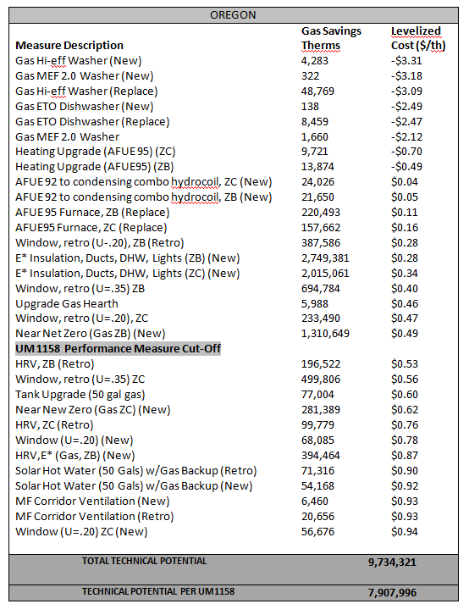

Table 6-3 shows the list of measures and their technical applicability to Cascade’s commercial market sector in Oregon.

Table 6-3
COMMERCIAL CONSERVATION MEASURES
TECHNICAL POTENTIAL BY 2031
OREGON
 | Gas Savings | Levelized
Measure Description | Therms | Cost ($/th)
EStar Steam Cooker (Replace) | 43 | -$1.85
EStar Steam Cooker (New) | 19 | -$1.85
EStar Commercial Clothes Washer (Retrofit) | 11 | $0.01
EStar Fryer (New) | 7,614 | $0.01
EStar Fryer (Replace) | 21,560 | $0.04
Estar Convection Oven (Replace) | 1,318 | $0.06
HW Boiler Tune (Retrofit) | 688 | $0.07
DHW Showerheads (Retrofit) | 20,327 | $0.12
Roof Insulation- Attic R0-30 | 38,423 | $0.13
Hot Water Temperature Reset (Retrofit) | 54,421 | $0.14
Wall Insulation- Blown R-11 (Retrofit) | 319,414 | $0.18
Roof Insulation- Rigid R0-11 (Replace) | 6,157 | $0.19
Steam Balance (Retrofit) | 18,700 | $0.20
Wall Insulation- Spray On for Metal Buildings (Retrofit) | 74,119 | $0.21
DHW Wrap (Retrofit) | 1,639 | $0.21
Estar Convection Oven | 698 | $0.22
Heat Reclaim (Replace) | 6,561 | $0.24
Heat Reclaim (New) | 5,213 | $0.24
Roof Insulation- Blanket R0-19 (Retrofit) | 102,150 | $0.25
Roof Insulation- Blanket R0-30 (Retrofit) | 107,174 | $0.27
Roof Insulation- Rigid R0-22 (Replace) | 6,988 | $0.30
DCV (Retrofit) | 113,718 | $0.31
Vent Damper (Retrofit) | 6,058 | $0.31
Hot Food Holding Cabinet (New) | 447 | $0.41
SPC Hieff Boiler (Retrofit) | 256 | $0.41
Hot Food Holding Cabinet (Replace) | 1,265 | $0.42
Roof Insulation- Attic 11-30 (Retrofit) | 87,293 | $0.43
SPC Hieff Boiler (New) | 987 | $0.43
Roof Insulation – Rigid R11-22 (Replace) | 18,127 | $0.44
Ducts (Retrofit) | 46,345 | $0.51
SPC Cond Boiler Replace | 741 | $0.52
UM 1158 Performance Measure Cut-Off
SPC Cond Boiler (New) | 2,364 | $0.53
Ozone Laundry Treatment | 15,030 | $0.57
Combo Hieff Boiler (New) | 2,254 | $0.59
DHW Recirc Controls (Retrofit) | 34,677 | $0.63
EStar Griddle (Retrofit) | 334 | $0.63
DHW Faucets (New) | 120 | $0.65
DHW Faucets (Retrofit) | 1,355 | $0.65
 | Gas Savings | Levelized
Measure Description | Therms | Cost ($/th)
Combo Hieff Boiler (Retrofit) | 2,553 | $0.66
Waste Water Heat Exchanger (Retrofit) | 3,957 | $0.67
EStar Griddle (New) | 177 | $0.69
DHW Condensing Tank (New) | 7,227 | $0.73
DHW Condensing Tank (Retrofit) | 8,186 | $0.73
Power Burner (Retrofit) | 62,502 | $0.74
Condensing Furnace (New) | 10,353 | $0.81
Roof Insulation – Roofcut 0-22 (Retrofit) | 17 | $0.83
Rooftop Condensing Burner (New) | 11.949 | $0.96
DHW Pipe Insulation (New) | 179 | $0.98
TOTAL TECHNICAL POTENTIAL | 1,231,708
TECHNICAL POTENTIAL PER UM1158 | 1,068,474

Note on Industrial Potential:
The details behind the Company’s technical industrial potential may require further analysis and refinement by the Energy Trust of Oregon and is unavailable at this time. However, according, to the ETO the current Cascade deployment scenario and relevant ramp rates correspond to 1,397,825 of therm savings for Energy Trust’s Industrial program. This would correspond to a combined technical potential of 2,629,533 therms, or approximately 230k therms less than the achievable potential identified by the ETO later in this document. Both the industrial and commercial conservation screens reflect a good-faith assessment of technical potential offered by the ETO. The data is based on best-estimates supported by the most recent Stellar-Ecotope study and additional analysis by Energy Trust staff. The analysis of achievable commercial/industrial potential noted later in the IRP offers a more optimistic view of therm savings opportunities based on a ground-level assessment conducted by the Organization's field team. This accounts for the inverse correlation between technical and achievable potential as it relates to Cascade's Oregon service territory.
The 2011 Stellar Processes resource assessment identified 633,000 therms of cost-effective, achievable resource potential in Industrial sites in Cascade Natural Gas territory for the 20 year IRP window. This presents a discrepancy of 873,370 therms of savings between what ETO Planners believe they can realistically achieve and the total resource potential identified in the market. All Company conservation and DSM evaluation efforts in the State of Oregon are lead by the Energy Trust of Oregon. The Company has received the following details explaining the perceived increase in industrial potential, and has integrated this information into the IRP in good faith. The Energy Trust has acknowledged the discrepancy between the Stellar assessment and their own findings, and feels confident moving forward with the higher potential forecasts on the following grounds:
- The Stellar Processes resource assessment model did not classify customers in the exact way that that Energy Trust separates its customers into sectors, and so a distributional discrepancy is introduced.

- The Stellar Processes model assumes that those customers who are identified as Industrial have a gas load that is dominated by processes, with very little of the load going to space conditioning needs.

- Weatherization measures such as air abatement, retro-commissioning (RCx), and custom O&M have dominated historical (actual reportable) CNG Industrial sector savings (92% of total savings). This is not reflected in the Stellar Resource Assessment Industrial supply curve.

- Forecasts for potential savings from emerging technologies are also excluded from the supply curve. Recent study presented at ACEEE found the Northwest Power and Conservation Council’s 5 year annual Power Plans to always find new resource available in the next years’ Plans.
Energy Trust’s understanding of industrial resource potential for CNG territory is evolving as the Organization learns more through actual deployment of Cascade’s industrial program. The Trust perceives characterizing industrial resource potential as particularly difficult because of confidential information related to end use that varies widely by site. It is more problematic for Cascade because Cascade has only a few industrial sites of significant size and some with unusual loads. Increased experience with natural gas Conservation Efforts in CNGC’s service territory will help refine the next resource assessment and has already helped refine the short term budget and action plan goals for Cascade industrial. For example, in 2011, the program achieved 87,000 therms and has set a 126,000 therm stretch goal for 2012. This is 100,000 therms more than was projected in the original deployment scenario taken directly from the dated Stellar model version referenced above.
Energy Trust program managers and planning staff remain confident in these higher goals and plan to continually improve resource planning tools going forward. Further updates to the resource supply curves will occur during future Cascade IRP processes, and will incorporate our increased understanding of Cascade’s customers.
With the list of measures established, the next step was to determine the achievable potential and the 20-year DSM deployment scenario along with the associated annual utility costs to determine the level of funding that will be necessary to obtain those therm savings. The measures are grouped into categories (SF New construction, SF Retrofit, etc.) and deployment curves were developed.
It should be noted that the 2010 CNG IRP featured relatively ‘flat’ growth in therm savings from year-to-year after 2015. This is a result of simplifying assumptions employed in previous IRP planning processes, where it was assumed that a roughly 1/20th of the technical potential was available in each year (flat or zero ramp rate). More recently, Energy Trust has shifted away from this approach by utilizing information about the current state of technologies and programs, as well as expected changes in codes and standards to estimate more realistic ramp rates. This difference can be seen most prominently when comparing the ‘shape’ of the acquisition curves featured in each of the 2010 and 2011 IRPs. The previous (2010) acquisition curve can be characterized by its relative flatness resulting from flat ramp rates, while the more recent (2011) acquisition curve has a more pronounced shape and definition as a consequence of using more detailed and granular data in the forecasting process.
Annual therm savings targets associated with the Low Income WAP have been included in the deployment curves as a separate line item as they are separate from the ETO’s targets. The Resource Assessment prepared by Stellar, includes the Conservation potential associated with the Low Income housing stock.
It should be noted that the figures shown for the residential and commercial sector represent the ETO’s best case “stretch” scenario annual therm savings targets for the planning horizon. In their annual budgeting process the ETO will typically develop their minimum target by applying 85% to their best case scenario to develop a range of therm savings to be achieved. For the 2012 period, the estimated range of annual therm savings for Cascade’s program would be between 347,996 (conservative goal) and 409,372 (stretch goal) and the estimated costs to achieve the stretch therm savings is currently estimated at $2,686,658.
Washington Conservation Study Results
As mentioned earlier, in 2008 the ETO approached Stellar to update the 2006 Oregon study. This Oregon update provided Cascade the opportunity to apply the relevant revisions seen in the Oregon assessment to the Washington study prepared in 2006. The most substantive change to the conservation assessment was the incorporation of the revised customer load growth forecast which significantly reduced the technical potential in the residential sector. It is anticipated that continued declines in the projected cost of natural gas; and the swift evolution in natural gas technologies and building code standards, will lead to the need for a fully updated, Washington-focused DSM potential study to be performed by Stellar Processes in time for the 2014 IRP planning period. This will be the first time an exclusively WA-centered study assessing conservation potential will be performed. The assessment should provide new insights regarding the Company’s overall technical and achievable conservation potential and approaches for achieving deep energy savings. In the meantime, the Company has made best efforts to effectively utilize and apply the current iteration of the 2008 version of the Washington Stellar Study, with the greatest level of relevance for the 2012 IRP.
Application of Stellar to the 2012 IRP
Although no major updates have been made to the Washington-focused portion of the Stellar study since 2008, some critical updates were applied in 2010, and have been further refined for 2012. Unlike earlier iterations of the Study that operated from assumptions of a continued housing boom across the planning horizon, the 2010 Plan took into account slowed growth in the housing sector due to the declining market. Thus it was estimated in 2010 that the technical potential by 2030 for the residential sector was approximately 26.2 million therms, when screened at a levelized cost per therm of $.85. This was a significant downward adjustment from the estimated technical potential of 40 million therms initially anticipated by Stellar in 2006 and has declined further during the 2012 IRP planning cycle.
During the 2012 IRP planning period the projected costs for natural gas continue to decline with long-term prices remaining between the $3 to $5 range over the planning horizon. Such reductions have been partially influenced by the global recession, but are perhaps most heavily affected by the new supply development technologies providing additional gas resources in North America. Shale gas from the Horn River Basin, Montney and Marcellus are likely to keep sufficient supplies in North America and some believe shale gas could represent more than a third of the US production by the mid 2020s. This improvement to the long-term gas supply outlook is a stark contrast to the diminishing supply outlook prevalent during the development of the Company’s 2008 IRP. As a result Cascade’s historical approach of screening measures at a levelized cost of $.85 - $1.00 per therm must be modified with this IRP, and a screening cap of $.65 cents or less put into effect. The associated reduction in potential amounts to approximately 6.7 million therms and is slightly offset by the restoration of 2 million therms of technical potential generated from the combined measures of “PTCS Duct Sealing plus concurrent installation of a 90%+ AFUE furnace,” which was removed during the 2010 planning cycle commensurate with anticipated changes to Washington State building code that were later repealed. These changes in total result in a net technical potential of approximately 21.5 million therms. It is important to keep in mind that the IRP is a long-term planning document. The Company has chosen to utilize the $.65 levelized cost screen in order to factor for increases in avoided costs over the 30-year planning horizon. However, it is likely in the short term, the actual conservation portfolio implemented by the Company will need to adhere to a more stringent cost effectiveness limit in the $.40 - $.50 range. For the purposes of pure DSM planning, Cascade has chosen to include a broader range of potential, recognizing that further refinement to the Company’s DSM potential assessment will be critical for the 2014 IRP planning period.
The complete list of currently assessed DSM measures and their applicability to Cascade’s Washington service territory for use in the 2012 IRP is included in Appendices D-3 & D-4.
As suggested earlier, in order to maintain the fullest understanding of the impacts of economic, technological, and code-based changes on the Company’s DSM potential, Cascade intends to launch a newly minted Conservation Potential Assessment which will be scheduled for completion in time for application to our DSM planning efforts in 2014.

For this IRP, the Company has grouped the residential measures into the following categories: Existing Shell Measures, New Construction Shell Measures, Domestic Water Heating (DWH), HVAC, Boiler to Combo System, and Appliances. Table 6-4 shows the group of residential measures and their technical applicability in Cascade's Washington service territory under the various levelized therm assumptions.

TABLE 6-4
WASHINGTON
RESIDENTIAL TECHNICAL POTENTIAL
 |  | Screened at Levelized cost/therm of
 | <$0.65 | $0.70 | $0.75 | $0.85 | $1.00 | $1.50 | >$2.00
Existing Shell | 3,585,461 | 3,585,461 | 3,585,461 | 3,585,461 | 3,585,461 | 3,585,461 | 3,585,461
New Construction Shell | 5,776,721 | 5,776,721 | 5,776,721 | 7,920,357 | 9,365,736 | 9,365,736 | 9,365,736
HVAC | 4,183,200 | 6,452,534 | 6,482,246 | 7,753,797 | 9,698,678 | 9,892,797 | 10,249,568
Water Heating (New/Existing) | 155,904 | 155,904 | 155,904 | 1,135,937 | 1,135,937 | 1,878,664 | 1,878,664
Boiler to Combo System | 6,777,258 | 6,777,258 | 6,777,258 | 6,777,258 | 6,777,258 | 6,777,258 | 6,777,258
Appliances | 1,060,550 | 1,065,143 | 1,065,143 | 1,065,143 | 1,065,143 | 1,065,143 | 1,065,143
Total | 21,539,094 | 23,813,021 | 23,842,733 | 28,237,953 | 31,628,213 | 32,565,059 | 32,921,830

Table 6-5 shows the list of measures and their technical applicability to Cascade’s commercial/industrial market sector. The bolded underline denoting the new levelized screening cut-off of $.65 for commercial technical potential. The new levelized cost screen reduces commercial potential from 22,502,350 to 21,487,000. Industrial potential remains the same.

Table 6-5
COMMERCIAL/INDUSTRIAL CONSERVATION MEASURES
TECHNICAL POTENTIAL BY 2030
WASHINGTON
COMMERCIAL
 | Gas Savings | Levelized
Measure Description | Therms | Cost ($/th)
New Heaters | 975,000 | $0.03
New Boilers | 673,000 | $0.09
Shell Measures | 11,606,000 | $0.29
Replace Heaters | 1,717,000 | $0.31
Cooking | 2,646,000 | $0.35
New Cooking | 944,000 | $0.35
O&M and Controls | 1,245,000 | $0.42
Replace Boiler | 437,000 | $0.53
DHW Measures | 839,000 | $0.55
New DHW Measures | 405,000 | $0.60
Refer Heat Reclaim | 470,500 | $0.80
New Refer Heat Reclaim | 277,800 | $0.80
Solar Pool Heat | 29,400 | $0.91
New Solar Pool Heat | 6,400 | $0.95
New Windows | 231,250 | $1.50
TOTAL COMMERCIAL | 21,487,000
INDUSTRIAL
Specialty Hot Water | 16,000 | -$0.81
Process Hot Water | 47,000 | $0.10
Boilers | 442,000 | $0.18
Unit Heater | 176,000 | $0.18
Shell Measures | 294,000 | $0.22
TOTAL INDUSTRIAL | 975,000
TOTAL TECHNICAL POTENTIAL | 22,462,000

Based on the above technical potential, the Company has developed an estimate of the incremental conservation resources that can be acquired through 2030 on an annual basis. The Company followed the ETO’s approach used to develop the targets for Oregon, making modifications when necessary to recognize the differences associated with Cascade’s Washington service territory. During the 2012 planning period, the Company has made modifications to achievable potential and the associated targets developed through this long-term assessment in order to more fully reflect the on-the-ground realities of CNGC’s Washington service territory.
It should be noted, that historically, the Company has estimated the achievable potential and then estimated the annual targets based on a percentage of the achievable potential. The Company modified its approach since the 2008 IRP basing the annual estimates as a percentage of the technical potential rather than estimating the achievable potential and then developing the deployment curves. Consistent with the development of the Oregon deployment curves, Cascade grouped the measures into categories and deployment curves were developed utilizing the following key assumptions:
- In the area of Residential New Construction it was assumed that the technical potential would be spread equally over the 20 year planning horizon. Continuing from the deployment curves estimated in the 2010 Plan, it is assumed participation levels will continue to ramp-up over the planning horizon, assuming 15% in 2011 and reaching a maximum participation of 75% by 2018.
- In the area of Residential replacement market, similar to the new construction sector, it was assumed the technical potential would be spread equally over the 20 year planning horizon. Participation levels continue to ramp up, beginning with 30% in 2011 reaching maximum participation of 80% in 2017.
- Participation in the Residential Retrofit market was also assumed to continue to ramp-up over the 20 year planning horizon. Similar to the Oregon approach, it was assumed that over the 20 year horizon, 80% of the technical potential would be realized through the residential retrofit program. Participation levels were assumed to range from 3% in 2011 reaching a maximum of 6% in 2017.
- In the Commercial retrofit market, similar to the residential retrofit market, it was assumed participation levels would range from 3% in 2011 to a maximum of 6% in the 2017 period.
- In the Commercial/Industrial New Construction and Replacement markets, the technical potential was spread evenly over the 20 year planning horizon. On the new construction side, participation levels ramp-up from 15% in 2011 to 75% in 2018. In the replacement market, the ramp-up period begins at 20% in 2011 and increases 5% per year until reaching the maximum participation level of 75% in 2021.
- Annual therm savings targets associated with the Low Income Weatherization program have been included in the deployment curves as a separate line item. The Low Income Weatherization program is delivered by the Community Action agencies rather than the third party contactor who delivers the residential program and therefore separate targets are necessary. The Resource Assessment prepared by Stellar, includes the conservation potential associated with the Low Income housing stock.
- In developing the estimated costs to achieve the annual therm savings targets, it was assumed commercial therm savings could be achieved at $4/therm while the residential sector would require approximately $6.50/therm.
Since prior IRP planning periods, the Company’s Washington Conservation Programs have acquired a more mature and sophisticated selection of DSM measures and strategies. The Company’s understanding of the “on the ground reality” of its service territory has likewise evolved. Therefore, commensurate with the evolution of the programs, the underlying assumptions highlighted above only provide a glimpse at one potential route through which savings may be annually achieved. Based on historic achievements and current market realities, the Company remains with the aggregate assumptions developed by Stellar which set Achievable Potential and associated targets at the averaged level of 61% of technical potential in the commercial sector, and 58% of technical in the residential sector. However, the ramp rate of annual targets in the commercial sector have been refined to reflect more stable growth from year-to-year (as opposed to more dramatic annual “jumps” in achievable potential) and provides targets that remain realistically aggressive in light of more stringent levelized cost standards and continued declines in the cost of natural gas. The residential programs will continue to ramp-up under the current assumptions set in prior Stellar analysis until further information is available following formal updates to the Study.
Based on the assumptions outlined above, the estimated annual therm savings targets for the Washington Residential and Commercial/Industrial programs are shown in Table 6-6 on the following page. The figures shown for the residential and commercial sector represent Cascade’s best case or “stretch” scenario for annual therm savings targets for the planning horizon.
Table 6-6 also offers adjustments to reflect more realistic annual achievements for its Low Income Weatherization program which is experiencing significant reductions to State and Federal funding levels. The funding provided through federal funds such as WAP and ARRA have traditionally provided the foundational dollars necessary to perform the whole-home and health and safety measure needed before natural gas-focused energy upgrades can be installed. While Cascade will continue to aggressively partner with the Community Action Agencies in Cascade’s service territory, both the Company and its Weatherization partners recognize the challenge of leveraging utility rebate dollars earmarked exclusively for acquiring therm savings associated with a list of prescriptive energy improvements. Such challenges can be mitigated, but it is unlikely annual targets beyond the 30-35k range will be realistic until such time that the Agencies have access once more to a greater level of dollars for administration and repairs. Such monies will likely be found through non-utility sources.
Conservation Summary
Based on the deployment curves developed for each state, Cascade estimates that the cumulative therm savings targets for the 2 Year Action Plan period (2011 – 2012) represents the displacement of approximately 44,869 residential customers’ annual load requirements.
DSM Implementation Issues and Uncertainties
The amount of DSM potential identified for the plan relies on the best available information today about prices, efficiency, consumer behavior and preferences, and projects information 20 years into the future. As with other resources, DSM resource assessments depend heavily on energy load forecasts and projected growth rates with all of the associated uncertainties. Also similar to supply side resources, assessments of DSM potential are limited by what is currently available in the marketplace in terms of cost-effective technologies for improving energy efficiency. The impacts of new technologies and new energy efficiency codes and standards are difficult to accurately predict. This uncertainty is mitigated through the biennial updates of the IRP, which provide the opportunity to incorporate improvements in demand side technologies and programs.
Annual conservation achievements resulting from the physical installation of Company-driven energy efficient equipment and upgrades can be more readily tracked and reduce the Company’s conservation potential by the amount previously accomplished during each 2 year planning cycle. Therefore the 2012 IRP has, for the first time, been adjusted to reflect prior Company-driven therm savings as calculated and measured through its Conservation Incentive Program.
It should be noted that it is likely an even greater level of therm savings is associated with Company efforts beyond those savings that have been directly driven by its conservation rebates. For example, pro-conservation messaging in Company bill inserts and active sponsorship of community efforts that provide direct energy services to CNGC customers have likely lead customers to engage in a wide variety of gas conservation upgrades and improvements that are directly attributable to Cascade’s aggressive messaging and outreach efforts but did not result in the completion of a CNGC rebate form.
Since all CNGC therm savings are tracked through the Company’s rebate program, and no rebate would necessarily be associated with these aforementioned efforts, the Company is unable to track this deeper level of achievement. Thus Company-driven therm savings may remain “on the table” as unachieved, leading to an overestimation of the Company’s remaining Achievable Potential.
Even though what has already been achieved cannot be re-achieved, it should be acknowledged that some level of continued growth to technical potential is possible with the advent of new cutting-edge conservation technologies. Thus it is essential the Company continue to monitor viable conservation options for its customers, and further refine and refresh its DSM research and formalized assessments.
However, it must be remembered that regardless of Company efforts, the utility is ultimately dependent on a large number of small purchases with each tied to the individual consumers’ day-to-day purchasing and behavioral decisions. While Cascade can attempt to influence these decisions through its programs, the consumer is the ultimate decision maker regarding the purchase of DSM resources. Cascade’s assessments of DSM make the best possible estimates of participation and costs; however, like any program operating under real-world conditions, the amounts are likely to vary from planning estimates.
Table 6-6 below reflects the Company’s best estimates of Achievable Potential over the 20 year planning cycle, and adjusts for previous annual achievements. The Company believes these figures more accurately reflect the reality of achievable annual therm savings within Cascade’s service territory based on the parameters of the Stellar Ecotope study’s potential estimate when lowered to the $.65 levelized cost range or below. The targets also take into account the Company’s on-the-ground experience delivering DSM programs in its WA service territory. The adjustments below also more accurately reflect what can be achieved within the Company’s existing DSM portfolio, which under current gas costs is currently stretching the boundaries of cost effectiveness.
Table 6-6 should be considered as a “stretch target” with a more realistic conservative target at 75% of these figures. The Company’s internal targets for the next IRP planning period are as follows:
2013
- Residential target of 189,619 therms,
- Commercial/Industrial target of 320,892 therms
- Low Income target of 26,250 therms
2014
- Residential target of 226,382 therms.
- Commercial/Industrial target of 339,768 therms,
- Low Income target of 22,500 therms.

These projected achievements are based on the Company’s current best estimates of its achievable potential based on projected gas costs and known mix of viable natural gas conservation measures and are subject to modification based on updated forecasts, knowledge of evolving efficiency technologies, and updates to the Company’s assessments of its conservation potential. Budgets for FY 2013 and FY 2014 will be based commensurately with these targets and adjusted dynamically to ensure maintenance of appropriate levelized costs.

Table 6-6
Many specific details are required to implement successful programs. As discussed above, actual implementation design, delivery, and market conditions will cause actual energy-efficiency program savings, costs, and overall achievements to vary. Customer participation in a program is heavily influenced by the level of incentive paid by the utility versus the cost to the customer. External infrastructure considerations must also be addressed, such as product availability to utility customers and an adequate network of contractors, retailers, and other trade allies to support a program. As new measures or expanded programs are developed and added to the current program mix, internal and external resources and capabilities need to grow accordingly and progress through a “learning curve”. For this reason, the company estimated conservation acquisition schedule increases over time. Additionally, revised projections regarding the cost of natural gas and other external factors will likely lead to needed revisions to the company’s existing programs, and will result in additional impacts on the company’s projected participation levels.
As of the time of this IRP planning period, the Company has three conservation programs operated under Tariffs 300 (Residential Conservation Incentive Program), 301 (Low Income Weatherization Incentive Program), and 302 (Commercial Industrial Conservation Program).

A summary of each portfolio can be found below, and each active tariff during this IRP planning cycle can be found in Appendix D.
Residential Portfolio:
- Insulation and PTCS Duct Sealing.
- 90%+ Natural Gas Furnaces.
- Energy Star Homes.
- High Efficiency Combo Radiant Heat w/ Natural Gas Water Heater.
- High Efficiency Natural Gas Water Heaters.
- 80% Thermal Efficiency Natural Gas Fireplace Inserts.
- Energy Savings Kits.
- Limited Custom incentives to mixed rate schedule facilities with 503 elements.
Commercial Portfolio:
- High Efficiency Natural Gas HVAC Unit Heaters, Furnaces, Boilers & Radiant Heating.
- Insulation.
- High Efficiency Natural Gas Water Heaters.
- Tariff-Approved Energy Star Qualified Natural Gas Foodservice Equipment.
- 1.8 MEF Natural Gas Clothes Washers.
- Custom Incentives with Cost-Effectiveness Limits Updated to match avoided cost limits of currently acknowledged IRP.
Low Income Portfolio:
- Ceiling, Wall, Floor and Duct Insulation.
- Duct Sealing.
- Air Infiltration Reduction.
As suggested above, all items offered at the time of the 2012 Integrated Resources Plan were developed based on the Company’s best understanding of avoided costs as outlined in Appendix H of the previous Integrated Resources Plan acknowledged by the WUTC. Measures were selected based on best available information regarding equipment and measure costs, measure lives, and estimated therm savings. The Company’s conservation portfolios and programs are subject to modification following the acknowledgement of this more recent IRP, and/or following any and all changes to the underlying data or circumstances surrounding the assessment and measurement of program cost-effectiveness. Customer participation levels will be commensurate with a cost-effective natural gas conservation measure mix that Cascade will be able to maintain in its portfolio. This shall be assessed by taking into account the cost-effectiveness parameters recommended by the WUTC following the outcome of UG 121207, “Rulemaking on Natural Gas Conservation Programs.”
Until such time that the Company/natural gas utilities operating in WA State receive formal guidance regarding the most appropriate method for assessing cost-effectiveness of natural gas conservation measures and programs, the Company will continue to review both the Utility Cost and Total Resource Cost tests as standards by which natural gas conservation measures should be added or modified. The TRC and UCT are the current standards that have been used both currently—and historically—to assist Cascade Natural Gas in the development of economically appropriate conservation incentives for our customers.
Cascade will continue to carefully monitor the cost-effectiveness and participation levels associated with all of its natural gas conservation efforts though the detailed annual report it files each year as part of Docket UG 060256. As described in the Company’s 2010 Annual Conservation Report, the Annual Conservation Achievement Report below shall—and does continue to— be filed with the WUTC in a format similar to its previous Conservation Reports, as an informational filing. This, and all future reports will be shared with the WUTC by July 1st of the following program year (for instance, 2011 achievements were reported no later than July 1, 2012). In the event that the reporting format or timing needs to be adjusted, the Company will notify Commission Staff prior to filing.
All other planning associated with the Company’s Conservation Programs (potential assessment and targets) shall remain within the Company’s Integrated Resource Plan.
Other uncertainties relating to conservation resources include the risk of free riders, and lost opportunities. Free riders are those individuals who would have undertaken some form of conservation action even if a program had not existed. Measuring free rider impacts makes program evaluation difficult since it requires information on a hypothetical situation that, by definition, will never be observed. Lost opportunities assume the opportunity to install cost-effective conservation measures occurs only once in the life of a home, office, or industrial plant. If all potential cost-effective conservation is not installed at one time, future DSM opportunities may be lost as a result. This is most likely true for commercial/industrial resources since it is unlikely that a business would close down or curtail operations for any period just to install conservation measures.
As discussed earlier, the potential for building code changes over the planning horizon represents another uncertainty that could impact the ability of the company to achieve its therm savings goals. When more aggressive code changes take effect, Company programs and targets are adjusted accordingly.
Potential carbon legislation is another area of uncertainty that Cascade continues to monitor closely. In Washington, specific requirements resulting from the Western Climate Initiative’s (WCI) Greenhouse Gas Cap and Trade design recommendation are still unknown. The recommendations include reducing greenhouse gas emissions to 15% below 2005 levels by 2020. GHG measurements and monitoring began on January 1, 2010 for reporting in early 2011. The first phase of the cap-and-trade program is proposed to begin in 2012 and will cover emissions from electricity. The second phase would begin in 2015, when the program expands to include other fossil fuels, including natural gas.
Although Oregon is a participant in the WCI, its governor, Ted Kulongoski, unveiled his own plan that includes the goal of reducing greenhouse gas levels to 10% below 1990 levels by the year 2020. The multi-faceted plan includes a regional cap and trade program, which if approved by the Legislature, would go into effect in 2012. Also included, among other proposals, are energy efficiency tax incentives and low-income support.
At the Federal level, the traction for national legislation such as Kerry-Lieberman has decreased significantly and it is uncertain at this point the level of impact federal legislation will have as compared to the impacts of regional legislation.

Environmental Externalities
When evaluating DSM resources, the company also includes an evaluation of the impacts of environmental externalities. The impact of utilizing energy on the environment continues to be a subject of societal concern and debate. If there are impacts that cannot be repaired naturally within a reasonable period of time, damage cost to the environment occurs for which society will have to pay in some, as yet undetermined, form. The question of who pays, how much and when payment should be made, are complicated issues.
For many years, The Northwest Power and Conservation Council (NPCC) has utilized a 10% cost advantage for electric utilities acquiring conservation resources to realize the benefits of not using supply side resources. Such electric utility benefits include reduced fish and wildlife impacts, load stability, load predictability and improved air quality. As discussed in Section 7, when calculating the avoided cost figures, the company includes an incremental cost advantage for conservation resources. Historically, Cascade has included the 10% cost advantage for conservation resources which was consistent with Oregon’s requirements for gas utilities for mandated residential weatherization programs. For this plan, the company developed a graduated scale ranging from 5% for short-term measures up to a 20% factor for longer-lived measures. The use of a graduated scale is an attempt to recognize non-quantifiable benefits associated with conservation, such as price certainty & a hedge value against future carbon costs.
The OPUC issued Order 93-965 (UM-424) to address how utilities should consider the impact of environmental externalities in planning for future energy resources that goes beyond the 10% cost advantage discussed above. In June 2008, the OPUC issued Order 08-338 (UM1302) which revised the IRP Guidelines associated with the analysis of environmental costs. The original guideline, established in UM1056, required utilities to analyze the range of potential CO₂ costs referenced in Order 93-965. Rather than providing a specific range of potential CO₂ costs to be analyzed, the revised guideline requires the utility to construct a basecase portfolio that reflects what it considers to be the most likely regulatory compliance future for the various emissions. Additionally the guideline requires the utility to develop several compliance scenarios ranging from the present CO₂ regulatory level to the upper reaches of credible proposals and each scenario should include a time profile of CO₂ costs.
Unlike electric utilities, environmental cost issues rarely impact a gas utility's supply-side resource choices. For example, Cascade cannot choose between coal-fired generation or wind energy sources to meet its load requirements. As a natural gas distribution company, the Company’s only supply-side energy resource is natural gas. However, environmental externality costs make a difference in the comparison between supply-side and demand-side resources.
At the time of this writing, specific details on the level of carbon allowances and how they may be allocated to the gas utilities under a cap and trade program are still unknown. Therefore, in an effort to create a more realistic and robust assumption with regard to potential carbon legislation, Cascade utilized the most recent draft legislation, the Kerry-Lieberman proposal. Table 6-7 on the following page shows the updated analysis.

Other Demand Side Management
The general purpose of demand response is to help manage demand during periods of system stress. The term encompasses a number of activities including real time pricing, time of use rates, critical peak pricing, demand buyback, interruptible rates, and direct load controls. As discussed earlier, the majority of Cascade’s annual throughput is for non-core transportation service customers who are responsible for securing their own pipeline capacity arrangements. Of the remaining industrial sales, approximately 25% of that load is being met through interruptible sales service. Interruptible service is attractive for large volume customers because of the lower distribution margin involved. As a result, the company believes that all customers that can manage their operations on interruptible service are currently served on an interruptible basis – leaving little opportunity to reduce peak loads through expanded interruptible service.

Table 6-7
Natural Gas Environmental Externality Cost Analysis
Updated with EIA's Estimated Emission Factors & Inflation
 |  | Emission | Cost | Externality Adder
Emission |  | (Lbs/Therm) | ($/Lb) | ($/Therm)
SCENARIO 1
NO₂ | $2500/Ton | 0.008 | $1.250 | $0.010
CO₂ | $15/Ton | 11.673 | $0.008 | $0.088
TOTAL |  |  |  | $0.090
SCENARIO 2
NO₂ | $2500/Ton | 0.008 | $1.250 | $0.010
CO₂ | $20/Ton | 11.673 | $0.010 | $0.117
TOTAL |  |  |  | $0.127
SCENARIO 3
NO₂ | $2500/Ton | 0.008 | $1.250 | $0.010
CO₂ | $30/Ton | 11.673 | $0.015 | $0.175
TOTAL |  |  |  | $0.185
SCENARIO 4
NO₂ | $2500/Ton | 0.008 | $1.250 | $0.010
CO₂ | $20/Ton | 11.673 | $0.010 | $0.117
TOTAL |  |  |  | $0.127
SCENARIO 5
NO₂ | $2500/Ton | 0.008 | $1.250 | $0.010
CO₂ | $25/Ton | 11.673 | $0.013 | $0.146
TOTAL |  |  |  | $0.156
SCENARIO 6
NO₂ | $2500/Ton | 0.008 | $1.250 | $0.010
CO₂ | $30/Ton | 11.673 | $0.015 | $0.175
TOTAL |  |  |  | $0.185
General Assumptions:
Externality Adder reflects 1st year adder
Adder will increase annually by 3% and will be adjusted by the CPI, estimated to be 3.5%/year

Section 7

Resource Integration
Resource integration is the last step in Cascade’s IRP process. It involves finding the least cost mix of demand and supply side resources given the forecasted load requirements of the core customers. The tool used to accomplish this task is a computer optimization model known as SENDOUT™. This model permits the Company to quickly develop and analyze a variety of resource portfolios to help determine the type, size, and timing of resources best matched to forecast requirements. SENDOUT™ is very powerful and complex. It operates by combining a series of existing and potential demand side and supply side resources and optimizes their utilization, at the lowest net present cost over the entire planning period, for a given demand forecast.
Resource Optimization Analysis Tools
SENDOUT™’s broad capabilities allow the Company to develop supply and demand relationships that closely mirror Cascade’s existing operations. Cascade continued to model demand areas grouped by the various pipeline zones, a practice that began with the 2008 IRP. A copy of the network diagram is shown in Figure 7-A on the following page. These demand centers reflect on a daily basis, the aggregate 20 year load forecasts of Cascade’s core market customers being served from either Northwest Pipeline GP (NWP) or Gas Transmission Northwest (GTN) interstate pipeline facilities. Individual transportation segments, storage, supply and demand side resources, both existing and potential, are targeted to these pipeline zones. This level of precision allows SENDOUT™ to consider each resource on an individual basis within the portfolio while also recognizing where physical system limitations exist. Resource characteristics such as a supply contract’s daily delivery capability, minimum take requirements, maximum daily transport capability by individual segment, and storage inventory limitations and withdrawal and injection curve characteristics can be part of each resource’s basic model inputs. The ability to model resources in this fashion allows SENDOUT™ to tailor its optimization within envisioned constraints and ensures that the model’s optimal solution can work under anticipated operating conditions.

However, because SENDOUT™ utilizes a linear programming approach, its results are considered “deterministic”. For example, the model knows the exact load and price for every day of the planning period based on the analyst’s input and can therefore minimize costs in a way that would not be possible in the real world. Therefore, it is important to acknowledge that linear programming analysis provides helpful but not perfect information to guide decisions.

Since decisions are made in the context of uncertainty about the future, in 2006 Cascade purchased VectorGasTM. VectorGasTM was an add-in product to the SENDOUT™ model that facilitates the ability to model gas price and load uncertainty (driven by weather) into the future. VectorGasTM utilizes a Monte Carlo approach in combination with the linear programming approach in SENDOUT™. The VectorGasTM functionality was integrated in the SENDOUT™ software with Version 12.5 which is the platform that Cascade prepared its integration analysis. The addition of the Monte-Carlo modeling capability provides additional information to decision makers under conditions of uncertainty. This tool continues to enhance the robustness of the Company’s long-term resource planning and acquisition activities.

FIGURE 7-A

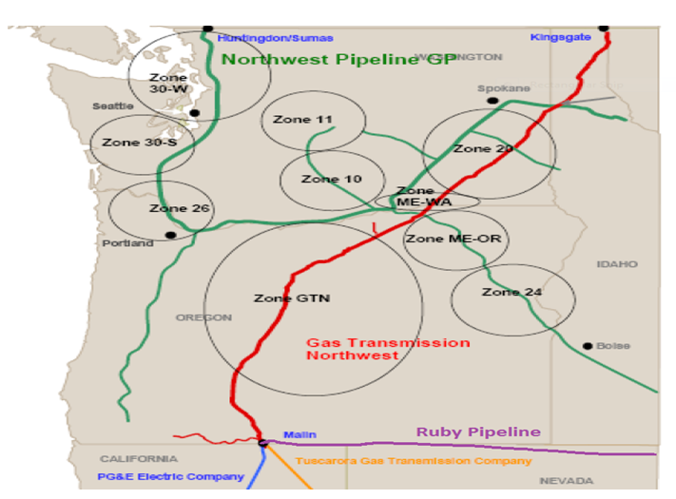

Scenarios versus Simulations
Prior to discussing the modeling process, inputs, and ultimately the results of the analyses, a brief discussion of the term scenarios versus simulations is necessary. As stated earlier,
SENDOUT™ relies on a series of inputs or assumptions and then solves for the least cost solution based on the information provided to the model. Each group of assumptions is considered a scenario. For example, the company models medium load growth under
average weather conditions where the assumed daily weather pattern is input into the SENDOUT™ model. The company also runs scenarios utilizing the low and high growth forecasts and historically has run several different price assumption scenarios. The results of each of these scenarios provide an answer or a least cost solution, which the optimization model has solved based on its perfect knowledge. Historically, this has provided the range of expected outcomes. However, with the addition of the Monte-Carlo functionality, the Company can now run simulations to determine if the scenario results are reasonable and to provide an expected range of results based on a statistical analysis.

Table 7-1 provides the list of scenarios included in this IRP and their key assumptions. To assess the impacts due to variations due in pricing and weather the company ran Monte- Carlo simulations on the Basecase scenario. The Company utilized the Basecase scenario as it represents the scenario Cascade considers most likely to be experienced over the planning horizon.

The basecase (Medium Load Growth, Medium Gas Price Forecast, Average weather with Peak Event) includes existing supply contracts, incremental supplies (peaking, annual, seasonal and citygate) from various receipt points (AECO, Rockies, Sumas, Station 2 and Malin). Other incremental supplies also include biogas and satellite LNG (behind citygate). The basecase includes current upstream pipeline transport capacity, as well as Ruby and incremental NWP and GTN capacity. We also included Cascade’s current Jackson Prairie storage accounts, our Plymouth LNG account, as well as the potential to obtain a third party’s Jackson Prairie account, Ryckman Creek or Mist storage.

In addition to the 200 draws, the Company prepared several sensitivity scenarios to test the resource selections when the baseline conditions were changed. Table 7-2 below describes those sensitivity scenarios.

Decision Making Tool
Analysis of optimization model results and other operational and contractual constraints allows Cascade to make more informed resource decisions. The IRP optimization model output and Monte-Carlo simulation analysis will provide the quantifiable output from numerous model inputs. The model does not prescribe the ultimate resource portfolio. It can only determine the least cost set of resources given their specific pricing and quantifiable constraint characteristics. However, there are many other combinations of resources that may be available over the planning horizon. Cascade must still make subjective risk judgments about unquantifiable and intangible issues related to resource selections. These will include future flexibility, supplier deliverability risk, pipeline(s) risk, financial risk to the utility and its ratepayers, operational constraints, regulatory risk, etc. The risk judgments are combined with the quantitative IRP analysis to form actual resource decisions.
TABLE 7-1
SUMMARY OF PORTFOLIO ANALYSIS AND RESOURCE ALTERNATI VES

ID | SCENARIO NAME | KEY ELEMENTS IN SENDOUT SCENARIO  Medium Load Growth, Medium Gas Price Forecast, Average weather with Peak Event. All elements considered. All items in RED mean that elements was excluded from the scenario
2934 | All in Case
  Current Station2 | Incremental NOVA | AECO Year, Seas, Spot
  Current NOVA-Foothills | Incremental GTN | Sumas Year, Seas, Spot
  Current GTN | Incremental NWP | Rockies Year, Seas, Spot
  Current NWP | Incremental Ruby | Station2Year, Seas, Spot
  Current Ruby | JP1, JPExp, JP3-4, LS | Citygate GTN, NWP
  Ryckman Crk Storage | T-South-So Crossing | BioNatualGas
  Incremental JP | Pacific Connector | Satellite LNG
  Mist Storage | N-MAX-Stan-Madr | WA Expansion
  DSM as a supply | N-MAX Madr I-5
2925 | As Is Scenario
  Current Station2 | Incremental NOVA | AECO Year, Seas, Spot
  Current NOVA-Foothills | Incremental GTN | Sumas Year, Seas, Spot
  Current GTN | Incremental NWP | Rockies Year, Seas, Spot
  Current NWP | Incremental Ruby | Station2Year, Seas, Spot
  Current Ruby | JP1, JPExp, JP3-4, LS | Citygate GTN, NWP
  Ryckman Crk Storage | T-South-So Crossing | BioNatualGas
  Incremental JP | Pacific Connector | Satellite LNG
  Mist Storage | N-MAX-Stan-Madr | WA Expansion
  DSM as a supply | N-MAX Madr I-5
2929 | Limited Canadian Imports
  Current Station2 | Incremental NOVA | AECO Year, Seas, Spot
  Current NOVA-Foothills | Incremental GTN | Sumas Year, Seas, Spot
  Current GTN | Incremental NWP | Rockies Year, Seas, Spot
  Current NWP | Incremental Ruby | Station2 Year, Seas, Spot
  Current Ruby | JP1, JPExp, JP3-4, LS | Citygate GTN, NWP
  Ryckman Crk Storage | T-South-So Crossing | BioNatualGas
  Incremental JP | Pacific Connector | Satellite LNG
  Mist Storage | N-MAX-Stan-Madr | WA Expansion
  DSM as a supply | N-MAX Madr I-5
2927 | Ryckman Creek
  Current Station2 | Incremental NOVA | AECO Year, Seas, Spot
  Current NOVA-Foothills | Incremental GTN | Sumas Year, Seas, Spot
  Current GTN | Incremental NWP | Rockies Year, Seas, Spot
  Current NWP | Incremental Ruby | Station2Year, Seas, Spot
  Current Ruby | JP1, JPExp, JP3-4, LS | Citygate GTN, NWP
  Ryckman Crk Storage | T-South-So Crossing | BioNatualGas
  Incremental JP | Pacific Connector | Satellite LNG
  Mist Storage | N-MAX-Stan-Madr | WA Expansion
  DSM as a supply | N-MAX Madr I-5
2928 | Mist
  Current Station2 | Incremental NOVA | AECO Year, Seas, Spot
  Current NOVA-Foothills | Incremental GTN | Sumas Year, Seas, Spot
  Current GTN | Incremental NWP | Rockies Year, Seas, Spot
  Current NWP | Incremental Ruby | Station2Year, Seas, Spot
  Current Ruby | JP1, JPExp, JP3-4, LS | Citygate GTN, NWP
  Ryckman Crk Storage | T-South-So Crossing | BioNatualGas
  Incremental JP | Pacific Connector | Satellite LNG
  Mist Storage | N-MAX-Stan-Madr | WA Expansion
  DSM as a supply | N-MAX Madr I-5
2928 | Mist and Ryckman Creek
  Current Station2 | Incremental NOVA | AECO Year, Seas, Spot
  Current NOVA-Foothills | Incremental GTN | Sumas Year, Seas, Spot
  Current GTN | Incremental NWP | Rockies Year, Seas, Spot
  Current NWP | Incremental Ruby | Station2Year, Seas, Spot
  Current Ruby | JP1, JPExp, JP3-4, LS | Citygate GTN, NWP
  Ryckman Crk Storage | T-South-So Crossing | BioNatualGas
  Incremental JP | Pacific Connector | Satellite LNG
  Mist Storage | N-MAX-Stan-Madr | WA Expansion
  DSM as a supply | N-MAX Madr I-5
2930 | T-South Enhancement/Southern Crossing with Limited Canadian
  Current Station2 | Incremental NOVA | AECO Year, Seas, Spot
  Current NOVA-Foothills | Incremental GTN | Sumas Year, Seas, Spot
  Current GTN | Incremental NWP | Rockies Year, Seas, Spot
  Current NWP | Incremental Ruby | Station2 Year, Seas, Spot
  Current Ruby | JP1, JPExp, JP3-4, LS | Citygate GTN, NWP
  Ryckman Crk Storage | T-South-So Crossing | BioNatualGas
  Incremental JP | Pacific Connector | Satellite LNG
  Mist Storage | N-MAX-Stan-Madr | WA Expansion
  DSM as a supply | N-MAX Madr I-5
2930-1 | T-South Enhancement/Southern Crossing
  Current Station2 | Incremental NOVA | AECO Year, Seas, Spot
  Current NOVA-Foothills | Incremental GTN | Sumas Year, Seas, Spot
  Current GTN | Incremental NWP | Rockies Year, Seas, Spot
  Current NWP | Incremental Ruby | Station2 Year, Seas, Spot
  Current Ruby | JP1, JPExp, JP3-4, LS | Citygate GTN, NWP
  Ryckman Crk Storage | T-South-So Crossing | BioNatualGas
  Incremental JP | Pacific Connector | Satellite LNG
  Mist Storage | N-MAX-Stan-Madr | WA Expansion
  DSM as a supply | N-MAX Madr I-5
2931 | Pacific Northwest Regional (NMAX, WA Expansion, Palomar)
  Current Station2 | Incremental NOVA | AECO Year, Seas, Spot
  Current NOVA-Foothills | Incremental GTN | Sumas Year, Seas, Spot
  Current GTN | Incremental NWP | Rockies Year, Seas, Spot
  Current NWP | Incremental Ruby | Station2Year, Seas, Spot
  Current Ruby | JP1, JPExp, JP3-4, LS | Citygate GTN, NWP
  Ryckman Crk Storage | T-South-So Crossing | BioNatualGas
  Incremental JP | Pacific Connector | Satellite LNG
  Mist Storage | N-MAX-Stan-Madr | WA Expansion
  DSM as a supply | N-MAX Madr I-5
2932 | Pacific Connector
  Current Station2 | Incremental NOVA | AECO Year, Seas, Spot
  Current NOVA-Foothills | Incremental GTN | Sumas Year, Seas, Spot
  Current GTN | Incremental NWP | Rockies Year, Seas, Spot
  Current NWP | Incremental Ruby | Station2Year, Seas, Spot
  Current Ruby | JP1, JPExp, JP3-4, LS | Citygate GTN, NWP
  Ryckman Crk Storage | T-South-So Crossing | BioNatualGas
  Incremental JP | Pacific Connector | Satellite LNG
  Mist Storage | N-MAX-Stan-Madr | WA Expansion
  DSM as a supply | N-MAX Madr I-5
2933 | Incremental JP
  Current Station2 | Incremental NOVA | AECO Year, Seas, Spot
  Current NOVA-Foothills | Incremental GTN | Sumas Year, Seas, Spot
  Current GTN | Incremental NWP | Rockies Year, Seas, Spot
  Current NWP | Incremental Ruby | Station2Year, Seas, Spot
  Current Ruby | JP1, JPExp, JP3-4, LS | Citygate GTN, NWP
  Ryckman Crk Storage | T-South-So Crossing | BioNatualGas
  Incremental JP | Pacific Connector | Satellite LNG
  Mist Storage | N-MAX-Stan-Madr | WA Expansion
  DSM as a supply | N-MAX Madr I-5

TABLE 7-2
SENSITIVITIES ANALYSES

Scenario Name | Key Assumptions
High Growth | Strong Economic Growth result in High Load growth, Average Weather, Medium Gas Prices
Low Growth | Economic Conditions result in Low Load growth, Average Weather, Medium Gas Prices
Environmental Externalities Carbon 1 | Medium Load Growth, Average Weather, Assumes Carbon Adder Implemented in 2017 for CO2 emissions at $15/ton with adder increasing annually by 3% plus CPI (Consumer Price Index)
Environmental Externalities Carbon 2 | Medium Load Growth, Average Weather, Assumes Carbon Adder Implemented in 2017 for CO2 emissions at $20/ton with adder increasing annually by 3% plus CPI (Consumer Price Index)
Environmental Externalities Carbon 3 | Medium Load Growth, Average Weather, Assumes Carbon Adder Implemented in 2017 for CO2 emissions at $30/ton with adder increasing annually by 3% plus CPI (Consumer Price Index)

Key Inputs
Demand Forecast Items & Weather Assumptions
The optimization process compares a portfolio of resources against a specific demand
requirement. SENDOUT™ generates a daily demand forecast by combining base load and temperature sensitive usage factor inputs with a specified daily temperature pattern input. The company develops usage factors for each of the zones shown on Figure 7-A; this includes nine demand centers on NWP and one on GTN which is utilized to meet Cascade’s Central Oregon load. In order to develop the temperature sensitive usage factors on a zone by zone basis, the company reviewed pipeline deliveries for the 2004 through 2010 period and developed monthly use per customer per degree day factors. The annual customer growth rates from the low, medium and high forecasts discussed in Section 3 were developed for each of the NWP zones and were applied to 2010 monthly core customer counts. Weather patterns for each of the zones were developed based on 5 distinct weather areas. The weather areas and their applicability to each of the zones are shown in Appendix B-1.

Prior to the 2007 IRP, the company had developed daily temperature patterns to estimate the impact of weather ranging from warmer than normal to design conditions, with the expected portfolio being one with average weather. The average weather pattern historically had been based on the 20 year average excluding the high/low annual degree day totals to develop an annual total for each area. These totals were then allocated to the daily readings based on the 90/91 winter pattern since that was the most recent year in the company’s weather history with a peak day reading of 61 DDs. However, with the
ability to run Monte-Carlo simulations, the company modified its approach and developed its “average” weather pattern based on the company’s 60+ year weather history, and the expected degree days for each month. The average pattern for each area was approached on a month-by-month expected value and then the degree days were allocated within the month based on the past years’ average daily distribution. Since a peak event can occur in an otherwise normal weather year, the average weather scenario includes one 3-day peak event, which includes a design day reading of 61 degree days system wide.

Demand Side Alternatives
For purposes of this IRP, the Company has utilized the annual achievable potential schedule shown on Table 6-6 in Section 6 as an input to the optimization model. Because the company models demand by individual zone, conservation has been treated as a “must-take” supply alternative available at the pipeline citygate level. This approach allows the conservation resource to displace supply and pipeline transportation resources that would otherwise be necessary to meet demand requirements. For purposes of modeling, 80% of the identified Oregon Conservation resources are assumed to occur on the GTN pipeline with the remaining 20% occurring on Northwest pipeline. Washington conservation was modeled as a must-take resource at the NWP citygate. Because the acquisition of DSM is dependent upon a number of small purchases, determining which pipeline zones will procure the most conservation at this point is still premature. In future planning cycles, the company will continue to review the results of the participation levels and determine if more detailed assumptions on conservation acquisition can be modeled. Under the basecase scenario the company has assumed that conservation resources could be purchased, on a levelized cost per therm basis of $6. The cost per therm figure of $6 is an estimate of the combined Total Resource Cost for all measures included in the program, including program delivery and administration costs.

Supply Side Resource Alternatives
For modeling purposes, supply side alternatives are grouped into one of three categories: gas supply, storage facilities, or pipeline transportation. As discussed in Section 5, some of the supply alternatives include one or more of these categories. For example, a gas supply resource may be delivered at Cascade’s citygate, essentially reducing the requirement for firm pipeline capacity. A satellite LNG facility (whether trucked in or liquefied on site) located within Cascade’s distribution system can reduce the need for pipeline capacity on a peak day as the supplies will be available to be directly flowed into Cascade’s local system. The following table provides a high level summary of the resource alternatives considered over the planning horizon.

Table 7-3
Supply Side Alternatives Modeled
Resource | Scenario Considered
Conventional Gas Supply Contracts with  annual, seasonal or winter only characteristics delivered to Northwest Pipeline & GTN Systems | All
Conventional Gas Supply Peaking  Contracts Delivered to Northwest Pipeline  & GTN Systems | All
Gas Supply Peaking Contract delivered to  Cascade's citygates | All
Incremental Storage Delivered to  Northwest Pipeline and GTN systems | All
Satellite LNG Storage within Cascade's  distribution sytem | All
Additional Pipeline Capacity secured  through medium--long term capacity agreements | All

Natural Gas Price Forecast
Price volatility has become an on-going factor in the natural gas industry since 2005. Prices in the natural gas market continued to be volatile through 2008 (upwards to $13 per dth), but have since dropped considerably (currently around $3-$4). As discussed in Section 5, natural gas prices will continue to be influenced by demand, oil price volatility, the global economy, electric generation, new extraction technologies, hurricanes and other weather activity. As a result, it is impossible to accurately estimate what future natural gas prices will be over the planning horizon. However, Cascade has considered price forecasts from several sources, such as Wood Mackenzie, Energy Information Administration, the Financial Forecast Center’s forecast, as well as our observations of the market to develop our low, base and high price forecast. As mentioned earlier, details of the company’s price forecast can be found in Appendix E.

The Company compared the Monte-Carlo price simulation results to the low, base and high forecasts and found that the 200 draws captured the same range of pricing outlined in the forecasts shown in the Appendix. Therefore, individual deterministic runs under the low and high price forecast were not run.

Integration Results and Key Findings
As described earlier in this section, Cascade performed several different scenarios and the results are summarized below. However, it should be noted that the results of these analyses should be considered broadly. Like all analyses, the results of the resource optimization models are dependent upon the input assumptions provided. Scenario and Monte-Carlo analysis help by providing information on the ranges of input assumptions. Whether Cascade eventually secures these particular resources, acquires ones of comparable size and characteristics, or decides on an alternative approach is subject to ongoing resource investigation and evaluation activities. Specific resources made

available to the model at this time may or may not be physically available at the time they are needed or economically attractive in comparison to alternatives that may become available in the future. Therefore, prior to securing any of these resources, additional analyses of the specific resource must be completed.

The results of the various scenarios are fairly consistent and reveal the following general trends:

- Even with energy efficiency programs, Cascade will need to acquire additional capacity resources to meet anticipated peak day requirements, due to Cascade’s continued growth in its residential and commercial customer base. Several of Cascade’s existing transportation agreements will expire over the next several years. In most cases, Cascade has the unilateral right to extend or cancel the expiring contracts upon one year’s notice. As a result, the company will have the opportunity to review alternatives to extend or replace those contracts.

- Satellite LNG/Peak shaving facilities located within Cascade’s distribution system (for example Zones 10 and 11—the Wenatchee lateral) may also be an attractive alternative to incremental pipeline capacity in areas where physical limitations at the gate stations would result in even higher costs associated with a pipeline solution. There may be additional advantages to such a strategy to the extent a facility could be strategically located on a portion of the distribution system that will eliminate or reduce distribution system constraints.

- Based on the shale boom, continuing low price supplies and increasing demand in Asia, it looks like LNG will become an exporter from the Pacific Northwest as opposed to importing. In a situation such as that with Pacific Connector, Cascade will not become a shipper to the export facility but rather we will compete for supplies at the Malin hub where several pipelines, including Pacific Connector will have supply trading activities.

- We considered the impact of possible reductions in exports of gas supplies physically produced in British Columbia and Alberta, by limiting the amount of physical Canadian supplies that could be exported via existing infrastructure at Station 2, Sumas or AECO to approximately 60% by not making several packages of these supplies available to the model.. Under this scenario, the model chose to increase the amount of imported Rockies gas via either Ruby/Malin transaction or Malin/Stanfield exchange. Given the proliferation of shale gas, we do not see access to Canadian gas being a problem—gas will be available—however, we will be competing with many parties and consequently, may experience potential volatility and price spikes.

- We modeled Ryckman Creek storage at varying reservation rates and working inventory levels. In a range of reservation rates that are enssentially equivalent to slight lower than Jackson Prairie expansion and significantly higher, SENDOUT consistently selected Ryckman Creek storage with working inventory between 300,000 and 500,000. It should be noted that the model also suggested picking up incremental GTN backhaul service as well as increased amounts of Ruby capacity. The model selected incremental Ruby capacity both on a seasonal basis as well as an annual basis, depending on reservation rate. It appears that Cascade should continue to hold discussions with Ryckman Creek as well as do additional al analysis in order to make a final determination of what level of participation would be appropriate.

- Incremental Jackson Prairie storage was also selected by the model. The company will continue to evaluate potential options to acquire more on system storage capabilities. However, it is worth noting that when we ran incremental Jackson Prairie as well as giving the model the option to pick up Mist, Jackson Prairie was selected. Using the current tariff rate for Mist, the model did not select Mist as a storage alternative, even when attached to discounted or current NWP transportation.

- 20 year portfolio costs on a Net Present Value (NPV) basis, are expected to range between $2,448,210,000 to $3,216,376,000 for the planning period, with an average cost per therm ranging between $.354 and $.447.

Table 7-4 on the following page summarizes the results from each of the modeling scenarios mentioned in Table 7-1.

Table 7-4
SUMMARY OF PORTFOLIO ANALYSIS RESULTS

ID | SCENARIO NAME | KEY ELEMENTS IN SENDOUT SCENARIO and RESULTS DISCUSSION  Medium Load Growth, Medium Gas Price Forecast, Average weather with Peak Event. All elements considered. All items in RED mean that elements was excluded from the scenario
2934 | All in Case | The All In Case run allows the company to see what the model would selcect if all current and probably resources are available.  AECO supplies, as the cheapest basin in the horizon, were selected, which makes sense as T-South Enhancement is essentially creates a slight discount to T-South on Spectra. Almost four times as much AECO is selected as compared of the base case. Gas at Malin on its way to the LNG facility is not selected as there are multitude of less expensive resources (for completion purposes we treat Pacific Connector supplies at Malin priced at AECO Plus $4, to mimic the Asian competition for the supplies. The proposed regional pipeline is is selected to take gas from Stanfield, past Madras and on to Bellingham. It is important to note that we set the transport rates for Palomar, N-MAX and WA South Expansion at approximately 3X times the current NWP rate. Until the pipeline(s) reveal the rates, we cannot reliably count on this as a valid resource option for the base case. Ryckman Creek is selected at levels between .3 and 5 Bcf, and is consistently selected regardless of the scenario. Hence we believe it is logical to include Ryckman Creek as part of the base case.
  Current Station2 | Incremental NOVA | AECO Year, Seas, Spot
  Current NOVA-Foothills | Incremental GTN | Sumas Year, Seas, Spot
  Current GTN | Incremental NWP | Rockies Year, Seas, Spot
  Current NWP | Incremental Ruby | Station2Year, Seas, Spot
  Current Ruby | JP1, JPExp, JP3-4, LS | Citygate GTN, NWP
  Ryckman Crk Storage | T-South-So Crossing | BioNatualGas
  Incremental JP | Pacific Connector | Satellite LNG
  Mist Storage | N-MAX-Stan-Madr | WA Expansion
  DSM as a supply | N-MAX Madr I-5
2925 | As Is Scenario | The As Is Case run allows the company to see what the model does without the alternative resources attached. It sets a bench mark to test th validity of the information (for instance comparing system costs the first year to the most recent PGA). Additionally, the model is given a some minor limits to determine see the range of served and unserved peak day load is. Unserved during the planning horizon was approximately 5,217,000 therms.
  Current Station2 | Incremental NOVA | AECO Year, Seas, Spot
  Current NOVA-Foothills | Incremental GTN | Sumas Year, Seas, Spot
  Current GTN | Incremental NWP | Rockies Year, Seas, Spot
  Current NWP | Incremental Ruby | Station2Year, Seas, Spot
  Current Ruby | JP1, JPExp, JP3-4, LS | Citygate GTN, NWP
  Ryckman Crk Storage | T-South-So Crossing | BioNatualGas
  Incremental JP | Pacific Connector | Satellite LNG
  Mist Storage | N-MAX-Stan-Madr | WA Expansion
  DSM as a supply | N-MAX Madr I-5
2929 | Limited Canadian Imports | In this scenario no AECO other than a small amount of an expensive supply (AECO plus $0.26) was made available to the model. In the base case none of the expensive AECO gas is selected. As expected, the model selects an additional 8000 dths of Ruby capacity and ramps up the Ryckman Creek to .5 Bcf. Ruby volumes double compared to the base case.
  Current Station2 | Incremental NOVA | AECO Year, Seas, Spot
  Current NOVA-Foothills | Incremental GTN | Sumas Year, Seas, Spot
  Current GTN | Incremental NWP | Rockies Year, Seas, Spot
  Current NWP | Incremental Ruby | Station2 Year, Seas, Spot
  Current Ruby | JP1, JPExp, JP3-4, LS | Citygate GTN, NWP
  Ryckman Crk Storage | T-South-So Crossing | BioNatualGas
  Incremental JP | Pacific Connector | Satellite LNG
  Mist Storage | N-MAX-Stan-Madr | WA Expansion
  DSM as a supply | N-MAX Madr I-5
2927 | Base Case | We chose this combination as the base case in that it contains the solid mix of existing supplies and transport. As identified earlier, Ryckman Creek storage is consistently selected by the model regardless of the scenarios so we it is advisable to consider this a viable resource for the horizon. Incremental JP is not currently available or anticipated. While we have managed to pick up some of PSE’s excess JP storage it appears from theirs (and other LDCs IRPs) that the ability to pick up long-term storage from existing customer is not likely. Unless steeply discounted, the model did not select Mist Storage when it was run separately, We will watch for an open season, but at this point given the model results this doesn’t strike us as prudent choice for the base case. In most of the runs for T-South/Southern Crossing, that resource was only selected at volumes of less than 2000 dths/day; the volume is insignificant and the nomination scheduling is operationally more complicated (Westcoast, Fortis, South Crossing, Nova, Foothills, GTN) . We see limited value in T-South Enhancement at this time. We have excluded Pacifc Connector supplies at Malin from the base case as it is only selected during cold events (e.g. Dec peak day), but it is not certain that the pipeline will get built to the LNG facility, let alone have supplies competitively priced for Cascade to obtain. The N-MAX and WA Expansions seem attractive on the surface in that the projects are along our distribution system—however, there are too many unknowns between the various partners (FERC approval, rates, final paths) so it seems imprudent to include these resources at this time as viable resource candidates for the base case. The has been a bit of interest raised in the last year or so by parties seeking to move biogas on the distribution system; additionally, we still view Satellite LNG at specific locations to be a cost effective solution to meet winter loads without incurring the additional expense of pipeline infrastructure. Therefore, we include small amounts of these potential resources in the base case portfolio.
  Current Station2 | Incremental NOVA | AECO Year, Seas, Spot
  Current NOVA-Foothills | Incremental GTN | Sumas Year, Seas, Spot
  Current GTN | Incremental NWP | Rockies Year, Seas, Spot
  Current NWP | Incremental Ruby | Station2Year, Seas, Spot
  Current Ruby | JP1, JPExp, JP3-4, LS | Citygate GTN, NWP
  Ryckman Crk Storage | T-South-So Crossing | BioNatualGas
  Incremental JP | Pacific Connector | Satellite LNG
  Mist Storage | N-MAX-Stan-Madr | WA Expansion
  DSM as a supply | N-MAX Madr I-5
2928 | Mist | Unless steeply discounted, the model did not select Mist Storage when it was run separately, We will watch for an open season, but at this point given the model results this doesn’t strike us as prudent choice for the base case. We ran this particular scenario without the completion of Ryckman Creek but the model still did not select Mist.
  Current Station2 | Incremental NOVA | AECO Year, Seas, Spot
  Current NOVA-Foothills | Incremental GTN | Sumas Year, Seas, Spot
  Current GTN | Incremental NWP | Rockies Year, Seas, Spot
  Current NWP | Incremental Ruby | Station2Year, Seas, Spot
  Current Ruby | JP1, JPExp, JP3-4, LS | Citygate GTN, NWP
  Ryckman Crk Storage | T-South-So Crossing | BioNatualGas
  Incremental JP | Pacific Connector | Satellite LNG
  Mist Storage | N-MAX-Stan-Madr | WA Expansion
  DSM as a supply | N-MAX Madr I-5
2928 | Mist and Ryckman Creek | We modeled Ryckman Creek storage at varying reservation rates and working inventory levels. In a range of reservation rates that are essentially equivalent to slight lower than Jackson Prairie expansion and significantly higher, SENDOUT consistently selected Ryckman Creek storage with working inventory between 300,000 and 500,000. It should be noted that the model also suggested picking up incremental GTN backhaul service as well as increased amounts of Ruby capacity. The model selected incremental Ruby capacity both on a seasonal basis as well as an annual basis, depending on reservation rate. It appears that Cascade should continue to hold discussions with Ryckman Creek as well as do additional al analysis in order to make a final determination of what level of participation would be appropriate.
  Current Station2 | Incremental NOVA | AECO Year, Seas, Spot
  Current NOVA-Foothills | Incremental GTN | Sumas Year, Seas, Spot
  Current GTN | Incremental NWP | Rockies Year, Seas, Spot
  Current NWP | Incremental Ruby | Station2Year, Seas, Spot
  Current Ruby | JP1, JPExp, JP3-4, LS | Citygate GTN, NWP
  Ryckman Crk Storage | T-South-So Crossing | BioNatualGas
  Incremental JP | Pacific Connector | Satellite LNG
  Mist Storage | N-MAX-Stan-Madr | WA Expansion
  DSM as a supply | N-MAX Madr I-5
2930 | T-South Enhancement/Southern Crossing with Limited Canadian | In most of the runs for T-South/Southern Crossing, that resource was only selected at volumes of less than 2000 dths/day; the volume is insignificant and the nomination scheduling is operationally more complicated (Westcoast, Fortis, South Crossing, Nova, Foothills, GTN) . We see limited value in T-South Enhancement at this time. We left the same parameters as the “Limited Canadian supplies” the only noticeable change was an increase of T-South supplies moving to Kingsgate to serve Oregon load.
  Current Station2 | Incremental NOVA | AECO Year, Seas, Spot
  Current NOVA-Foothills | Incremental GTN | Sumas Year, Seas, Spot
  Current GTN | Incremental NWP | Rockies Year, Seas, Spot
  Current NWP | Incremental Ruby | Station2 Year, Seas, Spot
  Current Ruby | JP1, JPExp, JP3-4, LS | Citygate GTN, NWP
  Ryckman Crk Storage | T-South-So Crossing | BioNatualGas
  Incremental JP | Pacific Connector | Satellite LNG
  Mist Storage | N-MAX-Stan-Madr | WA Expansion
  DSM as a supply | N-MAX Madr I-5
2930-1 | T-South Enhancement/Southern Crossing | When no restrictions were placed on Canadian supplies the model did select a higher level of volumes to run on T-South/Southern Crossing, It should be noted that this resource is bi-directional, and even though it was the lease expensive leg the model never selected the Kingsgate to Huntingdon/Sumas path. While the volumes have increased the nomination scheduling is operationally more complicated (Westcoast, Fortis, South Crossing, Nova, Foothills, GTN) . We see limited value in T-South Enhancement at this time. We left the same parameters as the “Limited Canadian supplies” the only noticeable change was an increase of T-South supplies moving to Kingsgate to serve Oregon load.
  Current Station2 | Incremental NOVA | AECO Year, Seas, Spot
  Current NOVA-Foothills | Incremental GTN | Sumas Year, Seas, Spot
  Current GTN | Incremental NWP | Rockies Year, Seas, Spot
  Current NWP | Incremental Ruby | Station2 Year, Seas, Spot
  Current Ruby | JP1, JPExp, JP3-4, LS | Citygate GTN, NWP
  Ryckman Crk Storage | T-South-So Crossing | BioNatualGas
  Incremental JP | Pacific Connector | Satellite LNG
  Mist Storage | N-MAX-Stan-Madr | WA Expansion
  DSM as a supply | N-MAX Madr I-5
2931 | Pacific Northwest Regional (NMAX, WA Expansion, Palomar) | The N-MAX and WA Expansions seem attractive on the surface in that the projects are along our distribution system—however, there are too many unknowns between the various partners (FERC approval, rates, final paths) so it seems imprudent to include these resources at this time as viable resource candidates for the base case. We priced these at approximately 3X the NWP tariff; still the model looked at this a viable solution to Zone 30 problems (it selected up to 26,000 dths/day when given the ability to resize the resource). We will need to keep an eye on this project as it has the potential, combined with incremental NWP to address shortfalls in both 30S and 30W.
  Current Station2 | Incremental NOVA | AECO Year, Seas, Spot
  Current NOVA-Foothills | Incremental GTN | Sumas Year, Seas, Spot
  Current GTN | Incremental NWP | Rockies Year, Seas, Spot
  Current NWP | Incremental Ruby | Station2Year, Seas, Spot
  Current Ruby | JP1, JPExp, JP3-4, LS | Citygate GTN, NWP
  Ryckman Crk Storage | T-South-So Crossing | BioNatualGas
  Incremental JP | Pacific Connector | Satellite LNG
  Mist Storage | N-MAX-Stan-Madr | WA Expansion
  DSM as a supply | N-MAX Madr I-5
2932 | Pacific Connector | Gas at Malin on its way to the LNG facility is not selected as there are multitude of less expensive resources (for completion purposes we treat Pacific Connector supplies at Malin priced at AECO Plus $4, to mimic the Asian competition for the supplies. Oddly enough, during the winter this supply was selected in leiu of citygate supplies on GTN. The was no notable increase in the incremental GTN backhaul so it appears the resource is has limited use.
  Current Station2 | Incremental NOVA | AECO Year, Seas, Spot
  Current NOVA-Foothills | Incremental GTN | Sumas Year, Seas, Spot
  Current GTN | Incremental NWP | Rockies Year, Seas, Spot
  Current NWP | Incremental Ruby | Station2Year, Seas, Spot
  Current Ruby | JP1, JPExp, JP3-4, LS | Citygate GTN, NWP
  Ryckman Crk Storage | T-South-So Crossing | BioNatualGas
  Incremental JP | Pacific Connector | Satellite LNG
  Mist Storage | N-MAX-Stan-Madr | WA Expansion
  DSM as a supply | N-MAX Madr I-5
2933 | Incremental JP | With similar pricing to JP Expansion, the model selected up to .3 Bcf of working inventory. We specifically tied the storage to Zone 30 to address the shortfalls in the area. As noted earlier, JP always seems to be desired by the model, but the likelihood of another block becoming available to us is not high at this point.
  Current Station2 | Incremental NOVA | AECO Year, Seas, Spot
  Current NOVA-Foothills | Incremental GTN | Sumas Year, Seas, Spot
  Current GTN | Incremental NWP | Rockies Year, Seas, Spot
  Current NWP | Incremental Ruby | Station2Year, Seas, Spot
  Current Ruby | JP1, JPExp, JP3-4, LS | Citygate GTN, NWP
  Ryckman Crk Storage | T-South-So Crossing | BioNatualGas
  Incremental JP | Pacific Connector | Satellite LNG
  Mist Storage | N-MAX-Stan-Madr | WA Expansion
  DSM as a supply | N-MAX Madr I-5

Table 7-4-A
SUMMARY OF PORTFOLIO ANALYSIS RESULTS by NPV

ID | SCENARIO NAME | NPV 20 YEAR PORTFOLIO COSTS IN $000s | AVERAGE COST PER THEM
2925 | As Is Scenario | $ 2,457,117 | $ 0.362529
2927 | Base Case | $ 2,457,398 | $ 0.362902
2928 | Mist | $ 2,459,606 | $ 0.363228
2928 | Mist and Ryckman Creek | $ 2,469,211 | $ 0.365308
2930-1 | T-South Enhancement/Southern Crossing | $ 2,475,877 | $ 0.365233
2931 | Pacific Northwest Regional (NMAX, WA Expansion, Palomar) | $ 2,483,584 | $ 0.366370
2933 | Incremental JP | $ 2,491,648 | $ 0.367564
2932 | Pacific Connector | $ 2,491,747 | $ 0.367579
2930 | T-South Enhancement/Southern Crossing with Limited Canadian | $ 2,498,265 | $ 0.367875
2929 | Limited Canadian Imports | $ 2,498,317 | $ 0.367882
2934 | All in Case | $ 2,511,442 | $ 0.372805

It should be noted that in running the SENDOUT runs there seemed to be a narrow range of NPV, regardless of the type of reasonable scenario run. Further analysis into the detail SENDOUT reports seem to bear out that because Cascade’s base resource basins (Rockies, British Columbia, Alberta) are utilized on a equal basis (“a third, a third, a third”) the mix of the alternative facilities and transport applied on top of those base resources had limited effect on the overall costs of the portfolio.

Peak Day Planning Results
Figures 7-B-1 through 7-B-3 show the projected peak day requirements compared to the Company’s existing capacity resources under the medium load growth forecast. This same comparison was completed for both the high and low load growth forecasts and results of the zone by zone analysis are included in Appendix F. Under all growth scenarios, the company will require incremental peak day delivery in order to meet Cascade’s anticipated peak loads located on the Northwest Pipeline system. This shortfall results from the expiration of a leased storage agreement that ended in April 2007. As discussed in Section 5, the company has acquired incremental Jackson Prairie storage inventory and withdrawal capability through the participation in the JP expansion open season, which took place during early 2006. The Company has also entered into a companion transportation agreement with Northwest Pipeline for the transportation to deliver the stored supplies under this agreement to Cascade’s service territory. In the interim, Cascade will meet its peak day requirements with citygate peaking resources, acquiring vintage transportation returned to the pipeline, and where operational feasible, re-aligning existing contract delivery rights form areas where we project excess capacity to areas where we forecast potential shortfalls.

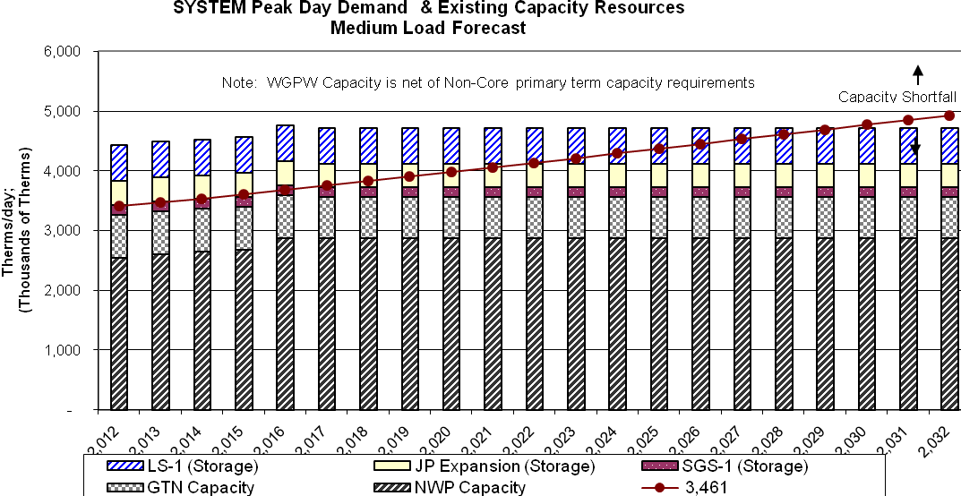
Figure 7-B-1

Figure 7-B-2
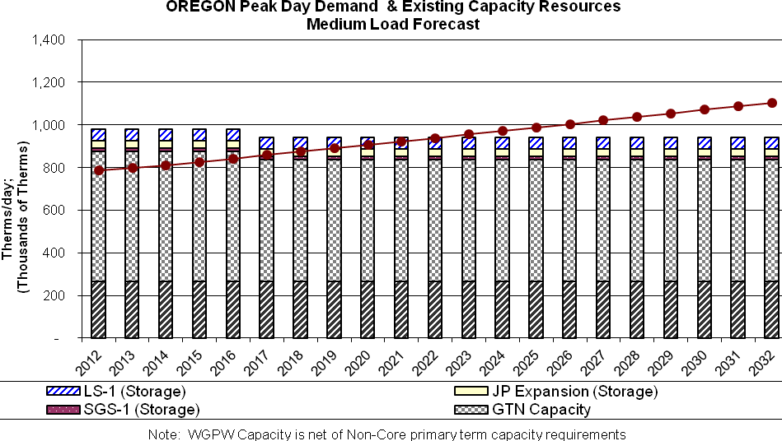

Figure 7-B-3
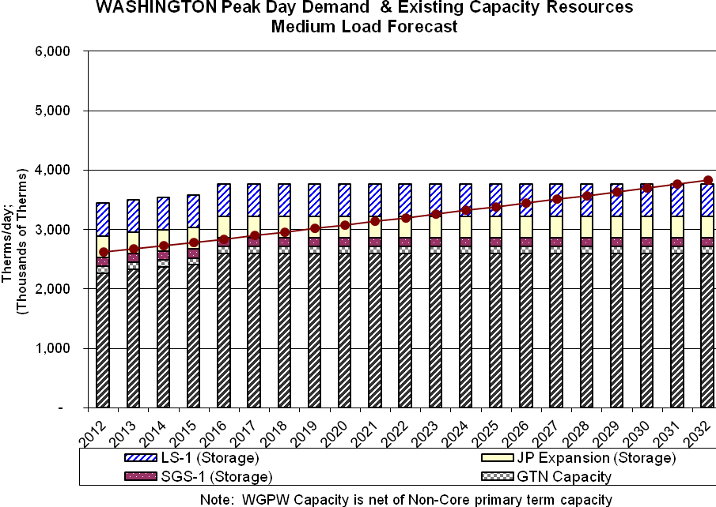

For modeling purposes, the company included several capacity alternatives to meet peak planning needs. Based on the analysis, peak day requirements will be met through a blend of resources. For purposes of the graphical depiction, the company has shown the incremental conservation resources as a capacity resource. As shown in Figures 7-C-1 through 7-C-3, incremental pipeline capacity on NWP, GTN, along with a combination of citygate peaking, Ruby and satellite LNG alternatives will be used to meet growing peak requirements.

FIGURE 7-C-1
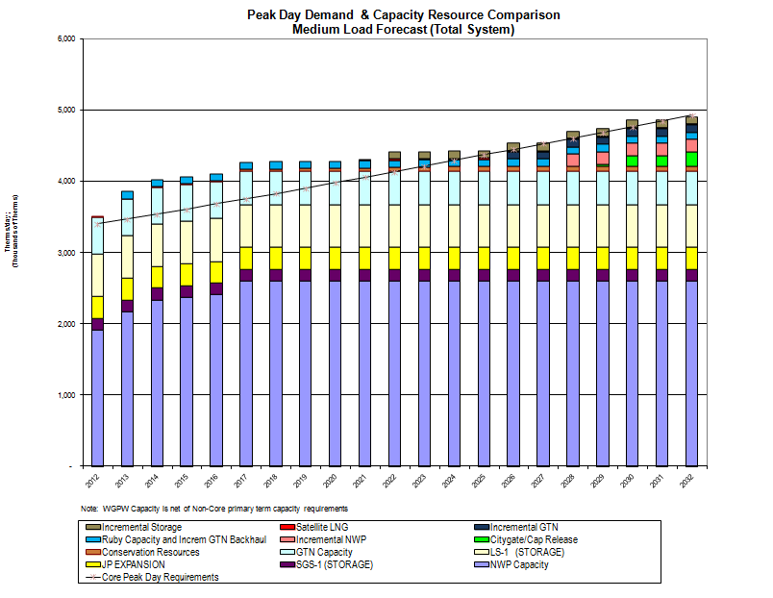
FIGURE 7-C-2
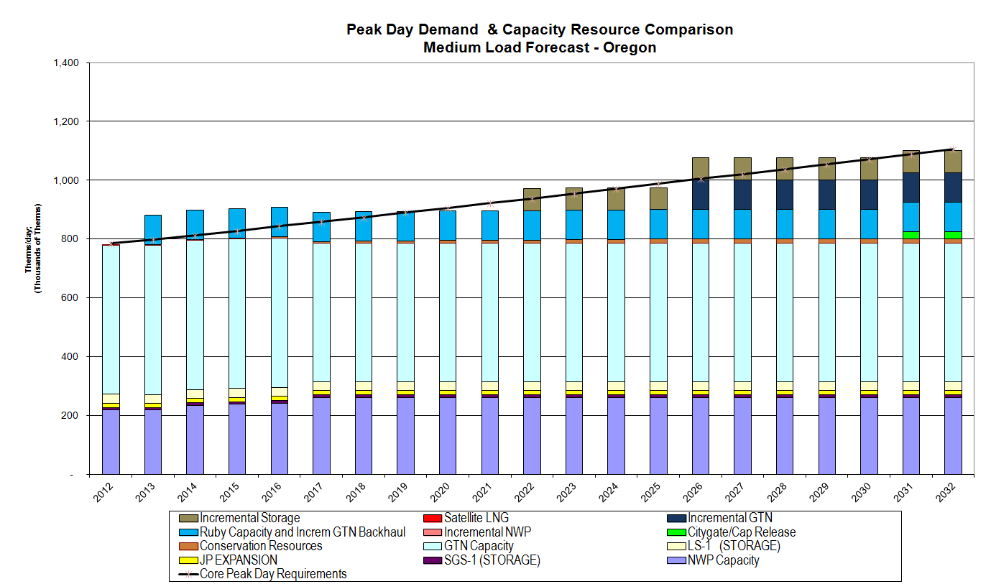

FIGURE 7-C-3

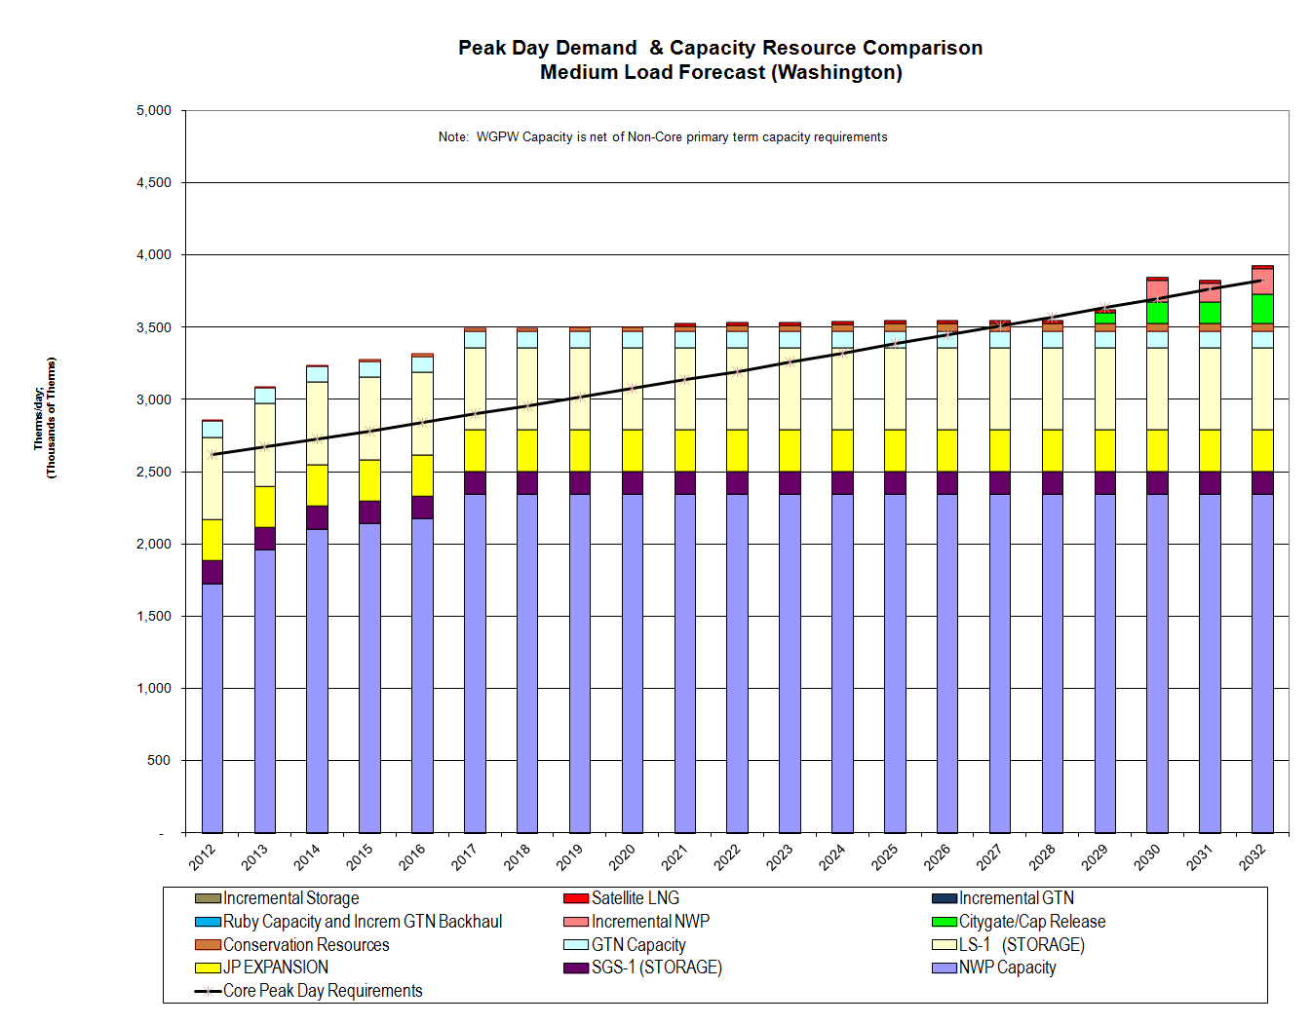

Annual Load Requirements and Weather Uncertainty
The annual load requirements will vary dramatically based on the weather assumptions.
Through the use of SENDOUT™ Monte-Carlo functionality, the company has the ability to analyze the impacts of weather on its load forecast. Figure 7-D shows the overall expected range of the load forecasts, before considering load reductions that can be achieved through incremental conservation programs. The chart provides the upper parameter, which is based on the assumption that the high load growth forecast occurs, with the lower parameter occurring under the low load growth forecast. Capturing the uncertainty around the medium load growth forecast was accomplished through SENDOUT™’s Monte-Carlo functionality. The Monte-Carlo simulation performed 200 draws, with each draw calculating the monthly load based on the weather as randomly determined by the model for each of the weather zones. Figure 7-E provides a more in depth look at the medium scenario results. The absolute maximum and absolute minimum amounts depict the minimum or maximum system demand from the 200 draws for a particular year. The absolute maximum/minimum does not represent any single results for the 20 year planning horizon.

Figure 7-D

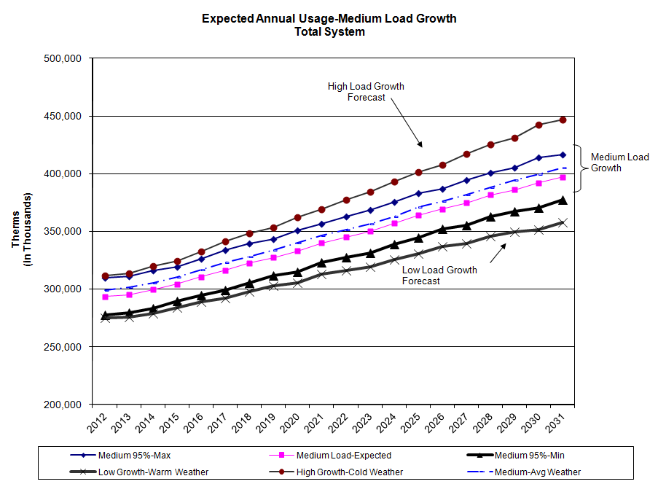

FIGURE 7-E

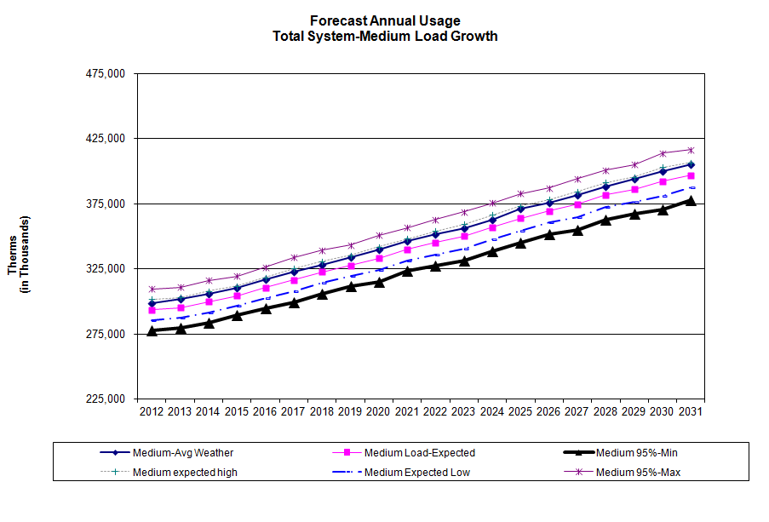
Additional tables and graphical analyses summarizing the weather and its impact on the annual load forecast are included in Appendix G-1.

To meet this demand, the company will need to acquire a blend of gas supply and conservation resources. For purposes of this plan, the company has estimated the level of conservation that is achievable over the course of the planning horizon which was discussed at length in Section 6. Figure 7-F shows how the company anticipates meeting the projected load over the planning horizon under the basecase scenario. Variations in the portfolio in order to meet actual load requirements during any year will occur primarily through the purchase of just-in-time, or spot gas purchases.

FIGURE 7-F
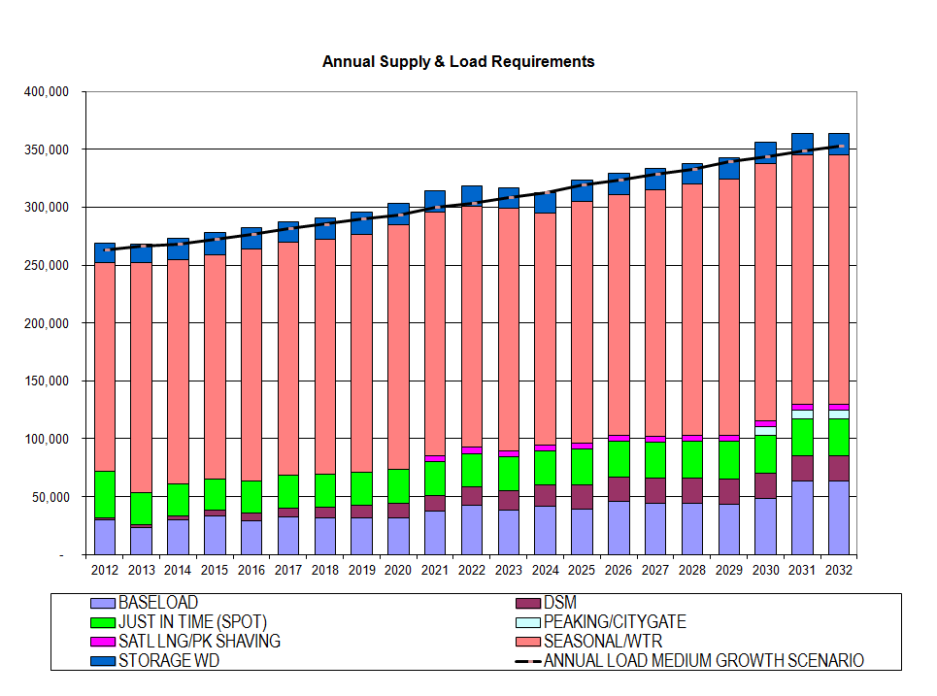

Impacts of Price Uncertainty and Overall System Costs
The ability to accurately forecast long-term gas prices is influenced by two different types of uncertainty: uncertainty related to long-term changes in the industry and uncertainty related to short-term gas price variability. Contributing to long-term uncertainty are long term supply and demand issues, including growth in demand for electric generation, changes in LNG import infrastructure, possible pipelines to bring Alaskan and other frontier gas supplies to market. Short-term price variability also affects the long-term predictability of gas prices. Even if long-term supply and demand outcomes are exactly as projected, actual prices in future months will still reflect variability due to short-term market conditions. In order to estimate this uncertainty, the Company utilized SENDOUT’s™ Monte-Carlo functionality, to analyze the impacts of price on the portfolio costs. Since natural gas is becoming more of a national market, the company believes that volatility in the NYMEX prices will have a far larger influence on the portfolio’s price volatility compared to the volatility in the AECO, Sumas and Rocky Mountain basin differentials.

Figure 7-G shows the overall expected range of the NYMEX prices over the planning horizon. The absolute maximum and absolute minimum amounts depicts the minimum amount or maximum amount from the 200 draws for a particular year. The Absolute maximum/minimum does not represent any single draw result for the 20 year planning horizon.

FIGURE 7-G
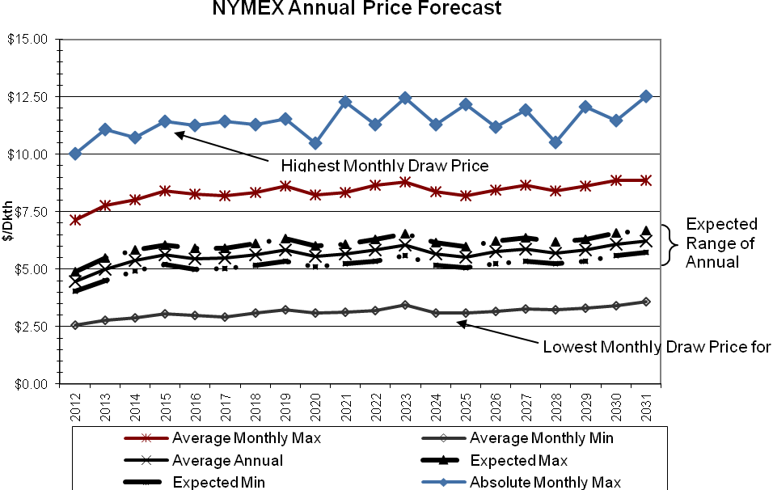

Figure 7-H compares the expected range of NYMEX prices from the Monte-Carlo analysis including the Environmental Externality costs that were discussed in Section 6. The highest anticipated NYMEX prices would result if the Scenario 3 Carbon Cost Adder was implemented in 2011. In that scenario, Carbon Cost Adder would increase the baseline forecasts by $1.85/dkth beginning in the first year, ramping up to $4.38/dkth over the 20 year planning horizon. Further tables and graphical analyses summarizing the pricing simulations are included in Appendix G-2.
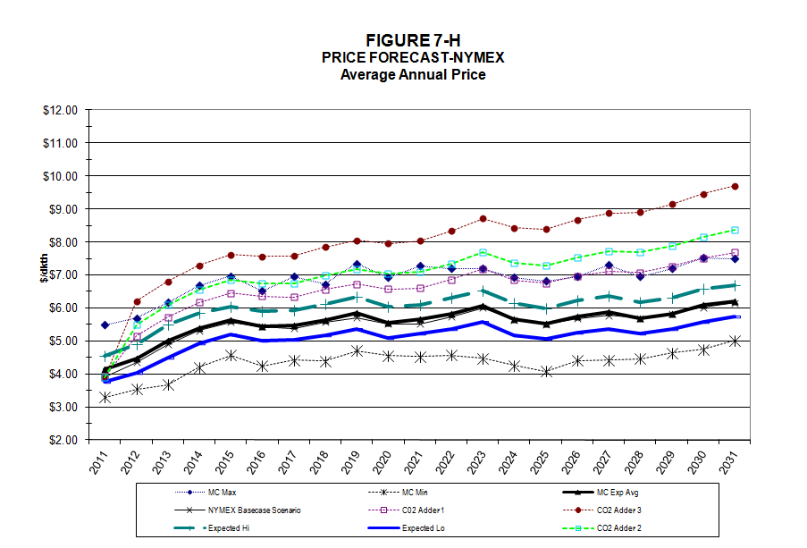

Table 7-5 summarizes the Net Present Value of the 20-year portfolio costs and average cost per therm for each of the scenarios and includes the anticipated range of costs from the Monte-Carlo modeling.

TABLE 7-5

 | NPV 20-Yr Portfolio Costs in $000's | Average Cost Per Therm
Scenario Results:
Basecase Scenario | $ 2,422,033 | $ 0.3428
High Load Growth | $ 2,881,269 | $ 0.3747
Low Load Growth | $ 2,276,711 | $ 0.3223
Environmental Externalities Case 1 | $ 2,358,400 | $ 0.3622
Environmental Externalities Case 2 | $ 2,829,140 | $ 0.4005
Environmental Externalities Case 3 | $ 2,666,852 | $ 0.3775
Simulation Results:
Monte-Carlo Average | $ 2,442,229 | $ 0.3666
Monte-Carlo Expected High | $ 2,811,113 | $ 0.4115
Monte-Carlo Expected Low | $ 2,152,417 | $ 0.3319

Based on the basecase results, Cascade has calculated its avoided costs. Cascade’s avoided cost estimates represent the marginal cost of natural gas usage incremental to the forecasted demand. In other words, avoided cost is the unit cost to serve the next unit of demand during any given period of time. If demand-side management measures reduce customer demand, the Company is able to “avoid” certain commodity and transportation costs. This concept is important to assessing the proper value to demand-side management efforts. As discussed in Section 6, when calculating the avoided cost figures, the company includes an incremental cost advantage for conservation resources to recognize the non-quantifiable benefits associated with conservation such as price certainty and hedge value against future carbon costs.

Two-year Action Plan

Prior IRP Action Plan and Progress Review
Cascade filed its last Integrated Resource Plan in December 2010. Since that time, Cascade has made significant progress in meeting its 2-Year Action Plan. Appendix I includes the detailed Two-year Action Plan along with a description of the Company’s progress on each of the items.

2012 Action Plan
Cascade’s 2012 Action Plan continues to focus on the following five areas:
• Demand Forecasting
• Distribution System Constraint Analysis
• Demand Side Resources
• Supply Side Resources
• Integration

The 2 year action plan embodies Cascade's commitment to maximizing the efficiency from its Integrated Resource Plan and to achieving the lowest cost resource portfolio of reliable natural gas services and conservation.

1. In continuing efforts to create a more accurate load forecast, Cascade will research the viability of expanding the detail of the data by determining therm usage per customer per degree day by customer class (residential, commercial, etc.) along with the non-heat sensitive baseload usage. This is largely dependent upon the capabilities of the Company’s new Customer Information System which came on-line in July 2010. We are continuing to work toward generating reports and data extracts from the new system to improve the forecast process.

2. Cascade will continue to monitor outside determinants of natural gas usage, such as legislative building code changes and electrical “Direct Use” campaigns as
they are determined to significantly affect the Company’s forecast.

3. Cascade will continue to monitor the effectiveness of the Oregon Public Purpose Fund to ensure the funds are adequate to capture significant portions of achievable therm savings in Oregon.

4. The company will continue to follow and analyze the impacts of the Western Climate Initiative and proposed carbon legislation at both the state and federal level as they pertain to natural gas conservation, as well as other such acts that may arise from these efforts. The company will continue to monitor the timing and the costs associated with carbon legislation and analyze the impacts on the company’s overall portfolio costs. As specific carbon legislation is passed, the company will update its avoided cost calculations, conservation potential and make modifications to its DSM incentive programs as necessary.

5. The company will continue to monitor the cost effectiveness of existing conservation measures and emerging technologies to ensure that the current mix of measures included in the Washington Conservation program is appropriate. Areas for further analysis include the impacts associated with modifications to building codes along with the cost effectiveness of newer technologies such as the next generation of high efficiency water heaters (.70 EF) and high-efficiency hybrid heat pumps. The applicability of these measures within Cascade’s service territory will be analyzed and the company’s Conservation Incentive Program will be modified as necessary.

6. The Company will continue to monitor the potential reporting, administrative and potential financial impacts of long term resources as a result of concerns surrounding fracking. In particular we are awaiting the EPA to reveal the results of their current study in alleged water contamination found in Wyoming as result of fracking activities.

7. Cascade will continue to evaluate gas supply resources on an ongoing basis including supplies of varying lengths (base, swing, peaking) and pricing alternatives. We will continue to analyze the uncertainties associated with supply and demand relationships.

8. The Company will continue to monitor the proposed pipeline expansion projects to access more supplies out of the Rockies. As cost estimates change, the company will analyze those resources under consideration to determine if modifications to the preferred portfolio are necessary.

9. Continue to refine our specific peak day resource acquisition action plans to address anticipated capacity shortfalls. Possible solutions may be Satellite LNG, peak shaving facilities or pipeline looping to meet the growing requirements of the firm core load. Specifically, the Company will further analyze issues such as determination of project location issues and risks, project cost estimates, and construction/acquisition lead times.

10. The Company will continue to explore options to incorporate biogas into its portfolio, as specific projects are identified in our service territory. Price, location and gas quality considerations of the biogas supply will be evaluated.

11. The Company will continue to monitor proposed LNG import facilities as information becomes available and will evaluate the various options that, if built, could result. Issues to monitor include specific cost, the availability of pipeline capacity and project timing.

12. The Company will continue to monitor the futures market for price trends and will evaluate the effectiveness of its risk management policy. Implementation of Dodd- Frank in the coming year raises potential administrative challenges from a reporting

standpoint; additionally it is unknown how the costs associated with the use of clearinghouses might impact price of natural gas in the future.

GLOSSARY OF TERMS AND ACRONYMS

ACEEE
American Council for an Energy-Efficient Economy.

ACHIEVABLE POTENTIAL
Represents a realistic assessment of expected energy savings recognizing and accounting for economic and other constraints that preclude full installation of every identified conservation measure.

AECO INDEX
Alberta Canada natural gas trading price.

AFUE
Thermal efficiency measure of combustion equipment like furnaces, boilers, and water heaters.

ANNUAL MEASURES
Conservation measures that achieve generally uniform year round energy savings independent of weather temperature changes. Annual measures are also often called base load measures.

ARRA
The American Recovery and Reinvestment Act of 2009.

BACKHAUL SERVICE
A transaction where gas is transported the opposite direction of normal flow on a unidirectional pipeline.

BASELOAD
As applied to natural gas, a given demand for natural gas that remains fairly constant over a period of time, usually not temperature sensitive.

BASE LOAD MEASURES
Conservation measures that achieve generally uniform year round energy savings independent of weather temperature changes. Base load measures are also often called annual measures.

BNG
Bio natural gas and typically refers to a gas produced by the biological breakdown of organic matter in the absence of oxygen.

BRITISH THERMAL UNIT (BTU)
The amount of heat required to raise the temperature of one pound of pure water one degree Fahrenheit under stated conditions of pressure and temperature; a therm (see below) of natural gas has an energy value of 100,000 BTUs and is approximately equivalent to 100 cubic feet of natural gas.

CD
Contract Demand

CITY GATE (ALSO KNOWN AS GATE STATION OR PIPELINE DELIVERY POINT)
The point at which natural gas deliveries transfer from the interstate pipelines to Cascade’s distribution system

CNG
Compressed Natural Gas

CNGC
Cascade Natural Gas Corporation

COMPRESSION
Increasing the pressure of natural gas in a pipeline by means of a mechanically driven compressor station to increase flow capacity.

COMPRESSOR
Equipment which pressurizes gas to keep it moving through the pipelines.

CONSERVATION MEASURES
Installations of appliances, products or facility upgrades that result in energy savings.

CONTRACT DEMAND
The maximum daily, monthly, seasonal or annual quantities of natural gas, which the supplier agrees to furnish, or the pipeline agrees to transport, and for which the buyer or shipper agrees to pay a demand charge.

CORE CUSTOMERS
Residential, firm industrial and commercial gas customers who require utility gas service.

COST EFFECTIVNESS
The determination of whether the present value of the therm savings for any given conservation measure is greater than the cost to achieve the savings.

CPI
Consumer Price Index, as calculated and published by the U.S. Department of Labor, Bureau of Labor Statistics

DEKATHERM
Unit of measurement for natural gas; a dekatherm is 10 therms, which is one thousand cubic feet (volume) or one million BTUs (energy).

DEMAND‐SIDE MANAGEMENT (DSM)
The activity pursued by an energy utility to influence its customers to reduce their energy consumption or change their patterns of energy use away from peak consumption periods.

DEMAND‐SIDE RESOURCES
Energy resources obtained through assisting customers to reduce their "demand" or use of natural gas. Also represents the aggregate energy savings attained from installation of conservation measures.

DSM
Demand-Side Management

DTH
Unit of measurement for natural gas; a dekatherm is 10 therms, which is one thousand cubic feet (volume) or one million BTUs (energy).

EIA
Energy Information Administration

EXTERNALITIES
Cost and benefits that are not reflected in the price paid for goods or services.

FEDERAL ENERGY REGULATORY COMMISSION (FERC)
The government agency charged with the regulation and oversight of interstate natural gas pipelines, wholesale electric rates and hydroelectric licensing; the FERC regulates the interstate pipelines with which Cascade does business and determines rates charged in interstate transactions.

FERC
Federal Energy Regulatory Commission

FIRM SERVICE OR FIRM TRANSPORTATION
Service offered to customers under schedules or contracts that anticipate no interruptions; the highest quality of service offered to customers.

FORCE MAJEURE
An unexpected event or occurrence not within the control of the parties to a contract, which alters the application of the terms of a contract; sometimes referred to as "an act of God;" examples include severe weather, war, strikes, pipeline failure and other similar events.

GAS TRANSMISSION NORTHWEST (GTN)
A subsidiary of TransCanada Pipeline which owns and operates a natural gas pipeline that runs from the Canada/USA border to the Oregon/California border. One of the six natural gas pipelines Cascade transacts with directly.

GHG
Greenhouse Gas

GTN
Gas Transmission Northwest

HEATING DEGREE DAY (HDD)
A measure of the coldness of the weather experienced, based on the extent to which the daily average temperature falls below 65 degrees Fahrenheit; a daily average temperature represents the sum of the high and low readings divided by two.

HENRY HUB
The physical location found in Louisiana that is widely recognized as the most important pricing point in the United States. It is also the trading hub for the New York Mercantile Exchange (NYMEX).

INJECTION
The process of putting natural gas into a storage facility; also called liquefaction when the storage facility is a liquefied natural gas plant.

INTERRUPTIBLE SERVICE
A service of lower priority than firm service offered to customers under schedules or contracts that anticipate and permit interruptions on short notice; the interruption happens when the demand of all firm customers exceeds the capability of the system to continue deliveries to all of those customers.

INTERSTATE PIPELINE
A federally regulated company that transports and/or sells natural gas across state lines.

IOU
Investor owned utility.

IRP
Integrated Resource Plan; the document that explains Cascade’s plans and preparations to maintain sufficient resources to meet customer needs at a reasonable price.

JACKSON PRAIRIE
An underground storage project jointly owned by Avista Corp., Puget Sound Energy, and NWP; the project is a naturally occurring aquifer near Chehalis, Washington, which is located some 1,800 feet beneath the surface and capped with a very thick layer of dense shale.

LIQUEFIED NATURAL GAS (LNG)
Natural gas that has been liquefied by reducing its temperature to minus 260 degrees Fahrenheit at atmospheric pressure.

LINEAR PROGRAMMING
A mathematical method of solving problems by means of linear functions where the multiple variables involved are subject to constraints; this method is utilized in the SENDOUT® Gas Model.

LNG
Liquefied natural gas. Natural gas that has been liquefied by chilling. It is liquefied to reduce its volume and thereby facilitate bulk storage and transport.

LOAD FACTOR
The average load of a customer, a group of customers, or an entire system, divided by the maximum load; can be calculated over any time period.

LOAD FORECAST
A forecast, an estimate, or a prediction of how much gas will be needed for residences, companies, and other institutions in the future.

LOAD MANAGEMENT
Seek to lower peak demand during specific, limited time periods by temporarily curtailing usage or shifting usage to other time periods. Load management reduces system peak demand very well, but can have little or no effect on total energy use. Its effects are temporary and of short duration.

LOAD PROFILE
Pattern of a customer’s gas usage, hour to hour, day to day, or month to month.

LOOPING
The construction of a second pipeline parallel to an existing pipeline over the whole or any part of its length, thus increasing the capacity of that section of the system.

MCF
A unit of volume equal to a thousand cubic feet.

MDDO
Maximum Daily Delivery Obligation

MDQ
Maximum Daily Quantity

MONTE CARLO ANALYSIS
A type of stochastic mathematical simulation which randomly and repeatedly samples input distributions (e.g. reservoir properties) to generate a results distribution.

MOU
Memorandum of understanding.

NAESB
North American Energy Standards Board.

NATIONAL ENERGY BOARD
The Canadian equivalent to the Federal Energy Regulatory Commission (FERC).

NATURAL GAS
A naturally occurring mixture of hydrocarbon and non-hydrocarbon gases found in porous geologic formations beneath the earth's surface, often in association with petroleum; the principal constituent is methane, and it is lighter than air.

NEEDLE PEAKING RESOURCE
Utilized during severe or “arctic” cold weather.

NEPA
National Environmental Policy Act

NEW YORK MERCANTILE EXCHANGE (NYMEX)
An organization that facilitates the trading of several commodities including natural gas.

NGV
Natural Gas Vehicles

NOMINATION
The scheduling of daily natural gas requirements.

NON-COINCIDENT PEAK
The sum of two or more peak loads on individual systems that do not occur in the same time interval. Meaningful only when considering loads within a limited period of time, such as a day, week, month, a heating or cooling season, and usually for not more than 1 year.

NON-CORE CUSTOMER
Large customers who contract with a third party for supply and upstream pipeline capacity. Cascade provides distribution services., Typical customers include large commercial, industrial, cogeneration, wholesale, and electric generation customers.

NORTHWEST PIPELINE CORPORATION (NWP)
A principal interstate pipeline serving the Pacific Northwest and one of six natural gas pipelines Cascade transacts with directly. NWP is a subsidiary of The Williams Companies and is headquartered in Salt Lake City, Utah.

NORTHWEST POWER PLANNING COUNCIL
Consist of two members from each of the four Northwest states, Oregon, Washington, Idaho and Montana, to develop a regional plan.

NOVA GAS TRANSMISSION (NOVA)
See TransCanada Alberta System

NWBOP
Northwest Builder Option Packages

NWP
Williams-Northwest Pipeline

NYMEX
New York Mercantile Exchange

NYMEX HH
New York Mercantile Exchange Henry Hubb

OEESC
Oregon Energy Efficiency Specialty Code

OFF-SYSTEM
Any point not on or directly interconnected with a transportation, storage, and/or distribution system operated by a natural gas company within a state.

OLIEC
Oregon Low Income Energy Conservation

ON SITE
At the point of injection.

OPUC
Oregon Public Utility Commission

ORSC
Oregon Residential Specialty Code

PASCAL
The SI unit of pressure, equal to one Newton per square meter.

PEAK DAY
The greatest total natural gas demand forecasted in a 24-hour period used as a basis for planning peak capacity requirements.

ORSC
Oregon Residential Specialty Code

PASCAL
The SI unit of pressure, equal to one Newton per square meter.

REAL
Discounting method that excludes inflation.

REGASIFICATION RESOURCE
Process by which LNG is heated, converting it to a gaseous state. Designed for vaporizing LNG where and when it will be used.

RENEWABLE FUEL
A power source that is continuously or cyclically renewed by nature, i.e. solar, wind, hydroelectric, geothermal, biomass or similar sources of energy.

SATELLITE LNG FACILITIES
A facility for storing and vaporizing LNG to meet relatively modest demands at remote locations or to meet short-term peak demands. LNG is usually trucked to such facilities.

SEASONAL PEAKING SERVICE
The delivery of gas, firm or interruptible, sold only during certain times of the year, generally when there are not high system demands.

SENDOUT®
Natural gas planning system from Ventyx; a linear programming model used to solve gas supply and transportation optimization questions.

SERVICE TERRITORY
Territory in which a utility system is required or has the right to provide natural gas service to ultimate customers.

SPOT MARKET GAS
Natural gas purchased under short-term agreements as available on the open market; prices are set by market pressure of supply and demand.

STANDBY
Support service that is available, as needed, to supplement a consumer, a utility system or to another utility to replace normally scheduled power that becomes unavailable.

STORAGE
The utilization of facilities for storing natural gas which has been transferred from its original location for the purposes of serving peak loads, load balancing and the optimization of basis differentials; the facilities are usually natural geological reservoirs such as depleted oil or natural gas fields or water-bearing sands sealed on the top by an impermeable cap rock; the facilities may be man-made or natural caverns. LNG storage facilities generally utilize above ground insulated tanks.

SWAP
Parties agree to exchange an index price for a fixed price over a defined period

TARIFF
A published volume of regulated rate schedules plus general terms and conditions under which a product or service will be supplied.

TECHNICAL ADVISORY GROUP (TAG)
Industry, customer and regulatory representatives that advise Cascade during the IRP planning process.

TECHNICAL POTENTIAL
An estimate of all energy savings that could theoretically be accomplished if every customer that could potentially install a conservation measure did so without consideration of market barriers such as cost and customer awareness.

THERM
A unit of heating value used with natural gas that is equivalent to 100,000 British thermal units (BTU); also approximately equivalent to 100 cubic feet of natural gas.

THROUGHPUT
The total of all natural gas volume moved through a pipeline system, including sales, company use, storage, transportation and exchange.

TRANSCANADA ALBERTA SYSTEM
Previously known as NOVA Gas Transmission; a natural gas gathering and transmission corporation in Alberta that delivers natural gas into the TransCanada BC System pipeline at the Alberta/British Columbia border; one of six natural gas pipelines Cascade transacts with directly.

TRANSCANADA BC SYSTEM
Previously known as Alberta Natural Gas; a natural gas transmission corporation of British Columbia that delivers natural gas between the TransCanada-Alberta System and GTN pipelines that runs from the Alberta/British Columbia border to the United States border; one of six natural gas pipelines Cascade transacts with directly.

TRANSPORTATION GAS
Natural gas purchased either directly from the producer or through a broker and is used for either system supply or for specific end-use customers, depending on the transportation arrangements; NWP and GTN transportation may be firm or interruptible.

TRC
Total Resource Cost

TSA
Transportation Service Agreement

TURN-BACK CAPACITY
When natural gas shippers, upon expiration of their contract(s) for pipeline capacity do not renew capacity rights, in whole or in part, with the original pipeline.

UPSTREAM PIPELINE CAPACITY
The pipeline delivering natural gas to another pipeline at an interconnection point where the second pipeline is closer to the consumer.

VECTORGASTM
Add-in product to the SENDOUT™ model that facilitates the ability to model gas price and load uncertainty (driven by weather) into the future. VECTORGASTM utilizes a Monte Carlo approach in combination with the linear programming approach in SENDOUT™.

WINTER GAS SUPPLIES
Gas supply purchased for all or part of the heating season.

WITHDRAWAL
The process of removing natural gas from a storage facility, making it available for delivery into the connected pipelines; vaporization is necessary to make withdrawals from an LNG plant.

ZONE
A geographical area. A geological zone, however, means an interval of strata of the geologic column that has distinguishing characteristics from surrounding strata.

ZONE - IRP
For modeling purposes, Cascade’s distribution system is divided into several zones. These zones are generally based on where the upstream pipelines have major compressor stations, have been historical upstream pipeline constraint or in specific weather areas. Where appropriate the Zone-IRP is separated by state. Please see the following chart that references the citygate/location to the appropriate IRP zone.

ZONE/GATE LOCATION (sorted by gate/location)
DESCRIPTION | METER | ZONEID | PIPELINE
7TH DAY ADVENTIST FARM TAP | ADVENSCH | ZONE 10 | NWP
A & M RNDERING | AMRENDER | ZONE 30-W | NWP
A&W FEED LOT FARM TAP | AWFEED | ZONE 20 | NWP
ABERDEEN/HOQUIAM/MCCLEARY | ABRNDHOQ | ZONE 30-S | NWP
ACME | ACME | ZONE 30-W | NWP
ALCOA, WENATCHEE | ALCOA | ZONE 11 | NWP
ARLINGTON | ARLINGTN | ZONE 30-W | NWP
ATHENA/WESTON | ATHENA | ZONE ME-OR | NWP
BAKER | BAKER | ZONE 24 | NWP
BELLINGHAM II | BLLINGII | ZONE 30-W | NWP
BELLINGHAM/FERNDALE | BLHAM | ZONE 30-W | NWP
BEND TAP | BEND | ZONE GTN | GTN
BREMERTON (SHELTON) | BREMERTON | ZONE 30-S | NWP
BRULOTTE HOP RANCH | BRULOTTE | ZONE 10 | NWP
BURBANK HEIGHTS | BURBANKH | ZONE 20 | NWP
CASTLE ROCK | CASTLERK | ZONE 26 | NWP
CHEMCIAL LIME | CHEMLIME | ZONE 24 | NWP
CHEMULT | CHEM | ZONE GTN | GTN
DEHANNS DAIRY FARM TAP | DEHANDRY | ZONE 10 | NWP
DEMING | DEMING | ZONE 30-W | NWP
FINLEY | FINLEY | ZONE 20 | NWP
GILCHRIST TAP | GILC | ZONE GTN | GTN
GRANDVIEW | GRDVEW | ZONE 10 | NWP
GREEN CIRCLE FARM TAP | GRENCIRL | ZONE 26 | NWP
HERMISTON | HERMSTON | ZONE ME-OR | NWP
HUNTINGTON | HTINGTON | ZONE 24 | NWP
KALAMA FARM TAP | KALAMA | ZONE 26 | NWP
KALAMA NO. 2 | KALAMA2 | ZONE 26 | NWP
KAWECKI, WENATCHEE | KAWECKI | ZONE 11 | NWP
KENNEWICK | KENEWICK | ZONE 20 | NWP
KOMOS FARMS TAP | KOMO | ZONE GTN | GTN
LA PINE TAP | LAPI | ZONE GTN | GTN
LAMBERT'S HORTICULTURE | LAMBERTS | ZONE 10 | NWP
LAWRENCE | LAWRENCE | ZONE 30-W | NWP
LDS CHURCH FARM TAP | LDSCHURC | ZONE 30-W | NWP
LONGVIEW-KELSO | LONGVIEW | ZONE 26 | NWP
LYNDEN | LYNDEN | ZONE 30-W | NWP
MADRAS TAP | MADR | ZONE GTN | GTN
MENAN STARCH | MEMANSTR | ZONE 20 | NWP
MILTON FREEWATER | MILFREE | ZONE ME-OR | NWP
MISSION TAP | MISSION | ZONE ME-OR | NWP
MOSES LAKE | MOS LAKE | ZONE 20 | NWP
MOUNT VERNON | MTVERNON | ZONE 30-W | NWP
MOXEE CITY | MOXEE | ZONE 11 | NWP
NORTH BEND | NBEND | ZONE GTN | GTN
NORTH PASCO METER STATION | NPASCO | ZONE 20 | NWP
NYSSA-ONTARIO | NYSSA | ZONE 24 | NWP
OAK HARBOR/STANWOOD | OAKHAR | ZONE 30-W | NWP
OTHELLO | OTHELLO | ZONE 20 | NWP
PASCO | PASCO | ZONE 20 | NWP
PATERSON | PATERSON | ZONE 26 | NWP
PENDLETON | PENDLETN | ZONE ME-OR | NWP
PLYMOUTH | PLYMTH | ZONE 20 | NWP
PRINEVILLE TAP | PRVL | ZONE GTN | GTN
PRONGHORN TAP | PRONGHORN | ZONE GTN | GTN
PROSSER | PROSSER | ZONE 10 | NWP
QUINCY | QUINCY | ZONE 11 | NWP
REDMOND TAP | REDM | ZONE GTN | GTN
RICHLAND | RICHLAND | ZONE 20 | NWP
SANDVIK, KENNEWICK | SANDVIK | ZONE 20 | NWP
SEDRO/WOOLLEY ET AL. | SEDRO | ZONE 30-W | NWP
SELAH | SELAH | ZONE 11 | NWP
SOUTH BEND | S BEND | ZONE GTN | GTN
SOUTH HERMISTON TAP | SHRM | ZONE GTN | GTN
SOUTH LONGVIEW FIBRE | SOLONG | ZONE 26 | NWP
STANFIELD CITY TAP | STTAP | ZONE GTN | GTN
STEARNS TAP | STEA | ZONE GTN | GTN
SUMAS, CITY OF | SUMASC | ZONE 30-W | NWP
SUNNYSIDE | SUNSIDE | ZONE 10 | NWP
TOPPENISH ET AL. (ZILLAH) | TOPENISH | ZONE 10 | NWP
U & I SUGAR, MOSES LAKE | UI SUGAR | ZONE 20 | NWP
UMATILLA | UMATILLA | ZONE ME-WA | NWP
WALLA WALLA | WALLA | ZONE ME-WA | NWP
WENATCHEE | WENATCHE | ZONE 11 | NWP
WOODLAND WA | WOODLAND | ZONE 26 | NWP
YAKIMA CHIEF FARMS | YAKCHFRM | ZONE 11 | NWP
YAKIMA FIRING CENTER | YAKFIRCR | ZONE 11 | NWP
YAKIMA/UNION GAP | YAKIMA | ZONE 11 | NWP

ZONE/GATE LOCATION (sorted by IRP Zone)

DESCRIPTION | METER | ZONEID | PIPELINE
7TH DAY ADVENTIST FARM TAP | ADVENSCH | ZONE 10 | NWP
BRULOTTE HOP RANCH | BRULOTTE | ZONE 10 | NWP
DEHANNS DAIRY FARM TAP | DEHANDRY | ZONE 10 | NWP
GRANDVIEW | GRDVEW | ZONE 10 | NWP
LAMBERT'S HORTICULTURE | LAMBERTS | ZONE 10 | NWP
PROSSER | PROSSER | ZONE 10 | NWP
SUNNYSIDE | SUNSIDE | ZONE 10 | NWP
TOPPENISH ET AL. (ZILLAH) | TOPENISH | ZONE 10 | NWP
ALCOA, WENATCHEE | ALCOA | ZONE 11 | NWP
KAWECKI, WENATCHEE | KAWECKI | ZONE 11 | NWP
MOXEE CITY | MOXEE | ZONE 11 | NWP
QUINCY | QUINCY | ZONE 11 | NWP
SELAH | SELAH | ZONE 11 | NWP
WENATCHEE | WENATCHE | ZONE 11 | NWP
YAKIMA CHIEF FARMS | YAKCHFRM | ZONE 11 | NWP
YAKIMA FIRING CENTER | YAKFIRCR | ZONE 11 | NWP
YAKIMA/UNION GAP | YAKIMA | ZONE 11 | NWP
A&W FEED LOT FARM TAP | AWFEED | ZONE 20 | NWP
BURBANK HEIGHTS | BURBANKH | ZONE 20 | NWP
FINLEY | FINLEY | ZONE 20 | NWP
KENNEWICK | KENEWICK | ZONE 20 | NWP
MENAN STARCH | MEMANSTR | ZONE 20 | NWP
MOSES LAKE | MOS LAKE | ZONE 20 | NWP
NORTH PASCO METER STATION | NPASCO | ZONE 20 | NWP
OTHELLO | OTHELLO | ZONE 20 | NWP
PASCO | PASCO | ZONE 20 | NWP
PLYMOUTH | PLYMTH | ZONE 20 | NWP
RICHLAND | RICHLAND | ZONE 20 | NWP
SANDVIK, KENNEWICK | SANDVIK | ZONE 20 | NWP
U & I SUGAR, MOSES LAKE | UI SUGAR | ZONE 20 | NWP
BAKER | BAKER | ZONE 24 | NWP
CHEMCIAL LIME | CHEMLIME | ZONE 24 | NWP
HUNTINGTON | HTINGTON | ZONE 24 | NWP
NYSSA-ONTARIO | NYSSA | ZONE 24 | NWP
CASTLE ROCK | CASTLERK | ZONE 26 | NWP
GREEN CIRCLE FARM TAP | GRENCIRL | ZONE 26 | NWP
KALAMA FARM TAP | KALAMA | ZONE 26 | NWP
KALAMA NO. 2 | KALAMA2 | ZONE 26 | NWP
LONGVIEW-KELSO | LONGVIEW | ZONE 26 | NWP
PATERSON | PATERSON | ZONE 26 | NWP
SOUTH LONGVIEW FIBRE | SOLONG | ZONE 26 | NWP
WOODLAND WA | WOODLAND | ZONE 26 | NWP
ABERDEEN/HOQUIAM/MCCLEARY | ABRNDHOQ | ZONE 30-S | NWP
BREMERTON (SHELTON) | BREMERTON | ZONE 30-S | NWP
A & M RNDERING | AMRENDER | ZONE 30-W | NWP
ACME | ACME | ZONE 30-W | NWP
ARLINGTON | ARLINGTN | ZONE 30-W | NWP
BELLINGHAM II | BLLINGII | ZONE 30-W | NWP
BELLINGHAM/FERNDALE | BLHAM | ZONE 30-W | NWP
DEMING | DEMING | ZONE 30-W | NWP
LAWRENCE | LAWRENCE | ZONE 30-W | NWP
LDS CHURCH FARM TAP | LDSCHURC | ZONE 30-W | NWP
LYNDEN | LYNDEN | ZONE 30-W | NWP
MOUNT VERNON | MTVERNON | ZONE 30-W | NWP
OAK HARBOR/STANWOOD | OAKHAR | ZONE 30-W | NWP
SEDRO/WOOLLEY ET AL. | SEDRO | ZONE 30-W | NWP
SUMAS, CITY OF | SUMASC | ZONE 30-W | NWP
BEND TAP | BEND | ZONE GTN | GTN
CHEMULT | CHEM | ZONE GTN | GTN
GILCHRIST TAP | GILC | ZONE GTN | GTN
KOMOS FARMS TAP | KOMO | ZONE GTN | GTN
LA PINE TAP | LAPI | ZONE GTN | GTN
MADRAS TAP | MADR | ZONE GTN | GTN
NORTH BEND | NBEND | ZONE GTN | GTN
PRINEVILLE TAP | PRVL | ZONE GTN | GTN
PRONGHORN TAP | PRONGHORN | ZONE GTN | GTN
REDMOND TAP | REDM | ZONE GTN | GTN
SOUTH BEND | S BEND | ZONE GTN | GTN
SOUTH HERMISTON TAP | SHRM | ZONE GTN | GTN
STANFIELD CITY TAP | STTAP | ZONE GTN | GTN
STEARNS TAP | STEA | ZONE GTN | GTN
ATHENA/WESTON | ATHENA | ZONE ME-OR | NWP
HERMISTON | HERMSTON | ZONE ME-OR | NWP
MILTON FREEWATER | MILFREE | ZONE ME-OR | NWP
MISSION TAP | MISSION | ZONE ME-OR | NWP
PENDLETON | PENDLETN | ZONE ME-OR | NWP
UMATILLA | UMATILLA | ZONE ME-WA | NWP
WALLA WALLA | WALLA | ZONE ME-WA | NWP

