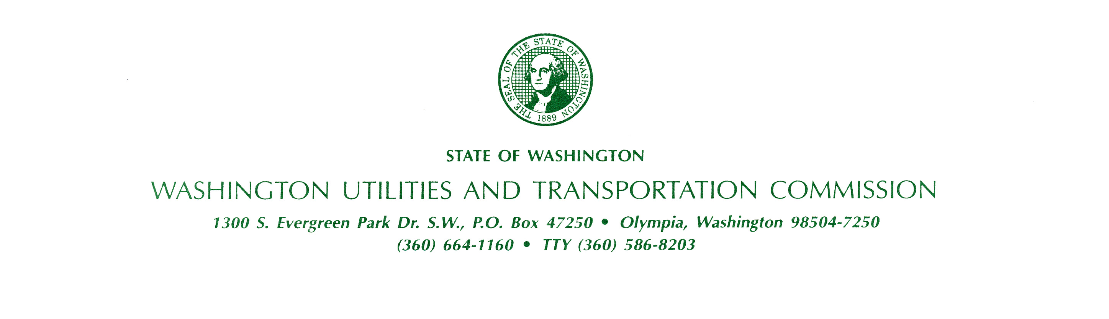
bkName
bkAddress
bkCityStateZip

July 30, 2026

Docket Number: bkDocket

Dear Interested Person:

Thank you for contacting the Washington Utilities and Transportation Commission (commission) regarding the proposal filed by Olympic Water and Sewer, Inc. (OWSI). This letter updates you on this filing’s status.

On October 6, 2010, OWSI submitted a letter to the commission requesting the effective date be extended to December 17, 2010. As a result, this filing has been removed from the October 14, 2010, open meeting agenda and will be presented during the commission’s regularly scheduled open meeting on December 16, 2010.

If you would like to comment on this filing further or have questions about the commission’s process, please use the contact information below or by using the “Public Comment” feature at the commission’s Web site, at http://www.utc.wa.gov.

Washington Utilities and Transportation Commission
1300 S. Evergreen Park Drive SW
P.O. Box 47250, Olympia, WA 98504-7250
E-mail: comments@utc.wa.gov
Telephone: 1-888-333-WUTC (9882)

Sincerely,

bkStaff
Public Involvement Coordinator

