March 19, 2010

SENT VIA E-MAIL AND FIRST CLASS MAIL
David Danner
Executive Director and Secretary
Washington Utilities and Transportation Commission
1300 S. Evergreen Pk. Dr. S.W.
PO Box 47250
Olympia, WA 98504-7250

Re: Avista’s Tariff Filing to Increase Schedule 191 Natural Gas DSM Tariff Rider Levels, Docket No. UG-100254

Dear Mr. Danner:

Public Counsel submits this letter in advance of the Commission’s March 25, 2010, Open Meeting with regard to Avista’s proposal to substantially increase its natural gas demand side management (DSM) tariff rider. Public Counsel does not oppose the March 17, 2010, revised filing of Avista, which reflects an agreement with Staff to reduce the amount of the natural gas DSM rider increase in order to attempt to recover the current negative balance over a sixteen month period, rather than Avista’s original proposal to do so over one year. Public Counsel’s recommendation is reached with some reluctance, given the concerns detailed below. The limited time available in a tariff rider filing does not allow for full examination of all relevant issues of concern. We therefore recommend:
- The Commission should direct the Company to provide a detailed plan in its next general rate case regarding actions the Company is taking to address persistent negative balances and DSM budget management issues.
- The prudence of Avista’s DSM expenditures should be closely examined in the Company’s next general rate case. Avista should provide comprehensive evidence regarding the cost-effectiveness analysis and prudence of its DSM expenditures in its next general rate case filing.
- The Commission should consider modifying Avista’s tariff rider filing schedule so that the electric and gas DSM tariff rider levels are reviewed and adjusted after the cost-effectiveness and annual reports are provided.
Negative Tariff Rider Balance
While Public Counsel strongly supports utility efforts to achieve cost-effective DSM, we are concerned about the increasingly large size of the negative natural gas DSM tariff rider balance. One year ago, Avista informed the Commission it was on a path to reduce the negative balances of its DSM tariff riders. While the electric account has been reduced, the natural gas balance has instead grown quite significantly. According to Avista, the negative balance in the Washington natural gas DSM rider account had grown to approximately $3.7 million at the close of January, 2010. The chart below shows the approximate annual natural gas DSM balances from 2001 through the close of January, 2010.

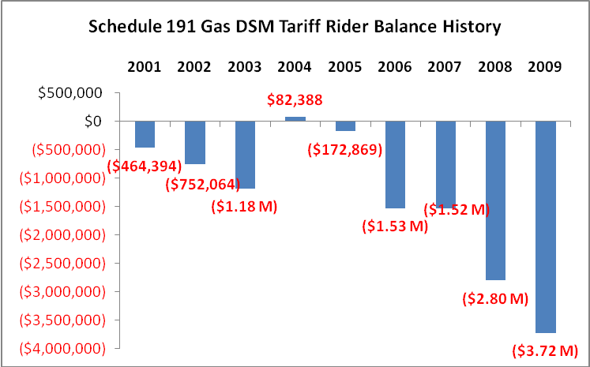

Avista’s proposal to significantly increase its DSM tariff rider revenues is driven in large part by the need to devote a substantial amount of the additional revenues to pay down this negative balance. When Avista almost doubled the natural gas DSM rider one year ago, in February, 2009, the Company projected that the natural gas negative balance would be eliminated by the end of 2010. Instead, however, the negative balance has grown by nearly an additional $1 million during the past year.

In this docket, Avista originally proposed a 4.5 percent increase to billed rates, and a 108 percent increase in the residential natural gas DSM rider amount (from $.03344 per therm to $.06972 per therm). On March 17, 2010 Avista submitted a revised filing, which decreased the request to a 2.27 percent increase in billed rates. Avista’s revised request still represents a near three-fold increase in the natural gas DSM rider rate compared to the rate that was in effect just 15 months ago, in December, 2008.

The impact of Avista’s proposal on residential customer bills is substantial. In terms of the monthly bill impact, under Avista’s revised proposal, natural gas DSM would represent $3.59 of the monthly bill for a residential customer using 70 therms. Just 15 months ago, this charge would have been $1.26 for a residential customer using 70 therms. The chart below illustrates these changes in the monthly bill impact of Schedule 191.

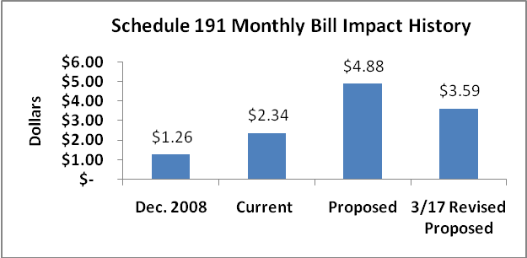

Cost Effectiveness
On their own, rate increases to support DSM are not necessarily cause for concern. Where justified, Public Counsel supports the use of ratepayer funds for the acquisition of cost-effective energy efficiency resources. However, a significant question exists as to whether Avista’s natural gas DSM portfolio is cost-effective. As Public Counsel pointed out in Avista’s recent general rate case, the available evidence raises serious doubts about the cost-effectiveness of Avista’s natural gas DSM portfolio. A thorough examination of cost-effectiveness of DSM expenditures should be conducted in the Company’s next rate case, to ensure that ratepayer funds are being spent prudently.

As the Commission observed in the Company’s last general rate case, Avista must improve its evaluation, measurement and verification (EM&V) efforts related to its DSM programs. The savings estimates associated with energy efficiency investments are a key input in the cost effectiveness analysis. This issue is currently being reviewed in a Commission-ordered collaborative and we are hopeful that enhanced measurement and verification of Avista’s savings estimates will result in greater confidence in the Company’s cost-effectiveness analysis.

Timing of Tariff Rider Filings
We also recommend that the Commission consider modifying the timing of Avista’s annual tariff rider filings. This current filing has posed some difficulty for the Commission, its Staff and other parties because we are asked to take a position on the approval of the tariff rider without having current information about the cost-effectiveness of the DSM programs being funded. It would be beneficial to all parties if the annual cost-effectiveness report is filed prior to Avista’s tariff rider filing.

In conclusion, Public Counsel supports Avista’s efforts to achieve cost-effective DSM, but remains very concerned with the growth in the negative balance in the natural gas DSM rider account. We are further concerned with the lack of convincing evidence regarding the cost-effectiveness of Avista’s natural gas DSM portfolio, and believe that issue warrants close scrutiny in conjunction with the DSM prudence review in the Company’s next general rate case. Mary Kimball will attend the March 25, 2010, Open Meeting to address this matter for Public Counsel.

Sincerely,

MARY M. KIMBALL
Senior Policy Analyst
(206) 389-2529

cc: Anne Solwick (E-mail)
Deborah Reynolds (E-mail)
Bruce Folsom (E-mail)
Linda Gervais (E-mail)

The amount reflected in the chart for the year 2009 is the total balance at the close of January 2010, as reported by Avista in their Schedule 191tariff revisions fling, Docket UG-100254. Data for 2001 to 2008 taken from Table C4-A WA DSM Tariff Rider Balance History, Evaluation of Avista’s Gas Decoupling Pilot Report “Titus Report,” Docket UG-060518.
It is troubling that Avista did not clearly and directly communicate to the Triple E Board that the Company was no longer on a path to retire the natural gas DSM balance to zero by the end of 2010. From February 2009 to October 2009 Avista’s monthly e-mail reports to the Triple E included the statement: “We believe that the current status of these balances is consistent with our objective of returning the Washington tariff riders to an approximate zero balance by the close of 2010 as we continue to examine our operations and associated expenditures in light of growing customer and regulatory obligations.” A review of the monthly filings indicated that the statement was removed in the November 2009 monthly report and subsequent reports.
With this proposed increase, Avista’s total annual Washington DSM revenues are estimated to be over $8 million for natural gas. Avista’s projected natural gas DSM expenditures for 2010 are projected at $4.8 million. Thus approximately $3.2 million in annual revenues (40 percent) will go to pay down the negative balance rather than to fund current programs.
See Brief of Public Counsel, Docket Nos. UE-090134, UG-090135 & UG-060518, pp. 36-38.
“We recognize that the cost-effectiveness and therefore prudence of programmatic DSM expenses and lost margin recovery under any decoupling or incentive mechanism rests on the evaluation, measurement and verification of energy savings achieved. Furthermore, we agree with the parties that Company’s EM&V efforts need to be improved.” See Order 10, Docket Nos. UE-090134, UG-090135 & UG-060518, ¶ 305.
The review of prudence should continue to occur in the general rate case where there is more adequate time for careful analysis.

