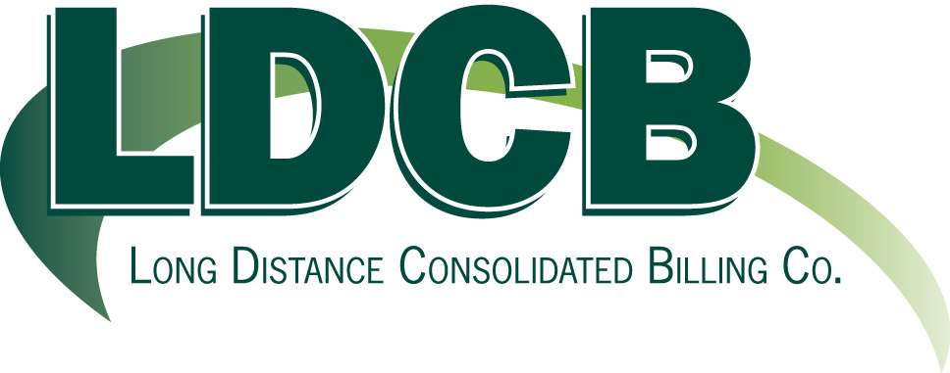

July 1, 2011

Mr. Steven Elliott
Customer Service Specialist
Washington Utilities and Transportation Commission

RE: UT-082018 Compliance Filing

Attached for your records is a copy of LDCB’s “drop-off” certification with a copy of Jan M. Lowe’s Declaration, which was filed electronically with the FCC and a copy of the electronic filing confirmation received by the FCC.

We are providing the Washington Utilities and Transportation Commission a copy based on the order dated at Olympia, Washington, and effective January 29, 2009.

If you have any further questions, please do not hesitate to contact us.

Sincerely,

Jan M. Lowe
President

JL/ac

20 W. Washington St./Suite 6A/Clarkston, MI 48346/(248)625-3245/fax#(248)625-4337

