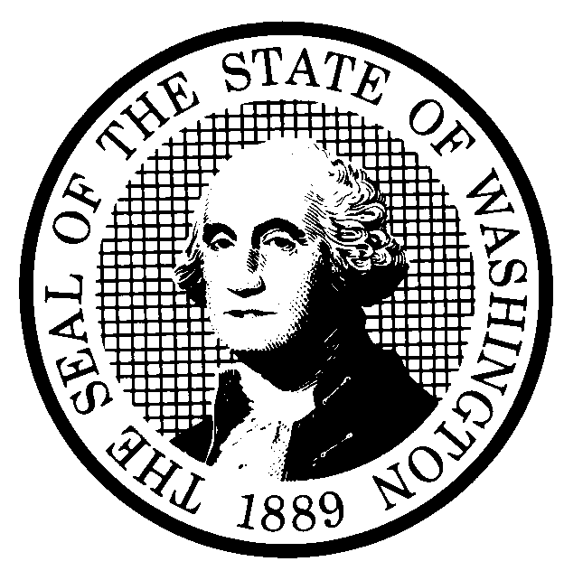 | PREPROPOSAL STATEMENT OF INQUIRY  (RCW 34.05.310) |  |  | CR-101 (7/22/01)  Do NOT use for expedited rule making
Agency: WASHINGTON UTILITIES AND TRANSPORTATION COMMISSION

Subject of possible rule making:
This rulemaking would consider possible corrections and changes to rules in Chapter 480-120 WAC, Telephone Companies, and Chapter 480-80 WAC, Utilities General—Tariffs, Price Lists, and Contracts, relating to telecommunications.

Docket No. UT-040015

(a) Statutes authorizing the agency to adopt rules on this subject:
RCW 80.01.040 and RCW 80.04.160,
(b) Reasons why rules on this subject may be needed and what they might accomplish: The Commission completed a comprehensive review of its rules in Chapter 480-120, Telephone Companies in 2002. The rules in Chapter 480-80 WAC took effect in June 2002. The rules in Chapter 480-120 took effect in July 2003. While implementing these rules, stakeholders and agency staff have identified a variety of issues with the rules, including unclear provisions, incomplete cross-references, inconsistencies with federal law, and provisions that have been struck down in court. In addition, there are provisions from the prior rules that were not an issue during the comprehensive review that have since become an issue. This rulemaking would consider possible corrections, changes, and clarifications to address the above issues and others that may emerge during the rulemaking process.

(c) Identify other federal and state agencies that regulate this subject and the process coordinating the rule with these agencies:
(d) Process for developing new rule (check all that apply):
Negotiated rule making
Pilot rule making
X Agency study
X Other (describe)

The Commission will ask for initial comments, and will provide the opportunity for additional comments. The Commission will schedule one or more workshops with representatives of affected companies and constituencies to discuss issues related to this rulemaking and any rule proposal.

(e) How interested parties can participate in the decision to adopt the new rule and formulation of the proposed rule before publication:
(List names, addresses, telephone, fax numbers of persons to contact; describe meetings, other exchanges of information, etc.)
Interested persons may file comments with the Secretary, Washington Utilities and Transportation Commission, P.O. Box 47250, 1300 S. Evergreen Park Drive, S.W., Olympia, Washington, 98504-7250; Telephone (360) 664-1174; Facsimile (360) 586-1150, by February 20, 2004. An initial workshop is scheduled for March 11, 2004.
For specific information regarding opportunities for written comments, participation in the workshop, and to ensure receipt of further information concerning this rulemaking, please see the attachment to this form.
 |  |  | CODE REVISER USE ONLY

Filed with the Code Reviser's Office
January 21, 2004
NAME (TYPE OR PRINT)  Carole J. Washburn |  |  | 11:21 a.m., WSR# 04-03-118
SIGNATURE
TITLE  Executive Secretary |  | DATE  January 21, 2004

