WN U-74 |  |  | Tenth Revision of Sheet No. 48T.2
 |  |  | Canceling Ninth Revision of Sheet No. 48T.2
PACIFIC POWER & LIGHT COMPANY
 |  |  |  |  |  |  |  |  |  |  | FOR COMMISSION’S RECEIPT STAMP
 | SCHEDULE 48T  (Continued)  LARGE GENERAL SERVICE - METERED TIME OF USE  1,000 KW AND OVER  Due to the expansions of Daylight Saving Time (DST) as adopted under Section 110 of the U.S. Energy Policy Act of 2005 the time periods shown above will begin and end one hour later for the period between the second Sunday in March and the First Sunday in April, and for the period between the last Sunday in October and the first Sunday in November.  MINIMUM CHARGE:  The monthly minimum charge shall be the basic and demand charge, unless a higher minimum is otherwise specified by contract.  REACTIVE POWER CHARGE:  The maximum 15-minute reactive demand for the billing month in kilovolt-amperes in excess of 40% of the maximum measured kilowatt demand for the billing month will be billed at the specific Delivery Service rate per kvar of such excess reactive demand.  DELIVERY SERVICE:  Secondary and Primary Service: Customers taking service when delivery and metering are at Company’s standard secondary voltage shall be billed at the Secondary level. Customers taking service at Company’s available primary distribution voltage of 11 kV or greater that do not qualify as a Primary Dedicated Facilities > 30,000 kW customer shall be billed at the Primary level. Customers that qualify as a Primary Dedicated Facilities > 30,000 kW customer shall be billed at that level.  Primary Dedicated Facilities > 30,000 kW: Customers that qualify for Primary Dedicated Facilities > 30,000 kW service must have a load size greater than 30,000 kW, take service at Company’s available primary distribution voltage of 11 kV or greater, be served by a dedicated substation that serves only that particular customer, have point(s) of delivery inside the substation, and provide and own the land on which the substation and related facilities are located.  VOLTAGE:  Company retains the right to change its line voltage or classifications thereof at any time, and after reasonable advance notice to any Customer affected by such change, such Customer then has the option to take service at the new line voltage or to accept service through transformers to be supplied by Company subject to the voltage adjustments above. |  |  |  |  |  |  |  |  |  |  |  | (M)  frm  Pg.1  (C)  (D)  (N)  (N)  (M)  frm  pg.3  (M)  frm  pg.3
(Continued)
Issued |  |  |  |  | February 9, 2009 |  | Effective |  |  | March 11, 2009
Issued by |  |  |  | PACIFIC POWER & LIGHT COMPANY
By |  | 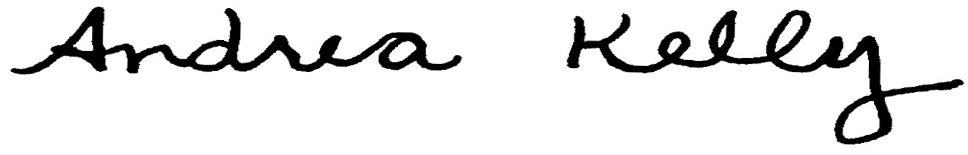  Andrea L. Kelly |  |  |  |  |  | Title | Vice President, Regulation
 |  | TF2 48T.2REV |  |  |  | Advice No. |  |  |  |  |  | UE-
Form F

