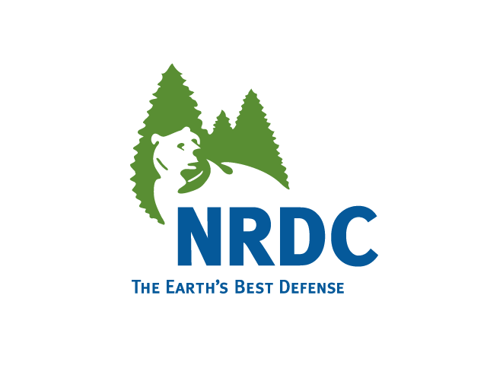
Natural Resources Defense Council

June 1, 2005

Carole Washburn
Executive Secretary
WASHINGTON UTILITIES AND
TRANSPORTATION COMMISSION
1300 So. Evergreen Park Drive SW
P.O. Box 47250
Olympia, WA 98504-7250

Re: Docket No. UE-050684

Dear Ms. Washburn:

Attached for filing with the Commission please find an original plus fourteen (14) copies of the Natural Resources Defense Council’s Petition to Intervene in the above referenced proceeding. I have e-mailed a copy of the Petition to Intervene to the Records Department. As Ralph Cavanagh has informed Administrative Law JudgeTheodora Mace, NRDC will be participating in the June 6th Prehearing Conference via phone.
Thank you for your assistance.

Sincerely,
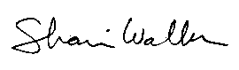

Shari Walker
Energy Program Assistant
Natural Resources Defense Council

Encl.
cc: all parties

BEFORE THE WASHINGTON STATE UTILITIES AND
TRANSPORTATION COMMISSION

Washington Utilities and Transportation )
Commission, )
Complainant, ) Docket NO. UE-050684
)
v. )
)
PACIFICORP d/b/a PACIFIC )
POWER AND LIGHT COMPANY )
)
Respondent. )
)
. . . . . . . . . . . . . . . . . . . . . . . . . . . . . . . . . . . . . . . . . . )

PETITION TO INTERVENE

The Natural Resources Defense Council (NRDC) hereby requests permission to intervene in the above referenced proceeding. In support of this Petition to Intervene, NRDC asserts the following:

A. NRDC’s business address is:

Natural Resources Defense Council
111 Sutter Street, 20th Floor
San Francisco, CA 94104

B. NRDC will be represented in this matter by Ralph Cavanagh, Northwest Project Director. Ralph Cavanagh, NRDC is designated for service of all documents in this matter at the address of the organizational office provided above.

C. NRDC is a non-profit organization under section 501(c)(3) of the Internal Revenue Code. NRDC has more than 24,000 individual members in Washington, many of whom are PacifiCorp customers. NRDC is dedicated to protecting natural resources and ensuring a safe and healthy environment. The organization has maintained a Northwest Energy Project since 1979 and has appeared frequently before the WUTC to assert its members' interest in a sustainable and affordable long-term energy future for the region, including but not limited to accelerated development of cost-effective energy efficiency and renewable resources.

D. NRDC has a special interest in this proceeding for the following reasons: (1) rate design or cost recovery modifications that occur as a result of this proceeding may affect PacifiCorp’s and customers’ investment in energy efficiency; (2) decisions made in this proceeding may influence PacifiCorp’s investments in energy conservation, renewable resources, and low-income energy services; and (3) decisions made regarding this proceeding may set a precedent for decision-making in future electric and gas rate cases.

E. NRDC intends to examine various issues in this proceeding, including but not limited to incentives for investments in energy efficiency, renewable energy and low-income energy services, and electric resource portfolio management more generally. NRDC notes that PacifiCorp has expressed strong interest in removing financial disincentives to promoting energy efficiency investments throughout its service territory. NRDC intends to offer specific proposals for the Commission's consideration that will meet this objective and secure more cost-effective electricity savings for the Company and its customers.

F. NRDC offers this process considerable expertise in the area of resource planning, industry structure and incentives, and economic and policy analysis. NRDC has participated in numerous rate cases, mergers, and resource planning proceedings in Oregon, Washington, Idaho, and Montana.

G. NRDC has no intention of unreasonably broadening the issues, burdening the record or delaying the proceeding through its intervention.

For the foregoing reasons, NRDC requests the Commission grant its motion to intervene in this matter.

June 1, 2005

Respectfully submitted,

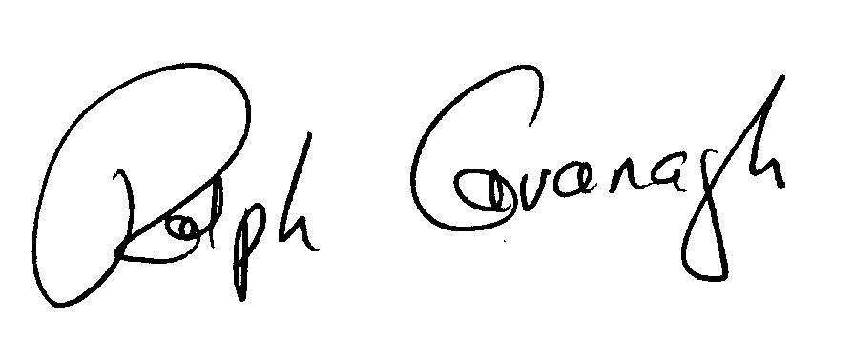

Ralph Cavanagh
Northwest Project Director
111 Sutter Street, 20th Floor
San Francisco, CA 94104
CERTIFICATE OF SERVICE

I hereby certify that on this day, June 1, 2005, I have served a copy of the foregoing Petition to Intervene of the Natural Resources Defense Council by first class, U.S. Mail on the following persons:

Complainant:

Washington Utilities and
Transportation Commission
Chandler Plaza Building
1300 S. Evergreen Park Drive S.W.
P.O. Box 47250
Olympia, WA 98504-7250
(360) 664-1160

Representatives:

Don Trotter and Shannon Smith
Assistant Attorneys General
1400 S. Evergreen Park Drive S.W.
P.O. Box 40128
Olympia, WA 98504-0128
(360) 664-1188

Respondent:

Christy Omohundro
Vice President, Regulation

Representatives:
James M. Van Nostrand
Stoel Rives LLP
Suite 3600, One Union Square
600 University Street
Seattle, WA 98101
(206) 386-7665

Stephen C. Hall
Stoel Rives LLP
900 S.W. Fifth Avenue, Suite 2600
Portland, OR 97204
(503) 294-9625

Public Counsel:

Robert Cromwell
Office of the Attorney General
900 Fourth Avenue, Suite 2000
Seattle, WA 98164-1012
(206) 464-7744

PacifiCorp
825 NE Multnomah, Suite 800
Portland, OR 97232
(503) 813-6065

Shari Walker
Energy Program
Natural Resources Defense Council

