February 6, 2015

VIA ELECTRONIC FILING

Steven V. King, Executive Director and Secretary
Washington Utilities and Transportation Commission
1300 S. Evergreen Park Dr SW
Olympia, Washington 98504-7250

Re: Docket U-140621 – Comments of XO Communications Services LLC
Dear Mr. King:
Enclosed for filing is XO Communications Services LLC’s Comments on Revised Draft Rules in the above-referenced Docket.
Very truly yours
Davis Wright Tremaine LLP
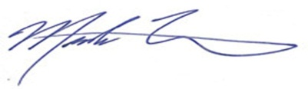
Mark P. Trinchero

Enclosure

