WN U-74 |  |  |  | Fifteenth Revision of Sheet No. 48T.1
 |  |  | Canceling Fourteenth Revision of Sheet No. 48T.1
PACIFIC POWER & LIGHT COMPANY
 |  |  |  |  |  |  |  |  |  |  |  | FOR COMMISSION’S RECEIPT STAMP
 | SCHEDULE 48T  LARGE GENERAL SERVICE - METERED TIME OF USE  1,000 KW AND OVER  AVAILABLE:  In all territory served by Company in the State of Washington.  APPLICABLE:  This Schedule is applicable to electric service loads which have exceeded 999 kW in more than one month of any consecutive 18-month period. This schedule will remain applicable until Customer fails to exceed 999 kW for a period of 36 consecutive months. Deliveries at more than one point, or more than one voltage and phase classification, will be separately metered and billed. Service for intermittent, partial requirements, or highly fluctuating loads, or where service is seasonally disconnected during any one-year period will be provided only by special contract for such service. Partial requirements service for loads of 1,000 kW and over will be provided only by application of the provisions of Schedule 47T.  MONTHLY BILLING:  The Monthly Billing shall be the sum of the Basic, Demand, Energy, and Reactive Power Charges. All Monthly Billings shall be adjusted in accordance with Schedules 91, 96, 98 and 191.  *Note: kW Load Size, for the determination of the Basic Charge, shall be the average of the two greatest non-zero monthly demands established any time during the 12-month period which includes and ends with the current billing month. |  |  |  |  |  |  |  |  |  |  |  |  | (D)  (C)  (C)K  (M)  to  pg.2
  Basic Charge: | Delivery Service
  If Load Size* is: | Secondary | Primary | Primary Dedicated Facilities  >30,000 kW
  Load Size* < 3,000 kW, per month | $1,250.00 | $1,310.00
  Load Size* >3,000 kW, per month | $1,500.00 | $1,560.00 | $2,550.00
  Load Size Charge*
  <3,000 kW, per kW Load Size | $0.94 | $0.53
  >3,000 kW, per kW Load Size | $0.86 | $0.45 | $0.15
  Demand Charge:
  On-Peak Period Demand
  (Monday through Friday:
  7:00 a.m. to 11:00 p.m.)
  Per kW for all kW of On-Peak Period Billing Demand | $6.78 | $6.71 | $6.62
  Energy Charge:  Per kWh | 4.345¢ | 4.292¢ | 4.235¢
  Reactive Power Charge:  Per kVar | $0.55 | $0.54 | $0.50
(Continued)
Issued |  |  |  |  |  | February 9, 2009 |  | Effective |  |  | March 11, 2009
Issued by |  |  |  |  | PACIFIC POWER & LIGHT COMPANY
By |  | 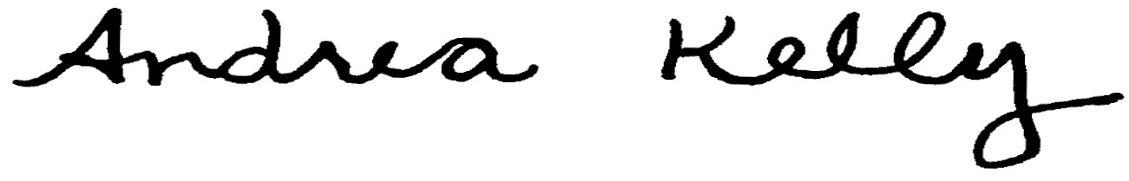  Andrea L. Kelly |  |  |  |  |  |  | Title | Vice President, Regulation
 |  | TF2 48T.1REV |  |  |  |  | Advice No. |  |  |  |  |  | UE-
Form F

