Comparison of Correct Data with Staff’s Erroneous Data

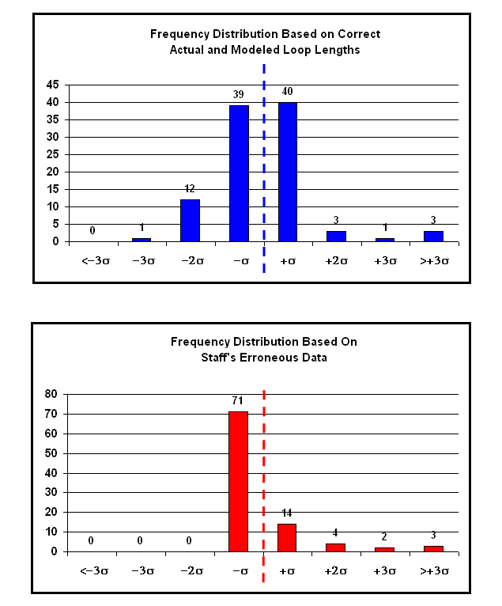
Comparison of Correct Data with HM 5.3 Data

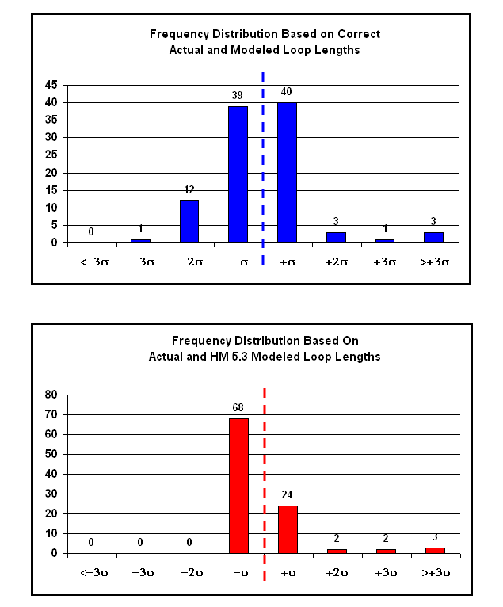

Comparison of Correct Data with ICM Data from UT-003013

