WN U-74 |  |  | Thirteenth Revision of Sheet No. 40.2
 |  |  | Canceling Twelfth Revision of Sheet No. 40.2
PACIFIC POWER & LIGHT COMPANY
 |  |  |  |  |  |  |  |  |  |  | FOR COMMISSION’S RECEIPT STAMP
 | SCHEDULE 40  (Continued)  AGRICULTURAL PUMPING SERVICE  MONTHLY KW:  Monthly kW is the measured kW shown by or computed from the readings of Company's meter, or by appropriate test, for the 15-minute period of Customer's greatest takings during the billing month; provided, however, that for motors 10 hp or less, the Monthly kW may, subject to confirmation by test, be determined from the nameplate hp rating and the following table:  If Motor Size is: Monthly kW is:  2 HP or less 2 kW  Over 2 through 3 HP 3 kW  Over 3 through 5 HP 5 kW  Over 5 through 7.5 HP 7 kW  Over 7.5 through 10 HP 9 kW  In no case shall the kW of Monthly kW be less than the average kW  determined as:  Average kW = kWh for billing month  hours in billing month  REACTIVE POWER CHARGE:  The maximum 15-minute reactive takings for the billing month in kilovolt-amperes in excess of 40% of the Monthly kW will be billed at 55¢ per kvar of such excess reactive takings.  (I)  PRIMARY VOLTAGE METERING AND DELIVERY ADJUSTMENTS:  The above monthly charges are applicable without adjustment for voltage when delivery and metering are at Company's standard secondary voltage.  Metering: For so long as metering voltage is at Company's available primary distribution voltage of 11 kV or greater, the above charges will be reduced by 1.0%.  Delivery: For so long as delivery voltage is at Company's available primary distribution voltage of 11 kV or greater, the total of the above charges will be reduced by 30¢ per kW of load size used for the determination of the Basic Charge billed in the month. A High Voltage Charge of $60 per month will be added where such deliveries are metered at the delivery voltage.  The reductions of charges herein shall not operate to reduce the minimum charge.  When a new delivery or an increase in capacity for an existing delivery is, at request of Customer, made by means of Company-owned transformers at a voltage other than a locally standard distribution voltage, the above charges for any month will be increased by 30¢ per kW of load size used for the determination of the Basic Charge billed in the month. |  |  |  |  |  |  |  |  |  |  |  | (C)  (C)
(Continued)
Issued |  |  |  |  | February 9, 2009 |  | Effective |  |  | March 11, 2009
Issued by |  |  |  | PACIFIC POWER & LIGHT COMPANY
By |  | 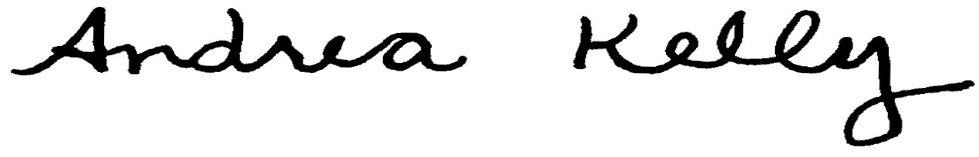  Andrea L. Kelly |  |  |  |  |  | Title | Vice President, Regulation
 |  | TF2 40.2REV |  |  |  | Case No. |  |  |  |  |  | UE-
Form F

