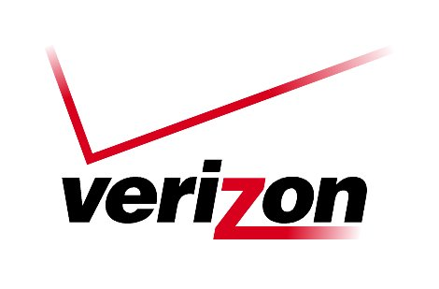 Verizon Northwest Inc.

1800 – 41st Street, WA0105RA
P. O. Box 1003
Everett, WA 98206-1003
Fax: 425-261-5262

July 29, 2026

Washington Utilities and
Transportation Commission
Chandler Plaza Building
1300 S. Evergreen Park Drive SW
P. O. Box 47250
Olympia, Washington 98504-7250

Subject: February 2009 Service Quality Report

To Whom It May Concern:

Pursuant to WAC 480-120-439, enclosed is the Verizon Northwest Inc. Service Quality Performance Report for last month.

Central office level detail is marked “Confidential pursuant to WAC 480-07-160” as it includes access line count and activity information that would have economic value to the Company’s current and potential competitors, such as in determining when and where to begin or modify competitive operations. In addition to the information required by WAC 480-120-439, we are also enclosing twelve month running trouble report document at the request and for the convenience of the Commission Staff.

If you have any questions concerning this report, please call me at 425-261-5006 or email me at richard.potter@verizon.com.

Very truly yours,

Richard E. Potter
Director
Public Affairs, Policy & Communications

Enclosures

