WN U-74 |  |  |  | Fifteenth Revision of Sheet No. 40.1
 |  |  | Canceling Fourteenth Revision of Sheet No. 40.1
PACIFIC POWER & LIGHT COMPANY
 |  |  |  |  |  |  |  |  |  |  |  | FOR COMMISSION’S RECEIPT STAMP
SCHEDULE 40
AGRICULTURAL PUMPING SERVICE

AVAILABLE:
In all territory served by Company in the State of Washington.

APPLICABLE:
To Customers desiring service for irrigation and soil drainage pumping installations only. Service furnished under this Schedule will be metered and billed separately at each point of delivery.

MONTHLY BILLING:
Except for November, the monthly billing shall be the sum of the applicable Energy Charges and the Reactive Power Charge. For November, the billing shall be the sum of the Energy Charge, the Reactive Power Charge, and the Load Size Charge. All Monthly Billings shall be adjusted in accordance with Schedules 91, 96, 98, and 191.

Load Size Charge: (Billed once each year, and to be included in the bill for the November billing period.)

If Load Size¹ is: Load Size¹ Charge is:
(I)
(I)

(I)
(I)
(I)

(I)

Single-phase service, 22.75 per kW of Load Size but not
any size: less than $68.25

Three-phase service:
50 kW or less $22.75 per kW of Load Size but not
less than $136.50
51 to 300 kW $330 plus $16.00 per kW of Load Size
Over 300 kW $1,350 plus $12.60 per kW of Load Size

¹Load Size is the average of the two greatest non-zero Monthly kW, as described on Sheet No. 40.2, established during the 12-month period which includes and ends with the November billing month.

Energy Charge:

Base
Rate
(I)
6.168¢ per kWh for all kWh
(Continued)
Issued |  |  |  |  |  | February 9, 2009 |  | Effective |  |  | March 11, 2009
Issued by |  |  |  |  | PACIFIC POWER & LIGHT COMPANY
By |  | 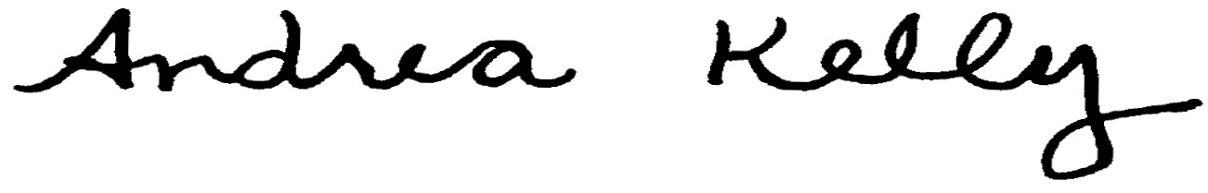  Andrea L. Kelly |  |  |  |  |  |  | Title | Vice President, Regulation
 |  | TF2 40.1.REV |  |  |  |  | Advice No. |  |  |  |  |  | UE-
Form F

