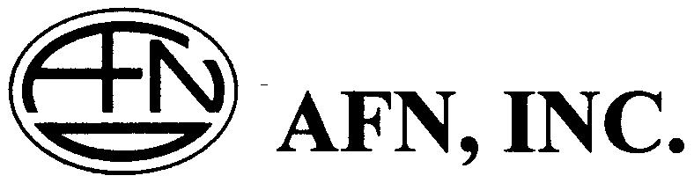

VIA CERTIFIED MAIL

November 5, 2003

Subject: Docket No. UT-033044, Order NO. 3 Petition of Quest Corporation to Initiate a Mass-Market Switching and Dedicated Transport Case Pursuant to the Triennial Review Order

Ms. Carole Washburn, Executive Secretary
Washington Utilities and Transportation Commission
1300 S. Evergreen Park Drive SW
Po Box 47250
Olympia, WA 98504-7250

Dear Ms.Washburn:

Ms. Ann E. Rendahl, Administrative Law Judge, and I corresponded with each other via e-mail on November 4 regarding our response to the above referenced Docket. She requested that I file the following information with the Commission.

American Fiber Network, Inc. is certified as a CLEC with the Washington State Utilities and Transportation Commission. We currently resell local telephone service and long distance service in Washington State. We do not own or lease any switching or other network facilities in the State.

In reading the 31 CLEC Questions issued by the Commission on October 23, 2003 in this Docket, American Fiber Network believes that none are applicable to the telecommunication services the company provides in the State. We are also requesting that American Fiber Network not be required to respond to future information requests by the Commission and rounds of discovery in Docket NO. UT-033044 unless they are applicable to our telecommunication service offerings in the State.

An electronic copy of this letter will also be sent to the Records Center at records@wutc.wa.gov.

If you need any additional information, please call me or e-mail me at bob.baranek@afnltd.com. Thank you for your assistance.

Sincerely,

Robert Baranek
American Fiber Network, Inc.

