WN U-74 |  |  | Thirteenth Revision of Sheet No. 36.2
 |  |  | Canceling Twelfth Revision of Sheet No. 36.2
PACIFIC POWER & LIGHT COMPANY
 |  |  |  |  |  |  |  |  |  |  | FOR COMMISSION’S RECEIPT STAMP
SCHEDULE 36
(Continued)
LARGE GENERAL SERVICE
LESS THAN 1,000 KW
Energy Charge:

Base
Rate
(I)
(I)

(I)
5.168¢ per kWh for the first 40,000 kWh
4.737¢ per kWh for all additional kWh

MINIMUM CHARGE:
The monthly minimum charge shall be the Basic Charge plus the Demand Charge. A higher minimum may be required under contract to cover special conditions.

REACTIVE POWER CHARGE:
The maximum 15-minute reactive demand for the month in kilovolt amperes in excess of 40% of the kilowatt demand for the same month will be billed, in addition to the above charges, at 55¢ per kvar of such excess reactive demand.

PRIMARY VOLTAGE METERING AND DELIVERY ADJUSTMENTS:
The above monthly charges are applicable without adjustment for voltage when delivery and metering are at Company's standard secondary voltage.

Metering: For so long as metering voltage is at Company's available primary distribution voltage of 11 kV or greater, the above charges will be reduced by 1.0%.

Delivery: For so long as delivery voltage is at Company's available primary distribution voltage of 11 kV or greater, the total of the above charges will be reduced by 30¢ per kW of load size used for the determination of the Basic Charge billed in the month. A High Voltage Charge of $60 per month will be added where such deliveries are metered at the delivery voltage.

The reductions of charges herein shall not operate to reduce the minimum charge.
When a new delivery or an increase in capacity for an existing delivery is, at request of Customer, made by means of Company-owned transformers at a voltage other than a locally standard distribution voltage, the above charges for any month will be increased by 30¢ per kW of load size used for the determination of the Basic Charge billed in the month.
Company retains the right to change its line voltage or classifications thereof at any time, and after reasonable advance notice to any Customer affected by such change, such Customer then has the option to take service at the new line voltage or to accept service through transformers to be supplied by Company subject to the voltage adjustments above.
(Continued)
Issued |  |  |  |  | February 9, 2009 |  | Effective |  |  | March 11, 2009
Issued by |  |  |  | PACIFIC POWER & LIGHT COMPANY
By |  | 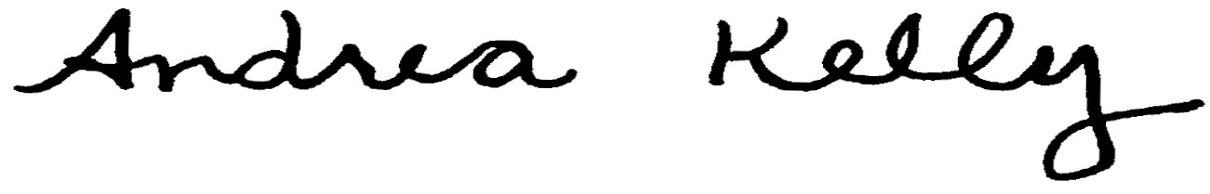  Andrea L. Kelly |  |  |  |  |  | Title | Vice President, Regulation
 |  | TF2 36.2REV |  |  |  | Advice No. |  |  |  |  |  | UE-
Form F

