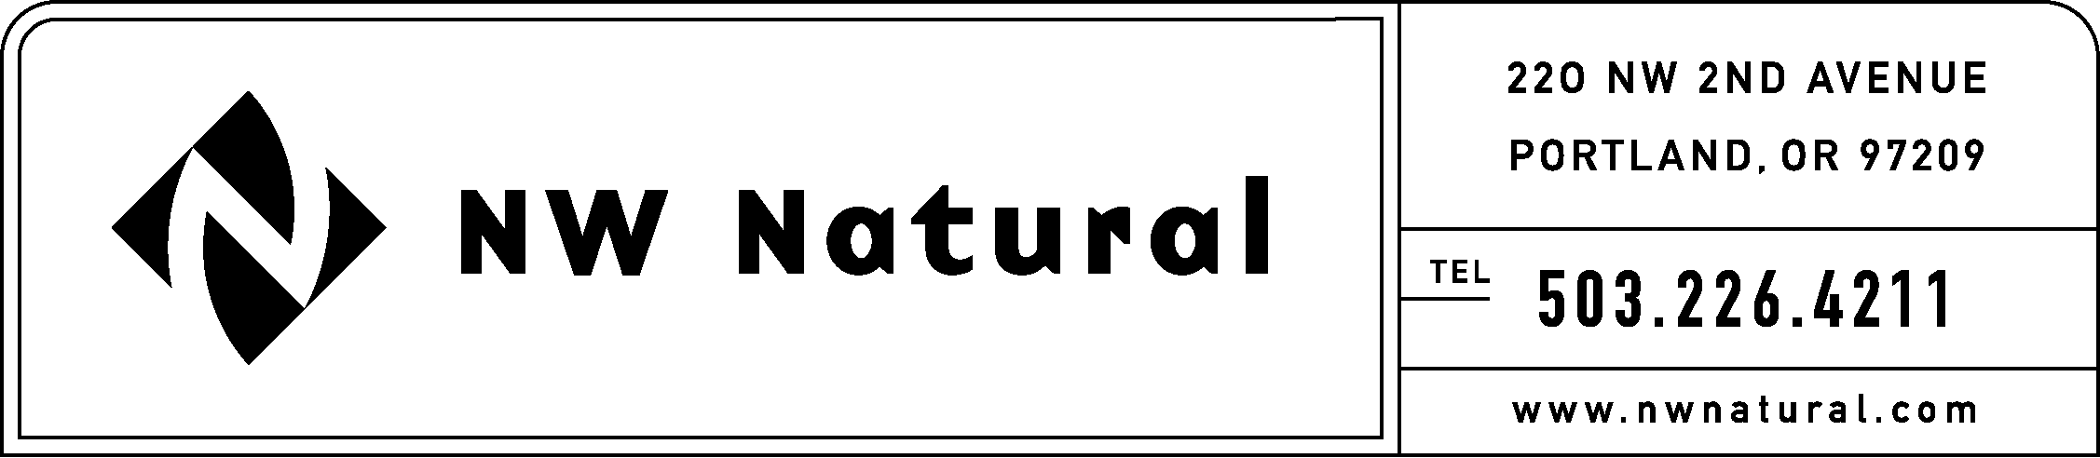
ONITA R. KING, MANAGER
TARIFFS AND REGULATORY COMPLIANCE
RATES AND REGULATORY AFFAIRS
Telephone: (503) 721-2452
Facsimile: (503) 721-2532
Email: ork@nwnatural.com

January 16, 2004

Secretary
Washington Utilities & TraTransportation Commission
P.O. Box 47250
Olympia, Washington 98504-7250

Re: Docket Number A-021178
Financial Reporting Rules

NW Natural respectfully submits the following comments on changes proposed in the above-referenced matter. These comments are not necessarily final or all inclusive, and we reserve the right to add to, delete from, or revise our comments as the rules review process in this docket continues.

WAC 480-90-023 Definitions. NW Natural is concerned about the proposed 5% ownership threshold for the definition of a subsidiary. With ownership of just 5% of an entities’ securities, there is virtually no likelihood that the utility would have any control over the activities, transactions or reporting of the other entity. We are not aware of a definition of subsidiary with such a low ownership standard. A preferable approach is to require that there be control (voting or otherwise) over the other entity.

WAC 480-90-X02 Additional Reports.
As proposed, the rule states “Part 3 does not supersede any reporting requirement specified in a Commission order or limit the commission’s ability to request additional information”. There is no Part 3 in this rule. What Part 3 is this sentence referring to?

WAC 480-90-X03 Issuing securities.
NW Natural has several significant concerns about this proposed rule.

- NW Natural opposes the addition of a requirement to file five business days in advance of issuing any securities. The addition of such a requirement would eliminate NW Natural’s ability to issue either debt or equity in the public markets. In each case, the final terms of a financing are determined by current market conditions and are not known five days in advance. NW Natural is not opposed to a reasonable advance notice requirement, but such a notice should include preliminary terms only, subject to a final report upon the issuance of securities. Our recent medium-term note issuance reviewed by the Commission was conducted in this manner.

- As written, the proposed rule appears to apply to the simple issuance of a new stock certificate pursuant to a transfer of a certificate, such as a transfer of stock from a parent to a child. The proposed rule should delete the reference to stock certificates.

- Many shares issued by a utility are issued pursuant to stock plans, such as an employee stock purchase plan or dividend reinvestment plan, for which the utility has received Commission approval under a unique and separate order. The proposed rule should explicitly exempt issuances of securities issued pursuant to a plan approved by the Commission, subject to compliance with the terms of a Commission order.

- NW Natural believes the existing requirement to file a verified statement 30 days after the issuance of the securities is sufficient. However, this requirement should be clarified to exclude issuances pursuant to stock plans, such as an employee stock purchase plan or dividend reinvestment plan, for which the utility files an annual issuance report pursuant to the terms of a Commission order.

Thank you for the opportunity to comment in this proceeding.

Sincerely,

NW NATURAL

Onita R. King, Manager
Tariffs and Regulatory Compliance

