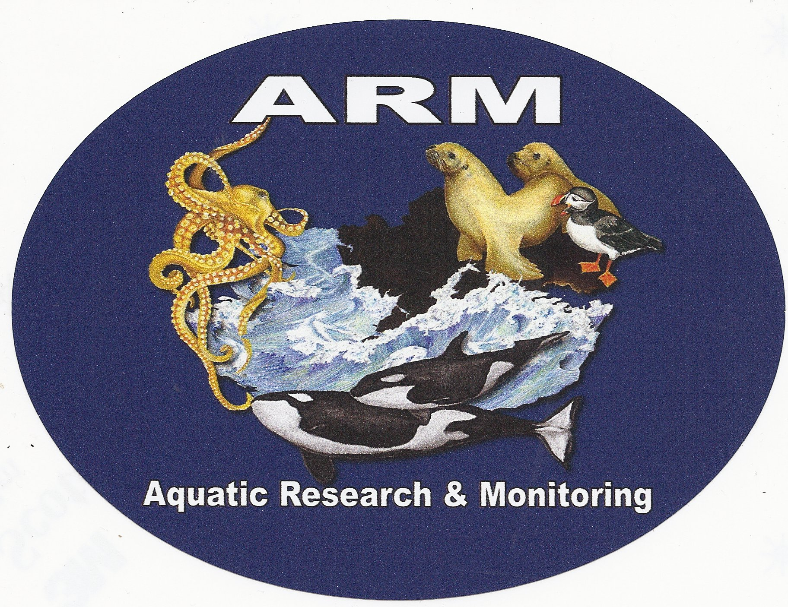

Aquatic Research & Monitoring

April 15, 2013

Steven King, Executive Director and Secretary
Washington Utilities and Transportation Commission
Attention: Judge Adam Torem, License services, Penny Ingram, Michael Fassio
PO Box 47250
1300 S. Evergreen Park Dr. SW
Olympia, WA 98504-7250

Re: Petition for Administrative Review

Dear Mr. King,

Enclosed please find an original and seven (7) copies of Island Mariners Cruises Petition for Administrative Review. Please feel free to contact me with any questions you may have.

Sincerely,

Terry Buzzard

