WN U-74 |  |  | Eleventh Revision of Sheet No. 36.1
 |  |  | Canceling Tenth Revision of Sheet No. 36.1
PACIFIC POWER & LIGHT COMPANY
 |  |  |  |  |  |  |  |  |  |  | FOR COMMISSION’S RECEIPT STAMP
SCHEDULE 36

LARGE GENERAL SERVICE
LESS THAN 1,000 KW

AVAILABLE:
In all territory served by Company in the State of Washington.

APPLICABLE:
To non-residential Customers with electric service loads which have exceeded 100 kW more than once in the preceding 12-month period, but have not exceeded 999 kW more than once in any consecutive 18-month period. And to seasonal Customers, as defined in Rule 1 of this tariff, with electric service loads which have exceeded 200 kW more than once in the preceding 12-month period, but have not exceeded 999 kW more than once in any consecutive 18-month period. In the case that the motor nameplate horsepower rating is used to determine the seasonal Customer’s load size, that load size will also be used to determine eligibility for this schedule.
The Company will not switch a Customer between General Service Schedules 24 and 36 more than once in a 12-month period, unless the following exception is met: In the event that a Customer’s load increases due to changes in operations, the Company may, at its discretion, place the Consumer on a schedule with a higher demand requirement, if so warranted.
Deliveries at more than one point, or more than one voltage and phase classification, will be separately metered and billed.
This Schedule is not applicable to standby service.
Partial requirements service for loads of less than 1,000 kW will be provided only by application of the provisions of Schedule 33.

MONTHLY BILLING:
The Monthly Billing shall be the sum of the Basic, Demand, Energy, and Reactive Power Charges; plus applicable Metering and Delivery Adjustments. All Monthly Billings shall be adjusted in accordance with Schedules 91, 96, 98, and 191.

Basic Charge:
If Load Size* is: The Monthly Basic Charge* is:
(I)
(I)
(I)

(I)

100 kW or less $230
101 kW - 300 kW $ 85 plus $1.50 per kW
Over 300 kW $170 plus $1.25 per kW

*Note: kW Load Size, for the determination of the Basic Charge, shall be the average of the two greatest non-zero monthly demands established any time during the 12-month period which includes and ends with the current billing month. For seasonal Customers, the Load Size will be the greater of this number or the number derived by applying the motor nameplate horsepower to the Billing Demand Table from Rule 10(a) if this tariff.

Demand Charge:
$4.09 per kW for each kW of Billing Demand

(Continued)
Issued |  |  |  |  | February 9, 2009 |  | Effective |  |  | March 11, 2009
Issued by |  |  |  | PACIFIC POWER & LIGHT COMPANY
By |  | 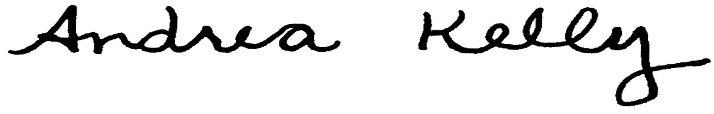  Andrea L. Kelly |  |  |  |  |  | Title | Vice President, Regulation
 |  | TF2 36.1.REV |  |  |  | Advice No. |  |  |  |  |  | UE-
Form F

