WN U-74 |  |  | Seventeenth Revision of Sheet No. 24.2
 |  |  | Canceling Sixteenth Revision of Sheet No. 24.2
PACIFIC POWER & LIGHT COMPANY
 |  |  |  |  |  |  |  |  |  | FOR COMMISSION’S RECEIPT STAMP
SCHEDULE 24
(Continued)
SMALL GENERAL SERVICE
MONTHLY BILLING: (Continued)

Seasonal Service Basic Charge: (Optional)

Customers qualifying as Seasonal Service in accordance with Rule 1 of this Tariff, have the option of the Company billing the Basic Charge annually with their November bill.

If Annual Load Size* is: The Annual Basic Charge is:
(I)

(I)

(I)

(I)
(I)
(I)

(I)

Single-Phase Service, $93.00 plus $9.96 per kW of Annual Any size: Load Size in excess of 15 kW.

Three-Phase Service, $138.12 plus $9.96 per kW of Annual
Any size: Load Size in excess of 15 kW.

*Note: Annual Load Size is the greater of:
The average of the two greatest non-zero monthly demands established anytime during the 12-month period which includes and ends with the November billing month; or applying the motor nameplate horsepower to the Billing Demand Table from Rule 10(a) of this Tariff.

Demand Charge:
No
Charge for the first 15 kW of demand

$3.07 per kW for all kW in excess of 15 kW

Energy Charge:

Base
Rate
8.949¢ per kWh for the first 1,000 kWh
6.179¢ per kWh for the next 8,000 kWh
5.323¢ per kWh for all additional kWh

MINIMUM CHARGE:
The monthly Minimum Charge shall be the Basic Charge. A higher minimum may be required under contract to cover special conditions.

REACTIVE POWER CHARGE:
The maximum 15-minute reactive demand for the month in kilovolt amperes in excess of 40% of the kilowatt demand for the same month will be billed, in addition to the above charges, at 55¢ per kvar of such excess reactive demand.

(Continued)
Issued |  |  |  | February 9, 2009 |  | Effective |  |  | March 11, 2009
Issued by |  |  | PACIFIC POWER & LIGHT COMPANY
By |  | 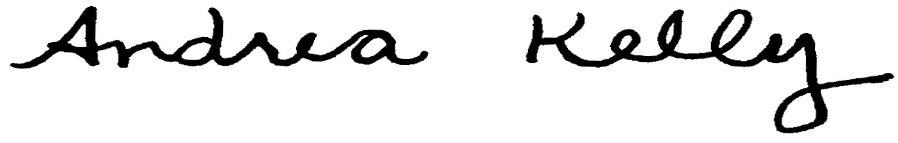  Andrea L. Kelly |  |  |  |  | Title | Vice President, Regulation
 |  | TF2 24.2.REV |  |  | Advice No. |  |  |  |  |  | UE-
Form F

