BEFORE THE WASHINGTON UTILITIES AND
TRANSPORTATION COMMISSION

Washington Utilities and Transportation )
Commission, )
Complainant, )
v. ) Docket NO. UG-080546
)
Northwest Natural Gas Company )
Respondent. )

In accordance with WAC 480-07-345(2), this document serves as the Notice of Appearance for Senior Policy Associate Steven Weiss to represent the NW Energy Coalition in proceedings related to the above-referenced docket.

Steven Weiss
Senior Policy Associate
NW Energy Coalition
c/o 4422 Oregon Trail Court NE
Salem, OR 97305

503-851-4054
steve@nwenergy.org

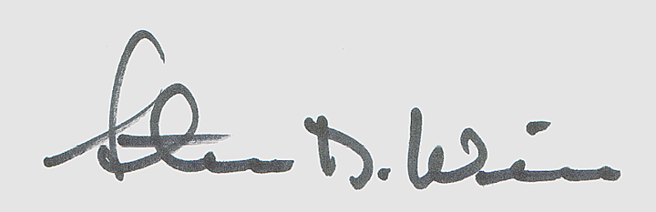

_______________________________
Steven Weiss

