BEFORE THE WASHINGTON UTILITIES AND TRANSPORTATION COMMISSION

In the Matter of the Joint Application of  QWEST COMMUNICATIONS INTERNATIONAL INC. AND CENTURYTEL, INC.  For Approval of Indirect Transfer of Control of Qwest Corporation, Qwest Communications Company LLC, and Qwest LD Corp. |  | DOCKET NO. UT-100820  PETITION FOR CONSIDERATION AND APPROVAL OF SETTLEMENT  AND NARRATIVE IN SUPPORT OF SETTLEMENT PURSUANT TO WAC 480-07-740

- Pursuant to WAC 480-07-740, CenturyLink, Inc., a Louisiana Corporation (“CenturyLink”) and its affiliates, Qwest Communications International Inc. (“QCII”), a Delaware Corporation and its affiliates, including Qwest Corporation (collectively “Joint Applicants”), Integra Telecom, Inc., an Oregon Corporation, and its affiliates (collectively “Integra” or “CLEC”) (collectively, the “Parties”) jointly file the Settlement Agreement (“Settlement”), including its exhibits, that is attached and marked as Attachment 1 to this Petition and request that this Commission approve the Settlement between Joint Applicants and Integra.

BACKGROUND
- CenturyLink and QCII have entered into an Agreement and Plan of Merger, dated April 21, 2010, which, upon completion, will result in QCI becoming a wholly owned subsidiary of CenturyLink (“the Transaction”). The Transaction requires the approval of the Federal Communications Commission (“FCC”) and various state commissions in states where CenturyLink, QCI, or Integra operate, among other approvals. CenturyLink and QCII have filed applications for authorization to effectuate the Transaction at the FCC and in several states, including in Washington. Integra intervened in the Washington review proceeding and filed or presented testimony expressing concerns related to the Transaction. The Parties have reached a mutually agreeable settlement of Integra’s concerns, objections, and proposed conditions regarding the Transaction such that Integra believes that with this Agreement, and without modification or addition to its terms, the Transaction is in the public interest from Integra’s perspective and should be approved by the Commission. The Parties have reached resolution of their disputed issues in this matter. The Parties have embodied that resolution in the Settlement and seek approval of the Settlement by the Commission.

SUMMARY OF SETTLEMENT
- The Settlement (Attachment 1 hereto) consists of eight sections and one attachment (an amendment, which has three attachments to the amendment, plus a rate sheet).

Settlement: Introduction
- This section, consisting of five “whereas” clauses, describes the proposed Transaction, the need for regulatory approvals, Integra’s intervention in proceedings relating to the Transaction, and the Parties’ settlement regarding concerns raised by Integra.

Settlement Section A: Definitions
- This section provides the applicable definitions of key terms used in the settlement agreement, including the definitions of Closing Date, Merged Company, Operational Support Systems, OSS Interfaces, and Qwest Corporation.
Settlement Section B: Terms
- This section states the Parties’ agreement about terms that will apply post-merger, if the Transaction is approved and closes. This section contains fifteen paragraphs relating generally to: (1) transaction-related costs; (2) wholesale performance requirements; (3) Qwest interconnection agreements, Commercial agreements, Wholesale agreements, interstate tariffs, and intrastate tariffs, and other wholesale agreements between Qwest Corporation or its successors and assigns and CLEC (“Extended Agreements”); (4) rates generally; (5) intervals; (6) Incumbent Local Exchange Carrier (“ILEC”) obligations; (7) Bell Operating Company (“BOC”) obligations; (8) wire centers and forbearance; (9) wholesale escalation and other information; (10) data, information, and assistance available to wholesale carriers; (11) staffing and support; (12) Operational Support Systems (“OSS”); (13) engineering and maintenance of network; (14) Unbundled Loops Used to Provide xDSL Services Amendment; and (15) availability of terms to requesting carriers.
Settlement Section C: Process for Treatment of Agreement
- This section confirms that the Settlement is not confidential and will be filed with the Commission for approval and describes the Parties’ agreement regarding the process for treatment of the Settlement agreement in this docket, as it relates to testimony, witnesses, consultants, outside counsel and other procedures. This section also addresses the process in event the Settlement is modified or rejected.
Settlement Section D: Entire Agreement
- This section provides that the Settlement is the entire agreement of the Parties
Settlement Section E: Agreement as Precedent
- This section confirms that the Settlement represents a compromise position of the Parties and addresses how the Settlement may and may not be used.
Settlement Section F: Effective Date
- This section provides that the Settlement is effective upon execution; however, the Settlement is not effective until the Transaction closes.
Settlement Section G: Manner of Execution
- This section confirms that the Parties may execute the agreement in counterparts.
Attachments: Amendment and Exhibits to the Amendment
- There is also an attachment to the Settlement with exhibits, as follows:
Attachment A: Unbundled Loops Used to Provide xDSL Services Amendment to the Interconnection Agreements between Qwest Corporation and Integra and its Affiliates
Attachment 1 to the Amendment: Terms of the amendment
Attachment 2 to the Amendment: Qwest NC/NCI Code Combinations
Attachment 3 to the Amendment: xDSL Capable Loop Performance Parameter Tests
Exhibit A to the Amendment: Rate sheet
- Paragraph 14 of the Settlement further describes the Amendment and the timing of its future filing with the Commission for approval.

THE SETTLEMENT IS IN THE PUBLIC INTEREST
- Pursuant to the requirements of WAC 480-07-740, the Parties believe that the Settlement is in the public interest. It resolves contested issues without further litigation among the Parties to the Settlement, and helps avoid future disputes by setting forth agreed upon post-merger terms. The Joint Applicants and Integra will each offer a witness in favor of approval of the Settlement, if the Commission deems it necessary.

CONCLUSION
The Parties respectfully request that the Commission promptly approve the Settlement.

DATED this 10th day of November, 2010.

CENTURYLINK QWEST

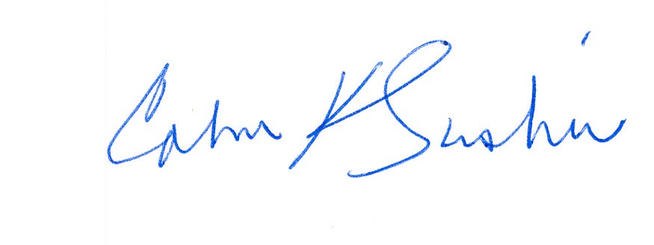
__________________ ____________________________
Calvin K. Simshaw Lisa A. Anderl (WSBA # 13236)
CenturyLink Qwest Law Department
805 Broadway 1600 – 7th Ave., room 1506
Vancouver, WA 98660 Seattle, WA 98191
calvin.simshaw@centurylink.com lisa.anderl@qwest.com

INTEGRA TELECOM OF WASHINGTON, INC.

By: __________________________
J. Jeffrey Oxley
EVP, General Counsel
jjoxley@integratelecom.com

