WN U-74 |  |  |  | Ninth Revision of Sheet No. 24.1
 |  |  |  | Canceling Eighth Revision Sheet No. 24.1
PACIFIC POWER & LIGHT COMPANY
 |  |  |  |  |  |  |  |  |  |  | FOR COMMISSION’S RECEIPT STAMP
SCHEDULE 24
SMALL GENERAL SERVICE

AVAILABLE:
In all territory served by Company in the State of Washington.

APPLICABLE:
To non-residential Customers whose entire requirements are supplied hereunder with electric service loads which have not exceeded 100 kW more than once in the preceding 12-month period, or with seven months or less of service, whose loads have not registered more than 100 kW. And to seasonal Customers, as defined in Rule 1 of this tariff, with electric service loads which have not exceeded 200 kW more than once in the preceding 12-month period, or with seven months or less of service, whose loads have not registered more than 200 kW. In the case that the motor nameplate horsepower rating is used to determine the seasonal Customer’s annual load size, that load size will also be used to determine eligibility for this schedule.
The Company will not switch a Customer between General Service Schedules 24 and 36 more than once in a 12-month period, unless the following exception is met: In the event that a Customer’s load increases due to changes in operations, the Company may, at its discretion, place the Customer on a schedule with a higher demand requirement, if so warranted.
Deliveries at more than one point, or more than one voltage and phase classification, will be separately metered and billed.
Emergency, Seasonal, and Remote Service will be furnished by contract in accordance with Rule 2 of this Tariff.
This Schedule is not applicable to standby service.

MONTHLY BILLING:
The Monthly Billing shall be the sum of the Basic, Demand, Energy, and Reactive Power Charges. All Monthly Billings shall be adjusted in accordance with Schedules 91, 96, 98, and 191.

Basic Charge:

If Load Size* is: The Monthly Basic Charge* is:
Single Phase Three Phase
(I)

(I)
(I)

15 kW or less $7.75 $11.51

Over 15 kW $7.75 plus $.83 per $11.51 plus $.83 per
kW for each kW in kW for each kW in
excess of 15 kW. excess of 15 kW.

*Note: kW Load Size, for the determination of the Basic Charge, shall be the average of the two greatest non-zero monthly demands established any time during the 12-month period which includes and ends with the current billing month.

(Continued)
Issued |  |  |  |  | February 9, 2009 |  | Effective |  |  | March 11, 2009
Issued by |  |  | PACIFIC POWER & LIGHT COMPANY
By |  | 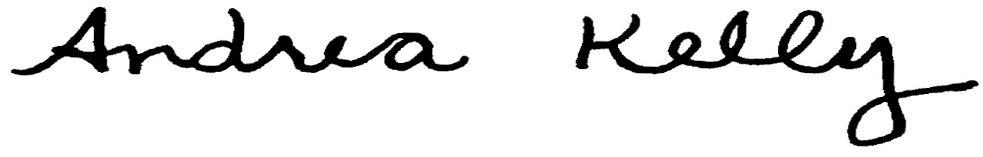  Andrea L. Kelly |  |  |  |  |  | Title | Vice President, Regulation
 |  | TF2 24.1REV |  |  |  | Advice No. |  |  |  |  |  | UE-08
Form F

