WN U-74 |  |  | Eighth Revision of Sheet No. 18.1
 |  |  | Canceling Seventh Revision of Sheet No. 18.1
PACIFIC POWER & LIGHT COMPANY
 |  |  |  |  |  |  |  |  |  |  | FOR COMMISSION’S RECEIPT STAMP
SCHEDULE 18
THREE PHASE RESIDENTIAL SERVICE RIDER

AVAILABLE:
In all territory served by Company in the State of Washington.

APPLICABLE:
To residential Customers requiring three-phase service whose single-phase requirements are or will be supplied under any residential schedule contained in this Tariff. Three-phase service will be supplied only when service is available from Company's presently existing facilities, or where such facilities can be installed under Company's Line Extension Rules, and in any event, only when deliveries can be made by using one service for Customer's single-phase and three-phase requirements.

MONTHLY BILLING:
The Monthly Billing shall be the sum of the Demand Charge, and the Basic and Energy Charges of the Residential Schedule 16. All Monthly Billings shall be adjusted in accordance with Schedules 91, 96, 98, and 191.

Demand Charge: Applicable only to Customer's three-phase Demand:

(I)
(I)

$1.65 for each kW of Demand, but not less than
$3.20 minimum demand charge.

MINIMUM CHARGE:
The monthly Minimum Charge shall be the Basic Charge specified on Residential Schedule 16, plus the demand charge herein. A higher minimum may be required under contract to cover special conditions.

DEMAND:
Applicable only to the Customer's three-phase demand.

The kW shown by or computed from the readings of Company's demand meter, for the 15-minute period of Customer's greatest use during the month, determined to the nearest whole kW.
(Continued)
Issued |  |  |  |  | February 9, 2009 |  | Effective |  |  | March 11, 2009
Issued by |  |  |  | PACIFIC POWER & LIGHT COMPANY
By |  | 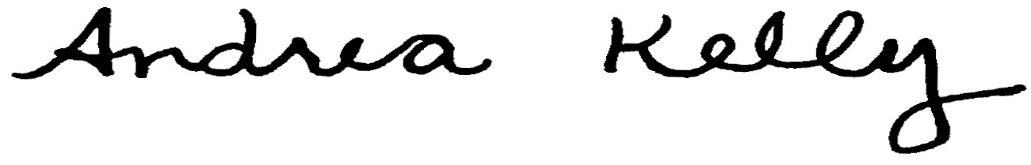  Andrea L. Kelly |  |  |  |  |  | Title | Vice President, Regulation
 |  | TF2 18.1REV |  |  |  | Advice No. |  |  |  |  |  | UE-
Form F

