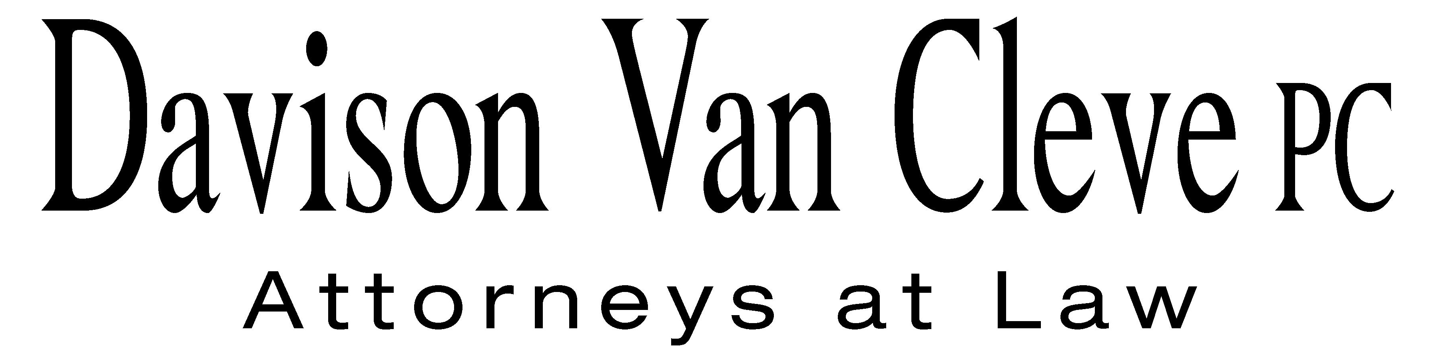
TEL (503) 241-7242 ● FAX (503) 241-8160 ● mail@dvclaw.com
Suite 400
333 SW Taylor
Portland, OR 97204

July 3, 2008

Via Email and Federal Express

Carole J. Washburn
Secretary
Washington Utilities and Transportation Commission
PO Box 47250
1300 S Evergreen Park Drive SW
Olympia, WA 98504-7250

Re: In the matter of the Puget Sound Energy, Inc.’s general rate increase.

Docket No. UE-072300/UG-072301

Dear Ms. Washburn:

Enclosed please find the original and twelve copies of the following documents on behalf of the Industrial Customers of Northwest Utilities for filing in the above-captioned matter:

Cross Answering Testimony of Donald W. Schoenbeck.

Thank you for your assistance.

Sincerely yours,

/s/ Brendan E. Levenick
Brendan E. Levenick

Enclosures

cc: Service List

CERTIFICATE OF SERVICE

I hereby certify that I have this day served the foregoing documents upon all parties of record in this proceeding by mailing a copy thereof in a sealed, first-class postage prepaid envelope to each individual’s last-known address, as listed below.
DATED in Portland, Oregon this 3rd day of July, 2008.
Davison Van Cleve, P.C.

/s/ Brendan E. Levenick
Brendan E. Levenick

PUGET SOUND ENERGY  TOM DEBOER  PO BOX 97034 PSE-08N  BELLEVUE WA 98009-9734  tom.deboer@pse.com | PERKINS COIE  SHEREE CARSON  JASON KUZMA  10885 N.E. FOURTH STREET STE 700  BELLEVUE WA 98004-5579  scarson@perkinscoie.com  jkuzma@perkinscoie.com
QUALITY FOOD CENTERS, INC.  10116 N.E. 8TH STREET  BELLEVUE WA 98004 | SEATTLE STEAM COMPANY  1325 FOURTH AVE. STE 1440  SEATTLE WA 98101
THE KROGER CO.  ATTN: CORPORATE ENERGY MANAGER (G09)  1014 VINE STREET  CINCINNATI OH 45202  dgeorge@kroger.com | WASHINGTON AND NORTHERN IDAHO DISTRICT  COUNCIL OF LABORERS  PO BOX 12917  MILL CREEK WA 98082-0917
NAVAL FACILITIES ENGINEERING COMMAND-HQ  ACQ-UTILITIES RATES AND STUDIES OFFICE  KAY DAVOODI  1322 PATTERSON AVENUE SE BUILDING # 33  WASHINGTON NAVY YARD DC 20374-5018  khojasteh.davoodi@navy.mil | THE ENERGY PROJECT  CHARLES M EBERDT  1322 N. STATE ST.  BELLINGHAM WA 98225  chuck_eberdt@oppcro.org
NORTHWEST INDUSTRIAL GAS USERS  PAULA E PYRON  4113 WOLF BERRY COURT  LAKE OSWEGO OR 97035-1827  ppyron@nwigu.org | SEATTLE STEAM CO.  ROBERT SHEPPARD  30 GLACIER KEY  BELLEVUE WA 98006
LARKIN AND ASSOCIATES  15728 FARMINGTON ROAD  LIVONIA MI 48154  rsmithLA@gmail.com | BOEHM, KURTZ & LOWRY  KURT J BOEHM  MICHAEL L KURTZ  36 E. SEVENTH ST. STE 1510  CINCINNATI OH 45202  kboehmlaw@aol.com  mkurtz@bkllawfirm.com
BRUBAKER & ASSOCIATES, INC.  MAURICE BRUBAKER  1215 FERN RIDGE PARKWAY STE 208  ST. LOUIS MO 63141  mbrubaker@consultbai.com | CABLE HUSTON BENEDICK HAAGENSEN & LLOYD  EDWARD A FINKLEA  CHAD M STOKES  1001 S.W. 5TH STE 2000  PORTLAND OR 97204  efinklea@chbh.com  cstokes@chbh.com
FEDERAL EXECUTIVE AGENCIES  NORMAN J FURUTA  333 MARKET ST FL 10 MS 1021A  SAN FRANCISCO CA 94105-2195  norman.furuta@navy.mil | DEPARTMENT OF THE NAVY  SCOTT JOHANSEN  1220 PACIFIC HIGHWAY  SAN DIEGO CA 92132  scott.johansen@navy.mil
RONALD L ROSEMAN  2011 - 14TH AVENUE EAST  SEATTLE WA 98112  ronaldroseman@comcast.net | GRAHAM & DUNN  ELAINE SPENCER  PIER 70 STE 300  2801 ALASKAN WAY  SEATTLE WA 98121-1128  espencer@grahamdunn.com
ATTORNEY GENERAL OFFICE  ROBERT D CEDARBAUM  STATE MAIL STOP 40128  OLYMPIA WA 98504-0128  bcedarba@wutc.wa.gov | OFFICE OF THE ATTORNEY GENERAL  SIMON FFITCH  800 FIFTH AVENUE STE 2000  SEATTLE WA 98104-3188  simonf@atg.wa.gov
SCHWERIN CAMPBELL BARNARD & IGLITZEN  DMITRI IGLITZIN  18 W MERCER STREET STE 400  SEATTLE WA 98119  iglitzin@workerlaw.com | WUTC  DON TROTTER  ASSISTANT ATTORNEY GENERAL  ATTORNEY GENERAL SECTION  STATE MAIL STOP 40128  OLYMPIA WA 98504-0128 dtrotter@wutc.wa.gov
MARILYN SHOWALTER  2601 CAPITOL WAY  OLYMPIA WA 98501  marilyn.showalter@gmail.com | DAVIS WRIGHT TREMAINE  CRAIG GANNETT  1201 THIRD AVENUE STE 2200  SEATTLE WA 98101-3045  E-mail: craiggannett@dwt.com

