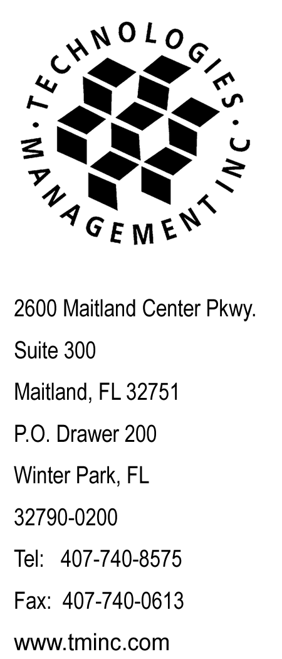
June 29, 2015
Via Email
Records@utc.wa.gov

Records Division (Email)
Washington Utilities &Transportation Comm.
Records@utc.wa.gov,

RE: Budget PrePay, Inc. d/b/a Budget Mobile
WA Copy of FCC Form 481 - Carrier Annual Reporting
Eligible Telecommunications Carriers' annual filings to the Federal Communications Commission pursuant to 47 C.F.R. § 54.313. and 47 C.F.R. 54.422 (Form 481). Docket Number UT-150063

Dear Sir or Madam:

Enclosed please find the WA Copy of FCC Form 481 - Carrier Annual Reporting, filed on behalf of Budget PrePay, Inc. d/b/a Budget Mobile. No check is enclosed as there are no remittance fees due.

This report has been emailed to Records@utc.wa.gov in PDF and Word format.

Questions regarding this filing should be directed to my attention at 407-740-8575. Thank you for your assistance in this matter.

Sincerely,

Craig Neeld
Compliance Reporting Specialist

cc: Lakisha Taylor - Budget PrePay, Inc. d/b/a Budget Mobile
file: Budget PrePay, Inc. d/b/a Budget Mobile - Reporting - Washington

CN/ab

