WN U-74 |  |  | Eleventh Revision of Sheet No. 17.1
 |  |  | Canceling Tenth Revision of Sheet No. 17.1

PACIFIC POWER & LIGHT COMPANY
 |  |  |  |  |  |  |  |  |  |  | FOR COMMISSION’S RECEIPT STAMP
SCHEDULE 17
LOW INCOME BILL ASSISTANCE PROGRAM - RESIDENTIAL SERVICE
OPTIONAL FOR QUALIFYING CUSTOMERS

AVAILABLE:
In all territory served by Company in the State of Washington.

APPLICABLE:
To residential Customers only for all single-phase electric requirements when all service is supplied at one point of delivery. For three-phase residential service see Schedule 18.

MONTHLY BILLING:
The Monthly Billing shall be the sum of the Basic and Energy Charges and the Low Income Energy Credit. All Monthly Billings shall be adjusted in accordance with Schedules 96, 98 and 191.

(I)

(I)
(I)

(I)

(I)

(I)

Basic Charge: $7.00

Energy Charge:

Base
Rate
5.657¢ per kWh for the first 600 kWh
8.929¢ per kWh for all additional kWh

LOW INCOME ENERGY CREDIT*:
The credit amount shall be based on the qualification level for which the customer was certified.

0-75% of Federal Poverty Level(FPL):
(4.172¢) per kWh for all kWh greater than 600 kWh
76-100% of Federal Poverty Level(FPL):
(2.807¢) per kWh for all kWh greater than 600 kWh
101-125% of Federal Poverty Level (FPL):
(1.754¢) per kWh for all kWh greater than 600 kWh

RULES AND REGULATIONS:
Service under this schedule is subject to the General Rules and Regulations contained in the tariff of which this schedule is a part and to those prescribed by regulatory authorities.
(continued)
Issued |  |  |  |  | February 9, 2009 |  | Effective |  |  | March 11, 2009
Issued by |  |  |  | PACIFIC POWER & LIGHT COMPANY
By |  | 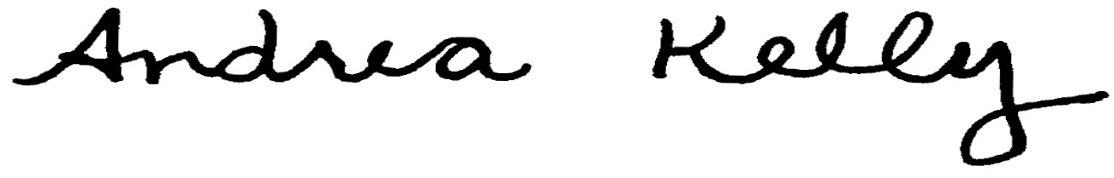  Andrea L. Kelly |  |  |  |  |  | Title | Vice President, Regulation
 |  | TF2 17.1REV |  |  |  | Advice No. |  |  |  |  |  | UE-
Form F

