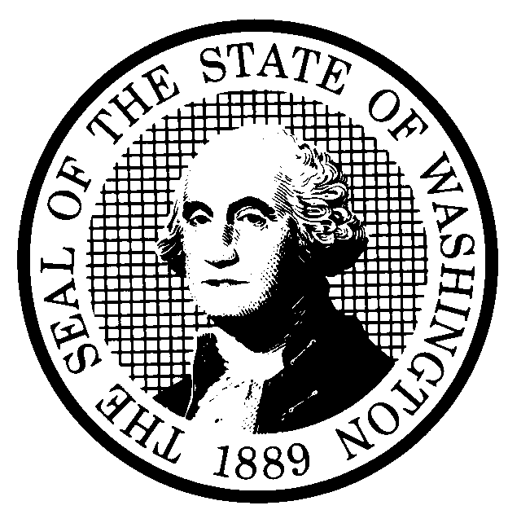 | PREPROPOSAL STATEMENT OF INQUIRY |  | CR-101 (June 2004)  (Implements RCW 34.05.310)  Do NOT use for expedited rule making
Agency: Washington Utilities and Transportation Commission

Subject of possible rule making: In 2006, the Washington Utilities and Transportation Commission (Commission) adopted rules requiring investor-owned electric (WAC 480-100-238) and natural gas (WAC 480-90-238) utilities to engage in long-term planning processes and file, every two years, an integrated resource plan (IRP) with the Commission. The rules also describe the basic principles and resource alternatives that utilities should consider in their plans and set forth requirements for public participation. Also in 2006, the Commission adopted rules relating to utility resource acquisition in WAC 480-107 that are closely aligned with the IRP rules.

The Commission’s inquiry will evaluate:
- Whether additional rule provisions are needed to implement IRP legislation in RCW 19.280;
- Rule language to clarify how recent advances in the energy industry should be treated in the IRP;
- How the resource acquisition rule in WAC 480-107 can be made more effective to reduce the frequency of utility waiver requests for this rule; and
- General process improvements to make the IRP review process more efficient.
Statutes authorizing the agency to adopt rules on this subject: RCW 80.01.040, 80.04.160, and 19.280.040
Reasons why rules on this subject may be needed and what they might accomplish: Shortly after Commission’s adoption of its IRP rules in 2006, the Legislature codified similar IRP requirements in RCW 19.280. The Legislature amended the IRP statute in the 2009, 2011, 2013, and 2015 legislative sessions, and the statute now includes provisions and legislative intent that are not explicitly addressed in the Commission’s rules. Furthermore, recent advances in the energy industry, such as the rapid growth of distributed generation and the development of energy storage technologies, have created modeling challenges for the IRP process that may be clarified through additional rulemaking. Finally, the Commission’s experience in administering the IRP and resource acquisition rules since 2006 has provided additional insight into opportunities for improving those processes and ensuring that utility planning and procurement processes meet the Legislature’s intent to develop “new, safe, clean, and reliable energy sources to meet demand in Washington for affordable and reliable electricity.” (RCW 19.280.010).
Identify other federal and state agencies that regulate this subject and the process coordinating the rule with these agencies: See Attachment
Process for developing new rule (check all that apply):
Negotiated rule making
Pilot rule making
Agency study
Other (describe) The UTC employs a collaborative rulemaking process that consists of stakeholder workshops, formal comments and draft rule reviews.
How interested parties can participate in the decision to adopt the new rule and formulation of the proposed rule before publication:
See Attachment
DATE  September 1, 2016 |  | CODE REVISER USE ONLY
NAME (TYPE OR PRINT)
Steven V. King

SIGNATURE
TITLE
Executive Director and Secretary

