August 29, 2016
Steven V. King
Executive Director and Secretary
Washington Utilities and Transportation Commission
1300 S. Evergreen Park Drive, SW
Olympia, WA 98504-7250
Re: T-Mobile West LLC AMENDED Annual Certification
Dear Mr. King:
Enclosed for filing are the following:
- A Word document of T-Mobile West LLC’s Amended Annual Petition for Certification as an ETC, with the amended portion of the Petition highlighted;
- A PDF of T-Mobile West LLC’s Amended Annual Petition for Certification as an ETC with a color copy of new Attachment I; and
- An electronic copy of new Attachment I to T-Mobile West LLC’s Amended Annual Petition for Certification as an ETC in ESRI.shp format provided on a thumb drive.
Please feel free to contact me with any questions.
Very truly yours,
Davis Wright Tremaine LLP
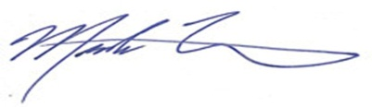
Mark P. Trinchero
Attorneys for T-Mobile West LLC

MPT/jan
Enclosures

