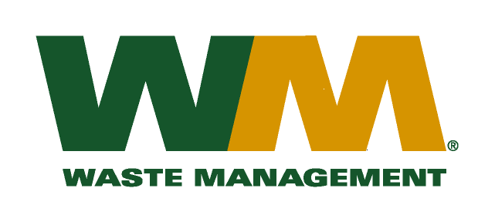
July 30, 2026
Washington Utilities and Transportation Commission
Chandler Plaza Building
1300 S. Evergreen Park Drive SW
P.O. Box 47250
Olympia, WA 98504-7250
Subject: Waste Management–North Sound and Waste Management - Marysville, divisions of Waste Management of Washington, Inc. (G-237); Tariff # 19
Enclosed are revised pages 2, 22, 23, 24, 27, 28, 29, 30, 31 and 32 to the above-referenced tariff. The purpose of these tariff revisions is to reflect the change in the commodity credits for residential and multi-family customers receiving recycling collection services. These tariff revisions reflect a decrease of the current commodity credit from $1.64 to $1.04 per month for residential customers in Snohomish County and a decrease from $1.52 to $1.13 per month for residential customers in King County. Multi-family commodity credits are decreasing proportionately to the decreases to residential customers. As a result, this filing seeks approval to implement an increase in customers’ solid waste collection rates.
These decreases in the commodity credits are due to the overall changes in commodity values and tonnages since our last commodity credit adjustment on January 1, 2015. The proposed effective date of the revised recycling commodity credits is January 1, 2016.
As a reminder of context, this filing is being submitted at the end of the two-year Revenue Sharing Plans with Snohomish and King Counties for 2014 - 2015. It is the second annual adjustment to commodity credits that has been made during the two-year plan period, and as required by WAC 480-70-351 reflects the changes to the commodity rebates due to actual prices and quantities over the past 12 months. In addition and in accordance with RCW 81.77.185 and the approved Plans, the Company has reflected in this filing the incentives earned and the amounts over or under spent on program activities over the past two years.
Furthermore, in accordance with RCW 81.77.185, the recycling commodity credit is also being adjusted to accommodate new Revenue Sharing Plans with Snohomish and King Counties for 2016 - 2017, under which the Company is authorized to retain up to 45.0% and 47.5%, respectively, of recycling commodity revenues to be spent on program activities. The 2016 - 2017 Revenue Sharing Plans with Snohomish and King Counties that have been certified by County officials, are included with this filing with budgets for anticipated revenues and expenditures and narrative explanations of how the recycling revenue retained will be used to increase recycling. The Counties will be separately filing their Plan certifications, as well as an analysis of the Company’s performance supporting the incentives earned under the 2014-2015 Plans.
Enclosed for your review are our accounting work papers. Customers will be notified of the change in their commodity credit adjustment on their next regularly scheduled billing after the approval of the Commission. In addition, the counties have been notified of these proposed tariff changes.
If you have any questions or need additional information, please contact me at (425) 814-7840.
Very truly yours,

Mike Weinstein
Senior Pricing Manager, Pacific Northwest Market Area
cc: Jeff McMahon & Carlton Paulmier, Waste Management
Pat D. McLaughlin, King County Solid Waste Division
Matt Zybas, Snohomish County Solid Waste Division

