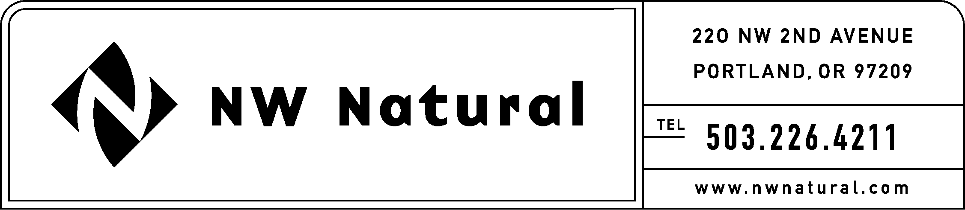
GAIL HAMMER
Rates and Regulatory Affairs
Phone: 503.226.4211 ext. 5865
Fax: 503.721.2516
gail.hammer@nwnatural.com

May 31, 2016

Steven King, Executive Director and Secretary
Washington Utilities and Transportation Commission
1300 S. Evergreen Park Drive, S.W.
P.O. Box 47250
Olympia, Washington 98504-7250

RE: UG-151776, NW Natural’s 2016 IRP Work Plan, Supplement No. 2
DO NOT REDOCKET

NW Natural Gas, dba NW Natural (“NW Natural” or the “Company”), herein files Supplement No. 2 to its 2016 Integrated Resource Plan (IRP) Work Plan which was originally submitted on August 28, 2015, in compliance with Washington Administrative Code (“WAC”) 480-90-238.

The Supplemental IRP Work Plan reflects revised start and end times to three of the Technical Working Group meetings as well as updated agenda topics for the Technical Working Group meetings. The schedule will now allow for topics that have not yet been covered to be discussed at the June 22 Technical Working Group meeting prior to releasing the Draft 2016 IRP. If it is determined that additional discussion is required following the release of the draft, a sixth Technical Working Group meeting will be scheduled.

If you have any questions regarding this plan, please contact me at
(503) 226-4211, extension 5865.

Sincerely,

/s/ Gail Hammer

Gail Hammer
NW Natural

Enclosures

