July 17, 2015

VIA ELECTRONIC FILING SYSTEM

Mr. Steven V. King
Washington Utilities & Transportation Commission
1300 S. Evergreen Park Drive SW
Olympia, WA 98504-7250

RE: Docket UT-151438: 2015 ETC Certification – Eligible Telecommunications Carrier’s Annual Report on High Cost Fund Support Pursuant to WAC 480-123-060, 070, and 080 and Affidavit Pursuant to WAC 480-123-060 and 070.

As requested by Staff, this cover letter and ETC annual report(s) attached is replacing the original filing document.. Pursuant to WAC 480-123-060, Pend Oreille(“Company”) hereby requests that the Washington Utilities and Transportation Commission (“Commission”) certify to the Federal Communications Commission and the Universal Service Administrative Company that the Company has met the requirements of 47 C.F.R. § 54.314 for eligibility for continued receipt of federal high-cost funds.
The certifications and reports that are specified in WAC 480-123-060, WAC 480-123-070 and WAC 480-123-080 have already been submitted.
Pend Oreille Telephone Company electronically submits its redacted ETC Annual Report and Affidavits pursuant to WAC 480-123-060, 070, and 080. Please be advised that a native version of some of the files is not available.

Please feel free to contact me with any questions regarding this particular matter.

Sincerely,
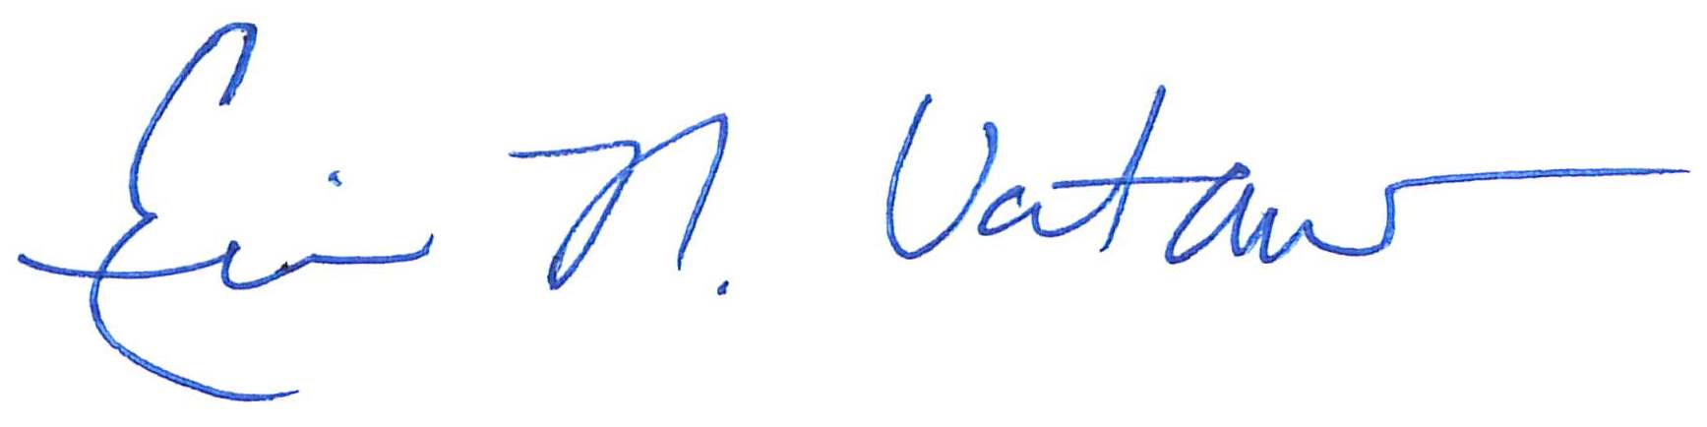
Eric N. Votaw, Senior Manager for
Moss Adams LLP
Enclosures

