
Thank you for being a Qwest customer

BILLING NAME 1
BILLING NAME 2 Help Us Go Green!
BILLING NAME 3 See page 2 for details!

Account Number: NPA NXX-LLLL CUSR
Bill Date: January 7, 2008

Customer Service: 1 800-244-1111 Or go online at: qwest.com
Repair: 1 800-573-1311

INCLUDED IN YOUR STATEMENT YOU MAY WANT TO CONSIDER

Phone Internet Wireless TV Example
Service Service Service Service Example
Call or visit qwest.com to learn more!
You have Qwest Bundle service
Box 2:
‘Past Due Balance (Disregard if Paid)’ will display when the dollar amount is greater than zero.
‘Balance’ will display when the dollar amount is zero or a credit. Existing rules apply.
and are receiving $XX in bundle savings and promotion discounts!

Previous Balance
$XXX.XX

- Payment(s)
Mmm. DD
$XXX.XX
- Adjustment(s)
$XX.XX

= Past Due Balance
$X.XX
(Disregard if Paid)
+ Total New Charges
$XXX.XX

Due by
Mmm. DD YYYY
= Total Amount Due
$XXX.XX

Thank you!



Marketing Message in this space
Marketing Message in this space
Marketing Message in this space

Please fold, tear here and return this portion with your payment.
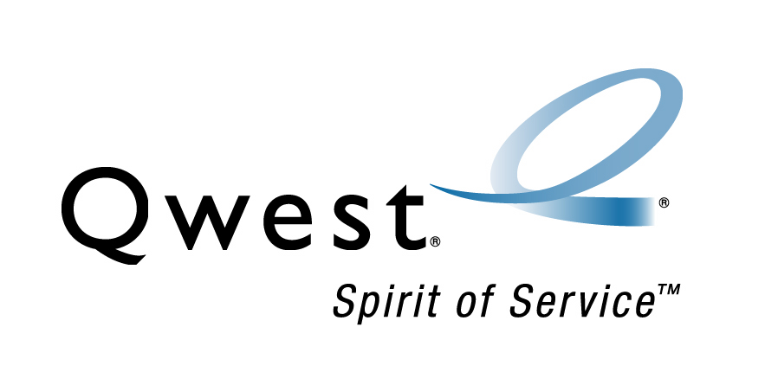
To change your billing address,
call us at 1 800-244-1111 Account: NPA NXX-LLLL CUSR
Payment Due Date: Month DD, YYYY
Total Amount Due: $XXX.XX
Amount Enclosed: ____________
Bill Name See reverse of this page to enroll in
Billing Address automatic payment and/or paperless billing!
City, ST Zip code

Qwest
PO BOX 173384
Denver, CO 80217-3384

CUSTOMER SERVICE ACCOUNT NUMBER BILL DATE Page 2 of X
1 800-244-1111 NPA NXX-LLLL CUSR Mmm D, YYYY
REPAIR Bill Name
1 800-573-1311

qwest.com


State specific mandated language currently in production will be used in this section.

LEAF If you would like to join Qwest in
ICON conserving natural resources,
please select “Paperless Billing” on
the stub below to opt out of receiving a paper bill. Should you ever need full details of your current bill, call Customer Service at the number above and they will be happy to provide a paper copy to you at no cost. Or log on to qwest.com/myaccount to view your bill details online. A charge will be assessed for a request of a paper copy of your bill older than six months or an online bill older than twelve months.

Your Long-Distance Provider Has Changed
At your request, Qwest Long Distance has recently been made your provider for long-distance calls outside your local toll calling area.

At your request, Qwest Long Distance has recently been made your provider for long-distance calls inside your local toll calling area.

If you did not authorize this, please call
1 800-922-1879.

This is a summary billing statement of your current bill. You may always get your current bill with detailed charges at qwest.com/myaccount or by calling Qwest. A charge will be assessed for requests for an online bill older than twelve months.
Information About Your Account
At Qwest, our top priority is providing you with quality customer service. As part of that commitment, we have prepared the following information to help you understand your account. If you need additional assistance, please call Customer Service at the number listed on this statement. Customers using Teletype (TTY) devices can direct their inquiries to Qwest at 1 800-223-3131, a TTY equipped number.

Charges for your monthly service are billed one month in advance. Qwest should receive your payment for the total amount due on or before the due date on your bill. If you are unable to pay by the due date, please contact Customer Service to avoid possible collection action. Your basic telephone service will not be disconnected for non-payment of charges for services that are identified by an asterisk [ * ]. Qwest packages of features and the amounts shown on the summary page may include both basic and charges that are not basic.

Late Charge Reminder: Any amount left unpaid 30 days after bill date is subject to a 1.2% late payment charge.

To make additional payments: Make a check payable to Qwest. Write your account on your check and mail to:
Qwest
Payment Center
Denver, CO 80244-0001

Or, pay online at qwest.com and/ or to view your bill, change your billing address, order new products and services, check your Qwest Wireless minutes.

Language change here for the Summary Billing Statement.


This is a recurring statement for customers who have elected to opt into the Summary Billing Statement.


_____________________________________________________________________________________

E-mail Address Signature Date

Check the appropriate box below and return with your check for this month’s payment.

Account Number NPA NXX-LLLL CUSR

Automatic By checking this box and signing above, you are authorizing and instructing your financial
Payment institution to debit the monthly amount due on your Qwest bill from your account associated with your enclosed payment, and remit directly to Qwest. Or, you may sign up for Automatic Payment at qwest.com/billpay. (To discontinue Automatic Payment you must call Qwest.)

Paperless By checking this box, providing your e-mail address, and signing above, you are authorizing
Billing Qwest to enroll you in Paperless Billing. You will need to create an online account at qwest.com/billpay in order to view your bill.

CUSTOMER SERVICE ACCOUNT NUMBER BILL DATE Page 3 of X
1 800-244-1111 NPA NXX-LLLL CUSR Mmm D, YYYY
REPAIR Bill Name
1 800-573-1311

qwest.com

Promotional and saving statements will appear as what is in production today.
Your savings this month

Thank you for being a valued Qwest customer with Bundle Savings from:
• Qwest Choice DSL with MSN® • Qwest Wireless Cross Country
• Qualifying LD Plan • DIRECTV® Bundle Savings based on the 4 products
you currently have is $37.00 per month. This bill includes a Bundle Savings of $37.00.

Bundle Savings Discount
Qwest Digital Voice $5.00
Qwest Connect SLVR w MSFT 12.00
Cross Country Plus 15.00
DIRECTV w/Minimum Programming 5.00

Total Bundle Savings $37.00

Promotional Discounts Discount
Qwest Broadband Promotion $XX.XX

Total Promotional Discounts $XX.XX

Total savings this month $XX.XX

Discounts are given one month in advance. Your bill may include a partial month and a month in advance of billing. Product changes may result in a charge for unused discounts previously given.
Local Service and Long Distance are shown separately on the Summary Billing Statement.

Summary of New Charges
DISCOUNTS TOTAL WITH
SERVICE PRICE & SAVINGS SAVINGS

Phone Service

Local Service Monthly Charges $29.99 $29.99
Long Distance Monthly Charges * 20.00 - 5.00 15.00
Related Monthly Charges 9.50 9.50

This statement was added for FCC TIB requirement
Taxes, Fees & Surcharges 9.60 9.60

Usage Charges 2.05 2.05
Your basic telephone service (dial tone) will not be disconnected for non-payment of other services included in this section. For a detailed breakdown of your services, go to: qwest.com/my account or call Qwest.
Total Phone Service $XX.XX
Internet Service *
Qwest Broadband with MSFT Monthly Charges 44.99 - 12.00 32.99
Related Monthly Charges 4.99 4.99
Taxes, Fees & Surcharges - .36 - .36
Total Internet Service $XX.XX

Qwest Leased Equipment * Total Qwest Leased Equipment $XX.XX
Wireless Phone Service *
Monthly Charges 44.99 - 15.00 29.99
Related Monthly Charges 1.75 1.75
Taxes, Fees & Surcharges 4.47 4.47
Total Wireless Phone Service $XX.XX
TV Service *
DIRECTV Monthly Charges 44.99 - 5.00 39.99
Related Monthly Charges 4.99 4.99
Total TV Service $XX.XX

Other Companies *
AT&T – contact 8XX NXX-LLLL Total AT&T Charges $XX.XX

Late Payment Charge on $XXX.XX Total Late Payment Charge $XX.XX
Total New Charges $XXX.XX
* For additional information, see Information About Your Account, on page 2.

