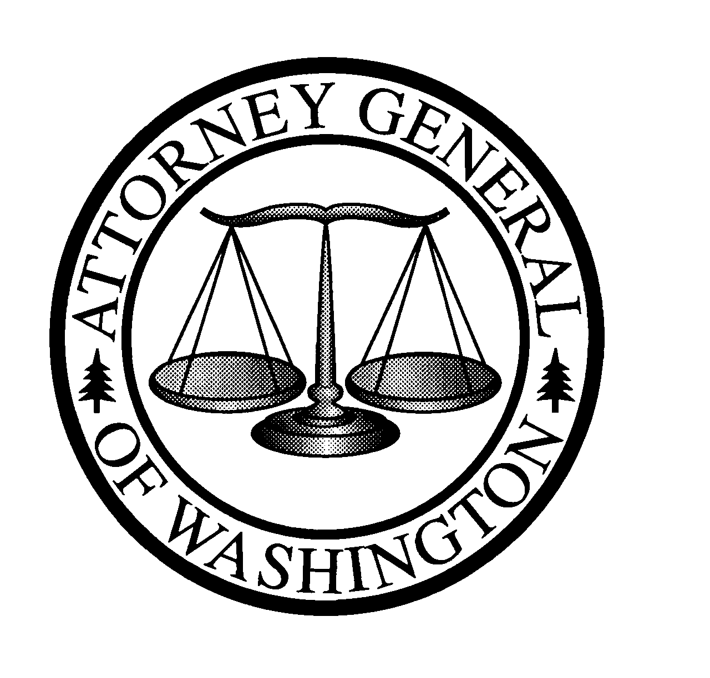
Christine O. Gregoire
ATTORNEY GENERAL OF WASHINGTON
900 Fourth Avenue, Suite 2000 • TB-14 • Seattle, Washington 98164-1012

November 27, 2002

Carole Washburn
Secretary, Washington Utilities and Transportation Commission
1300 S. Evergreen Pk. Dr. S.W.
PO Box 47250
Olympia, WA 98504-7250

Re: Telecommunications Rulemaking, Docket No. UT-990146

Dear Ms. Washburn:

Public Counsel files these comments in support of the proposed rule modifications filed recently by the Low Income Telecommunications Project (LITE) and the Seattle Telecom Consortium.
The comments filed by the LITE project at Spokane Neighborhood Action Programs (SNAP) recommended modifications to the proposed rule WAC 480-120-174. Comments of the Low Income Telecommunications Project on Proposed WAC 480-120-174, November 13, 2002. This proposed rule would establish certain provisions to facilitate service restoration to customers eligible for the Washington Telephone Assistance Program (WTAP) or Tribal Lifeline. We believe the recommended language changes proposed by LITE would provide for significant consumer benefit by promoting the goal of universal service, and would impose a very minimal burden on local exchange companies. The changes LITE recommends would allow WTAP and Tribal Lifeline customers who were disconnected – even while participating in those programs – to utilize the provisions in the proposed rule. The modifications proposed by LITE would also enable WTAP and Tribal Lifeline eligible customers to get reconnected once they pay any basic service prior obligation. Companies would be allowed to toll restrict and ancillary-restrict, and thus the potential exposure for a company is only $4 per month (for WTAP customers) or $1 per month (for Tribal Lifeline customers). We believe LITE provides compelling evidence in support of their recommended modifications, and we respectfully encourage the Commission to consider LITE’s proposed changes to proposed WAC 480-120-174.

Public Counsel also supports the recent comments filed by the Seattle Telecom Consortium in this docket. Comments of the Seattle Telecom Consortium: Senior Service, WPAS, and ACRS, November 12, 2002. In their November 12, 2002 comments, the Seattle Telecom Consortium has recommended three modifications to the proposed rules, including two changes to proposed WAC 480-120-172 (Discontinuing service—company initiated) and a related change to proposed WAC 480-120-251 (Directory service). The recommended modifications would help to provide customers with valuable information related to their rights to a grace period for disconnection due to a medical emergency, and the customer’s right not be disconnected or have service restricted while they are pursuing a remedy or appeal. Again, we believe these proposed modifications offer tremendous consumer benefit, with little to no additional burden being placed on companies. Thus, we respectfully encourage the Commission to consider the proposed changes recommended by the Seattle Telecom Consortium.

Very truly yours,

Robert Cromwell
Assistant Attorney General
Public Counsel Section

cc: Chairwoman Marilyn Showalter
Commissioner Richard Hemstad
Commissioner Patrick Oshie
Bob Shirley

