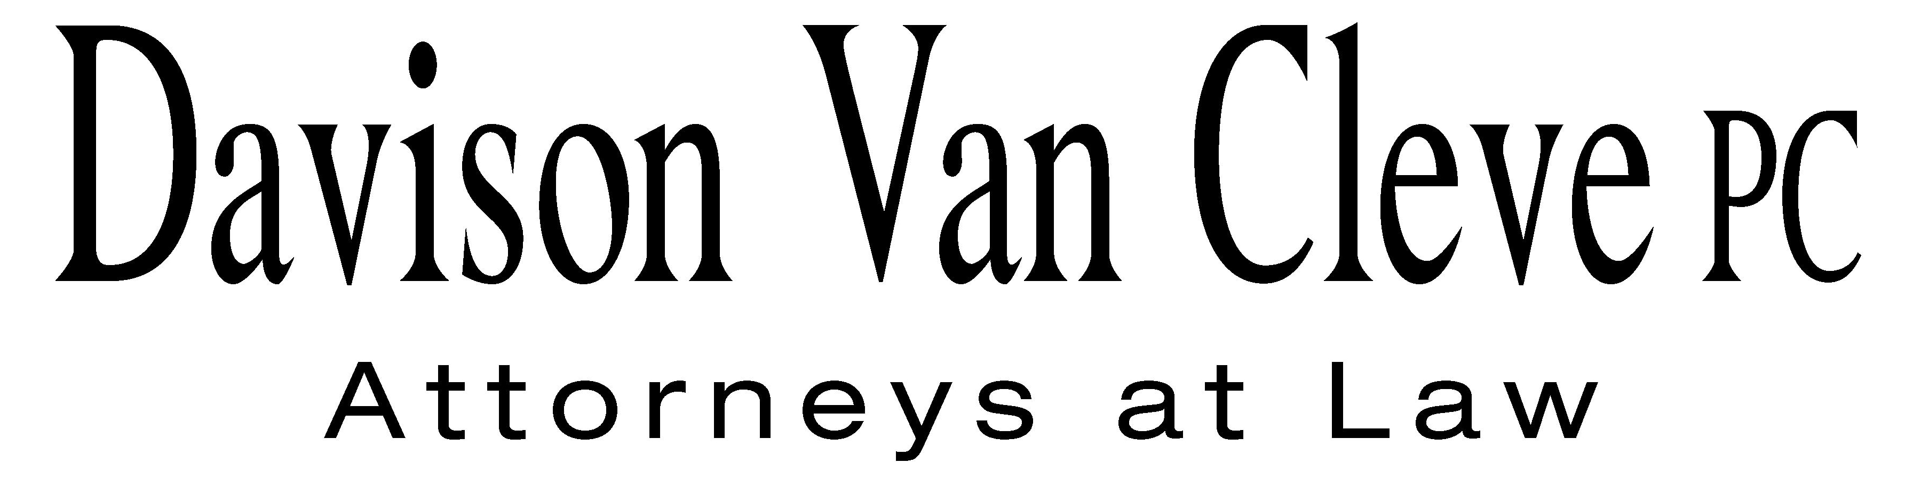
TEL (503) 241-7242 ● FAX (503) 241-8160 ● mail@dvclaw.com
Suite 400
333 SW Taylor
Portland, OR 97204

March 8, 2013

Via Email and Federal Express

Mr. Steven V. King
Acting Executive Director
Washington Utilities & Transportation Commission
1300 S. Evergreen Pk. Dr. S.W.
P. O. Box 47250
Olympia, WA 98504-7250

Re: In the Matter of PUGET SOUND ENERGY, INC. Expedited Rate Filing
WN V-60, Tariff G, Electric Service, Advice No. 2013-01
Docket No. UE-130137/UG-130138

Dear Mr. King:

Enclosed please find an original and twelve (12) copies of the Joint Motion to Consolidate of the Industrial Customers of Northwest Utilities, Public Counsel, and the Northwest Industrial Gas Users.

Thank you for your assistance.

Sincerely yours,

/s/ Sarah A. Kohler
Sarah A. Kohler
Enclosures

cc: Service List

CERTIFICATE OF SERVICE

I hereby certify that I have this day served the foregoing Joint Motion to Consolidate upon all parties of record in this proceeding by mailing a copy thereof in a sealed, first-class postage prepaid envelope to each individual’s last-known address, as listed below.
DATED this 8th day of March, 2013.
Davison Van Cleve, P.C.

/s/ Sarah A. Kohler
Sarah A. Kohler

PUGET SOUND ENERGY  KEN JOHNSON  PO BOX 97034 PSE-08N  BELLEVUE WA 98009-9734  ken.s.johnson@pse.com | PERKINS COIE  SHEREE CARSON  10885 N.E. FOURTH STREET STE 700 BELLEVUE WA 98004-5579  scarson@perkinscoie.com
SALLY BROWN  Assistant Attorney General  WUTC  PO Box 40128  Olympia, WA 98504-0128 | MICHAEL DEEN  REGULATORY & COGENERATION SERVICES, INC.  900 Washington St. STE 780  Vancouver, WA 98660
SIMON FFITCH  Office of the Attorney General  800 Fifth Avenue STE 2000  Seattle, WA 98104-3188 | GREG TRAUTMAN  Assistant Attorney General  WUTC  PO Box 40128  Olympia, WA 98504-0128

