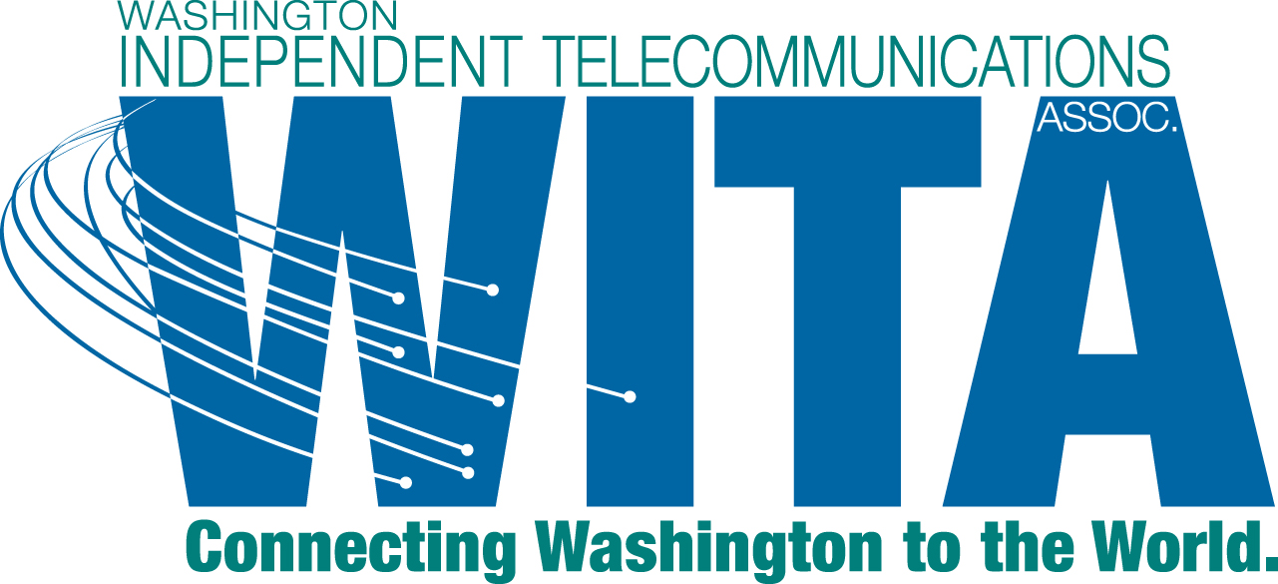

September 25, 2012

David Danner, Executive Director and Secretary
Washington Utilities and Transportation Commission
1300 S. Evergreen Park Drive SW
Olympia, WA 98504-7250

Re: UT-120451 - Response of WITA to Notice of Opportunity to File a Response

Dear Mr. Danner:

On September 14, 2012, the Commission issued a Notice of Opportunity to File a Response (the Notice). This letter constitutes the response of the Washington Independent Telecommunications Association (WITA).

In the Notice, the Commission is providing interested persons an opportunity to respond to the first round of comments filed August 20, 2012. The Notice sets a response date of September 25, 2012. In addition, the Commission seeks additional information concerning certain aspects of the comments that were filed earlier in this docket. WITA will first address the Commission's questions and then provide a response to certain comments.

Response to Commission Questions

Most of WITA's rate-of-return members only operate in Washington. However, TDS operates in multiple states. TDS reports that of the twenty-nine states in which it operates ILECs, in no state have they been required to go to an "opt-in" process for distribution of directories. TDS includes opt-out language in the inside of the front cover of the TDS directories in most states, including Washington. In the states of Missouri, Michigan, Indiana, Pennsylvania, Florida, Georgia and Virginia there is no requirement related to either opt-in or opt-out. In those states, companies are not required to do a mandatory directory distribution and can choose to do so if they desire. WITA understands that more information on this question may be provided by CenturyLink and Frontier.

As to the Commission's second question, each of WITA's rate-of-return members (i.e., the members other than CenturyLink and Frontier) provide co-bound directories in their service areas. The companies do not provide stand-alone white page directories. WITA understands that CenturyLink and Frontier will provide the information concerning their service areas.

Response to Earlier Comments - General

WITA's primary position is that the Commission should not regulate whether an incumbent local exchange carrier (ILEC) provides a directory or not. There are a wide choice of directories out in the market place, including both print and online versions provided by entities not regulated by the Commission. WITA hopes that the Commission will take this opportunity to reduce regulatory burden on ILECs that are struggling to control costs in an environment of decreasing revenue while providing a high quality level of service to their customers. Each company should have the choice of providing a directory in the form that it thinks is best, or no directory at all.

In addition, attached is a statement from Forum Communications Printing calling into question whether an opt-in approach will save more than it costs.

If the Commission is going to mandate that directories continue to be provided by ILECs to their customers, WITA strongly supports the opt-out approach as set forth in WITA's earlier comments.
Comments in Response to Public Counsel

Public Counsel submitted comments dated August 20, 2012, that would actually increase the regulatory burden in ILECs on this subject. WITA objects to steps that increase the regulatory burden on and the cost of operations of its members.

WITA does note that Public Counsel, like WITA, supports the opt-out mechanism. However, Public Counsel's regulatory requests for an opt-in approach are problematic.

Public Counsel suggests that, perhaps, seven forms of customer notice might be appropriate, citing to what has occurred in New Jersey concerning Verizon's request in that state. However, Public Counsel later reduces the number of proposed forms of notice to five. WITA believes that Public Counsel's suggestions are regulatory overkill and propose too much in the way of regulatory requirements.

At pages three and four of its comments, Public Counsel recommends that the "blue pages" continue to be provided to all customers, even in an opt-in approach. Why should it be assumed that customers that do not opt-in want to receive the "blue pages." WITA objects to this requirement as imposing an unreasonable additional cost on its members. To have to run a publication of a separate portion of the directory will increase the operating costs for WITA's members and is not appropriate.

Public Counsel recommends that ILECs be required to provide alternative directory forms. Public Counsel suggests that the minimum should be an online directory. Since Public Counsel couches this requirement in terms of posing it on a "national website," perhaps Public Counsel did not have in mind the smaller rate-of-return carriers that are WITA members. In any event, WITA believes that requiring additional forms of directories is imposing unneeded additional regulation on ILECs.

At pages five and six of its comments, Public Counsel recommends quarterly reporting.
What is the benefit of this additional reporting? Why should these costs be imposed on ILECs? WITA strongly objects to additional reporting requirements.

Response to Comments of The Broadband Communications Association of Washington

The Broadband Communications Association of Washington (BCAW) submitted comments on April 20, 2012. The thrust of those comments is urging the Commission to impose conditions on ILECs, as a preemptive matter, over items that should be negotiated in a competitive setting as part of an interconnection agreement (ICA).

The points raised by BCAW are all matters that should be subject to ICA negotiations between the parties affected by the issues, not imposed by regulatory fiat. If the parties cannot agree, the matter can always be brought to arbitration before the Commission under 47 U.S.C. 252. However, it is not appropriate for the Commission to side with the CLEC's view of what would be ideal conditions and by doing so preempt negotiations between the parties.

Specifically, BCAW would have the Commission mandate that directories be provided to competitors and competitors customers. BCAW would have the Commission mandate that ILECs cannot market to CLEC customers through the provision of directories. Yet, BCAW does not impose any restrictions on CLEC marketing. BCAW would have the Commission mandate that ILECs accept electronic files from CLECs. All of these are matters which should be subject to negotiation, not regulation.
Most ILECs do not publish their own directories. Instead, most ILECs contract with directory publishing firms. Those directory publishing firms may have certain requirements that may have to be met. All of these matters should be issues to be negotiated between the parties. It should not be imposed by a regulatory mandate.

Conclusion

WITA respectfully requests that the Commission repeal WAC 480-120-251. It should be the business determination of each local exchange company whether it provides a telephone directory to its customers and, if so, in what format.

If the Commission is going to continue to require that directories to be provided, WITA recommends that an opt-out approach be used. An opt-in imposes additional costs on the local exchange carriers at a time when those additional costs cannot be absorbed.

As an alternative, WITA recommends that co-bound directories be exempted from an opt-in requirement for the reasons set forth in WITA's prior comments.

Thank you for the opportunity to comment and your attention to these comments.

Sincerely,

) Forum Communications Printing refers to "legislation" which should be taken as a layperson's understanding of what is meant by "regulation."
) Frontier has taken a different position and is not joining in WITA's comments on this point.
) Frontier does join in the WITA Response to both Public Counsel and BCAW.
) Comments of Public Counsel at p.3.
) Comments of Public Counsel at p.2.
) Comments of Public Counsel at p.5.
) Comments of Public Counsel at p.4.
) It is likely that the Commission cannot enforce these additional reporting requirements for those companies that fall below the two percent threshold. However, it is WITA's position that it is not appropriate for such requirements to apply to any local exchange carrier.

