WN U-74 |  |  |  | Fifteenth Revision of Sheet No. 16.1
 |  |  | Canceling Fourteenth Revision of Sheet No. 16.1
PACIFIC POWER & LIGHT COMPANY
 |  |  |  |  |  |  |  |  |  |  |  | FOR COMMISSION’S RECEIPT STAMP
SCHEDULE 16
RESIDENTIAL SERVICE

AVAILABLE:
In all territory served by Company in the State of Washington.

APPLICABLE:
To single-family residential Customers only for all single-phase electric requirements when all service is supplied at one point of delivery. For three-phase residential service see Schedule 18.

MONTHLY BILLING:

(I)

(I)
(I)

The Monthly Billing shall be the sum of the Basic and Energy Charges.
All Monthly Billings shall be adjusted in accordance with Schedules 91, 96, 98, and 191.

(I)
(I)

Basic Charge: $7.00

Energy Charge:

Base
Rate
5.657¢ per kWh for the first 600 kWh
8.929¢ per kWh for all additional kWh

MINIMUM CHARGE:
The monthly Minimum Charge shall be the Basic Charge. A higher minimum may be required under contract to cover special conditions.

CONTINUING SERVICE:
Except as specifically provided otherwise, the rates of this Tariff are based on continuing service at each service location. Disconnect and reconnect transactions shall not operate to relieve a Customer from monthly minimum charges.

RULES AND REGULATIONS:
Service under this Schedule is subject to the General Rules and Regulations contained in the tariff of which this Schedule is a part and to those prescribed by regulatory authorities.
Issued |  |  |  |  |  | February 9, 2009 |  | Effective |  |  | March 11, 2009
Issued by |  |  |  |  | PACIFIC POWER & LIGHT COMPANY
By |  | 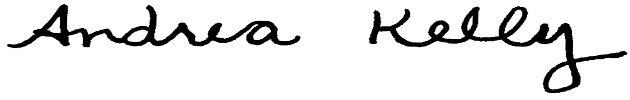  Andrea L. Kelly |  |  |  |  |  |  | Title | Vice President, Regulation
 |  | TF2 16.1REV |  |  |  |  | Advice No. |  |  |  |  |  | UE-
Form F

