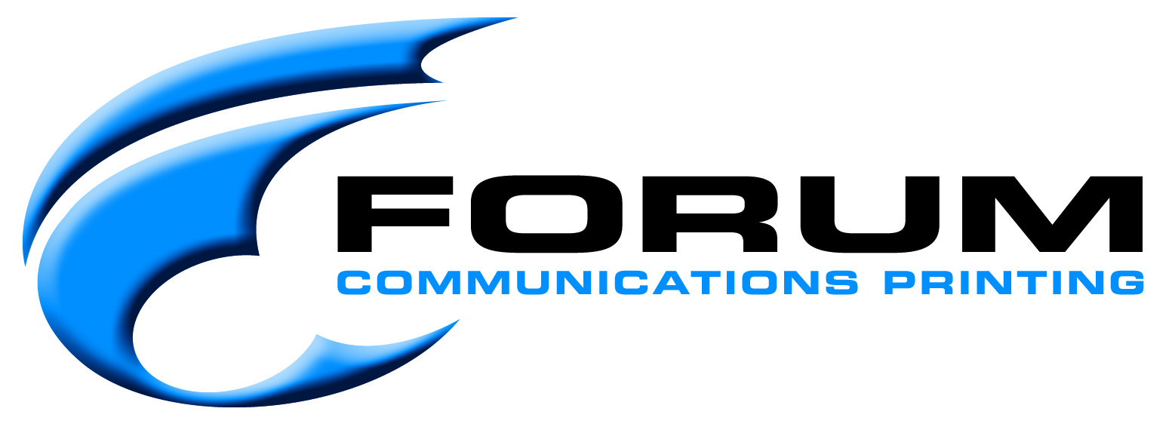

To Whom It May Concern:

In regards to pending legislation in Washington which would require an “opt-in only” for printed telephone directories, we feel it is imperative that the negative impact of such legislation be thoroughly explored. While the concern may be that of trying to be “green” and protect the environment, the actual impact of such legislation could result in even more paper and resources being utilized.
As a commercial printing company, we take great pride in being as “green” as possible - using only paper that has been harvested in an environmentally responsible fashion. Our paper vendors replant trees at a ratio that far exceeds what is harvested to ensure an abundance of trees for future generations. We recycle paper, cardboard, plates, inks, and many other materials in our production facility. Most of the paper we use has recycled content in it.
While the thought of “opt-in” sounds like it will save paper and materials on the surface, upon further exploration, there are multiple scenarios in which this concept would use MORE material. For example, on a 4,300 quantity telephone directory with 264 pages in it, an approximate printing cost would be $4,236.36 per book. It would use approximately 4,000 pounds of paper. With an “opt-in” scenario – there would be smaller numbers of end users requesting a print edition and this number would be spread throughout the year. If the telephone company projected all 4000 would still be requested, and printed that ahead of time, no resources are saved. If not all are requested, then a number of those directories would be wasted – wasted papers, inks, electricity to produce, etc.
If the telephone company tried to “print on demand” each month as directories were requested, it would be 1) cost prohibitive, and 2) potentially use MORE resources. An explanation of the pricing is as follows: Printing 4,300 at once as shown in the above paragraph is $.85 per book and uses 4,000 pounds of paper. Every time a new project is printed on a press, set up costs are incurred. This includes new plates and a certain percentage of paper that is “waste” while the press is getting the printed project’s colors to where they need to be, and the registration of the product where it needs to be. If opt-ins were at 100 books per month on average, you would be looking at a total of 1200 books, but cost per book would now be at $24.51 per book. And for 1200 books, you would be using 900 pounds of paper when factoring in the start-up waste.
In addition to the above concerns, such legislation can have a very HUMAN impact. By reducing the printed directories, at a minimum, people will lose jobs in the telephone directory and printing businesses due to layoffs and cut-backs. Worse case – you could put these companies out of business and hundreds of people would lose their jobs. The economic impacts of these scenarios far outweigh a “possible” reduction in material savings you might reap through “opt-in only” legislations.
We urge you to consider all of the negative ramifications that this proposed legislation could have on people and on employment. Commercial printing is one of the largest employment sectors in this country and is already facing enough challenges from overseas. Please think of the additional negative impact you may have on this industry by enacting such legislation.

Sincerely,
Forum Communications Printing
Detroit Lakes, MN

