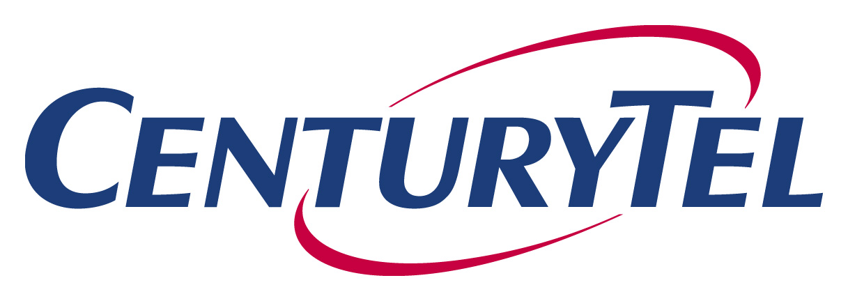
P.O. Box 9901
Vancouver, WA 98668-8701
Tel 360 905 5958
Fax 360 905 5953
calvin.simshaw@centurytel.com
Calvin K. Simshaw
Vice President
Associate General Counsel - Regulatory

July 28, 2006

VIA E-FILING AND OVERNIGHT MAIL

Ms. Carole J. Washburn
Washington Utilities and Transportation Commission
1300 S. Evergreen Park Dr. SW
Olympia, WA 98504-7250

Re: Docket No. UT-063038

Dear Ms. Washburn:

Enclosed are the original and three copies of Exhibit A (Attorney Agreement) for the Protective Order (Order 02) in the above referenced docket.

Very truly yours,

Calvin K. Simshaw
Assoc. General Counsel-Regulatory

CKS/rp
Enclosures

cc: Service List (via e-mail and U.S. mail)

