2/1/16

WUTC
Executive Secretary
Steven King
Washington Utilities and Transportation Commission
1300 South Evergreen Park Drive SW
Olympia, Wa. 98504-7250

RE: FCC Form 555 Submittal

Dear Mr. King:

Please find the attached regulatory filing of FCC Form 555. Westgate Communications LLC d/b/a WeavTel respectfully submits this document to meet regulatory filing requirements.

Sincerely,

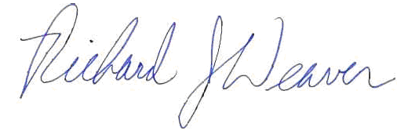
Richard J. Weaver
General Manager

