Exhibit No. ___ (KSC-4)
Docket No. PG-041624
Witness: Kuang-Shi Chu

BEFORE THE WASHINGTON UTILITIES AND TRANSPORTATION COMMISSION

WASHINGTON UTILITIES AND TRANSPORTATION COMMISSION,  Complainant,  v.  PUGET SOUND ENERGY,  Respondent. | DOCKET NO. PG-041624

EXHIBIT TO
TESTIMONY OF

Kuang-Shi Chu

STAFF OF
WASHINGTON UTILITIES AND
TRANSPORTATION COMMISSION

Photographs of the Schmitz house
after the explosion

July 21, 2005

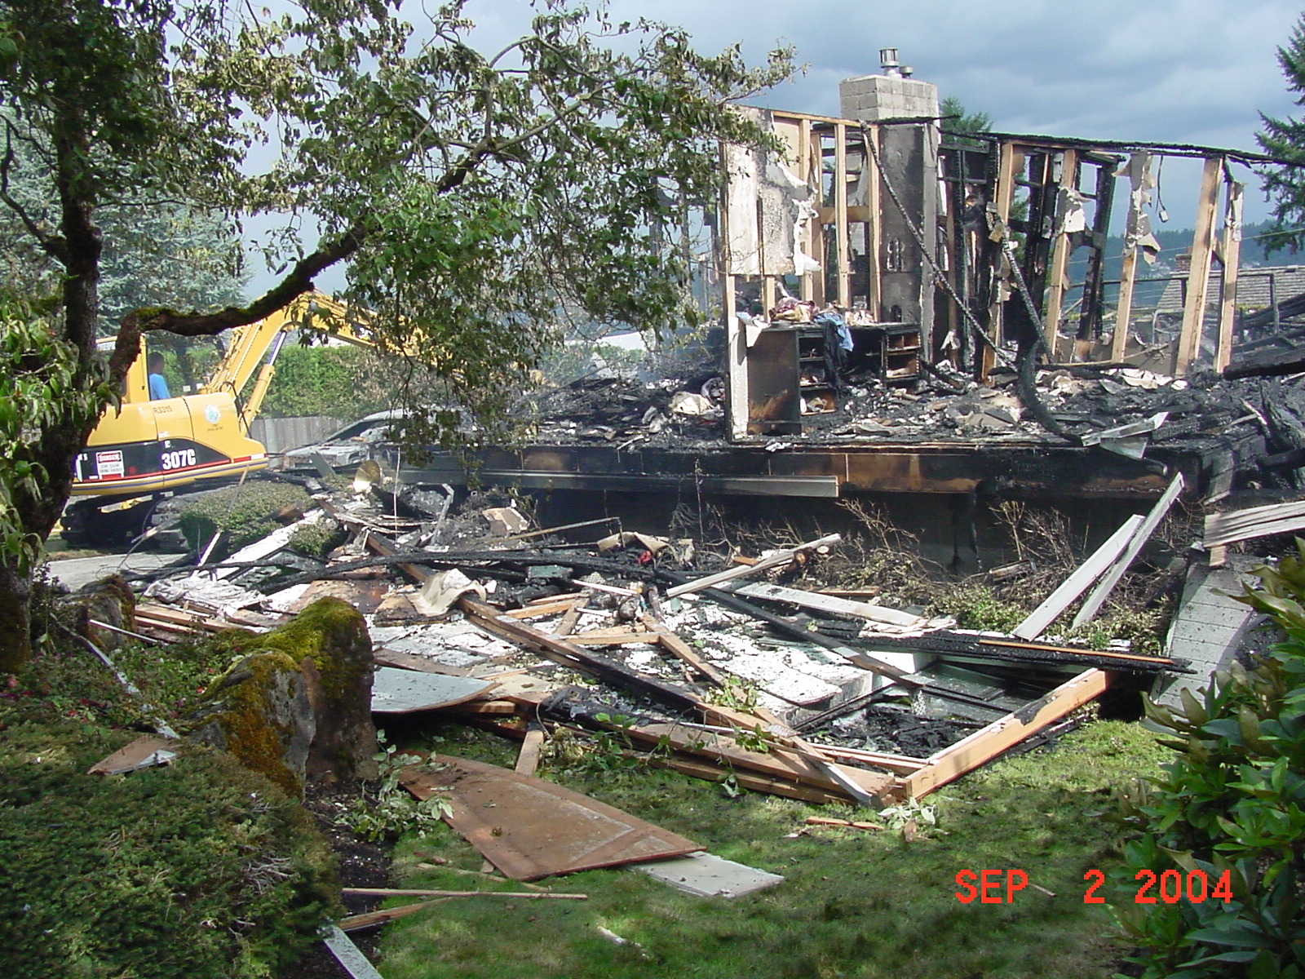

The west side of the house looking east.

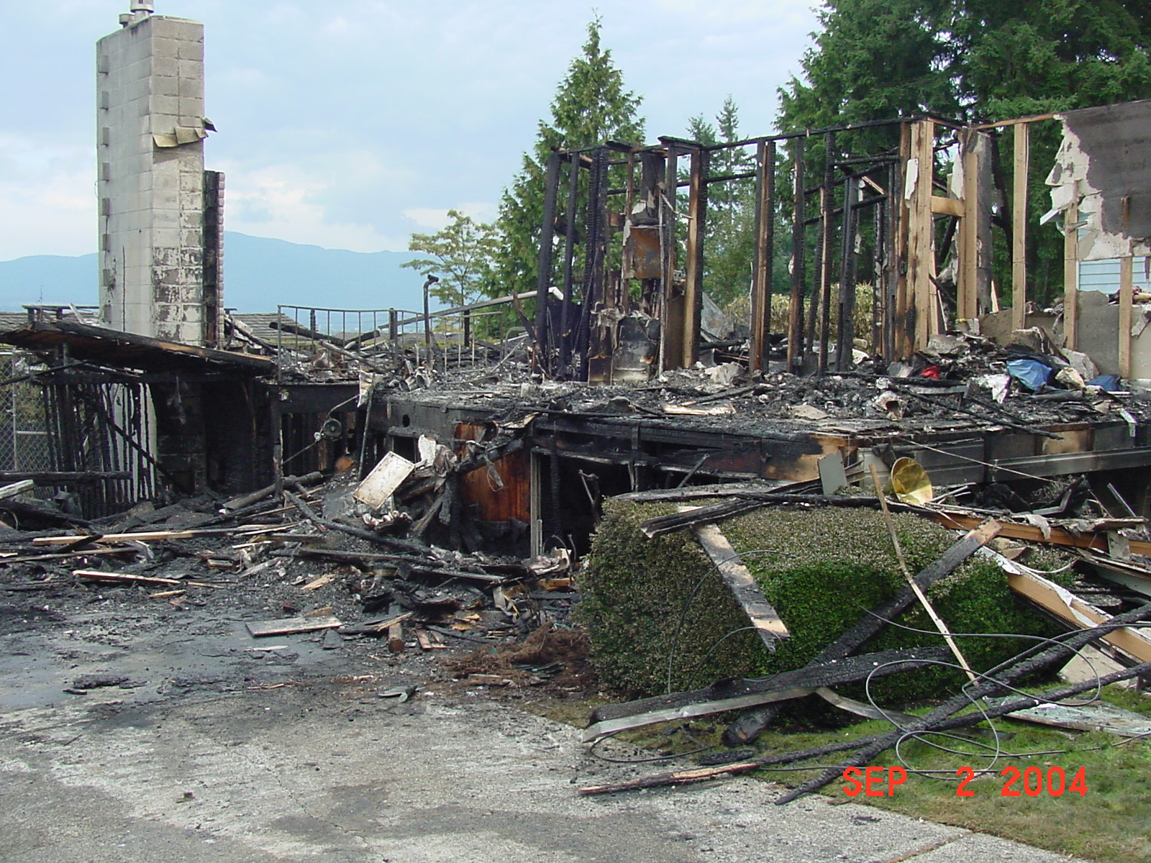

The north side of the house looking south.

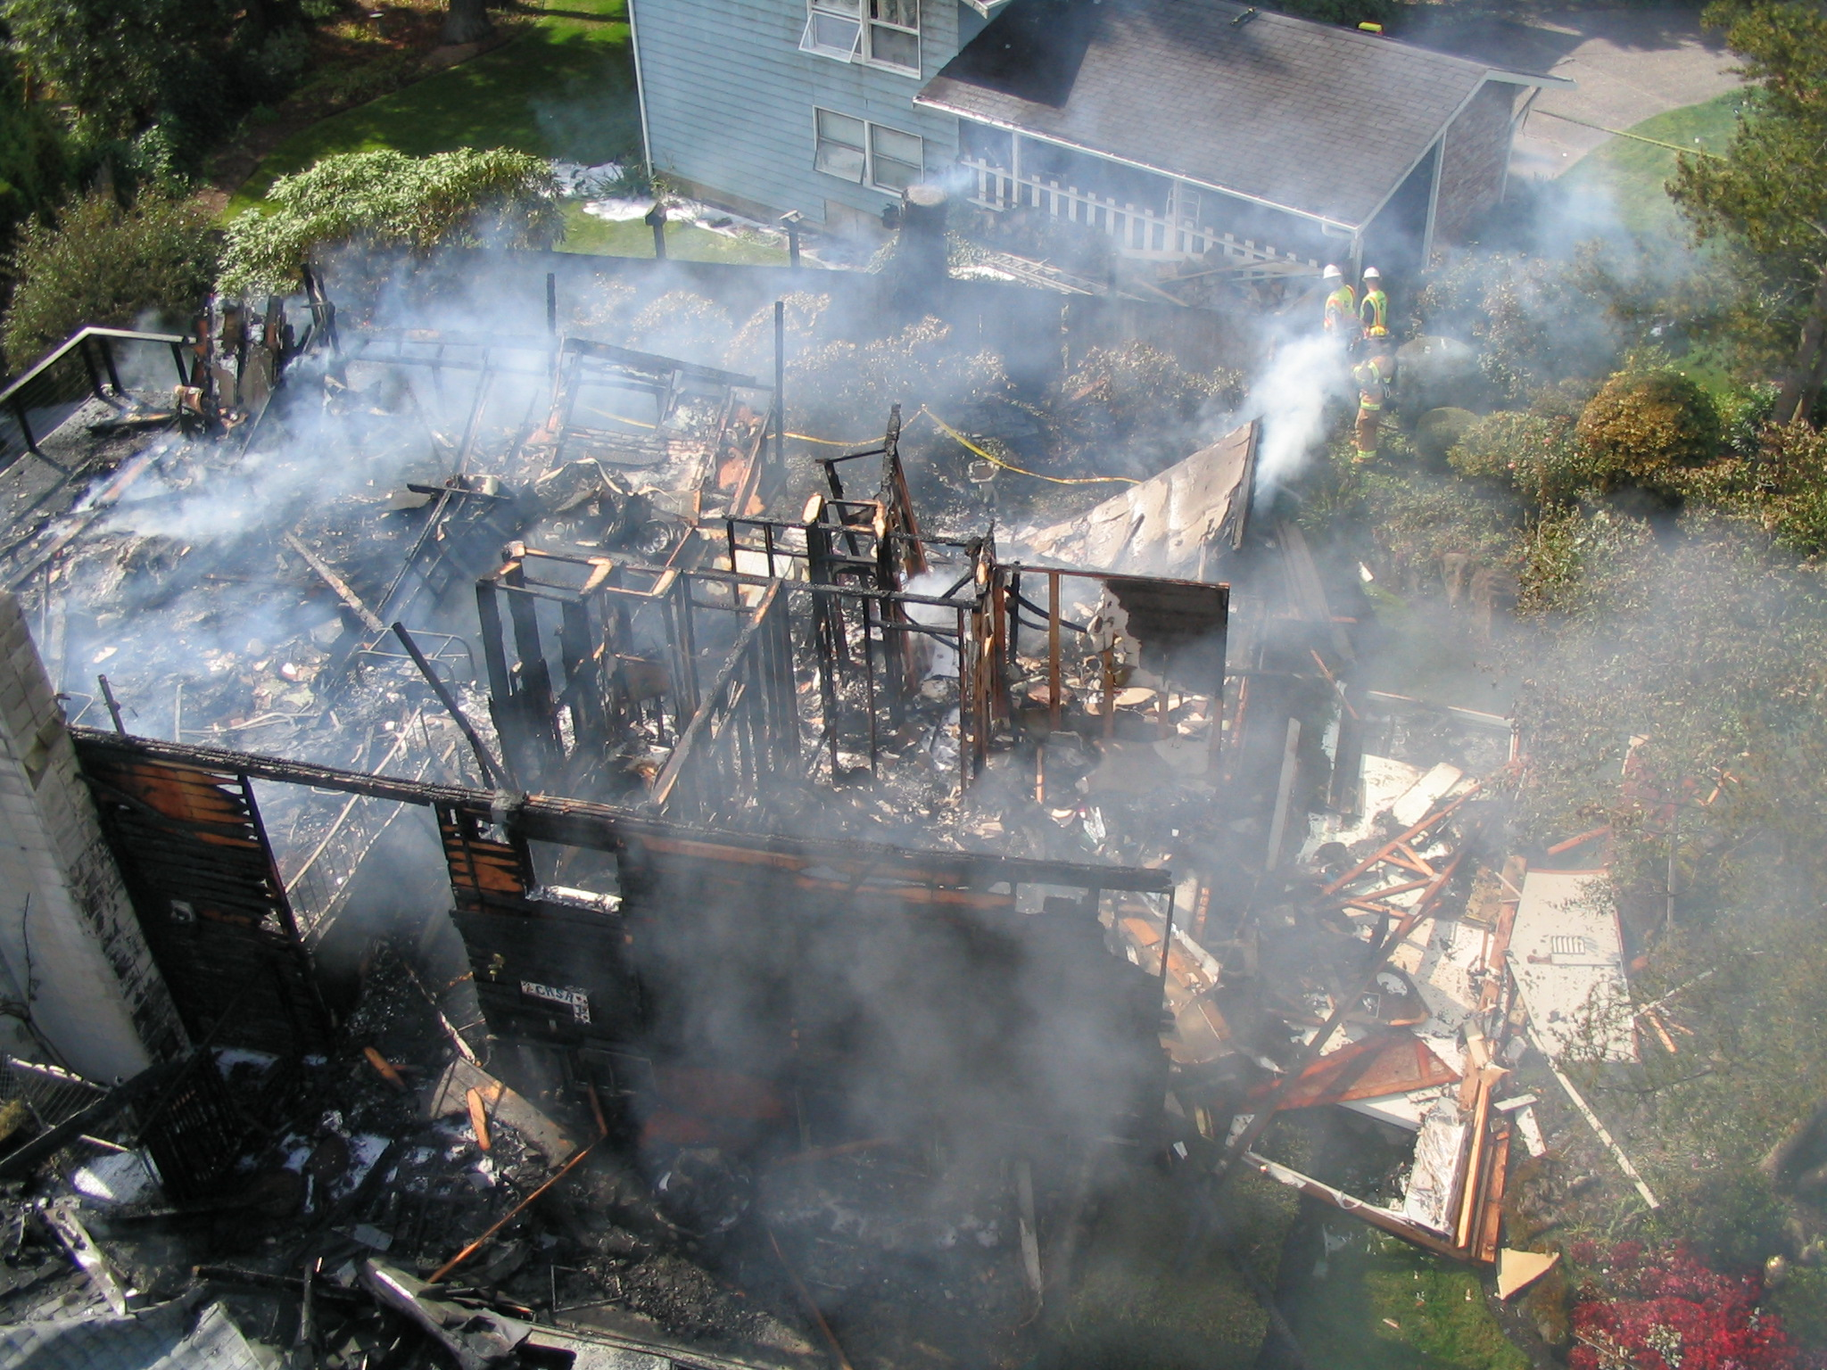

The aerial overview of the house looking south.

