Comparison of Alternative 5-Zone Proposals

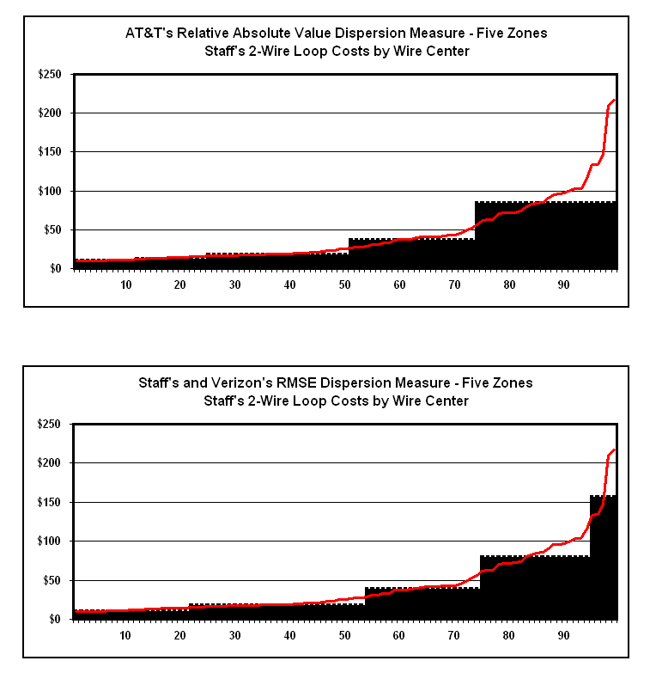
Comparison of Alternative 5-Zone Proposals

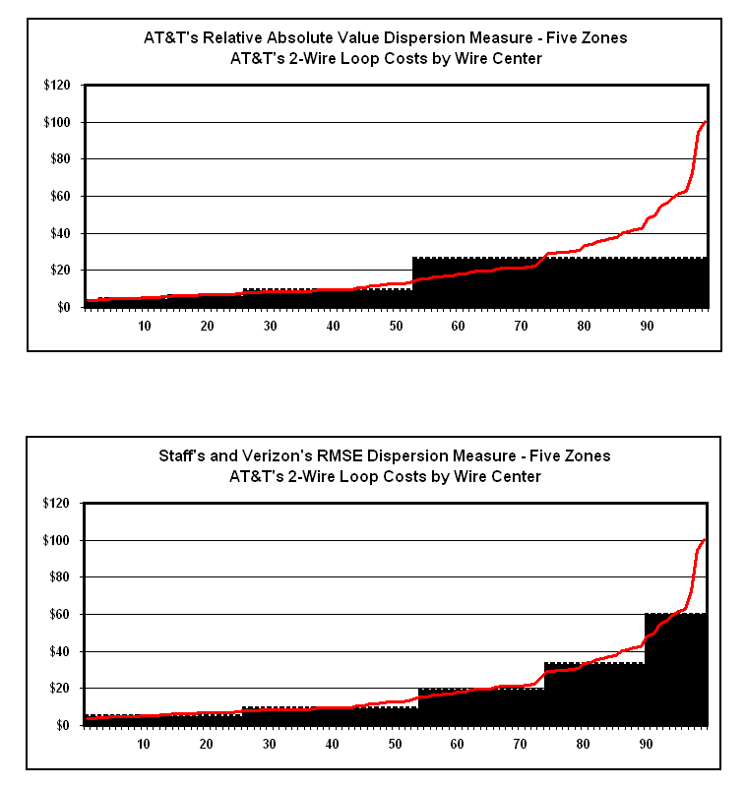
Comparison of Alternative 5-Zone Proposals

