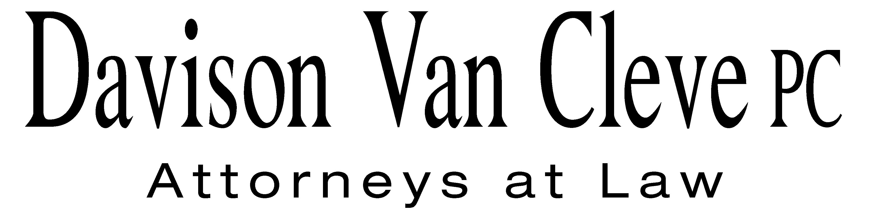
TEL (503) 241-7242 ● FAX (503) 241-8160 ● row@dvclaw.com
Suite 400
333 SW Taylor
Portland, OR 97204

December 4, 2014

Via E-mail and Federal Express

Mr. Steven V. King
Executive Director & Secretary
Washington Utilities and Transportation Commission
PO Box 47250
1300 S Evergreen Park Drive SW
Olympia, WA 98504-7250

Re: WUTC v. PacifiCorp
2014 General Rate Case and consolidated dockets
Docket Nos. UE-140762, UE-140617, UE-131384, UE-140094 (consolidated)

Dear Mr. King:

Enclosed for filing in the above-referenced dockets, please find the original and eighteen (18) copies of Boise White Paper, L.L.C.’s Motion for Permission to Reply to Pacific Power’s Response in Opposition to Motion to Strike. Also enclosed are the original and eighteen (18) copies of the Reply of Boise White Paper, L.L.C. to Pacific Power’s Response in Opposition to Motion to Strike.

Thank you for your assistance. If you have any questions, please do not hesitate to call.

Sincerely,

/s/ Jesse O. Gorsuch
Jesse O. Gorsuch

Enclosures
cc: Service List

CERTIFICATE OF SERVICE

I hereby certify that I have this day served the attached documents upon all parties in this proceeding, as shown below, by sending copiess via electronic mail and by mailing copies via First Class U.S. Mail, postage prepaid.
DATED at Portland, Oregon, this 4th day of December, 2014.
Davison Van Cleve, P.C.

/s/ Jesse O. Gorsuch
Jesse O. Gorsuch

KATHERINE MCDOWELL  McDowell Rackner & Gibson PC  419 Southwest 11th Avenue  Suite 400  Portland, Or 97205-2605  katherine@mcd-law.com | R. BRYCE DALLEY  Vice President, Regulation  Pacific Power & Light Co.  825 NE Multnomah STE 2000  Portland, OR 97232  bryce.dalley@pacificorp.com
BRETT SHEARER  Assistant Attorney General  P.O. Box 40128  Olympia, WA 98504  bshearer@utc.wa.gov | SARAH WALLACE  Senior Counsel  Pacific Power & Light Co.  825 NE Multnomah STE 1800  Portland OR 97232  sarah.wallace@pacificorp.com
SIMON FFITCH  LISA GAFKEN  Office of the Attorney General  800 Fifth Avenue STE 2000  Seattle, WA 98104-3188  simonf@atg.wa.gov  Lisaw4@atg.wa.gov | PATRICK OSHIE  Assistant Attorney General  WUTC  P.O. Box 40128  Olympia, WA 98504  poshie@utc.wa.gov
SAMUEL L. ROBERTS  Hutchinson, Cox, Coons, Orr &  Sherlock, P.C.  P.O. Box 10886  Eugene, OR 97440  sroberts@eugenelaw.com | STEVE CHRISS  Manager – State Rate Proceedings  Walmart Stores, Inc.  2001 SE 10th Street  Bentonville, AR 72716-0550  stephen.chriss@wal-mart.com
KATHLEEN D. KAPLA  c/o Kapla Law PLLC  8205 31st Ave NE  Seattle, WA 98115  kkapla@kfwlaw.com | BRAD M. PURDY  Attorney at Law  2019 N. 17th St.  Boise, ID 83702  bmpurdy@hotmail.com
JOSEPH WIEDMAN  Keyes, Fox & Wiedman, LLP  436 14th Street, Suite 1305  Oakland, CA 94612  jwiedman@kfwlaw.com  (via e-mail only)  JENNIFER CAMERON-RULKOWSKI  Assistant Attorney General  WUTC  P.O. Box 40128  Olympia, WA 98504  JCameron@utc.wa.gov | WASHINGTON DOCKETS  Pacific Power & Light Co.  825 NE Multnomah, Suite 2000  Portland, OR 97232  washingtondockets@pacificorp.com

