 Verizon Northwest Inc.

1800 – 41st Street, WA0105RA
P. O. Box 1003
Everett, WA 98206-1003
Fax: 425-261-5262

February 6, 2008

Advice No. 3252

Ms. Carole J. Washburn, Executive Secretary
Washington Utilities and Transportation Commission
1300 S. Evergreen Park Drive, S. W.
Olympia, Washington 98504-7250

Dear Ms. Washburn:

Verizon Northwest Inc. (“Verizon NW”) filed Advice No. 3252 on July 2, 2007, which provides changes to the General and Local Exchange Tariff, WN U-17, Sections 2 and 5, related to the residential Late Payment Charge (LPC). This filing is currently suspended in Docket No. UT-040788. Specifically, the purpose of this filing was to remove the December 31, 2007 expiration of the effectiveness of the residential Late Payment Charge from the tariff. As the commission noted in paragraph 3 of Order No. 17 in Docket No. UT-040788 (referring back to Order No. 15 in the same docket), Verizon NW may re-file the residential Late Payment Charge tariff provision or file a modified tariff for continued operation of the residential Late Payment Charge at any time after July 1, 2007.

The company filed to extend the effective date of Advice No. 3252 on August 20, 2007, October 19, 2007 and again on November 2, 2007 at Commission Staff’s and Public Counsel’s request to allow additional time for review. On November 28, 2007, the Commission issued Order 19 in Docket No. UT-040788 suspending this tariff filing and extending the current residential late payment charge from December 31, 2007 to February 26, 2008 to allow an additional 90 days for review.

Verizon NW, Commission Staff and Public Counsel have reached an agreement, subject to commission approval, for the residential Late Payment Charge to be made permanent at 1% or $2.00, whichever is greater, on customer bills that are greater than $2.00. Please find attached slip-sheets to amend the tariff language as originally filed to include the changes noted above.

The company requests approval on less than statutory notice with a requested effective date of February 21, 2008. This LSN approval is requested to insure the new rates are made effective so that company systems can be updated with the new rates prior to the expiration date of the current LPC rates on February 26, 2008. If the proposed LPC rates are not made effective prior to February 26, 2008 the current rate will expire and the company will incur a revenue loss unless the expiration date (February 26, 2008) of the current rate is extended.

Please contact Lin Fogg at (425) 261-6380 with questions.

Very truly yours,
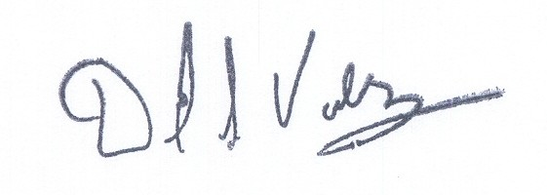

David S. Valdez
Senior Vice President - West
Public Affairs, Policy and Communications

DSV:kad
(WAIGLU-17-0284)

Attachment A

General and Local Exchange Tariff, WN U-17 (Slipsheets)

Section 2

4th Revised Sheet 19

5th Revised Sheet 20

Section 5

2nd Revised Sheet 5.1

5th Revised Sheet 6

