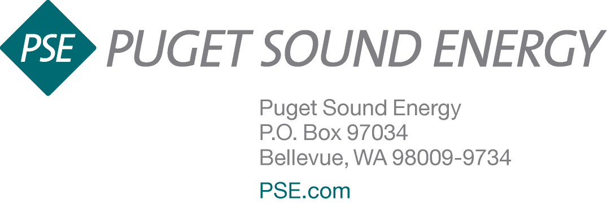

Dear Renewable Energy Customer,

This year has been phenomenal for renewables. In addition to record temperatures and a higher number of sunny days, we predict ending the year with 1,200 new solar customers, bringing the total number of PSE net metered customers to 3,800. We also have 19 community solar arrays in neighborhoods across our service area, and the momentum is substantial going into next year.

The increase in customers combined with greater production means we are on track to reach the limit of Washington State incentives for renewables. In order to welcome future projects into the program, and to comply with PSE’s state prescribed cap, currently $10 million, the base rate will need to be adjusted for all renewable energy customers starting next year. As of September 2015, the incentive payment is expected to drop between 2 to 5 cents per kilowatt-hour (kWh). This would move the base rate from 15 cents to between 10 and 13 cents. For customers using in-state manufactured solar equipment where the payout is highest, the payment would be adjusted from 54 cents per kWh to between 36 and 46.8 cents. We will continue to adjust the base payment annually until all payouts can be made and will communicate quarterly with customers and installers about the increasing solar adoption. The base rate amounts will be finalized in early summer 2016. For more details on how our state’s renewable incentives work, please visit pse.com/REAP.

As we head into the last five years of Washington State’s solar incentive, we look forward to working with you, installers, legislators, and manufacturers, to extend solar payments and to continue to grow renewable energy in our state.

Thank you for your dedication to renewable energy.

Jake Wade
PSE Net Metering Program Manager

