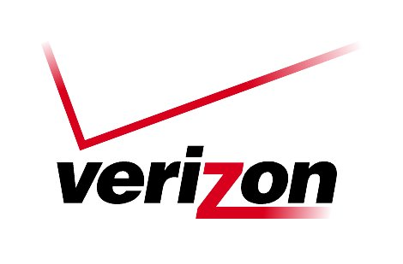 Verizon Northwest Inc.

1800 – 41st Street, WA0105RA
P. O. Box 1003
Everett, WA 98206-1003
Fax: 425-261-5262

November 2, 2007

Advice No. 3252

Ms. Carole J. Washburn, Executive Secretary
Washington Utilities and Transportation Commission
1300 S. Evergreen Park Drive, S. W.
Olympia, Washington 98504-7250

Dear Ms. Washburn:

Verizon Northwest Inc. (“Verizon NW”) filed Advice No. 3252 on July 2, 2007, which provides changes to the General and Local Exchange Tariff, WN U-17, Sections 2 and 5, related to the residential Late Payment Charge. This filing is currently pending in Docket No. UT-040788. Specifically, the purpose of this filing is to remove the December 31, 2007 expiration of the effectiveness of the residential Late Payment Charge from the tariff. As the commission noted in paragraph 3 of Order No. 17 in Docket No. UT-040788 (referring back to Order No. 15 in the same docket), Verizon NW may re-file the residential Late Payment Charge tariff provision or file a modified tariff for continued operation of the residential Late Payment Charge at any time after July 1, 2007. Verizon NW does so with this filing by making three deletions to provisions within the tariff that describe expiration of the residential Late Payment Charge on December 31, 2007.

The company filed on August 20, 2007 to extend the effective date of the filing to October 25, 2007 at Staff’s and Public Counsel’s request to allow more time for review. The company filed on October 19, 2007 to extend the effective date for this filing to November 8, 2007 at the request of Staff and Public Counsel to accommodate additional review time. The company requests to extend the effective date of this filing to November 29, 2007 to allow additional time for review by Staff and Public Counsel.

Please contact Lin Fogg at (425) 261-6380 with questions.

Very truly yours,
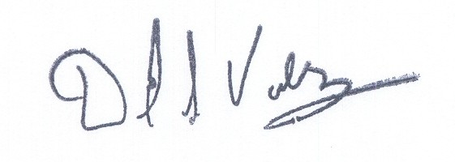

David S. Valdez
Senior Vice President - West
Public Affairs, Policy and Communications

DSV:LF:lf
(WAIGLU-17-0250)

