Exhibit No. ___ (KSC-17)
Docket No. PG-041624
Witness: Kuang-Shi Chu

BEFORE THE WASHINGTON UTILITIES AND TRANSPORTATION COMMISSION

WASHINGTON UTILITIES AND TRANSPORTATION COMMISSION,  Complainant,  v.  PUGET SOUND ENERGY,  Respondent. | DOCKET NO. PG-041624

EXHIBIT TO
TESTIMONY OF

Kuang-Shi Chu

STAFF OF
WASHINGTON UTILITIES AND
TRANSPORTATION COMMISSION

Analog volt meter

July 21, 2005

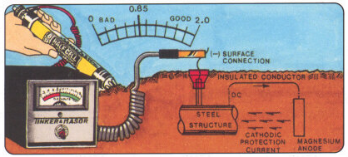

Analog volt meter

