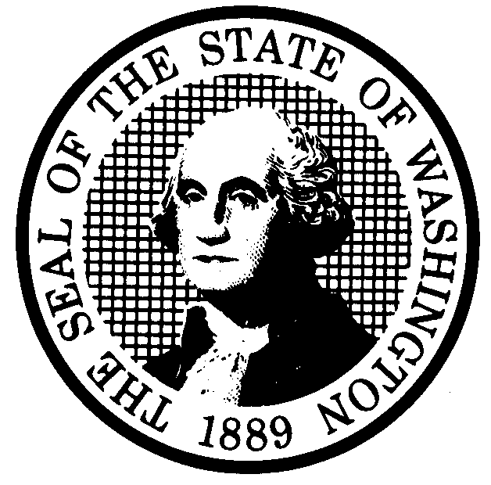  PROPOSED RULE MAKING  (RCW 34.05.320) |  |  |  | CR-102 (7/10/97)  Do NOT use for expedites adoption
Agency: WASHINGTON UTILITIES AND TRANSPORTATION COMMISSION |  |  |  | X Original Notice   Supplemental Notice  to WSR ___________   Continuance of WSR  __________________
X Preproposal Statement of Inquiry was filed as WSR 00-17-167; or
□ Expedited Adoption--Proposed Rule Making notice was filed as
WSR____________________; or
□ Proposal is exempt under RCW 34.05.310(4).
(a) Title of rule: (Describe Subject) Chapter 480-122 WAC Washington Telephone Assistance Program. Commission Docket UT-003074
Purpose: To implement the requirements of Executive Order 97-02, requiring agencies to review significant rules for Need; Effectiveness and Efficiency; Clarity; Intent and Statutory Authority; Cost and Fairness. The proposal would repeal several existing rules which are duplicative of rules under the jurisdiction of the Department of Social and Health Services, adds and clarifies definitions, and includes a new requirement defining when local exchange carriers must begin offering telephone assistance rates and discounts.

(b) Statutory authority for adoption:  RCW 80.01.040 RCW 80.36.410 RCW 80.66.010  RCW 80.04.160 RCW 80.36.420 |  |  | Statute being implemented:
(c) Summary:
See section (j) below:

Reasons supporting proposal:
(d) Name of Agency Personnel Responsible for: Office Location Telephone
1. Drafting Kristen Russell 1300 S. Evergreen Park Drive SW, Olympia, WA 98504 360-664-1281
2. Implementation Carole J. Washburn, Secretary, 1300 S. Evergreen Park Drive SW, Olympia, WA 98504 360-664-1174
3. Enforcement Carole J. Washburn, Secretary, 1300 S. Evergreen Park Drive SW, Olympia, WA 98504 360-664-1174
(e) Name of proponent (person or organization) □ Private
□ Public
Washington Utilities and Transportation Commission X Governmental
(f) Agency comments or recommendations, if any, as to statutory language, implementation,
enforcement, and fiscal matters: NONE

(g) Is rule necessary because of:
Federal Law? □ Yes X No If yes, ATTACH COPY OF TEXT
Federal Court Decision? □ Yes X No Citation:
State Court Decision? □ Yes X No
 | (h) HEARING LOCATION:  Commission Hearing Room 206  2nd Floor, Chandler Plaza Building  1300 So. Evergreen Park Dr. SW  Olympia, WA 98504-7250  Date: September 12, 2001 Time: 9:30 a.m.  Assistance for persons with disabilities: Contact Mary DeYoung  by Monday, September 10, 2001  TDD (360) 586-8203 or (360) 664-1133 |  | Submit written comments to: Carole J. Washburn,  Secretary, P.O. Box 47250, Olympia, WA 98504-7250 or  E-mail to <records@wutc.wa.gov>. Please include Docket No. UT-003074 in your communication.  FAX (360 ) 586-1150 By (date) August 22, 2001
 |  |  | DATE OF INTENDED ADOPTION: September 12, 2001
 |  |  | CODE REVISER USE ONLY
NAME (TYPE OR PRINT)
Carole J. Washburn
 | SIGNATURE
 | TITLE  Secretary | DATE  August 1, 2001

(COMPLETE REVERSE SIDE)

(j) Short explanation of rule, its purpose, and anticipated effects:

To implement the requirements of Executive Order 97-02, requiring agencies to review significant rules for Need; Effectiveness and Efficiency; Clarity; Intent and Statutory Authority; Cost and Fairness. The proposal would repeal several existing rules which address the criteria for consumer participation, and benefits received by participants. These rules are duplicative of rules under the jurisdiction of the Department of Social and Health Services. The rule redraft adds a definition for radio communications service company and clarifies existing definitions, and includes a new requirement defining when local exchange carriers must begin offering telephone assistance rates and discounts.

Does proposal change existing rules? X YES □ NO If yes, describe changes:

WAC 480-122-010: clarifies definitions used throughout the chapter, eliminates definitions not pertinent to the Commission’s jurisdiction
WAC 480-122-020: clarifies when telecommunications carriers are required to offer telephone assistance rates and discounts
WAC 480-122-030: repealed, falls under the jurisdiction of DSHS
WAC 480-122-040: repealed, falls under the jurisdiction of DSHS
WAC 480-122-060: clarifies that only wireline carriers will collect the excise tax, and eliminates a set rate to allow for flexibility to adjust the rate within the statutory amount by order, at the request of DSHS
WAC 480-122-070: repealed, falls under the jurisdiction of DSHS
WAC 480-122-080: eliminates language that is no longer necessary, and was confusing to carriers
WAC 480-122-090: repealed, falls under the jurisdiction of DSHS

(k) Has a small business economic impact statement been prepared under chapter 19.85 RCW?

X Yes. Attach copy of small business economic impact statement.
Commission Staff contacted companies seeking data regarding whether the proposed rules would impose increased costs. The responses indicate that affected companies have not identified such increased costs. The Commission analyzed the rules to identify those that impose requirements that are new or differ from current requirements. The Commission analysis identified only minor costs.
A copy of the statement may be obtained by writing to:

Carole J. Washburn, Secretary
P.O. Box 47250
Olympia, WA 98504-7250

Telephoning: 360-664-1174
Faxing: 360-586-1150

□ No. Explain why no statement was prepared.

(l) Does RCW 34.05.328 apply to this rule adoption? □ YES X NO
Please explain:

The Commission is not an agency to which RCW 34.05.328 applies. The proposed rules are not significant legislative rules as referenced in RCW 34.05.328(5).

