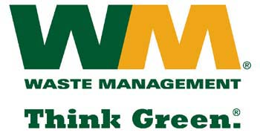

July 29, 2026

Steven King, Executive Director and Secretary
Washington Utilities & Transportation Commission
1300 South Evergreen Park Drive SW
P.O. Box 47250
Olympia, Washington 98504-7250

Re: TG-160020 (Waste Management of Greater Wenatchee, a division of Waste Management of Washington, Inc. (G-237); Tariff No. 13
Dear Secretary King:
Enclosed please find replacement pages 2, 21, 22, 23, 25, 31, 32, 33, 34 and 35 for the above-referenced docket. These pages are being replaced in concurrence with WUTC Staff recommendations. Please do not re-docket.

If you have any questions or need additional information, please contact me at:

Address: 720 4th Avenue, Suite 400, Kirkland, WA 98033
Telephone /Fax #: (425) 814-7840 / (425) 814-7866
e-mail: mweinstein@wm.com

Thank you for your attention to this matter.

Respectfully,

Michael A. Weinstein
Senior Pricing Manager, Pacific Northwest Market Area

