

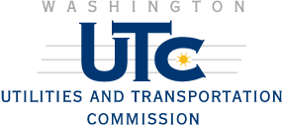

REGISTRATION
OF

Talk America Services, LLC

AS A COMPETITIVE
TELECOMMUNICATIONS COMPANY

Docket Number UT-143626 October 28, 2014
Effective Date

STEVEN V. KING

Executive Director and Secretary

CERTIFICATE IS NOT TRANSFERABLE

